
CCTV & SURVEILLANCE SYSTEM

NexPro 4CH 1-Bay 8MP PoE NVR (H.265+)
4 IP Channels | 4 PoE Ports | Single HDD Bay | Seetong Cloud

PRODUCT IMAGES
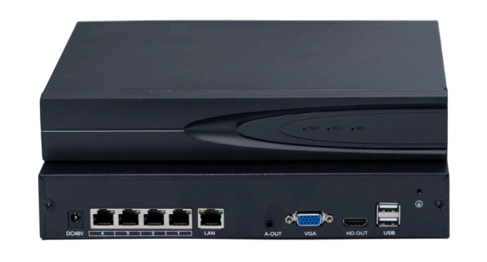
4-Channel PoE NVR · Reference Rear Panel

PRODUCT OVERVIEW
4-channel PoE network video recorder with 80Mbps incoming bandwidth. Supports IP camera input up to 8MP, with recording resolutions up to 5MP. Automatic camera discovery, addition and recording enable plug-and-play setup. One SATA HDD bay supports up to 14TB, with 2-channel playback and Seetong remote access.
Product line | CCTV & Surveillance System
Series / family | PoE Network Video Recorder
Product variant | 4CH PoE NVR · 1 SATA HDD bay · Up to 8MP IP camera input
Applications | Small Warehouse, Restaurant, Retail

MODEL IDENTIFICATION
Product | Product / variant | Channels | Camera input | Storage
NexPro PoE NVR | 4CH 1-Bay 8MP PoE NVR (H.265+) | 4 IP / 4 PoE | Up to 8MP | 1 SATA HDD bay  Max. 14TB

TECHNICAL SPECIFICATIONS
Parameter | Specification
Network Video Input | 4 channels
Incoming Bandwidth | 80Mbps
Camera Input Resolution | Up to 8MP
Recording Resolutions | 5MP / 4MP / 3MP / 1080P / 960P / 720P
Video Compression | H.265+ / H.265
Automatic Setup | Automatic camera discovery, addition and recording; plug-and-play setup without manual IPC addition
Simultaneous Playback | 2 channels
HDD Storage | 1× SATA interface; 1 HDD bay; up to 14TB
Video Outputs | 1× HDMI + 1× VGA; simultaneous output supported
Audio Output | 1× RCA, line level; audio output associated with VGA
Two-way Audio Input | 1× RCA; signal level: 2.0Vp-p; impedance: 1kΩ
LAN Interface | 1× RJ45, 10/100/1000Mbps auto-adaptive Ethernet port
PoE Interfaces | 4× 10/100Mbps auto-adaptive Ethernet ports; 48V standard PoE supply
USB Interfaces | 2× USB 2.0
Network Protocols | UPnP, SNMP, NTP, SADP, SMTP, PPPoE, DHCP
AC Supply | AC 220V
Power Consumption | 15W, excluding HDD
Operating Temperature | -10°C to +55°C
Weight | 3.35kg, excluding HDD
Cloud and Remote Access | Seetong Cloud; remote live view and recorded-video playback via mobile app and PC client
Reference image shows a DC48V recorder inlet. Confirm the AC adapter arrangement, RCA audio connections and PoE power budget for the final hardware configuration.

AI FUNCTIONS & ALARM LINKAGE
Parameter | Specification
Human / Vehicle Detection | Accurate human and vehicle detection
Simultaneous Human Detection | Up to 3 people detected simultaneously
Perimeter Protection | Tripwire detection and region intrusion detection
NVR Alarm | Pop-up alarm on the NVR display
App Notifications | Alarm push notifications, including push when the app is inactive
Intelligent Playback | Human and vehicle event recording playback
AI function compatibility should be confirmed with the selected IP cameras and firmware. App push notifications require an available network connection.

KEY FEATURES
1. Stable operation. 50% CPU headroom at full load, IP conflict adaptation and fault-tolerant recording with 99.99% completeness.*
2. Easy installation. Intuitive menus, IPC/router adaptation and automatic camera discovery, addition and recording for zero-configuration setup.
3. Efficient storage. H.265+ can save up to 90% of HDD space versus H.264; up to 14TB supports extended recording.*
4. Fast remote access. Stated performance: 10% traffic and up to 5× smoother viewing, with rapid cloud access and remote playback.*
*Performance figures depend on test conditions and system configuration. Storage savings vary with scene and encoding settings; remote performance varies with the network.

PRODUCT FAMILY & ACCESSORY REFERENCE
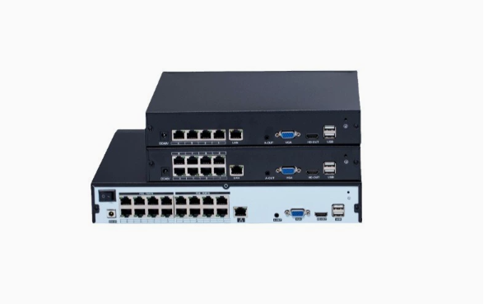 | 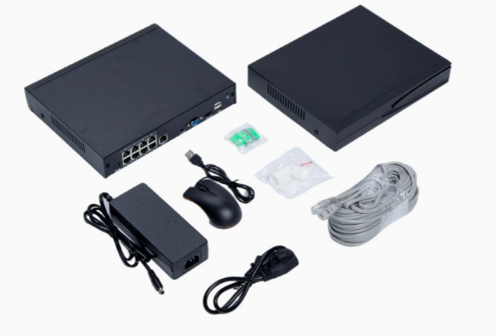
PoE NVR family · 4 / 8 / 16 ports  This datasheet covers the 4CH model only. | Accessory reference · 8-port chassis shown  The 4CH recorder is shown on page 1.
Accessory items shown include a power adapter, AC power cord, USB mouse, Ethernet cable and small accessory packs. Final accessory selection and quantities follow the project quotation.

APPLICATIONS & RFQ CONFIRMATION
Typical applications | Confirm in the project RFQ
Small Warehouse  Restaurant  Retail | Confirm the 4CH PoE configuration, HDD capacity and AI camera compatibility.  Confirm quantity, destination, packing, branding and documentation requirements.
Project supply: MOQ — Confirm by project quantity · Lead time — Confirm by project list · FOB port — China main ports · OEM/ODM — Available; confirm project scope

PROJECT CONFIGURATION CHECKLIST
Product configuration | 4 IP channels; 4 PoE ports; 1 SATA HDD bay; up to 14TB
Cameras and AI functions | Confirm IP camera models, input resolution, detection functions and alarm linkage.
HDD and recording plan | Confirm HDD capacity, recording mode, bitrate and required retention period.
Interfaces and accessories | Confirm display and RCA audio connections, power adapter, total PoE budget and accessories.
Finish, branding and packing | Confirm branding, packing and customization requirements for the order.
Quantity and destination | Confirm order quantity, delivery plan, destination, power plug and documentation.

STORAGE RETENTION REFERENCE (H.265+)
Actual recording storage requirements vary with the surveillance scene. The figures below are for reference only and were calculated using H.265+ encoding. All values are recording days.
Camera  resolution | Recording  channels | 2TB | 4TB | 6TB | 8TB | 14TB | 18TB*
3MP | 2 | 114 | 228 | 341 | 455 | 796 | 1024
3MP | 4 | 57 | 114 | 171 | 228 | 398 | 512
3MP | 6 | 38 | 76 | 114 | 152 | 265 | 341
3MP | 8 | 28 | 57 | 85 | 114 | 199 | 256
3MP | 10 | 23 | 46 | 68 | 91 | 159 | 205
4MP | 2 | 102 | 205 | 307 | 410 | 717 | 922
4MP | 4 | 51 | 102 | 154 | 205 | 358 | 461
4MP | 6 | 34 | 68 | 102 | 137 | 239 | 307
4MP | 8 | 26 | 51 | 77 | 102 | 179 | 230
4MP | 10 | 20 | 41 | 61 | 82 | 143 | 184
5MP | 2 | 93 | 186 | 279 | 372 | 652 | 838
5MP | 4 | 47 | 93 | 140 | 186 | 326 | 419
5MP | 6 | 31 | 62 | 93 | 124 | 217 | 279
5MP | 8 | 23 | 47 | 70 | 93 | 163 | 209
5MP | 10 | 19 | 37 | 56 | 74 | 130 | 168
*The 18TB column is reproduced as a general storage reference. It does not confirm compatibility with an 18TB HDD.

HOW TO READ AND APPLY THE TABLE
Read a scenario. Select the camera resolution and recording-channel count, then read the storage-capacity column. The number is the reference duration in days.
Check project settings. The source does not specify bitrate, frame rate, recording schedule or usable-capacity allowance. Confirm these inputs when sizing storage for an installation.
Observe the source coverage. The reference covers 3MP, 4MP and 5MP at 2, 4, 6, 8 or 10 channels. No 8MP or 16-channel recording figures are provided.

APPLICATION TO THIS 4CH MODEL
Recorder configuration | 4 IP channels; 1 SATA HDD bay; maximum 14TB per HDD
Applicable source rows | Use the 2- or 4-channel rows. The 4-channel rows are highlighted; rows above 4 channels are general reference only.
14TB example: 4 channels | 3MP: 398 days · 4MP: 358 days · 5MP: 326 days, as listed in the source.
Capacity scope | The 18TB reference column exceeds this single-bay model’s specified 14TB maximum HDD capacity.
Source: supplied H.265+ storage reference table. Original numerical values have been preserved.

