
CCTV & SURVEILLANCE SYSTEM

NexPro 16CH 2-Bay 8MP PoE NVR (H.265+)
16 IP Channels | 16 PoE Ports | Dual HDD Bays | Seetong Cloud

PRODUCT IMAGES
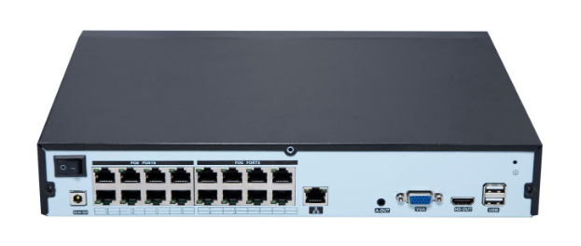
16-Channel PoE NVR · Reference Rear Panel
Reference image shows a DC-type recorder inlet. Confirm the AC input/adapter arrangement and RCA audio connections for the final hardware configuration.

PRODUCT OVERVIEW
16-channel PoE network video recorder with 260Mbps incoming bandwidth. Supports IP camera input up to 8MP, with recording resolutions up to 5MP. Automatic camera discovery, addition and recording enable plug-and-play setup. Two SATA HDD bays support up to 14TB per HDD, with 2-channel playback and Seetong remote access.
Product line | CCTV & Surveillance System
Series / family | PoE Network Video Recorder
Product variant | 16CH PoE NVR · 2 SATA HDD bays · Up to 8MP IP camera input
Applications | Small Warehouse, Restaurant, Retail

MODEL IDENTIFICATION
Product | Product / variant | Channels | Camera input | Storage
NexPro PoE NVR | 16CH 2-Bay 8MP PoE NVR (H.265+) | 16 IP / 16 PoE | Up to 8MP | 2 SATA HDD bays  Max. 14TB per HDD

TECHNICAL SPECIFICATIONS
Parameter | Specification
Network Video Input | 16 channels
Incoming Bandwidth | 260Mbps
Camera Input Resolution | Up to 8MP
Recording Resolutions | 5MP / 4MP / 3MP / 1080P / 960P / 720P
Video Compression | H.265+ / H.265
Automatic Setup | Automatic camera discovery, addition and recording; plug-and-play setup without manual IPC addition
Simultaneous Playback | 2 channels
HDD Storage | 2× SATA interfaces; 2 HDD bays; up to 14TB per HDD
Video Outputs | 1× HDMI + 1× VGA; simultaneous output supported
Audio Output | 1× RCA
Two-way Audio Input | 1× RCA
LAN Interface | 1× RJ45, 10/100/1000Mbps auto-adaptive Ethernet port
PoE Interfaces | 16× 10/100Mbps auto-adaptive Ethernet ports; 48V standard PoE supply
USB Interfaces | 2× USB 2.0
Network Protocols | IPv6, UPnP, SNMP, NTP, SADP, SMTP, PPPoE, DHCP
AC Supply | AC 220V; 100–240V wide-range input recommended (not confirmed)
Power Consumption | 25–30W, excluding HDDs and PoE load (reference)
Total PoE Power Budget | 150–200W reference range; model- and PSU-dependent; final rating to be confirmed
Operating Temperature | -10°C to +55°C
Weight | Approx. 5.0kg, excluding HDDs
Cloud and Remote Access | Seetong Cloud; remote live view and recorded-video playback via mobile app and PC client
Power figures are reference values. The supplied 150–200W loaded-system estimate is not a verified full-load rating; confirm PSU sizing for the recorder, HDDs and maximum planned PoE load.

AI FUNCTIONS & ALARM LINKAGE
Parameter | Specification
Human / Vehicle Detection | Accurate human and vehicle detection
Simultaneous Human Detection | Up to 3 people detected simultaneously
Perimeter Protection | Tripwire detection and region intrusion detection
NVR Alarm | Pop-up alarm on the NVR display
App Notifications | Alarm push notifications, including push when the app is inactive
Intelligent Playback | Human and vehicle event recording playback
AI function compatibility should be confirmed with the selected IP cameras and firmware. App push notifications require an available network connection.

KEY FEATURES
1. Stable operation. 50% CPU headroom at full load, IP conflict adaptation and fault-tolerant recording with 99.99% completeness.*
2. Easy installation. Intuitive menus, IPC/router adaptation and automatic camera discovery, addition and recording for zero-configuration setup.
3. Efficient storage. H.265+ can save up to 90% of HDD space versus H.264; dual HDD bays and up to 14TB per HDD support extended recording.*
4. Fast remote access. Stated performance: 10% traffic and up to 5× smoother viewing, with rapid cloud access and remote playback.*
*Performance figures depend on test conditions and system configuration. Storage savings vary with scene and encoding settings; remote performance varies with the network.

PRODUCT FAMILY & ACCESSORY REFERENCE
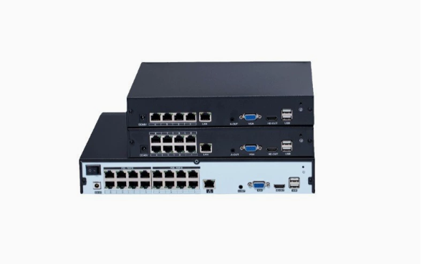 | 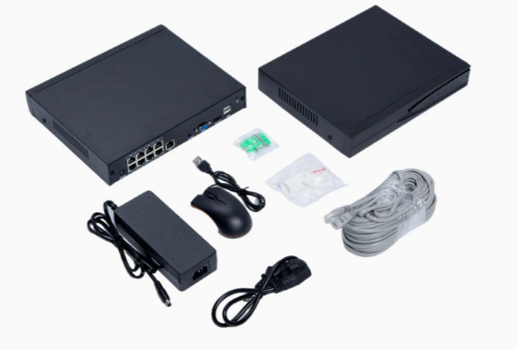
PoE NVR family · 4 / 8 / 16 ports  This datasheet covers the 16CH model only. | Accessory reference · 8-port chassis shown  Final 16CH accessories follow the project quotation.
Accessory items shown include a power adapter, AC power cord, USB mouse, Ethernet cable and small accessory packs. Final accessory selection and quantities follow the project quotation.

APPLICATIONS & RFQ CONFIRMATION
Typical applications | Confirm in the project RFQ
Small Warehouse  Restaurant  Retail | Confirm the 16CH PoE configuration, HDD capacity and AI camera compatibility.  Confirm quantity, destination, packing, branding and documentation requirements.
Project supply: MOQ — Confirm by project quantity · Lead time — Confirm by project list · FOB port — China main ports · OEM/ODM — Available; confirm project scope

PROJECT CONFIGURATION CHECKLIST
Product configuration | 16 IP channels; 16 PoE ports; 2 SATA HDD bays; up to 14TB per HDD
Cameras and AI functions | Confirm IP camera models, input resolution, detection functions and alarm linkage.
HDD and recording plan | Confirm HDD capacity, recording mode, bitrate and required retention period.
Interfaces and accessories | Confirm AC input/adapter rating, RCA connections, recorder/HDD load, total PoE budget and accessories.
Finish, branding and packing | Confirm branding, packing and customization requirements for the order.
Quantity and destination | Confirm order quantity, delivery plan, destination, power plug and documentation.

STORAGE RETENTION REFERENCE (H.265+)
Actual recording storage requirements vary with the surveillance scene. The figures below are for reference only and were calculated using H.265+ encoding. All values are recording days.
Camera  resolution | Recording  channels | 2TB | 4TB | 6TB | 8TB | 14TB | 18TB*
3MP | 2 | 114 | 228 | 341 | 455 | 796 | 1024
3MP | 4 | 57 | 114 | 171 | 228 | 398 | 512
3MP | 6 | 38 | 76 | 114 | 152 | 265 | 341
3MP | 8 | 28 | 57 | 85 | 114 | 199 | 256
3MP | 10 | 23 | 46 | 68 | 91 | 159 | 205
4MP | 2 | 102 | 205 | 307 | 410 | 717 | 922
4MP | 4 | 51 | 102 | 154 | 205 | 358 | 461
4MP | 6 | 34 | 68 | 102 | 137 | 239 | 307
4MP | 8 | 26 | 51 | 77 | 102 | 179 | 230
4MP | 10 | 20 | 41 | 61 | 82 | 143 | 184
5MP | 2 | 93 | 186 | 279 | 372 | 652 | 838
5MP | 4 | 47 | 93 | 140 | 186 | 326 | 419
5MP | 6 | 31 | 62 | 93 | 124 | 217 | 279
5MP | 8 | 23 | 47 | 70 | 93 | 163 | 209
5MP | 10 | 19 | 37 | 56 | 74 | 130 | 168
*The 18TB column is reproduced as a general storage reference. It does not confirm compatibility with an 18TB HDD.

HOW TO READ AND APPLY THE TABLE
Read a scenario. Select the camera resolution and recording-channel count, then read the storage-capacity column. The number is the reference duration in days.
Check project settings. The source does not specify bitrate, frame rate, recording schedule or usable-capacity allowance. Confirm these inputs when sizing storage for an installation.
Observe the source coverage. The reference covers 3MP, 4MP and 5MP at 2, 4, 6, 8 or 10 channels. No 8MP or 16-channel recording figures are provided.

APPLICATION TO THIS 16CH MODEL
Recorder configuration | 16 IP channels; 2 SATA HDD bays; maximum 14TB per HDD
Available source rows | The supplied table covers 2, 4, 6, 8 and 10 recording channels. It does not include a 16-channel row.
Full 16-channel retention | Calculate separately using the planned recording settings and total usable HDD capacity; no 16-channel duration has been inferred here.
Capacity scope | The 18TB column is a general storage reference. The recorder’s specified limit remains 14TB per HDD, with two HDD bays.
Source: supplied H.265+ storage reference table. Original numerical values have been preserved.

