NEXPRO

NexPro Seetong Client
Video Management Software User Manual
User Manual Version 1.0.0 | April 2026
Powered by Seetong Technology | Fully Integrated with NexPro Surveillance Solutions

Statement
Thank you for choosing NexPro surveillance solutions. This manual applies to the Seetong Client software for Windows desktop (Windows 7/8/10/11).
NexPro & Seetong Partnership
NexPro is an authorized system integration partner of Seetong, delivering fully compatible hardware-software solutions for hotel, industrial, and enterprise surveillance projects. All NexPro cameras, NVRs, and accessories are pre-qualified and pre-loaded with Seetong-compatible firmware — ensuring plug-and-play deployment, unified firmware management across all devices, and single-vendor technical support for hardware and platform issues.
This manual may contain technical inaccuracies or typographical errors. The content is subject to periodic updates without prior notice. For the latest version, please contact your NexPro support representative. In case of any discrepancy between this manual and the actual product, the product shall prevail. NexPro reserves the right of final interpretation.

NexPro & Seetong: Integrated Solution Overview
NexPro's complete product ecosystem is fully integrated with the Seetong video management platform, providing a unified surveillance experience from camera hardware to client software:
NexPro Product Category | Seetong Compatibility
NexPro-BL Series Bullet Cameras | Automatic discovery, plug-and-play, dual-stream preview, motion detection
NexPro-PT & PTL Series PTZ Cameras | Full PTZ control, 128 presets, cruise, patrol, human/vehicle tracking
NexPro-ANPR License Plate Cameras | Plate recognition, black/white list management, vehicle statistics
NexPro-SC Specialty Cameras | Anti-flicker, high-altitude object detection, configurable algorithms
NexPro-NVR Series Recorders | Seetong Cloud direct access, remote playback, alarm linkage, RAID storage
NexPro CORE Modules (OEM) | Pre-loaded with Seetong-compatible firmware, available in PoE variant
NexPro SW-POE Switch Series | Transparent network layer, zero-config forwarding, Extend mode (250m)

Table of Contents
Chapter 1: Software Introduction
1.1 Key Features
Chapter 2: System Requirements
2.1 Hardware Requirements
2.2 Software Requirements
Chapter 3: Installation & Uninstallation
3.1 Installation Steps
3.2 Uninstallation Steps
Chapter 4: Login & Main Interface
4.1 Login
4.2 Main Interface Overview
Chapter 5: Video Preview
5.1 Live View Operations
5.2 Device List Management
5.3 PTZ Control
Chapter 6: Device Management
Chapter 7: Local Playback
Chapter 8: Remote Playback
Chapter 9: Recording Schedule
Chapter 10: System Settings
Appendix: NexPro Hardware Compatibility Summary

Chapter 1: Software Introduction

1.1 Key Features
Seetong Client is a powerful video management software that integrates multi-window viewing, two-way audio, PTZ control, remote playback, and recording into a unified interface. It supports direct connection to standalone devices as well as multi-device management for comprehensive surveillance systems.
Seetong Client is the designated management software for all NexPro IP cameras and NVRs. All NexPro devices ship with Seetong-compatible firmware pre-installed, requiring no additional configuration for software compatibility.
- Supports local and cloud platform login
- Displays different operation interfaces based on user type (local user vs. cloud user)
- Supports device list display and grouping
- Supports modifying device aliases
- Maintains and manages device online status
- Supports remote device configuration (local login only)
- Supports multi-window and full-screen display control
- Supports real-time video stream monitoring
- Supports manual recording for selected devices
- Supports drag-and-drop window switching
- Supports screen lock function
- Supports video tour function
- Supports PTZ control on NexPro-PT, NexPro-PTL, and NexPro-PTQ/PTN series cameras
- Supports two-way audio intercom with status display (requires NexPro cameras with audio capability)
- Supports main stream / sub stream switching
- Supports snapshot capture
- Supports local recording
- Supports local and remote recording query, playback, and download
- Supports direct playback of queried recordings
- Supports real-time audio on/off control with status display
- Supports recording status display and maintenance per video window
- Supports NVR audio playback and time-based recording download
- Auto-searches and plays devices when device list is empty
- Supports single and batch IP modification
- Supports batch firmware upgrade (NexPro provides consolidated firmware packages)
- Supports configuration file upload and download

Chapter 2: System Requirements

2.1 Hardware Requirements
CPU | Intel Core i3 2.0GHz or above (i5 recommended for 32+ channels)
RAM | DDR3 4GB or above
Network | 100/1000M adaptive Ethernet
Hard Disk | 250GB or above
Graphics | OpenGL 2.0 or above
Monitor | 17-inch or above, resolution 1024×768 or above
Note: For multi-channel real-time viewing and recording, higher CPU, RAM, and graphics specifications are recommended. NexPro recommends Intel Core i5 or above for systems managing 32+ cameras.

2.2 Software Requirements
Seetong Client supports Windows 7/8/10/11 operating systems.
Note: Windows XP is not recommended.

Chapter 3: Installation & Uninstallation

3.1 Installation Steps
Double-click the installation file Seetong_*.*.*.*_YYYYMMDDhhmmss.exe to begin.
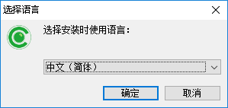
- Select installation language (Simplified Chinese / English).
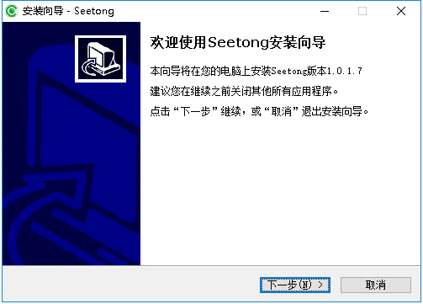
- Click "Next" to proceed through the welcome wizard.
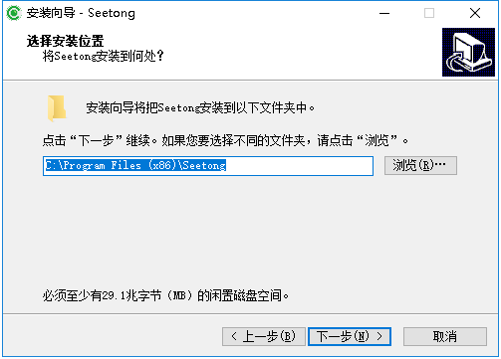
- Select the installation directory.
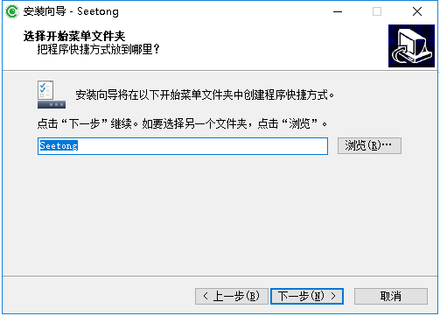
- Select the Start Menu folder.
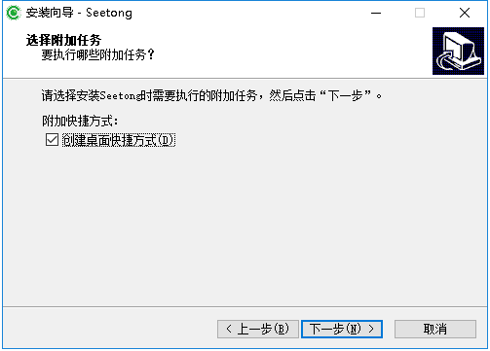
- Choose whether to create desktop shortcuts.
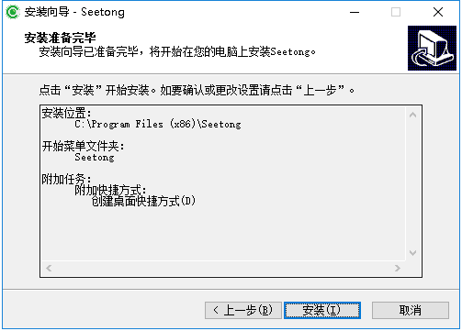
- Click "Install" to begin installation.
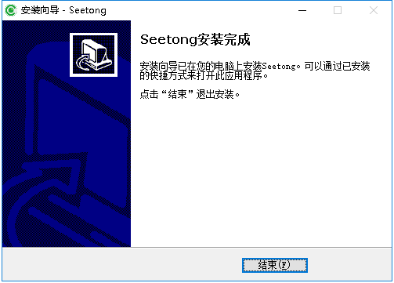
- Click "Finish" to complete installation.

3.2 Uninstallation Steps
Via Control Panel > Add/Remove Programs, or Start Menu > Seetong > Uninstall.
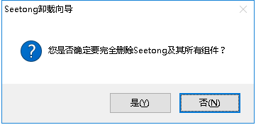
- Click "Uninstall" to initiate removal.
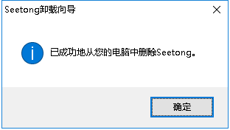
- Click "Yes" to confirm.
- Click "OK" to complete uninstallation.

Chapter 4: Login & Main Interface

4.1 Login
Double-click the Seetong icon on the desktop to open the login dialog. Seetong Client supports two login methods:
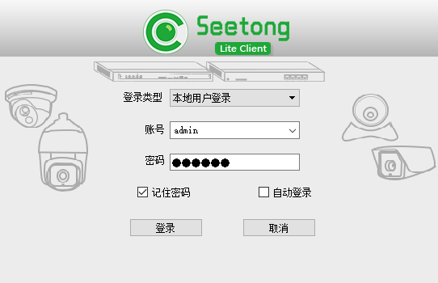
Local User Login:
- Default account: admin
- Default password: 123456
- Check "Save Password" to store credentials for future sessions.
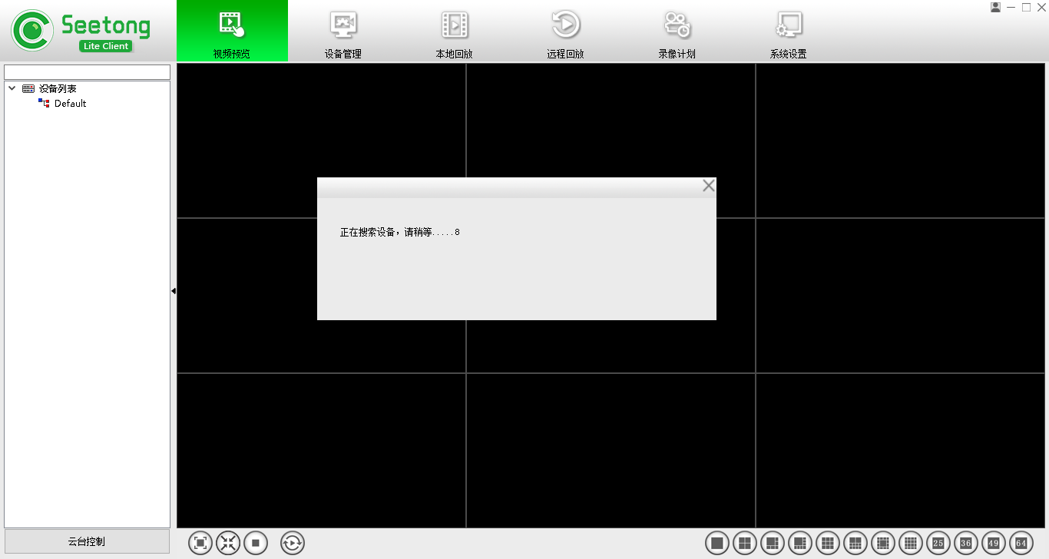
- Check "Auto Login" to bypass the login dialog on subsequent launches.
- When the device list is empty upon login, Seetong automatically searches for and adds devices, playing the first 9 discovered devices.
Cloud Platform Login:

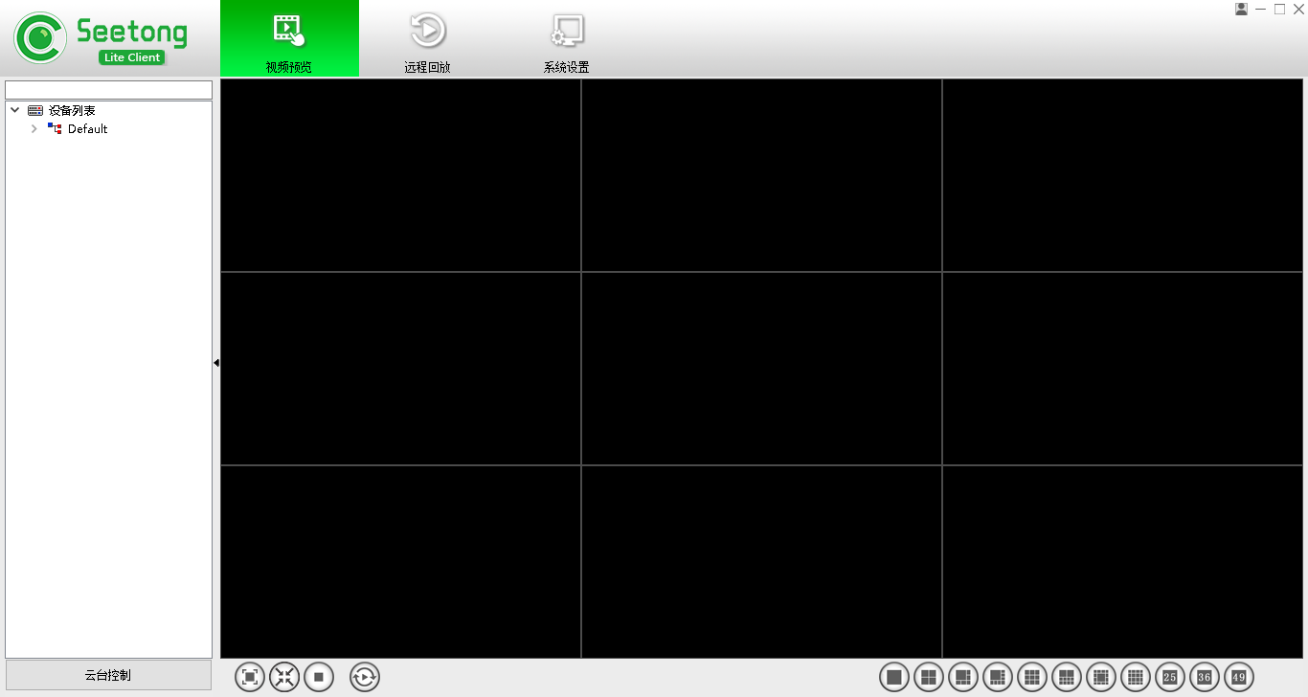
- Use the account and password registered via the Seetong mobile APP or cloud web portal.
- Cloud login automatically retrieves devices associated with the account for preview, recording, and playback.
- Device configuration and local device management are not available in cloud login mode.

4.2 Main Interface Overview
The main interface consists of the following functional areas:
- Function Tab Bar: Video Preview, Device Management, Local Playback, Remote Playback, Recording Schedule, System Settings.
- Video Window Area: Displays live video feeds and responds to operations from the device list and toolbar.
- PTZ Control Area: Pan, tilt, zoom, focus, iris control, presets, cruise, and advanced functions.
- Device List Area: Device tree with online/offline status indicators and right-click context menus.
- Video Toolbar: Stream switching, snapshot, two-way audio, audio on/off, manual recording, video tour, full/standard screen, screen lock, close/close all, start all recording. Screen layout: 1, 4, 6, 8, 9, 10, 13, 16, 25, 36, 49, 64 windows.
- Playback Functions: Local playback and remote playback.
- Recording Schedule: Local recording strategy configuration, start/stop recording.
- Settings: Auto-run on startup, auto-login, system configuration.

Chapter 5: Video Preview

5.1 Live View Operations

5.1.1 Playing Live Video
- Drag & Drop: Drag a device from the device list into a video window.
- Double-Click: Double-click a device to auto-assign it to the first available window.
- Preview All: Right-click a device group and select "Preview All" to play all online devices in that group.
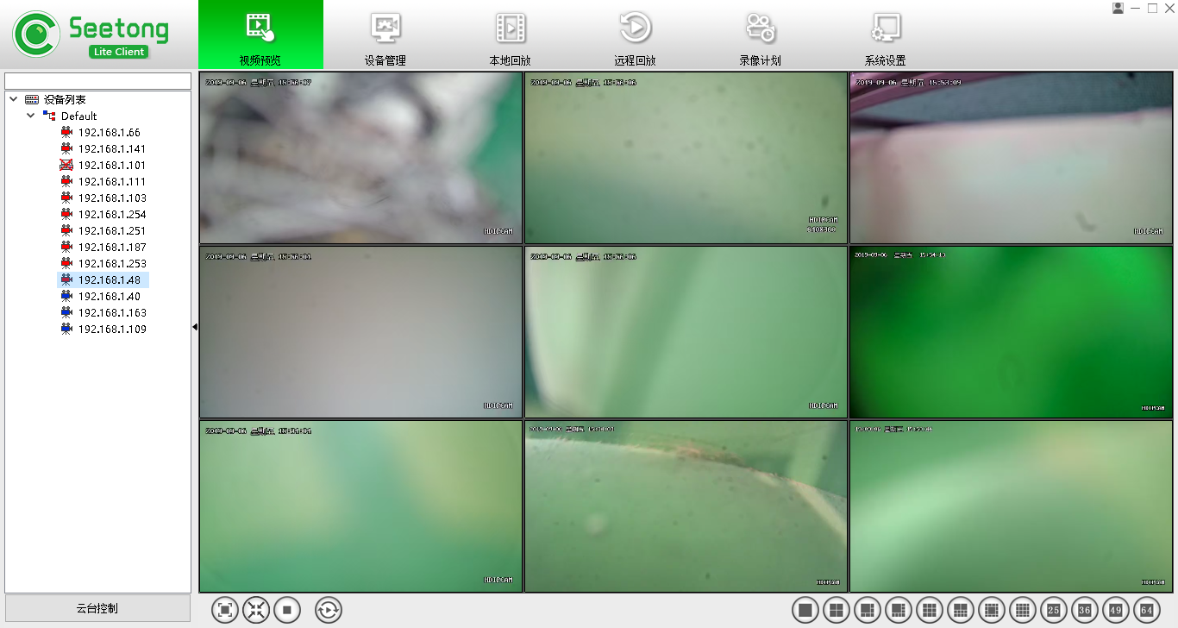

5.1.2 Stopping Live Video

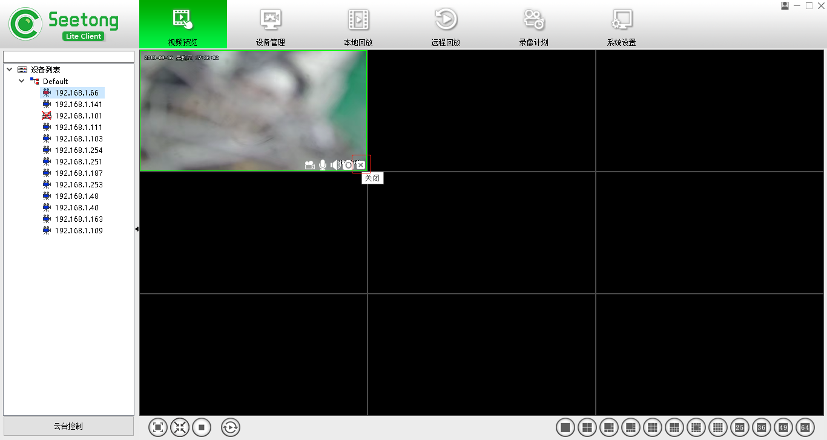
- Close Button: Hover over a video window; click the Close button at the bottom right.
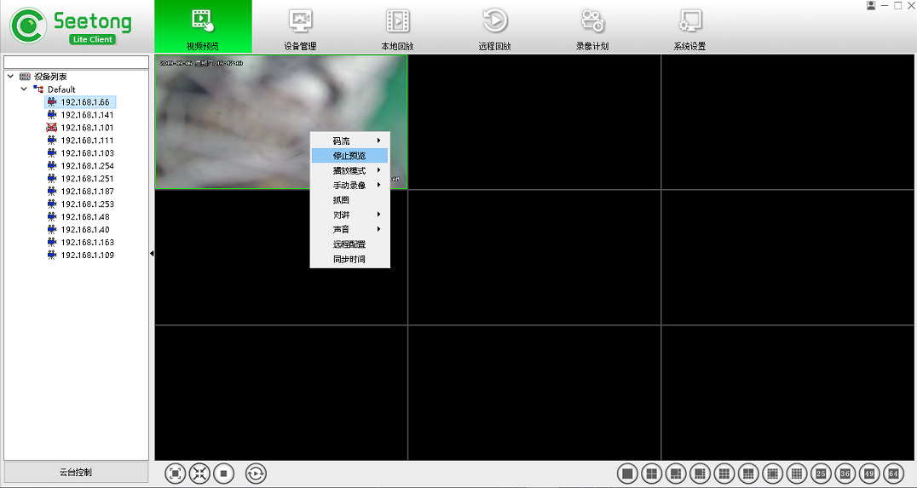
- Right-Click Menu: Right-click a video window and select "Stop Preview."
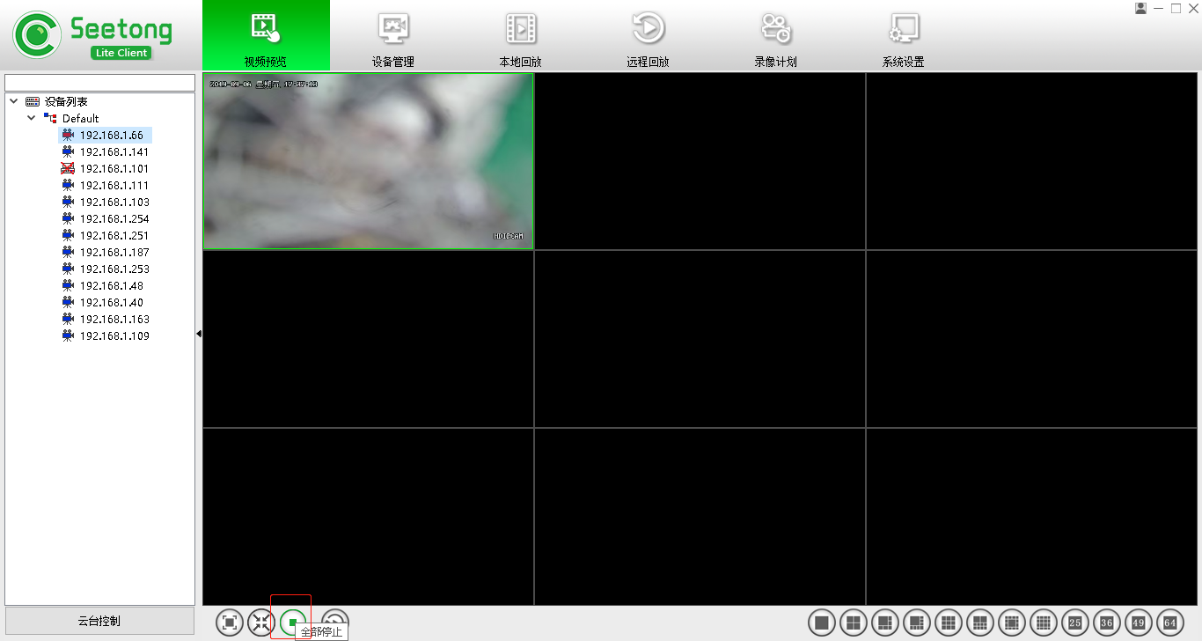
- Stop All: Click the "Stop All" button at the bottom left of the video area.

5.1.3 Full Screen
Click the "Full Screen" button on the toolbar. Press Esc or double-click to exit full screen.

5.1.4 Standard / Stretch Display
Toggle between standard aspect ratio and stretched display using the toolbar button. The setting is saved and restored upon next login.

5.1.5 Screen Layout Control
Select from 1, 4, 6, 8, 9, 10, 13, 16, 25, 36, 49, or 64-window layouts using the toolbar buttons.

5.1.6 Stream Switching
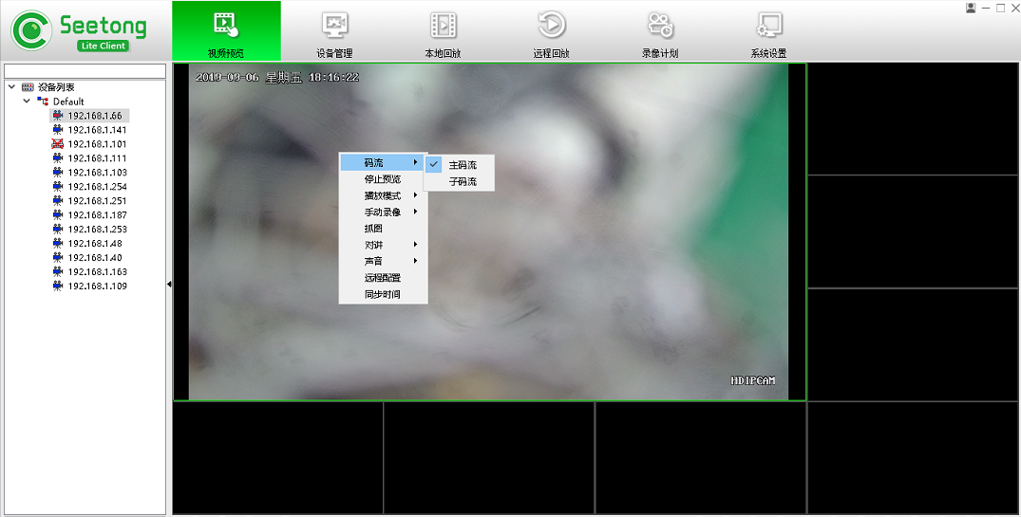
NexPro cameras support dual-stream encoding — main stream for local high-quality storage, sub stream for remote transmission with reduced bandwidth. 1-window and 4-window layouts default to main stream; other layouts default to sub stream. Right-click a video window > Code Stream > select Main Stream or Sub Stream to switch.

5.1.7 Play Mode
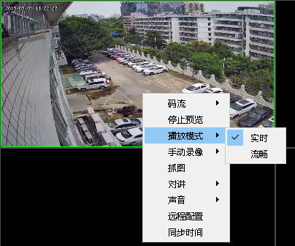
Right-click a video window > Play Mode > select "Real-Time" or "Smooth."

5.1.8 Manual Recording
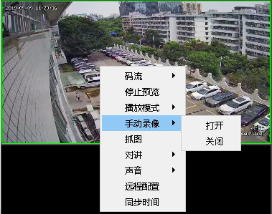
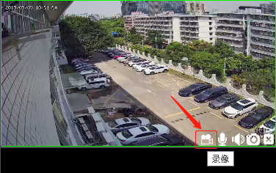
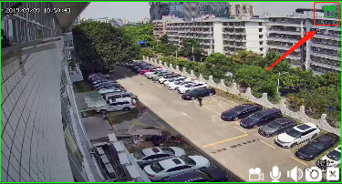
Manual recording can be activated via right-click menu or the Record button at the bottom right of each window. Individual recording files are limited to 30 minutes. Default recording path: [Installation Directory]\Video.

5.1.9 Snapshot
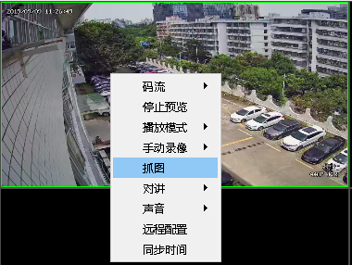
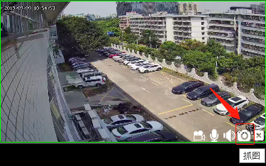
Snapshots can be captured via right-click menu or the Snapshot button at the bottom right. Default snapshot path: [Installation Directory]\Picture.

5.1.10 Two-Way Audio
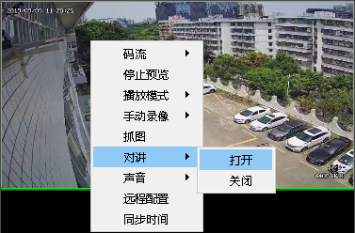
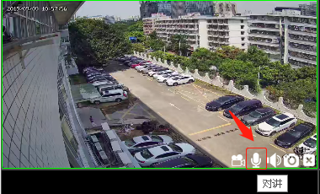
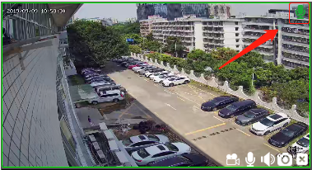
Two-way audio can be activated via right-click menu or the Intercom button at the bottom right. This feature requires NexPro cameras with built-in microphone and speaker (NexPro-BL series with -AUD suffix, NexPro-PT series with speaker).

5.1.11 Audio
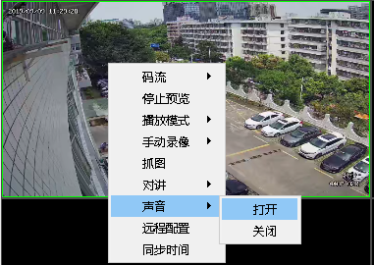
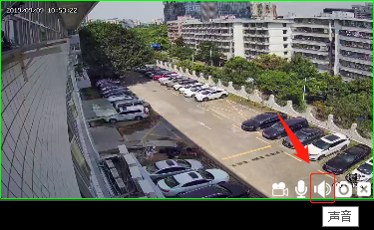
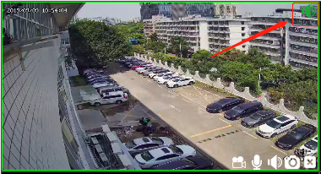
Audio monitoring can be controlled via right-click menu or the Audio button. When enabled, audio follows the focus window.

5.1.12 Video Tour
Click "Start Tour" to cycle through video windows. Configure the tour interval in System Settings (Chapter 10, Section 10.6).

5.2 Device List Management

5.2.1 Device Status Display
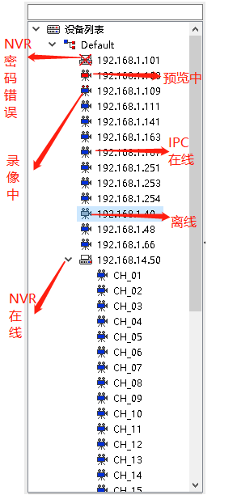
- Blue: Device online and connected.
- Gray: Device offline.
- Red: Device currently streaming.
- Red dots (top): Device currently recording.

5.2.2 Grouping
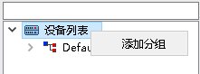
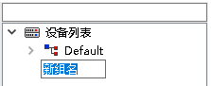
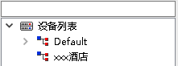
Add Group: Right-click empty area > "Add Group" > Enter name > Press Enter.
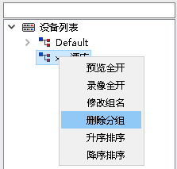
Delete Group: Right-click group > "Delete Group." (Default group cannot be deleted.)
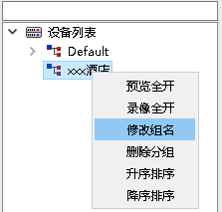
Rename Group: Right-click group > "Rename Group" > Enter new name.

5.2.3 Preview All
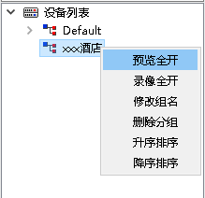
Right-click a group > "Preview All" to play all devices in that group.

5.2.4 Record All
Right-click a group > "Record All" to start recording all devices using the default schedule.

5.2.5 Edit Device Name
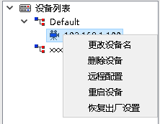
Right-click a device > "Edit Device Name" > Enter new name.

5.2.6 Delete Device
Right-click a device > "Delete Device."

5.2.7 Restart Device
Right-click a device > "Restart Device."

5.2.8 Factory Reset
Right-click a device > "Factory Reset."

5.2.9 Remote Configuration
Local login users can remotely configure device parameters. Note: Cloud platform login does not support remote device configuration.

5.3 PTZ Control

5.3.1 PTZ Control Interface
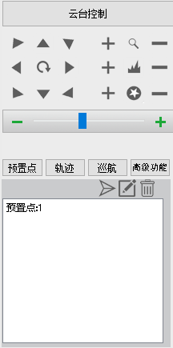
The PTZ control panel provides: Up, Down, Left, Right, Iris, Focus, Zoom, Presets, Cruise, and Advanced functions. For directional control, press and hold the button; release to stop. Control speed is adjustable. Full PTZ functionality is available on all NexPro-PT, NexPro-PTL, and NexPro-PTQ/PTN series cameras.

5.3.2 PTZ Advanced Functions
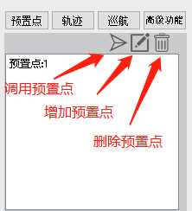
- Presets: Add, call, and delete preset positions. Up to 128 presets supported on NexPro-PT series.
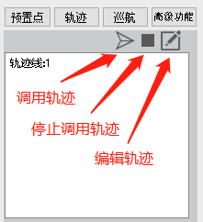
- Cruise: Record and play back cruise paths. Human tracking option available — camera follows detected persons, then resumes cruise path when the person exits the frame.
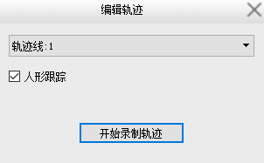
- Patrol: Build patrol sequences from presets with configurable dwell times.
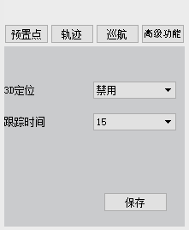
4) Advanced Functions: 3D positioning (click-to-center), tracking duration configuration.

Chapter 6: Device Management

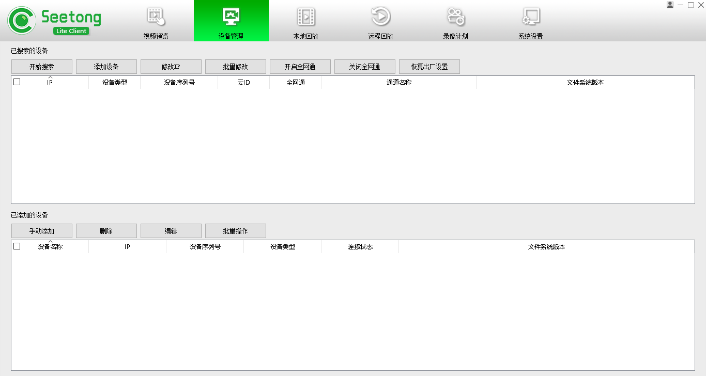
Local login provides access to the Device Management page. Cloud login does not display this page.

6.1 Device Search
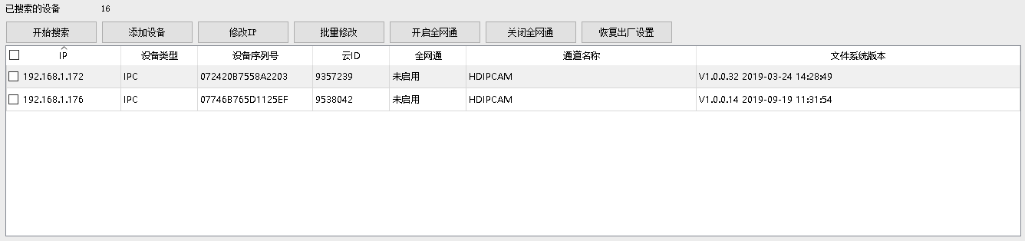
Click "Start Search" to automatically discover all connected cameras on the local network. Search results can be sorted by clicking column headers. All NexPro cameras are pre-configured with Seetong-compatible discovery protocols and appear automatically in search results.

6.1.2 Modify IP
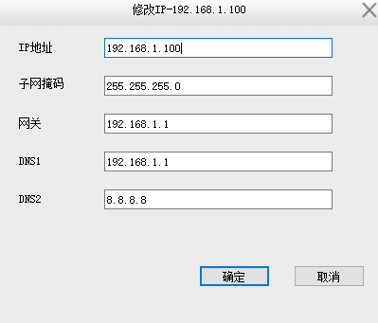
Select a device > Click "Modify IP" > Enter new IP configuration.

6.1.3 Batch Modify IP
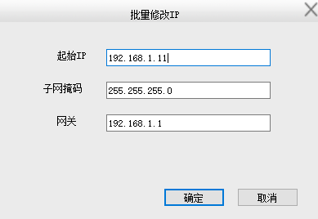
Select multiple devices > Click "Batch Modify IP" > Configure IP range.

6.1.4 Enable / Disable P2P
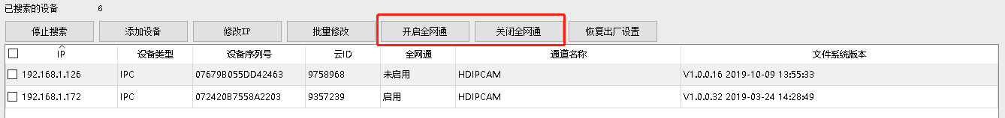
Select devices > Click "Enable P2P" or "Disable P2P" to toggle cloud connectivity.

6.1.5 Factory Reset
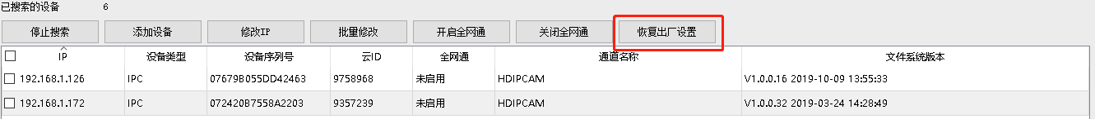
Select devices > Click "Factory Reset" to restore factory defaults.

6.2 Add Device
Search Add: Double-click a discovered device or select it and click "Add Device."
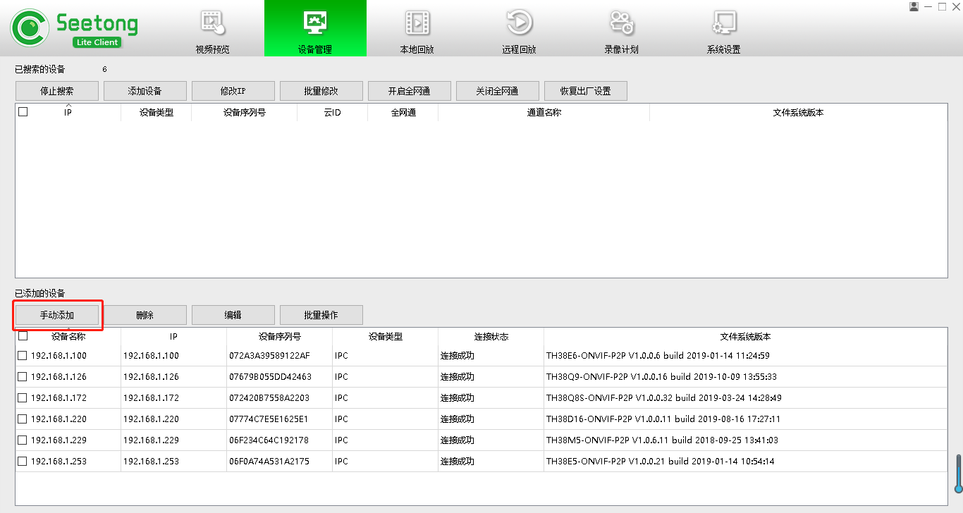
Manual Add: Click "Manual Add" > Enter device name, IP address, device type (IPC/NVR), group, username, and password > Click "OK."
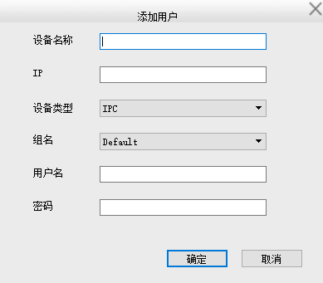
Note: The username and password must match the front-end device credentials.

6.3 Delete Device
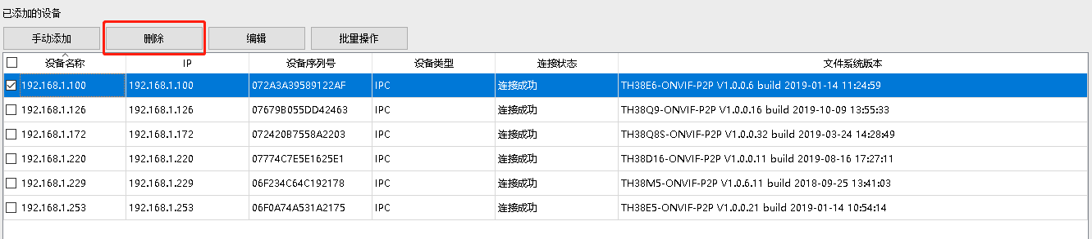
Select devices > Click "Delete Device."

6.4 Edit Device
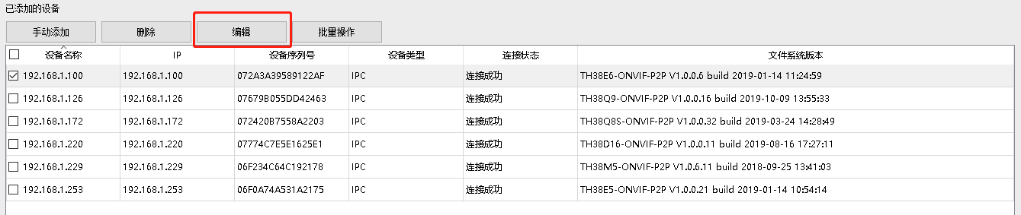
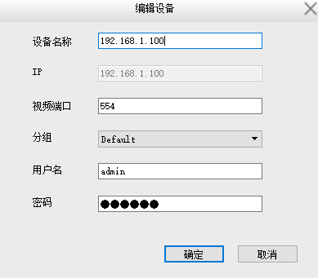
Select a device > Click "Edit" > Modify parameters > Click "OK."

6.5 Batch Operations
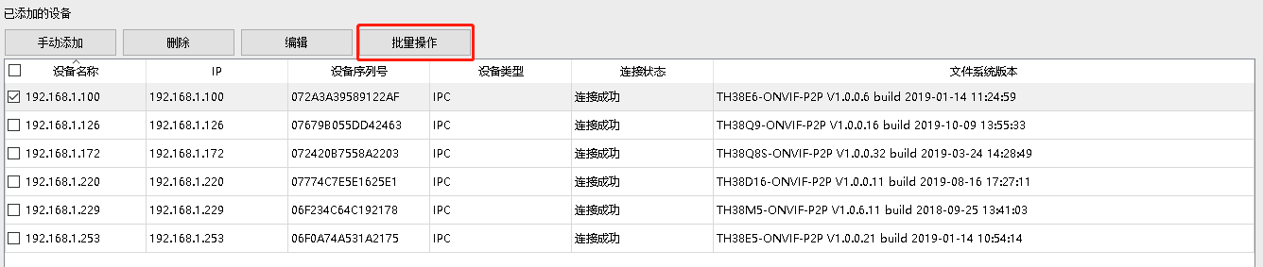
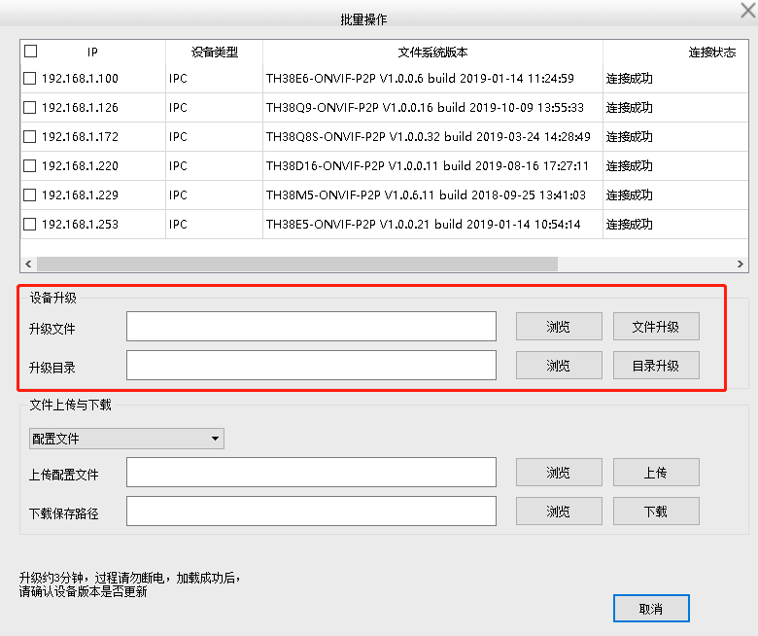

6.5.1 Device Upgrade: NexPro provides consolidated firmware packages for all camera models, simplifying batch upgrades.
6.5.2 Upload/Download Configuration File: Transfer configuration files to or from selected devices.
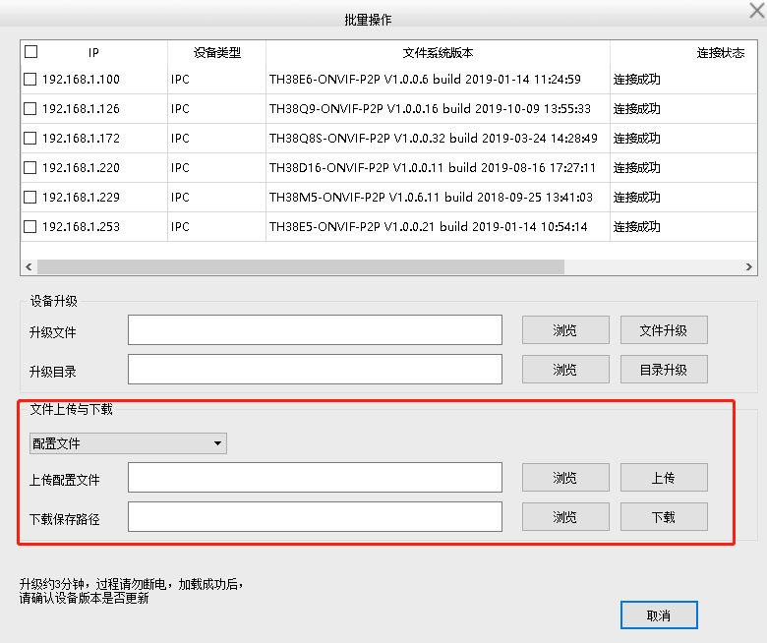
6.5.3 Download Configuration Package: Export configuration files as a compressed package.

6.7 Firmware Upgrade
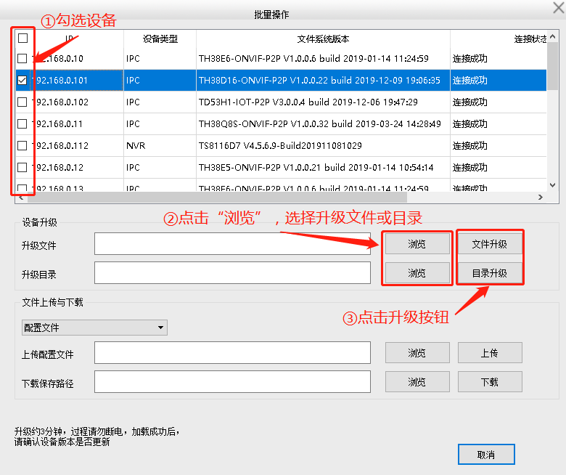
Select devices > Browse to firmware file > Click "Upgrade." Upgrade status is displayed in real time. If an upgrade fails, retry once. For persistent failures, power-cycle the device.

6.8 Restart, Factory Reset & Time Sync
- Restart: Select devices > Click "Restart."
- Factory Reset: Select devices > Click "Factory Reset."
- Sync System Time: Select devices > Click "Sync System Time."

Chapter 7: Local Playback
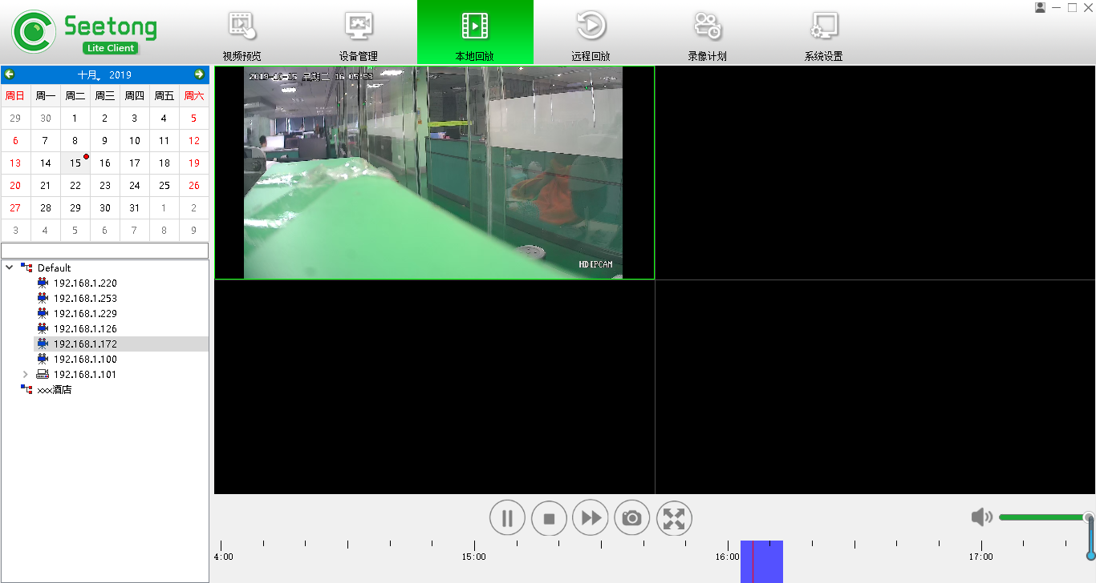
Local playback queries and plays video files stored on the local PC according to the recording schedule configuration. Up to four simultaneous playback windows are supported. Local playback is only available in local login mode.

7.1 Local Playback
Note: Manual recording files cannot be retrieved through the playback interface. NVR local recordings should be queried via Remote Playback (Chapter 8).

7.1.1 Playback Steps
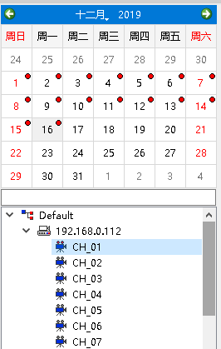
- Select a device from the device list.
- The left-side calendar displays dates with local recordings (marked with red dots).
- Select a date (defaults to today).
- Playback begins on the right side.

7.1.2 Controls
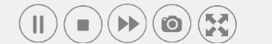
Pause, Stop, Fast Forward, Snapshot, and Full Screen are available on the control bar.

7.1.3 Audio Control

Adjust volume using the audio control slider.

7.1.4 Time & Type Selection
Navigate the timeline; filter by alarm type color coding.

Chapter 8: Remote Playback
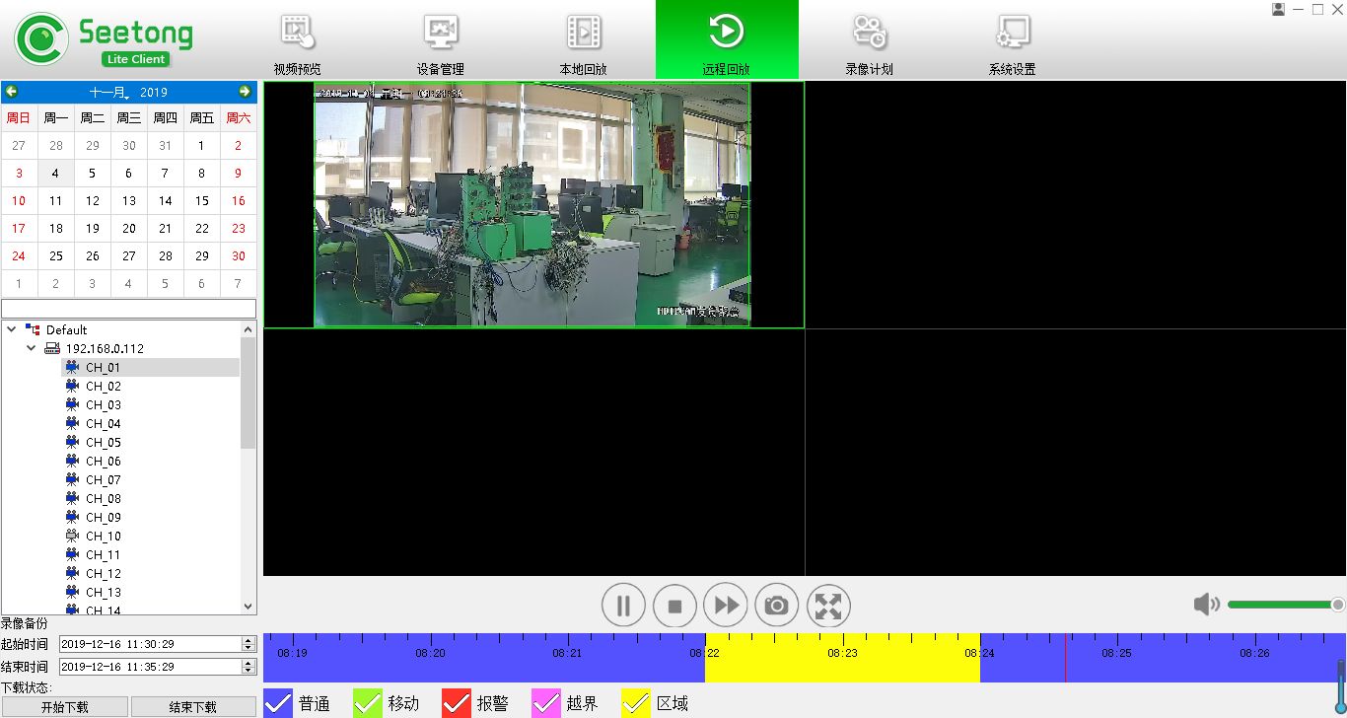
Remote playback queries and plays video files stored on remote devices (NVRs or cameras with onboard storage such as TF card).

8.1 Remote Playback

8.1.1 Playback Steps
- Select a device from the device list.
- The left-side calendar displays dates with remote recordings (marked with red dots).
- Select a date.
- Playback begins on the right side.

8.1.2 Controls
Same as local playback: Pause, Stop, Fast Forward, Snapshot, Full Screen.

8.1.3 Audio Control
Adjust volume using the audio control slider.

8.1.4 Time & Type Selection
Same filtering and navigation as local playback.

8.1.5 Recording Download
- Select the device.
- Set start and end time.
- Click "Start Download."
- Wait for completion.
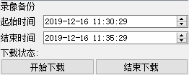

Chapter 9: Recording Schedule
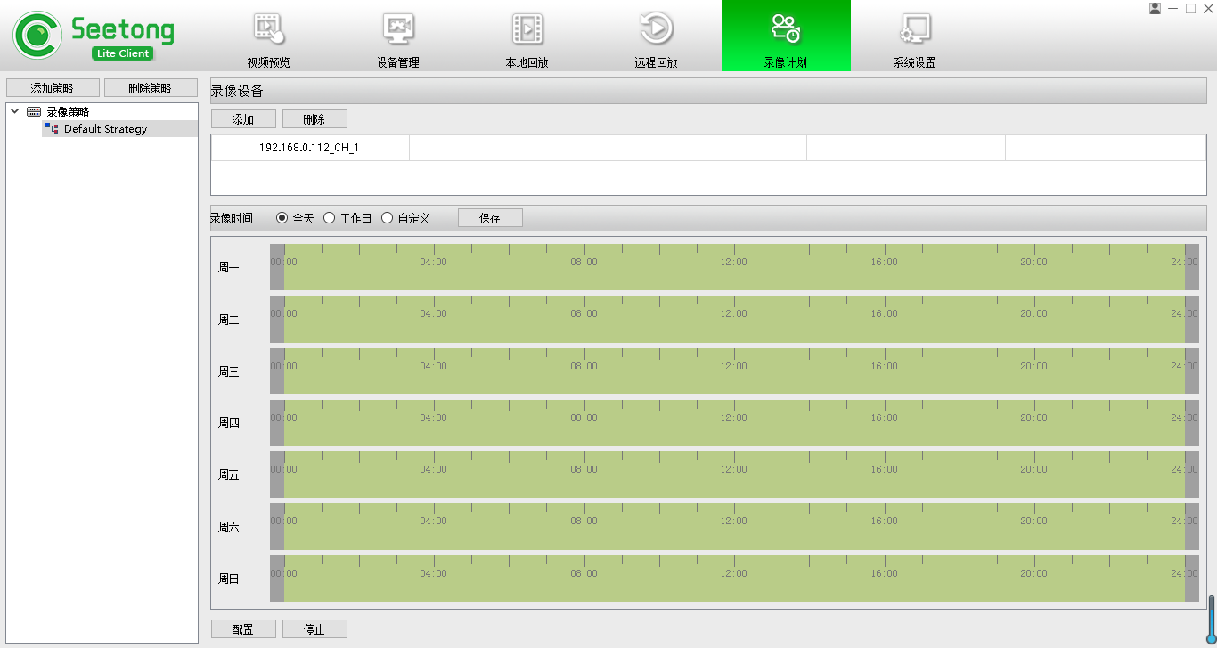
The Recording Schedule module enables configuration of local recording strategies. Only available in local login mode.

9.1 Recording Strategy
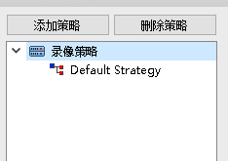
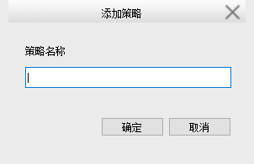
Default Strategy: Pre-configured as "Default Strategy" (cannot be renamed or deleted).
Custom Strategies: Create additional strategies for different recording trigger modes or device groups.

9.2 Add Recording Device
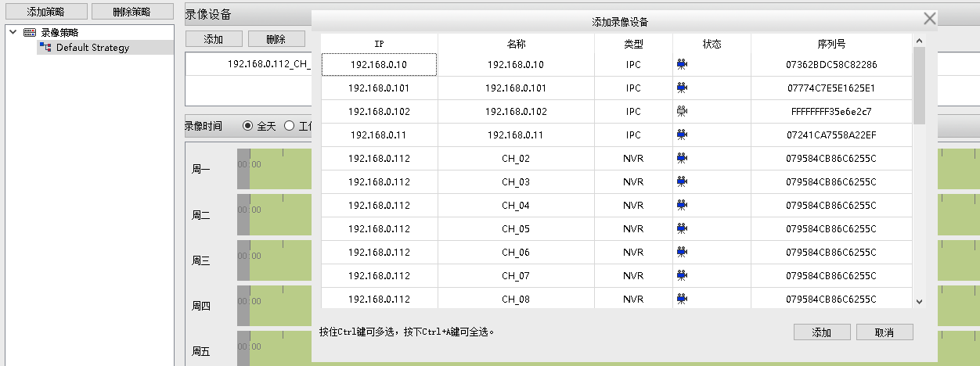
Select a strategy > Click "Add" > Select devices (multi-select via Ctrl+click or Ctrl+A).

9.3 Strategy Configuration
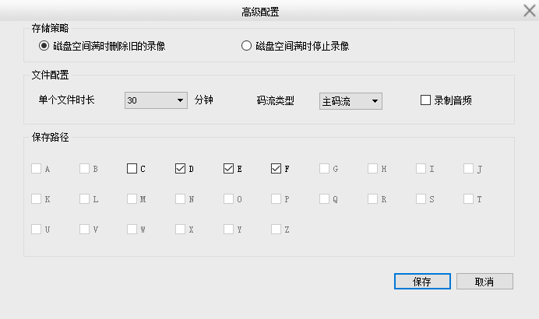
Configure storage policy, file settings, save path, and audio recording. Audio recording requires NexPro cameras with audio capability.

9.4 Recording Schedule
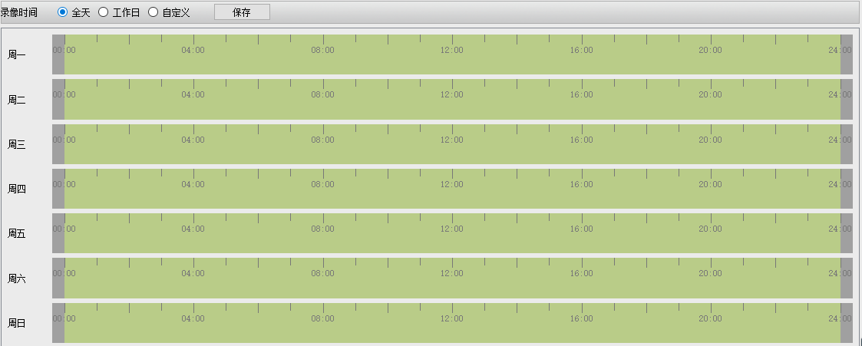

- All Day: 00:00–24:00, Monday–Sunday.
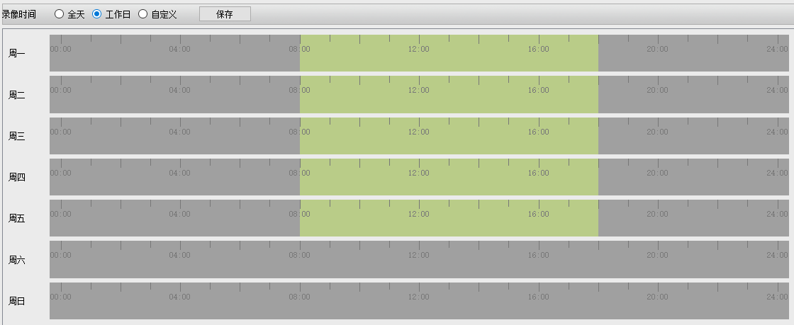
- Work Days: 08:00–18:00, Monday–Friday.
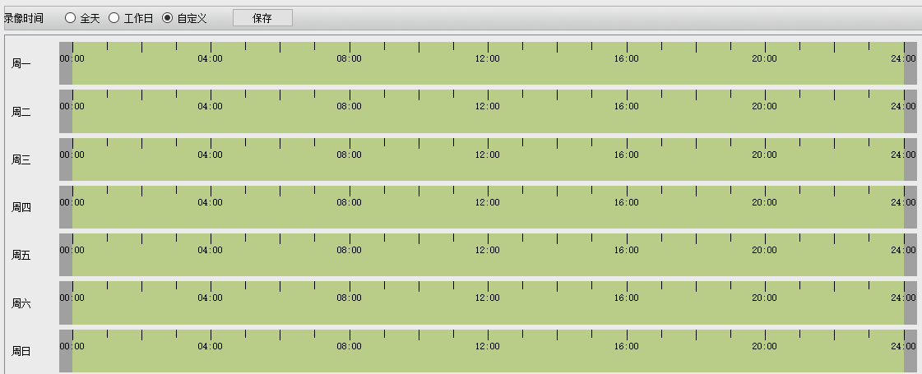
- Custom: Fully editable schedule with drag-to-adjust time bars.

9.5 Start Recording
Each strategy has a recording toggle. Click "Start" to begin; click "Stop" to end.

Chapter 10: System Settings
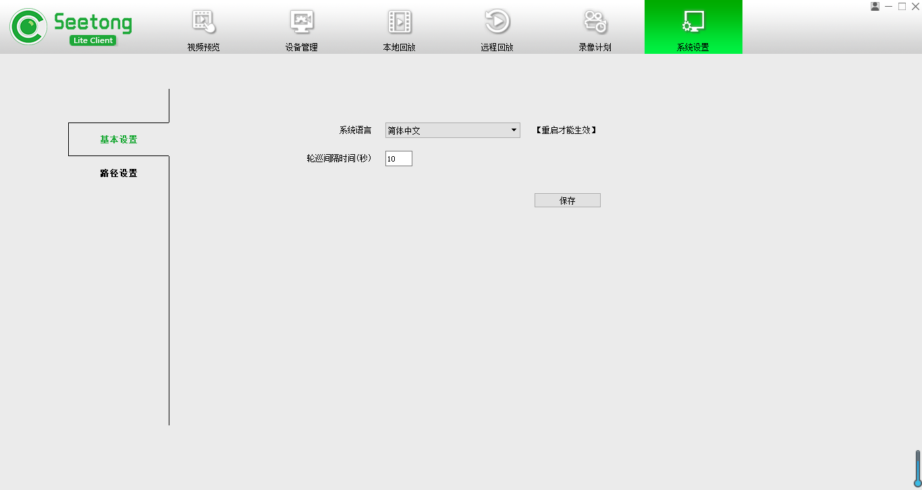

10.1 Auto-Run on Startup
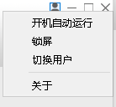
Toggle in settings menu. When enabled, user credentials are saved and auto-login is configured.

10.2 Screen Lock
Click "Lock Screen" to lock the interface. Enter credentials to unlock.

10.3 Switch User
Click "Switch User" to return to the login screen.

10.4 About
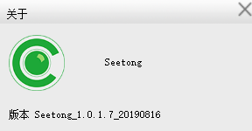
Select "About" to view the Seetong Client version and NexPro partnership information.

10.5 System Language
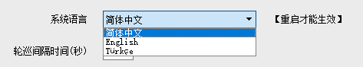
Seetong supports English, Simplified Chinese, and Traditional Chinese. Select and restart to apply.

10.6 Tour Interval
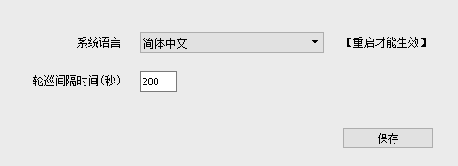
Set the video tour interval in seconds. Click "Save" to apply.

10.7 Path Settings
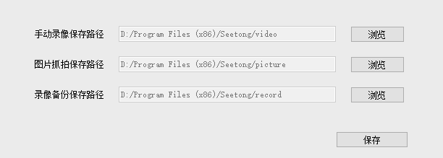
Default Recording Path | [Installation Directory]\Video
Default Snapshot Path | [Installation Directory]\Picture
Default Backup Path | [Installation Directory]\record
To change paths, select new local directories and click "Save." Path settings are retained across sessions.

Appendix: NexPro Hardware Compatibility Summary
The following NexPro product series are fully compatible with Seetong Client:
Product Series | Seetong Features Supported
NexPro-BL Series Bullet Cameras | Dual-stream preview, motion detection, audio intercom (-AUD models), ONVIF discovery
NexPro-PT Series PTZ Cameras | Full PTZ control, 128 presets, cruise, patrol, 3D positioning, human tracking
NexPro-PTL Series Laser PTZ | All PTZ features + extended IR control, vehicle tracking
NexPro-PTQ / PTN Combo Cameras | Dual-channel preview, AI tracking, custom voice deterrence
NexPro-ANPR Series | Plate recognition, black/white list management, vehicle statistics
NexPro-SC Series Specialty | Anti-flicker, high-altitude object detection, configurable algorithms
NexPro-NVR2232 / 4449 / 8864 | Seetong Cloud direct access, remote playback, alarm linkage, RAID storage
NexPro CORE Modules (OEM) | Pre-loaded Seetong firmware, PoE variant, ONVIF, GB28181
NexPro SW-POE Switch Series | Transparent network layer, Extend mode (250m) for far-end cameras
© NexPro. Where Systems Connect.
Powered by Seetong Client & Seetong Cloud.
For software support, device compatibility inquiries, and system design assistance: contact your NexPro integration specialist.

