NEXPRO

NexPro NVR Cloud Access
Quick Start Guide
Quick Start Guide Version 1.4 | April 2026
For NexPro NVR1108 / NVR1116 / NVR2232 / NVR4449 / NVR8864 Series
Powered by Seetong Cloud

Purpose
This guide provides the fastest path to accessing live surveillance video from your NexPro NVR via the Seetong mobile APP. All NexPro NVR models ship with Seetong Cloud pre-integrated — simply complete network setup and cloud activation to begin remote monitoring on your smartphone within minutes.
NexPro & Seetong Cloud
NexPro NVRs are factory-preloaded with Seetong Cloud firmware. Each NVR is assigned a unique Cloud ID and QR code at first boot. The Seetong APP (iOS/Android) connects directly to this Cloud ID, enabling instant remote preview, playback, and alarm notifications — no port forwarding, no static IP, no complex network configuration required.

Overview: Six Steps to Mobile Access
- Configure NVR network settings
- Launch Seetong APP on your mobile device
- Register a Seetong Cloud account
- Log in with your Cloud account
- Add your NVR device via Cloud ID or QR code
- Begin live preview and remote operations

Step 1: Configure NVR Network Settings

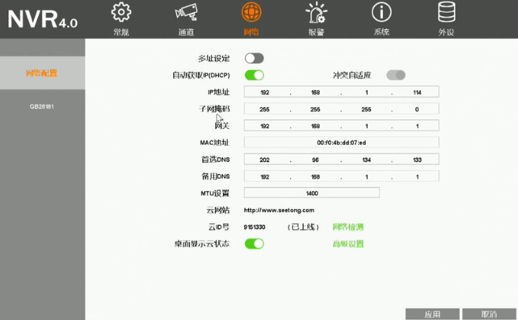
Power on your NexPro NVR and log in. Right-click on the desktop and select "System Configuration" → "Network" to configure the NVR network parameters.
- IP Address: Set to a valid LAN IP address within your router's subnet.
- DNS Server: Use the DNS address provided by your local ISP. The router must have internet access.
Once network settings are correctly configured, the top status bar will display "Inactive: Click to Activate".
Click the top status bar. In the pop-up password modification dialog, set a secure cloud password and wait a few moments — the NVR will automatically register with Seetong Cloud and appear as online.
Important: The cloud password may only contain uppercase letters, lowercase letters, and digits. It cannot be empty, and must not match the default password "123456".

Locate Cloud ID & QR Code
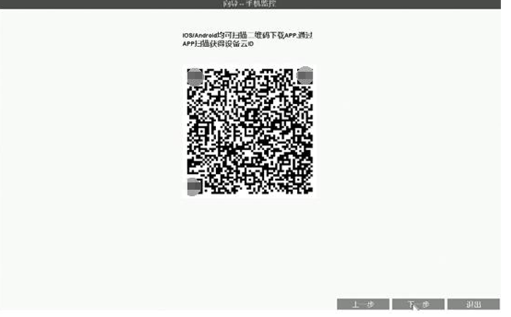
After successful network configuration, the NVR automatically connects to Seetong Cloud. You can view the Cloud ID and cloud connection status at:
- The top center of the NVR desktop screen
- "System Configuration" → "Network" page
To view the QR code, navigate to "System Configuration" → "System" → "Basic Information".
QR Code Usage: If the Seetong APP is not yet installed, scan this QR code to download the Android or iOS version of Seetong APP. Once installed, use the APP's "Add Device" → "Scan QR Code" function — scanning this QR code automatically adds the NVR to your device list without manual ID entry.

Step 2: Launch Seetong Mobile APP
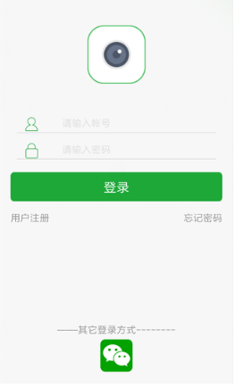
Ensure your mobile device is connected to the internet via Wi-Fi or 4G/5G. Tap the "Seetong" APP icon to launch the application and enter the login interface.

Step 3: Register a Seetong Cloud Account
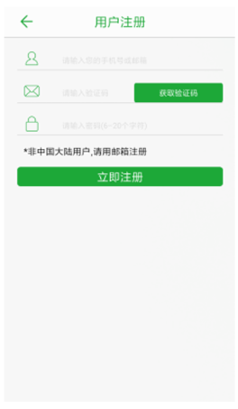
For managing multiple devices conveniently, tap "User Registration" on the login screen to enter the registration interface. Complete the registration form with your mobile number or email address.
Upon successful registration, you will be automatically returned to the login interface with your credentials pre-filled. Tap "Login" to proceed.

Step 4: Log In with Your Cloud Account
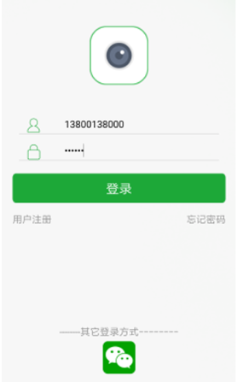
Enter your registered mobile number or email address and password, then tap "Login".
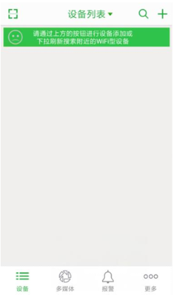
After logging in, you can access all devices associated with your account. A newly registered account starts with an empty device list. If devices have already been added, simply tap any device in the list to begin live video preview.

Step 5: Add NVR Device to Your Account
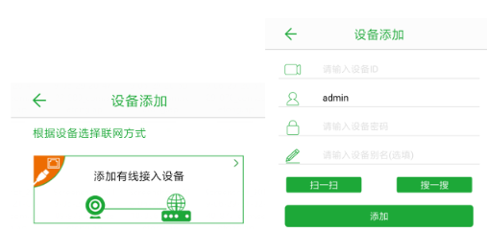
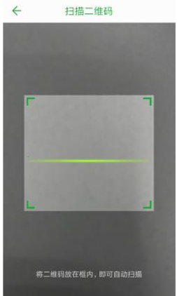
After successful login, tap the "+" icon on the device list screen to enter the Add Device interface.
Enter the following information:
- Device ID: The Cloud ID displayed on your NVR (e.g., 6729718)
- Username: Default is "admin"
- Password: The cloud password you set during activation
Tap "Add" to complete. For security, change the default device password. The added device will automatically appear in your device list.
Alternative Method: You can also use the APP's "Scan QR Code" function to scan the QR code displayed on your NVR screen — this automatically adds the device without manual ID entry.
Once a device is successfully added, your account automatically receives device access and management permissions.

Step 6: Device List Display & Live Preview
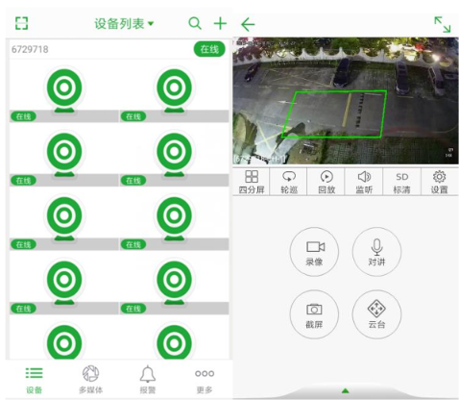
Added devices are categorized by online/offline status in the device list:
- IPC (IP Cameras): Displayed as large thumbnail cards
- NVR Devices: Displayed in a two-column small thumbnail layout
Tap any online device in the list to immediately begin live preview, snapshot capture, manual recording, and other operations.

NexPro NVR Cloud Compatibility
All current NexPro NVR models support Seetong Cloud with zero additional configuration:
NexPro NVR Model | Cloud ID | QR Code | Seetong APP | Remote Playback | Alarm Push
NexPro NVR1108 (10CH / 1-Bay) | ✓ | ✓ | ✓ | ✓ | ✓
NexPro NVR1116 (16CH / 1-Bay) | ✓ | ✓ | ✓ | ✓ | ✓
NexPro NVR2232-4K (32CH / 2-Bay) | ✓ | ✓ | ✓ | ✓ | ✓
NexPro NVR4449-4K (49CH / 4-Bay) | ✓ | ✓ | ✓ | ✓ | ✓
NexPro NVR8864-4K (64CH / 8-Bay) | ✓ | ✓ | ✓ | ✓ | ✓

Quick Troubleshooting Checklist
Symptom | Check
NVR shows "Offline" in cloud status | Verify LAN cable is connected; check router internet access; confirm DNS settings match ISP-provided values
APP cannot find device after adding Cloud ID | Ensure Cloud ID is entered correctly; confirm cloud password is not "123456"; check NVR top status bar shows online status
Video preview is slow or fails to load | Check mobile network (Wi-Fi or 4G/5G signal strength); verify NVR uplink bandwidth is adequate
QR code won't scan | Ensure the Seetong APP is the latest version; clean the QR code display on the monitor; adjust monitor brightness
© NexPro. Where Systems Connect.
Powered by Seetong Cloud & Seetong APP.
For NVR setup assistance, cloud connectivity troubleshooting, and system integration support: contact your NexPro solutions team.

