
VIDEO WALL DISPLAY & NETWORK DECODING SYSTEM

4K Network Video Decoder with Video Wall Management
  - Exact model: NX-VD-4K16
PRODUCT IMAGES
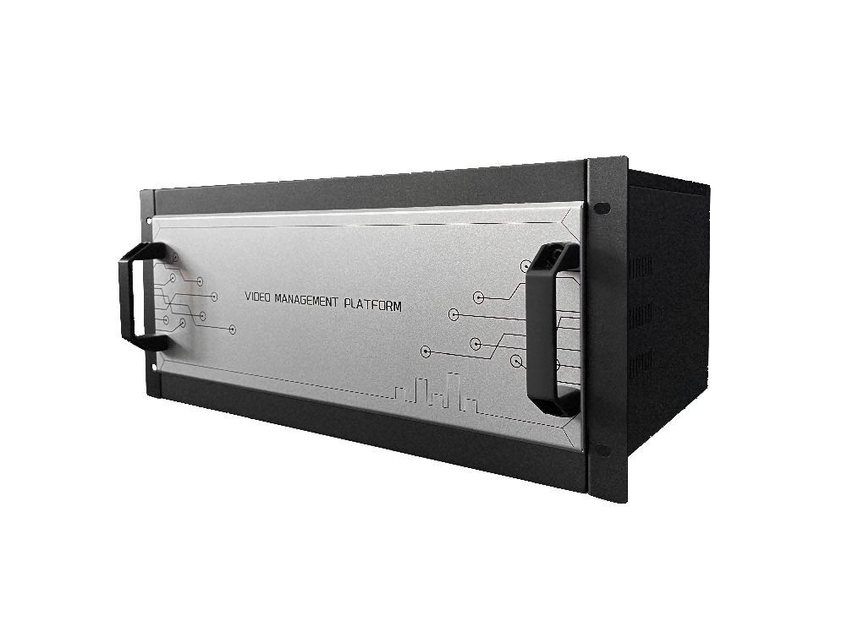 | 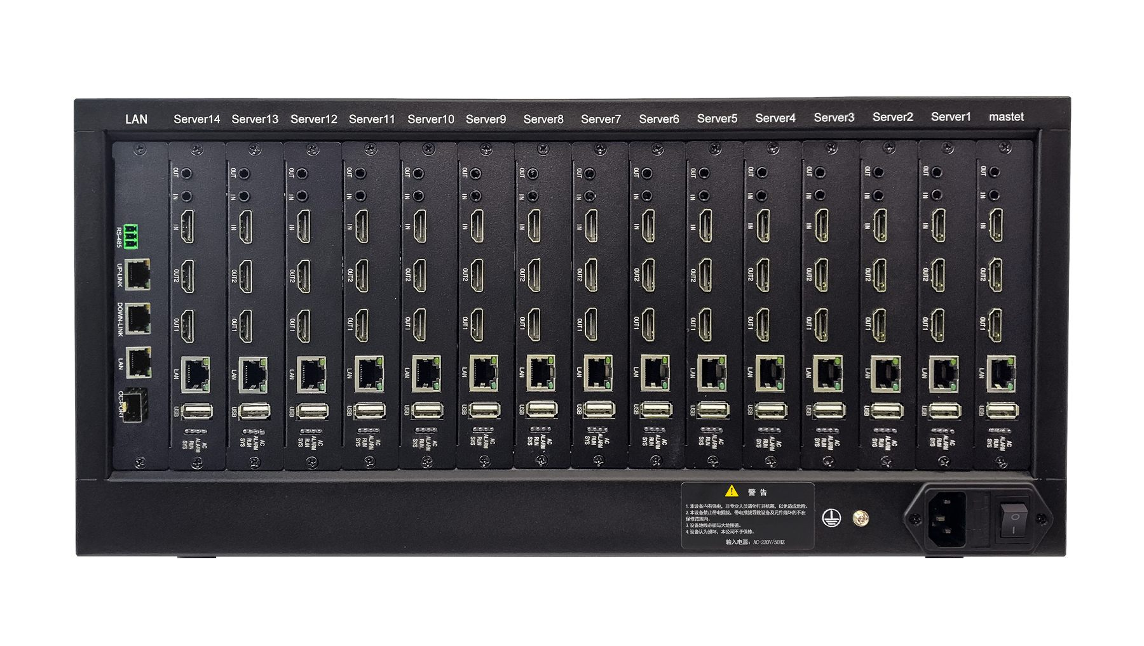 | 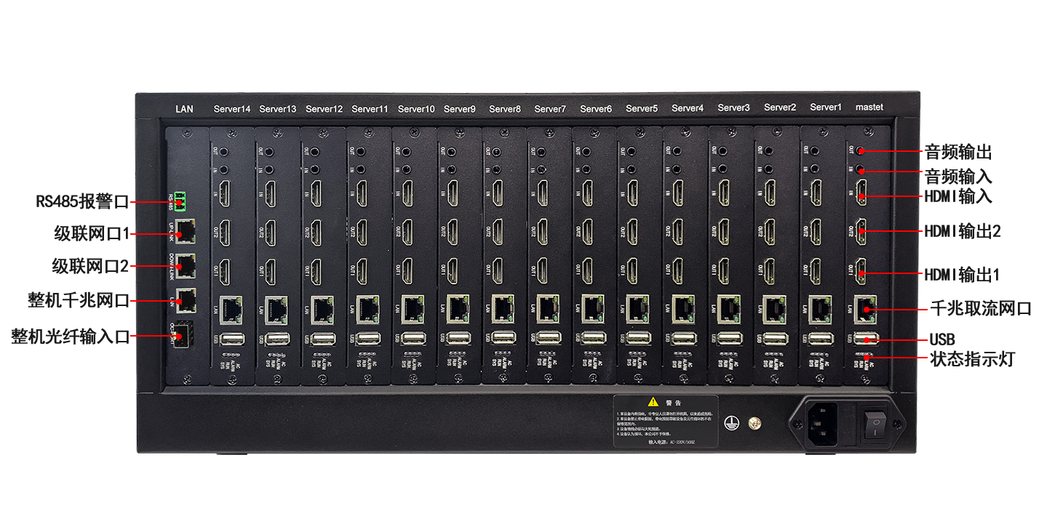 | 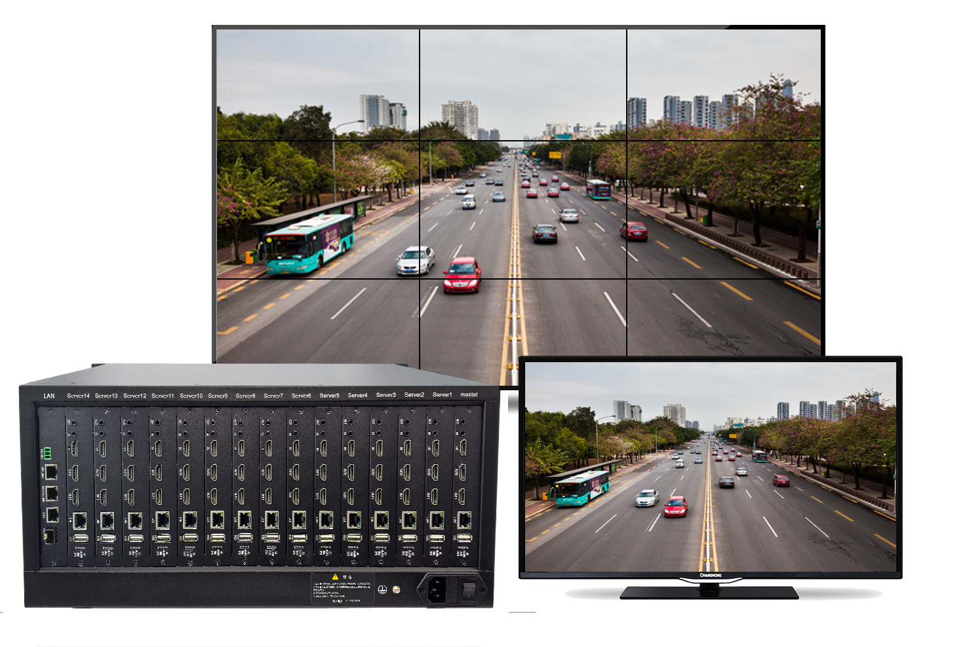
NX-VD-4K16 · Primary | NX-VD-4K16 · Gallery | NX-VD-4K16 · Gallery | NX-VD-4K16 · Gallery

 | 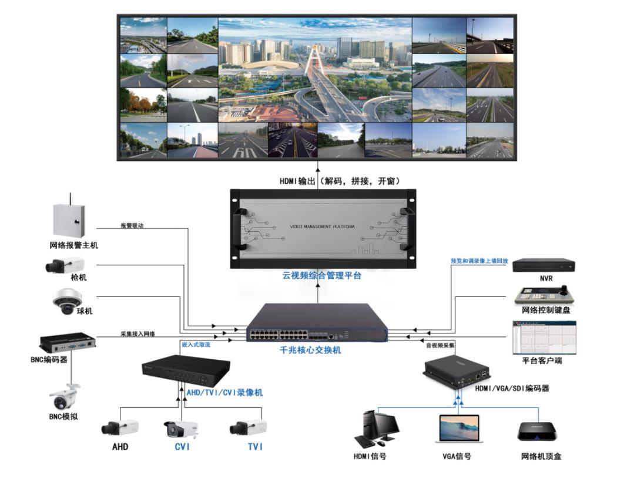
NX-VD-4K16 · Gallery | NX-VD-4K16 · Gallery

PRODUCT OVERVIEW
A modular 5U decoder platform for multi-screen control rooms, supporting 4K 60 Hz output, multi-window layouts and scalable video wall operation.
Product line | Video Wall Display & Network Decoding System
Series / family | Standalone model
Exact model | NX-VD-4K16
Applications | CCTV command center, Security operations center, Large monitoring wall, Multi-source display
MODEL IDENTIFICATION
Exact model | Product / variant | Chassis | Modules | Maximum output
NX-VD-4K16 | 4K Network Video Decoder with Video Wall Management | 5U modular | Up to 16 | 3840 × 2160 at 60 Hz
TECHNICAL SPECIFICATIONS
Parameter | Specification
Chassis | 5U modular chassis
Modules | Up to 16
Maximum output | 3840 × 2160 at 60 Hz
Wall outputs | Up to 32 displays
Network | Gigabit Ethernet
Power | Up to 160 W
Chassis dimensions | 430 × 300 × 210 mm
Module capacity | Up to 16 modules
Maximum 5U wall outputs | 32 displays
Video decoding | H.265+, H.265, H.264, MPEG4 and MJPEG
Window layouts | 1 / 4 / 6 / 8 / 9 / 10 / 16 / 25 / 36
Integration protocols | ONVIF, GB28181, RTSP, RTP and SDK
Power consumption | Up to 160 W
Operating temperature | -10 to 55 °C
APPLICATIONS & RFQ CONFIRMATION
Typical applications | Confirm in the project RFQ
CCTV command center  Security operations center  Large monitoring wall  Multi-source display | Submit source types, channel count, stream resolution, target wall layout and required simultaneous windows.  Protocol and third-party device compatibility must be confirmed by model and project configuration.
Project supply: MOQ — Project-based; confirm from source and output counts · Lead time — Confirm after module and interface configuration · FOB port — China main ports · OEM/ODM — Available; confirm project scope
PROJECT CONFIGURATION CHECKLIST
Exact model | NX-VD-4K16
Application and site conditions | Confirm installation environment and operating requirements.
Quantity and model mix | Confirm forecast quantity, phase plan and required variants.
Interfaces and accessories | Confirm compatible interfaces, accessories and system integration scope.
Finish, branding and packing | Confirm only when project customization is required.
Documentation and destination | Confirm drawings, datasheets, packing documents and destination country or port.

