
VIDEO WALL DISPLAY & NETWORK DECODING SYSTEM

55-inch LCD Video Wall Panel for Control Room Display
  - Exact model: NX-VP-5535
PRODUCT IMAGES
 | 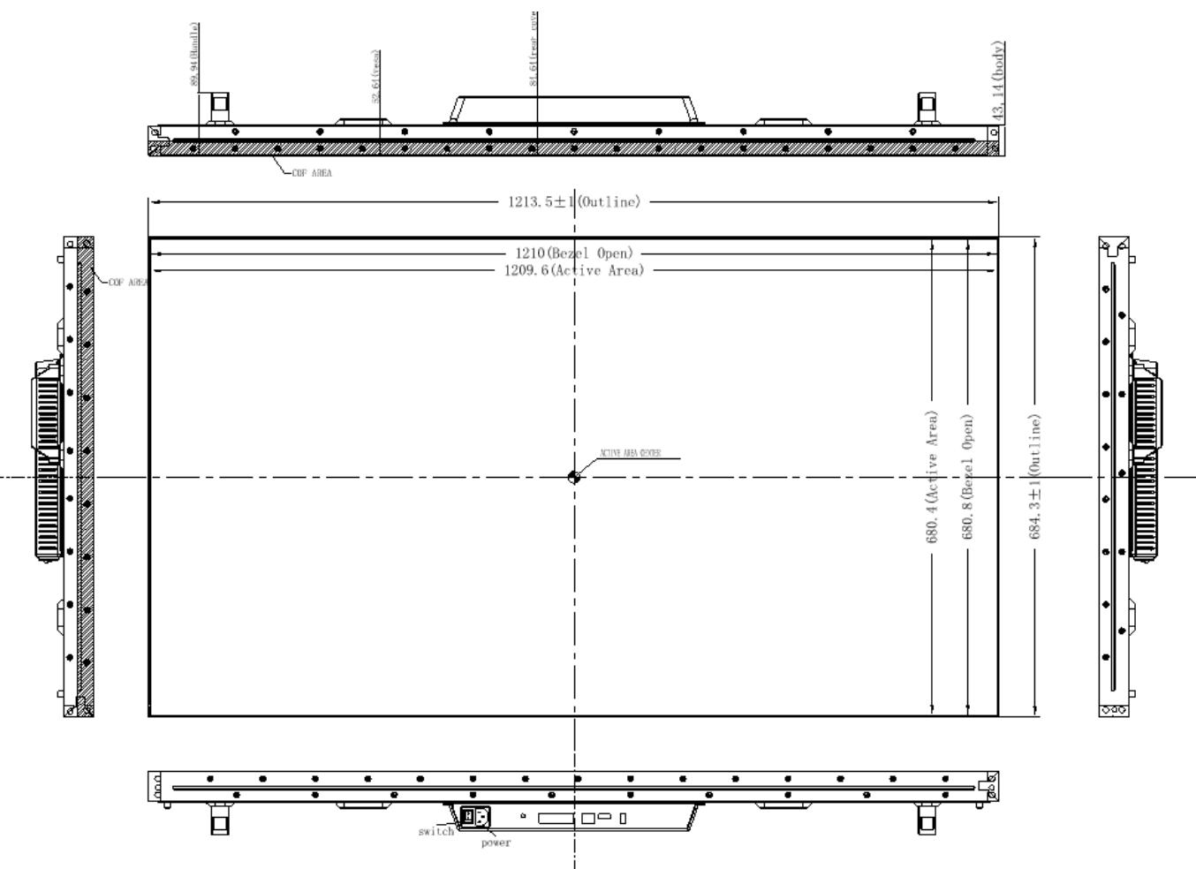 | 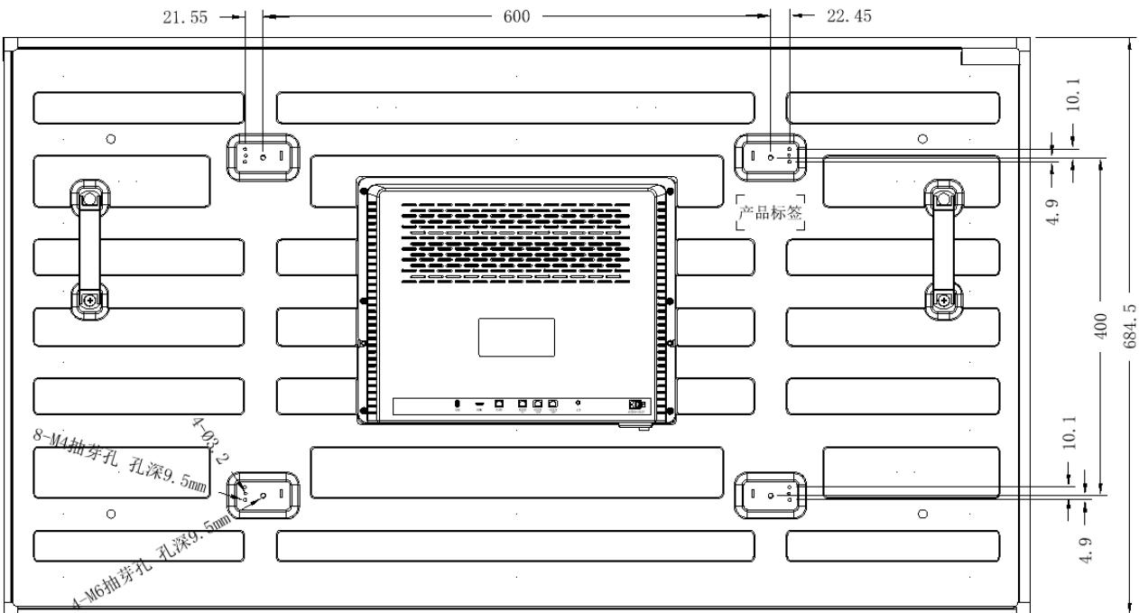 | 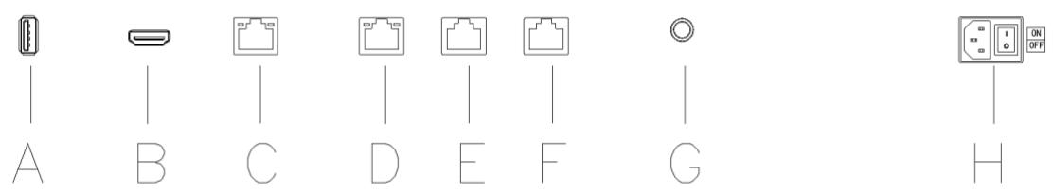
NX-VP-5535 · Primary | NX-VP-5535 · Gallery | NX-VP-5535 · Gallery | NX-VP-5535 · Gallery

PRODUCT OVERVIEW
A 55-inch Full HD LCD panel with a 3.5 mm combined bezel, designed for tiled monitoring, command and presentation walls.
Product line | Video Wall Display & Network Decoding System
Series / family | Standalone model
Exact model | NX-VP-5535
Applications | Security control room, Command center, Monitoring center, Presentation wall
MODEL IDENTIFICATION
Exact model | Product / variant | Panel size | Combined bezel | Resolution
NX-VP-5535 | 55-inch LCD Video Wall Panel for Control Room Display | 55 inches | 3.5 mm | 1920 × 1080
TECHNICAL SPECIFICATIONS
Parameter | Specification
Panel size | 55 inches
Combined bezel | 3.5 mm
Resolution | 1920 × 1080
Brightness | 400 nit typical
Viewing angle | 178° H / V; 178° horizontal / vertical
Power | Up to 150 W
Contrast ratio | 1200:1 typical
Response time | 8 ms typical
Backlight | D-LED
Dimensions | 1213.5 × 684.3 × 89.94 mm
Net weight | 14.4 kg
Power consumption | Up to 150 W
Mounting review | Confirm wall, cabinet or front-maintenance structure from the approved project drawing
APPLICATIONS & RFQ CONFIRMATION
Typical applications | Confirm in the project RFQ
Security control room  Command center  Monitoring center  Presentation wall | Confirm rows × columns, mounting method, maintenance access and packing before quotation.  Color calibration, controller compatibility and final interfaces must be checked against the approved project submittal.
Project supply: MOQ — Project-based; confirm from wall layout and quantity · Lead time — Confirm after layout, mounting and packing review · FOB port — China main ports · OEM/ODM — Available; confirm project scope
PROJECT CONFIGURATION CHECKLIST
Exact model | NX-VP-5535
Application and site conditions | Confirm installation environment and operating requirements.
Quantity and model mix | Confirm forecast quantity, phase plan and required variants.
Interfaces and accessories | Confirm compatible interfaces, accessories and system integration scope.
Finish, branding and packing | Confirm only when project customization is required.
Documentation and destination | Confirm drawings, datasheets, packing documents and destination country or port.

