
VIDEO WALL DISPLAY & NETWORK DECODING SYSTEM

5-inch Network PTZ Control Keyboard
  - Exact model: NX-PC-5S3
PRODUCT IMAGES
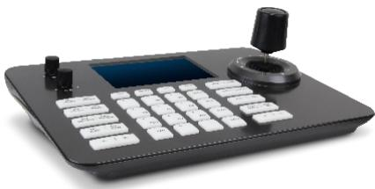 | 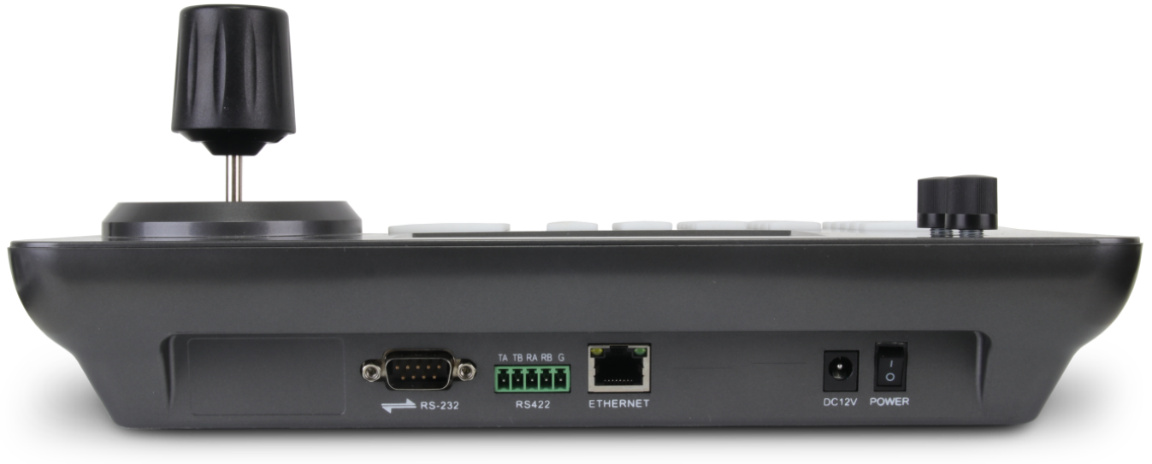 | 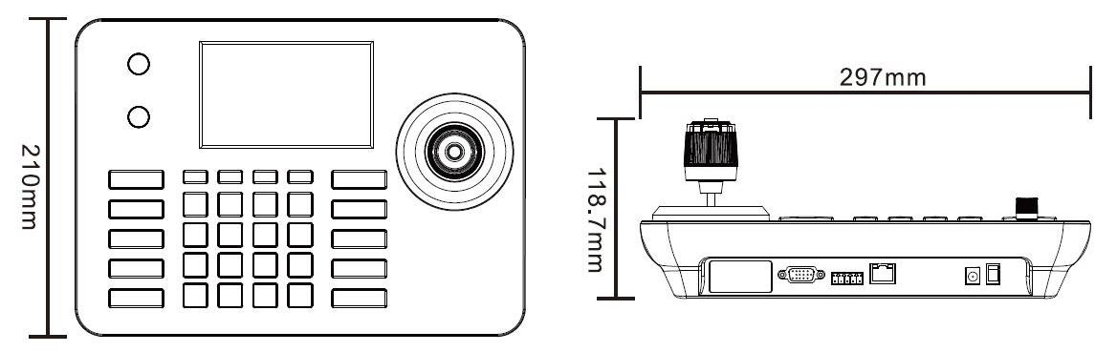 | 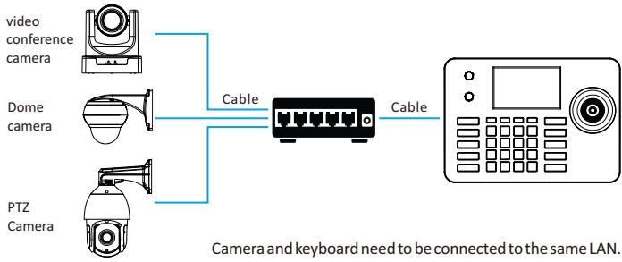
NX-PC-5S3 · Primary | NX-PC-5S3 · Gallery | NX-PC-5S3 · Gallery | NX-PC-5S3 · Gallery

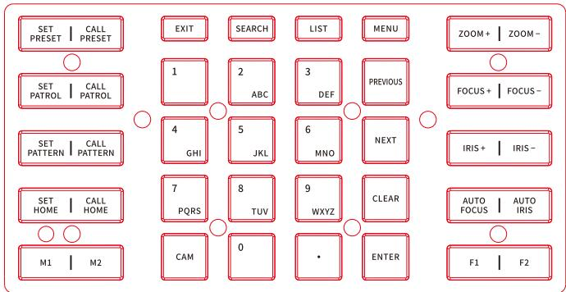 | 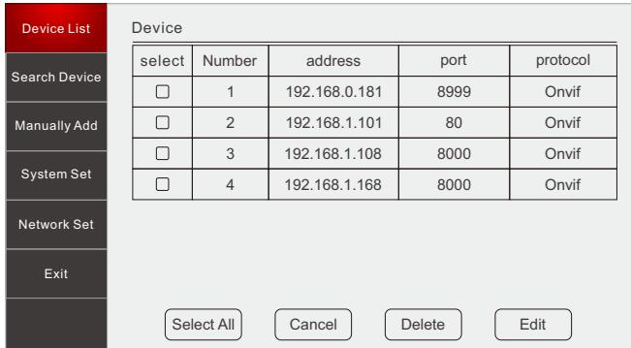
NX-PC-5S3 · Gallery | NX-PC-5S3 · Gallery

PRODUCT OVERVIEW
A network PTZ control keyboard with a 5-inch display, four-axis joystick, video decoding and PoE support for surveillance operators.
Product line | Video Wall Display & Network Decoding System
Series / family | Standalone model
Exact model | NX-PC-5S3
Applications | Security operator desk, PTZ camera control, Monitoring center, Decoder operation
MODEL IDENTIFICATION
Exact model | Product / variant | Display | Managed devices | Decoding
NX-PC-5S3 | 5-inch Network PTZ Control Keyboard | 5-inch 800 × 480 | Up to 999 | 1080p at 30 fps
TECHNICAL SPECIFICATIONS
Parameter | Specification
Display | 5-inch 800 × 480 TFT LCD
Managed devices | Up to 999
Decoding | 1080p at 30 fps
Interfaces | RJ45 / RS422 / RS232; RJ45, RS422 and RS232
Power | DC 12 V / PoE
Consumption | Up to 5 W
Operating system | Linux
Video decoding | H.265 / H.264, up to 1080p at 30 fps
Control | Four-axis variable-speed joystick
Power consumption | Up to 5 W
Operating temperature | -10 to 55 °C
APPLICATIONS & RFQ CONFIRMATION
Typical applications | Confirm in the project RFQ
Security operator desk  PTZ camera control  Monitoring center  Decoder operation | Confirm camera brands/models, protocol, device count and required serial interfaces before quotation.
Project supply: MOQ — Confirm by project quantity · Lead time — Confirm after compatibility review · FOB port — China main ports · OEM/ODM — Available; confirm project scope
PROJECT CONFIGURATION CHECKLIST
Exact model | NX-PC-5S3
Application and site conditions | Confirm installation environment and operating requirements.
Quantity and model mix | Confirm forecast quantity, phase plan and required variants.
Interfaces and accessories | Confirm compatible interfaces, accessories and system integration scope.
Finish, branding and packing | Confirm only when project customization is required.
Documentation and destination | Confirm drawings, datasheets, packing documents and destination country or port.

