
VIDEO WALL DISPLAY & NETWORK DECODING SYSTEM

5-inch HD IP Joystick Controller
  - Exact model: NX-PC-5HD
PRODUCT IMAGES
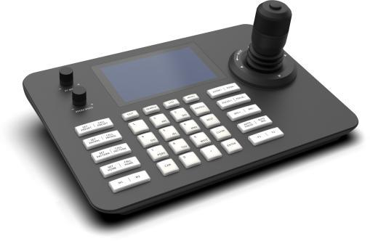 | 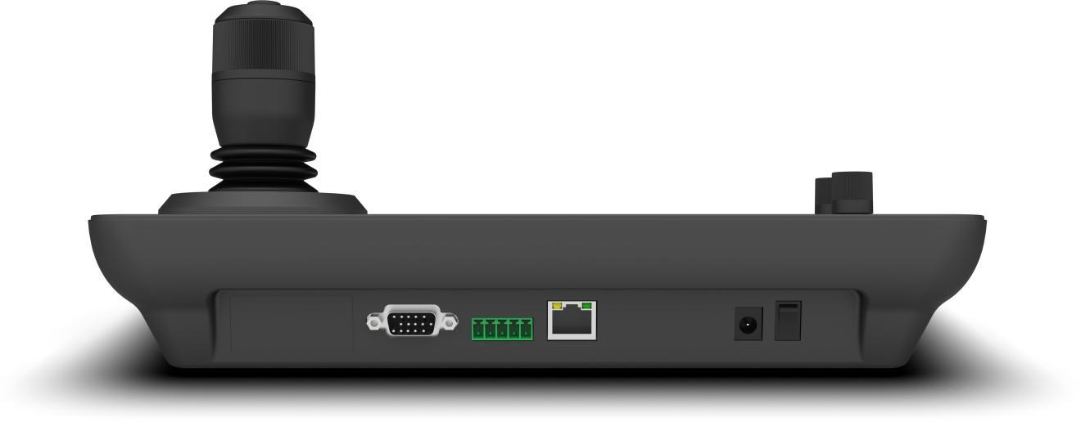 | 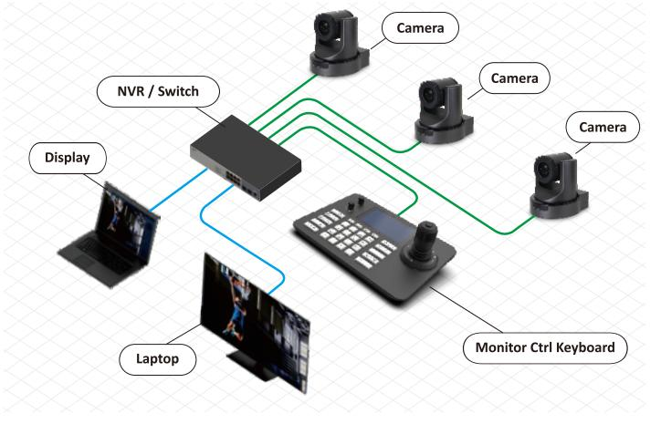
NX-PC-5HD · Primary | NX-PC-5HD · Gallery | NX-PC-5HD · Gallery

PRODUCT OVERVIEW
A low-power IP joystick controller with a 5-inch HD display, ONVIF control and serial interfaces for camera and decoder operation.
Product line | Video Wall Display & Network Decoding System
Series / family | Standalone model
Exact model | NX-PC-5HD
Applications | Compact monitoring desk, PTZ camera control, Local video preview, Decoder operation
MODEL IDENTIFICATION
Exact model | Product / variant | Display | Managed devices | Decoding
NX-PC-5HD | 5-inch HD IP Joystick Controller | 5-inch 1280 × 720 | Up to 254 | 1080p at 30 fps
TECHNICAL SPECIFICATIONS
Parameter | Specification
Display | 5-inch 1280 × 720 LCD
Managed devices | Up to 254
Decoding | 1080p at 30 fps
Interfaces | RJ45 / RS485 / RS422 / RS232; RJ45, RS485, RS422 and RS232
Power | DC 12 V / PoE
Consumption | Below 1.5 W
Operating system | Linux
Video decoding | H.264 / H.265, up to 1080p at 30 fps
Control | Four-axis joystick and rotary control
Power consumption | Below 1.5 W
Operating temperature | -10 to 50 °C
APPLICATIONS & RFQ CONFIRMATION
Typical applications | Confirm in the project RFQ
Compact monitoring desk  PTZ camera control  Local video preview  Decoder operation | Confirm camera brands/models, ONVIF behavior, device database size and required serial interfaces before quotation.
Project supply: MOQ — Confirm by project quantity · Lead time — Confirm after compatibility review · FOB port — China main ports · OEM/ODM — Available; confirm project scope
PROJECT CONFIGURATION CHECKLIST
Exact model | NX-PC-5HD
Application and site conditions | Confirm installation environment and operating requirements.
Quantity and model mix | Confirm forecast quantity, phase plan and required variants.
Interfaces and accessories | Confirm compatible interfaces, accessories and system integration scope.
Finish, branding and packing | Confirm only when project customization is required.
Documentation and destination | Confirm drawings, datasheets, packing documents and destination country or port.

