
UPS UNINTERRUPTIBLE POWER SUPPLY

SP-6.2KW/48VPro Parallel Hybrid Inverter
  - Exact model: SP-6.2KW-48VPRO-HYBRID-INVERTER
PRODUCT IMAGES
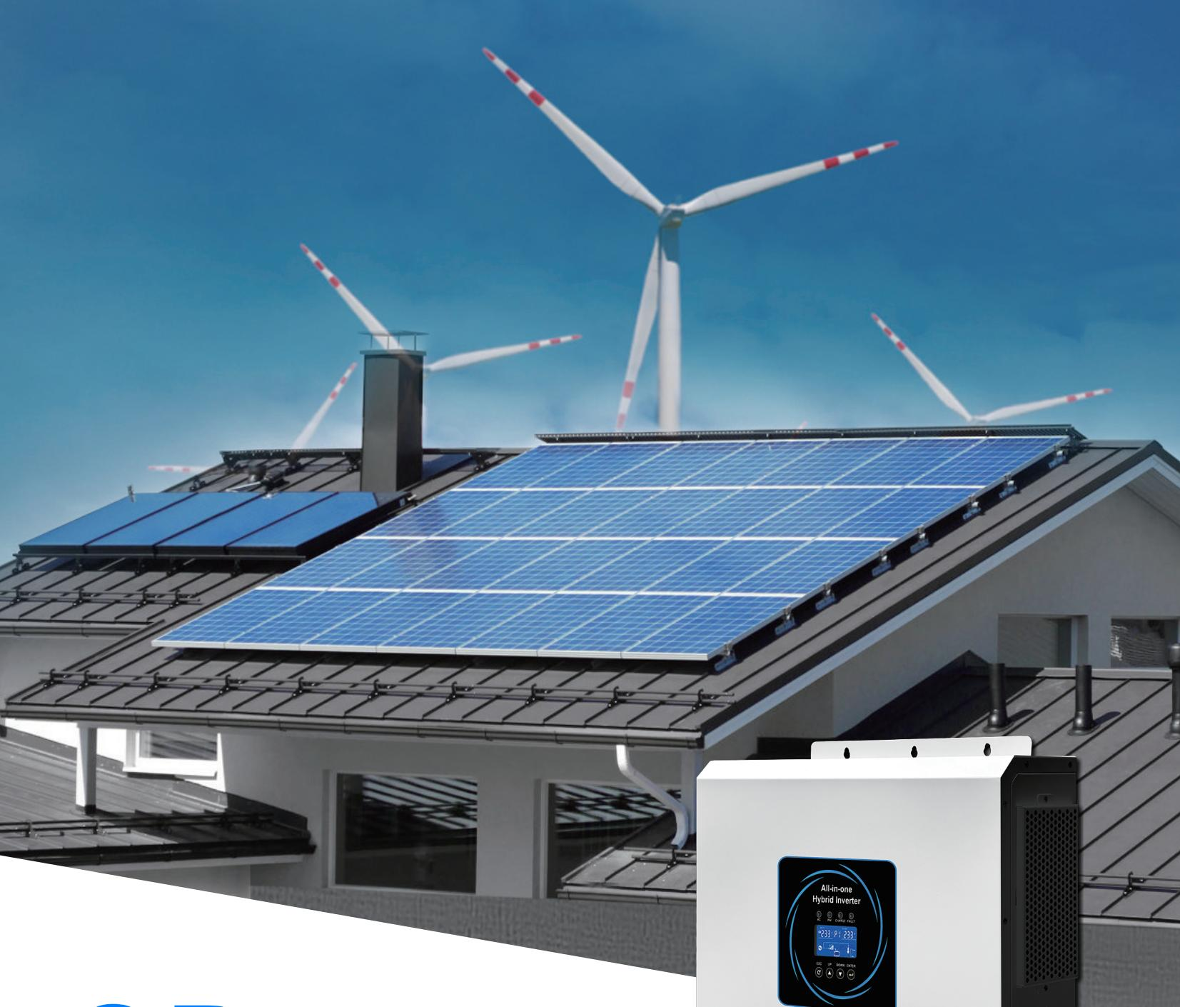 | 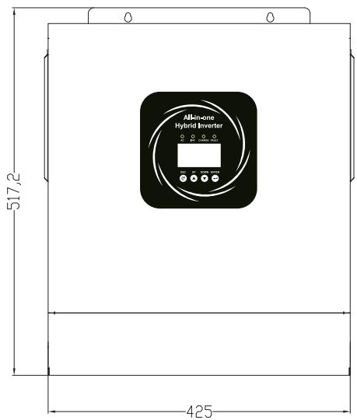 | 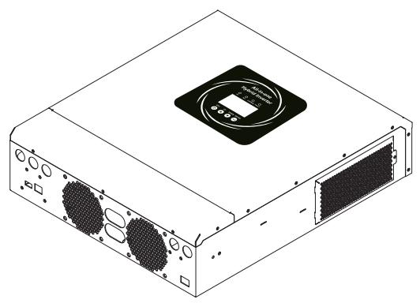 | 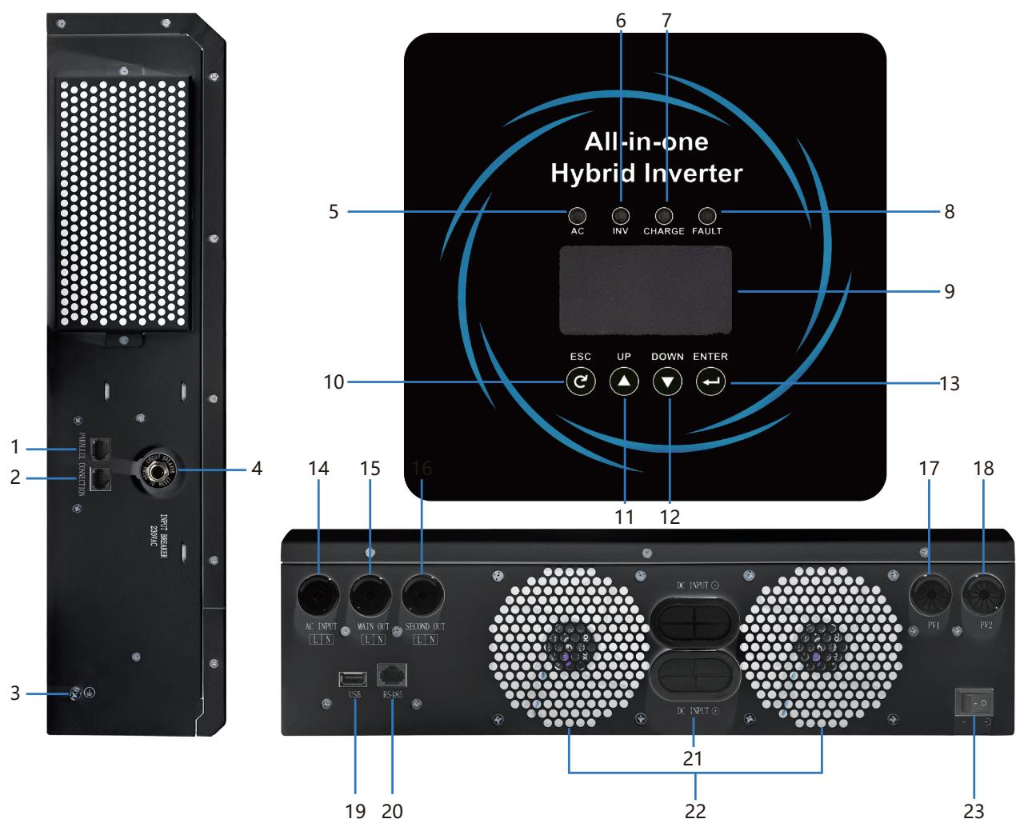
SP-6.2KW-48VPRO-HYBRID-INVERTER · Primary | SP-6.2KW-48VPRO-HYBRID-INVERTER · Gallery | SP-6.2KW-48VPRO-HYBRID-INVERTER · Gallery | SP-6.2KW-48VPRO-HYBRID-INVERTER · Gallery

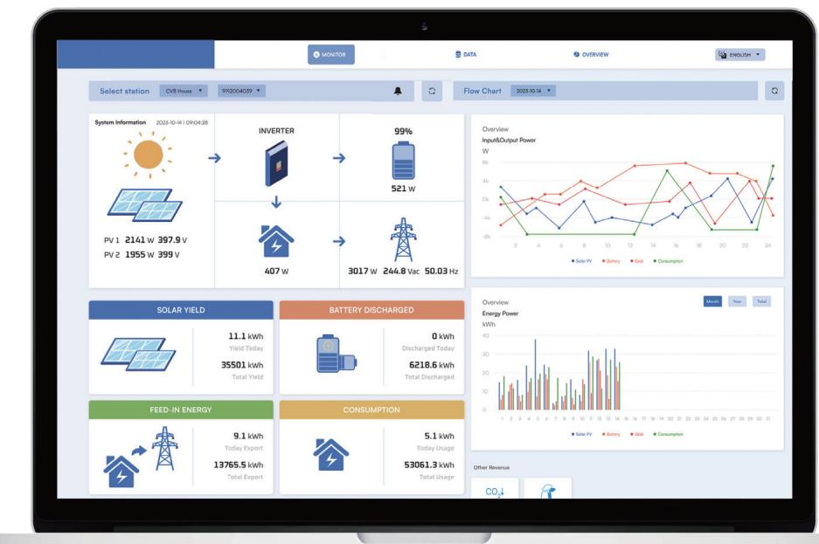 | 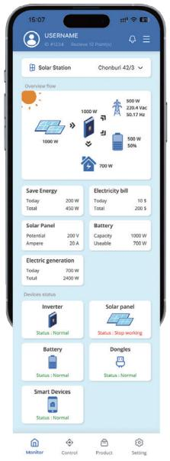 | 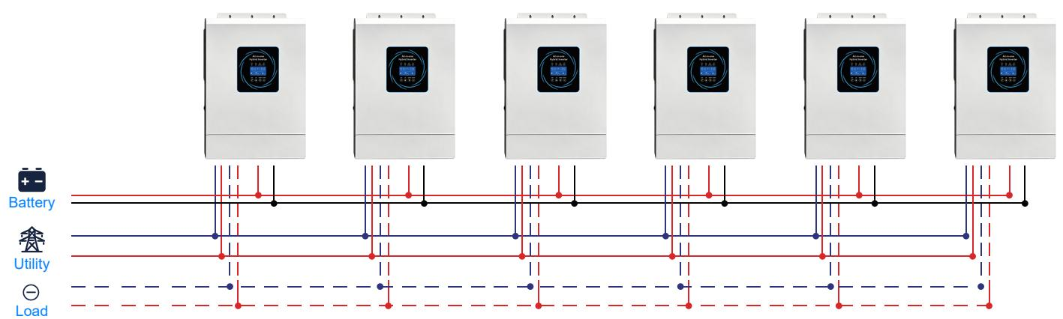 | 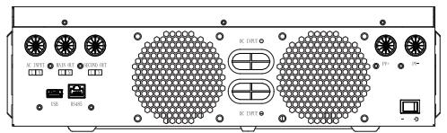
SP-6.2KW-48VPRO-HYBRID-INVERTER · Gallery | SP-6.2KW-48VPRO-HYBRID-INVERTER · Gallery | SP-6.2KW-48VPRO-HYBRID-INVERTER · Gallery | SP-6.2KW-48VPRO-HYBRID-INVERTER · Gallery

PRODUCT OVERVIEW
SP-6.2KW/48VPro Parallel Hybrid Inverter with 1 source-reviewed model for Residential solar storage, off-grid power and small commercial backup. Model configuration and destination-market requirements are confirmed during RFQ review.
Product line | UPS Uninterruptible Power Supply
Series / family | Standalone model
Exact model | SP-6.2KW-48VPRO-HYBRID-INVERTER
Applications | Residential solar storage, off-grid power and small commercial backup
MODEL IDENTIFICATION
Exact model | Product / variant | Topology | Power Range | Phase
SP-6.2KW-48VPRO-HYBRID-INVERTER | SP-6.2KW/48VPro Parallel Hybrid Inverter | Parallel hybrid solar inverter | SP-6.2KW-48VPRO | Single phase AC and PV input / Single phase AC output
TECHNICAL SPECIFICATIONS
Parameter | Specification
Topology | Parallel hybrid solar inverter
Power Range | SP-6.2KW-48VPRO
Phase | Single phase AC and PV input / Single phase AC output
Form Factor | Wall mounted
Waveform | Pure sine wave
Power Factor | Model-specific; confirm on quotation
Battery Types | Model-dependent
SKU | SP-6.2KW-48VPRO-HYBRID-INVERTER
Available Configurations | SP-6.2KW-48VPRO
Exact Configuration | Confirm one listed configuration during RFQ review
Destination Requirements | To be confirmed
ENGINEERING TABLES
SP-6.2KW-48VPRO-HYBRID-INVERTER · Complete Model Specifications — SP-6.2KW-48VPRO
Parameter | SP-6.2KW-48VPRO
Rated capacity | SP-6.2KW-48VPRO
Battery configuration | Not provided
Dimensions | 536*352*135mm
Net weight | 10.5
Transfer time | 10ms (Typical)
Efficiency | >94%
Technical Data — Model | SP-6.2KW/48VPro
INPUT — Single Phase | L+N+PE
INPUT — Rated Input Voltage | 220/230/240VAC
INPUT — Voltage Range | 90-280VAC ± 3V (Normal Mode) 170-280VAC ± 3V
INPUT — Frequency Range | 50/60Hz (Adaptive)
OUTPUT — Rated Output Power | 6000W
OUTPUT — Output Voltage | 220/230/240VAC±5%
OUTPUT — Output Frequency | 50/60Hz±0.1%
OUTPUT — Waveform | Pure Sine Wave
OUTPUT — Switch Time | 10ms (Typical)
OUTPUT — Peak Power | 12400VA
OUTPUT — Overload Capacity | 10.5s@110%~150% Load; 5.5s@150%~200% Load; 200ms@>200% Load
OUTPUT — Peak Efficiency | >94%
OUTPUT — Rated Voltage | 48Vdc
OUTPUT — Constant Voltage Charging Voltage | 56.4Vdc
OUTPUT — Float Charging Voltage | 54Vdc
OUTPUT — PV Charging Method | MPPT
OUTPUT — PV Maximum Input Power | 9000W
OUTPUT — MPPT Input Voltage Range | 120~500Vdc
OUTPUT — Optimal working range of Vmp | 300~400Vdc
OUTPUT — Maximum PV Input Voltage | 500Vdc
OUTPUT — Maximum PV Input Current | 27A
OUTPUT — Maximum AC Charging Current | 100A
OUTPUT — Maximum AC Input Current | 80A
OUTPUT — Maximum Charging Current | 100A
OUTPUT — LCD Interface | Operating /Load /Input /Output....
OUTPUT — Embedded Interfaces | BMS /RS232 /RS485 /CAN /USB /Dry Contact
OUTPUT — Parallel Interface | Yes
OUTPUT — Operating Environment Temperature | -10~50
OUTPUT — Operating Environment Humidity | 20%~95% (Without Condensation)
OUTPUT — Storage Temperature | -15~60
OUTPUT — Altitude | The altitude should not exceed 1000m
OUTPUT — Noise | ≤50db
OUTPUT — Dimension(D*W*H) | 536*352*135mm
OUTPUT — Net Weight(kgs) | 10.5

