
UPS UNINTERRUPTIBLE POWER SUPPLY

Line-Interactive UPS 650VA-2000VA Series
  - Exact model: NX-UP-ST-002
PRODUCT IMAGES
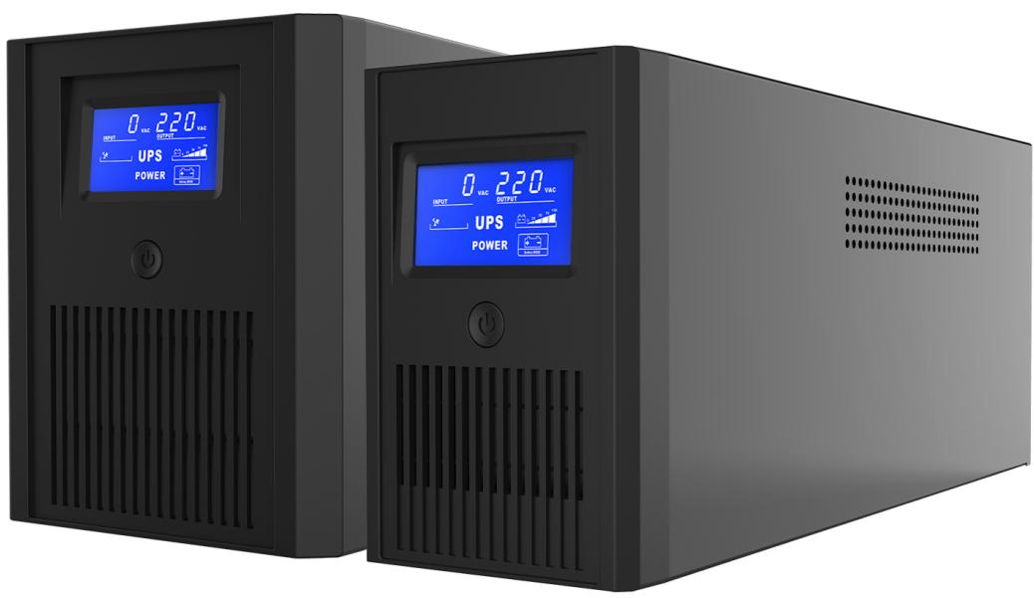 | 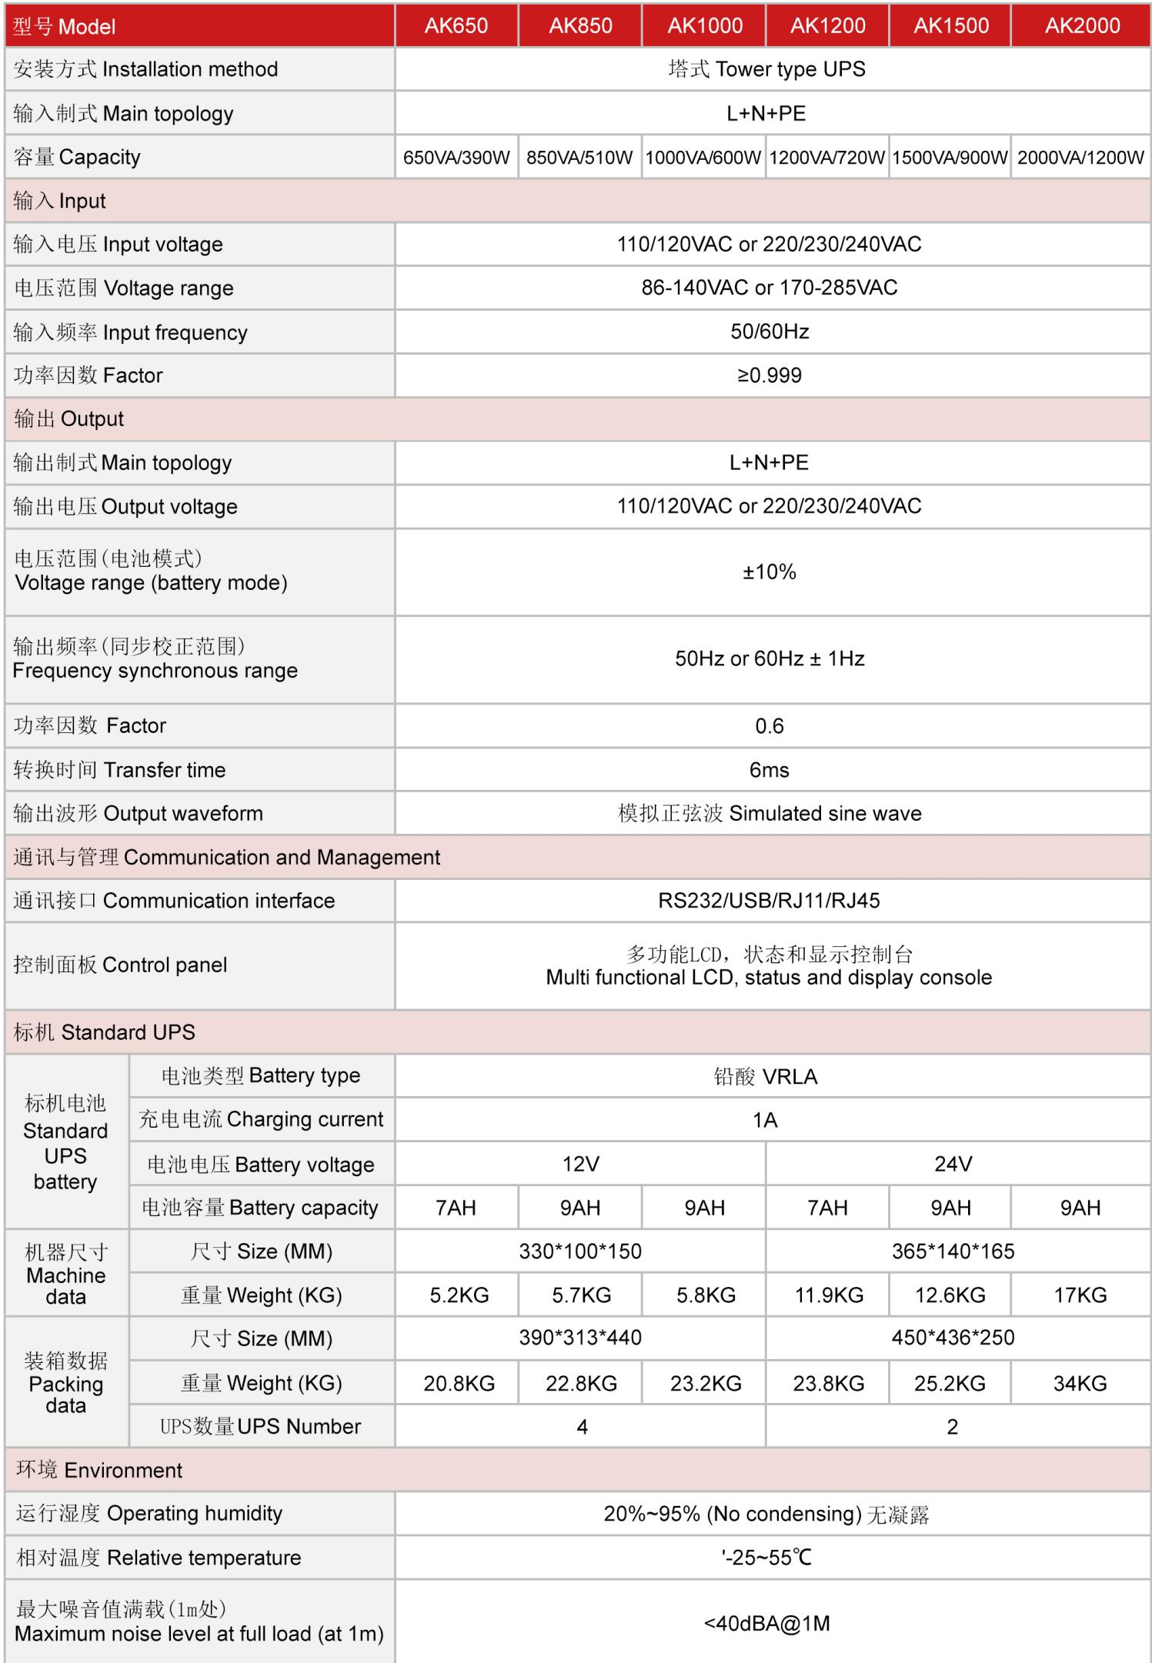
NX-UP-ST-002 · Primary | NX-UP-ST-002 · Gallery

PRODUCT OVERVIEW
Line-interactive UPS with AVR providing enhanced voltage regulation for environments with frequent power fluctuations. Six models from 650VA to 2000VA.
Product line | UPS Uninterruptible Power Supply
Series / family | Standalone model
Exact model | NX-UP-ST-002
Applications | Small offices, Home offices, POS terminals, Security systems, Printers and peripherals
MODEL IDENTIFICATION
Exact model | Product / variant | Topology | Power Range | Phase
NX-UP-ST-002 | Line-Interactive UPS 650VA-2000VA Series | Line-Interactive with AVR | 650VA-2000VA / 390W-1200W | Single phase input / Single phase output
TECHNICAL SPECIFICATIONS
Parameter | Specification
Topology | Line-Interactive with AVR
Power Range | 650VA-2000VA / 390W-1200W
Phase | Single phase input / Single phase output
Form Factor | Tower
Waveform | Simulated sine wave
Power Factor | 0.6
Battery Types | VRLA sealed lead-acid
SKU | NX-UP-ST-002
Available Configurations | AK650; AK850; AK1000; AK1200; AK1500; AK2000
Exact Configuration | Confirm one listed configuration during RFQ review
Destination Requirements | To be confirmed
ENGINEERING TABLES
NX-UP-ST-002 · Complete Model Specifications — AK650 | AK850 | AK1000 | AK1200
Parameter | AK650 | AK850 | AK1000 | AK1200
Rated capacity | 650VA / 390W | 850VA / 510W | 1000VA / 600W | 1200VA / 720W
Battery configuration | Not provided | Not provided | Not provided | Not provided
Dimensions | Not provided | Not provided | Not provided | Not provided
Net weight | Not provided | Not provided | Not provided | Not provided
Transfer time | 6ms | 6ms | 6ms | 6ms
Efficiency | Not provided | Not provided | Not provided | Not provided
Model configuration — Rated capacity | 650VA / 390W | 850VA / 510W | 1000VA / 600W | 1200VA / 720W
Model configuration — Transfer time | 6ms | 6ms | 6ms | 6ms
Input — Input voltage | 110/120VAC or 220/230/240VAC | 110/120VAC or 220/230/240VAC | 110/120VAC or 220/230/240VAC | 110/120VAC or 220/230/240VAC
Input — Input voltage range | 86–140VAC or 170–285VAC | 86–140VAC or 170–285VAC | 86–140VAC or 170–285VAC | 86–140VAC or 170–285VAC
Input — Input frequency | 50/60Hz | 50/60Hz | 50/60Hz | 50/60Hz
Input — Input power factor | ≥0.999 | ≥0.999 | ≥0.999 | ≥0.999
Input — Wiring | L+N+PE | L+N+PE | L+N+PE | L+N+PE
Output — Output voltage | 110/120VAC or 220/230/240VAC | 110/120VAC or 220/230/240VAC | 110/120VAC or 220/230/240VAC | 110/120VAC or 220/230/240VAC
Output — Voltage regulation | ±10% | ±10% | ±10% | ±10%
Output — Output frequency | 50/60Hz ±1Hz | 50/60Hz ±1Hz | 50/60Hz ±1Hz | 50/60Hz ±1Hz
Output — Output power factor | 0.6 | 0.6 | 0.6 | 0.6
Charging — Charging current | 1A | 1A | 1A | 1A
Communication & Monitoring — Communication interface | RS232 / USB / RJ11 / RJ45 | RS232 / USB / RJ11 / RJ45 | RS232 / USB / RJ11 / RJ45 | RS232 / USB / RJ11 / RJ45
Communication & Monitoring — Display | LCD | LCD | LCD | LCD
Environment — Operating temperature | -25–55°C | -25–55°C | -25–55°C | -25–55°C
Environment — Relative humidity | 20–95% RH (non-condensing) | 20–95% RH (non-condensing) | 20–95% RH (non-condensing) | 20–95% RH (non-condensing)
Environment — Noise level | <40dBA @1m | <40dBA @1m | <40dBA @1m | <40dBA @1m
Packaging — Package dimensions | 390×313×440mm | 390×313×440mm | 390×313×440mm | 450×436×250mm
Packaging — Package weight | 20.8kg | 22.8kg | 23.2kg | 23.8kg
Packaging — Units per carton | 4 | 4 | 4 | 2
NX-UP-ST-002 · Complete Model Specifications — AK1500 | AK2000
Parameter | AK1500 | AK2000
Rated capacity | 1500VA / 900W | 2000VA / 1200W
Battery configuration | Not provided | Not provided
Dimensions | Not provided | Not provided
Net weight | Not provided | Not provided
Transfer time | 6ms | 6ms
Efficiency | Not provided | Not provided
Model configuration — Rated capacity | 1500VA / 900W | 2000VA / 1200W
Model configuration — Transfer time | 6ms | 6ms
Input — Input voltage | 110/120VAC or 220/230/240VAC | 110/120VAC or 220/230/240VAC
Input — Input voltage range | 86–140VAC or 170–285VAC | 86–140VAC or 170–285VAC
Input — Input frequency | 50/60Hz | 50/60Hz
Input — Input power factor | ≥0.999 | ≥0.999
Input — Wiring | L+N+PE | L+N+PE
Output — Output voltage | 110/120VAC or 220/230/240VAC | 110/120VAC or 220/230/240VAC
Output — Voltage regulation | ±10% | ±10%
Output — Output frequency | 50/60Hz ±1Hz | 50/60Hz ±1Hz
Output — Output power factor | 0.6 | 0.6
Charging — Charging current | 1A | 1A
Communication & Monitoring — Communication interface | RS232 / USB / RJ11 / RJ45 | RS232 / USB / RJ11 / RJ45
Communication & Monitoring — Display | LCD | LCD
Environment — Operating temperature | -25–55°C | -25–55°C
Environment — Relative humidity | 20–95% RH (non-condensing) | 20–95% RH (non-condensing)
Environment — Noise level | <40dBA @1m | <40dBA @1m
Packaging — Package dimensions | 450×436×250mm | 450×436×250mm
Packaging — Package weight | 25.2kg | 34kg
Packaging — Units per carton | 2 | 2

