
UPS UNINTERRUPTIBLE POWER SUPPLY

Standby UPS 650VA-3000VA Series
  - Exact model: NX-UP-ST-001
PRODUCT IMAGES
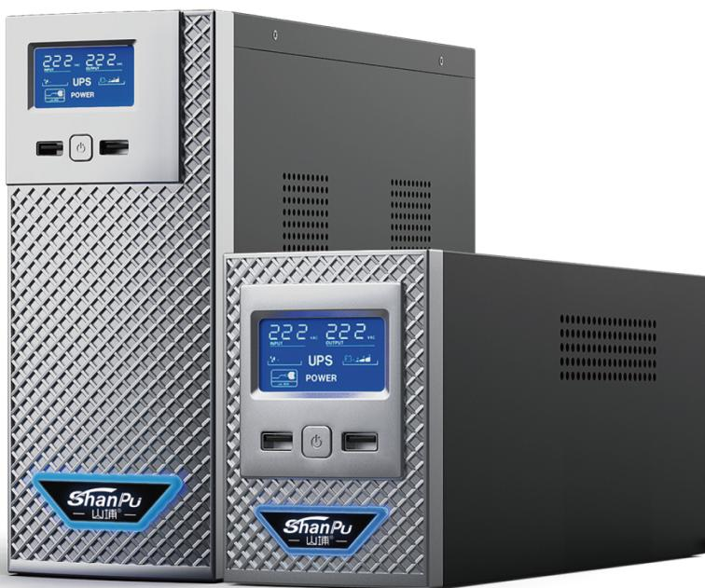 | 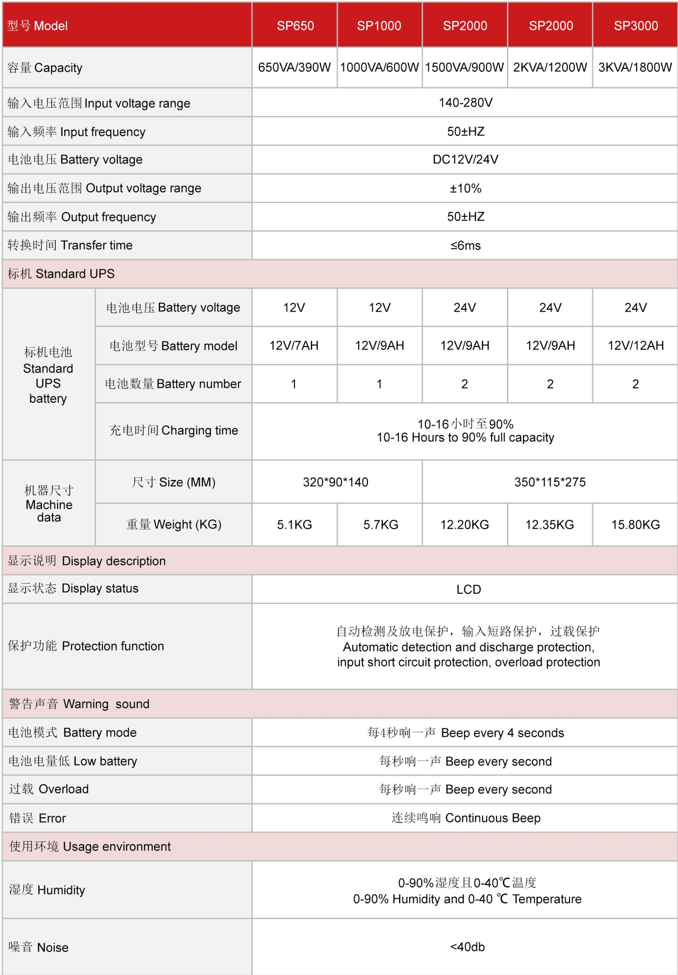
NX-UP-ST-001 · Primary | NX-UP-ST-001 · Gallery

PRODUCT OVERVIEW
Cost-effective offline UPS series providing reliable battery backup and surge protection for personal computers, POS systems, and small office equipment. Available in 650VA to 3000VA capacities.
Product line | UPS Uninterruptible Power Supply
Series / family | Standalone model
Exact model | NX-UP-ST-001
Applications | Personal computers, Printers, POS terminals, Security systems, Fax machines, Modems and routers
MODEL IDENTIFICATION
Exact model | Product / variant | Topology | Power Range | Phase
NX-UP-ST-001 | Standby UPS 650VA-3000VA Series | Offline (Standby) | 650VA-3000VA / 390W-1800W | Single phase input / Single phase output
TECHNICAL SPECIFICATIONS
Parameter | Specification
Topology | Offline (Standby)
Power Range | 650VA-3000VA / 390W-1800W
Phase | Single phase input / Single phase output
Form Factor | Tower
Waveform | Simulated sine wave
Power Factor | 0.6
Battery Types | VRLA sealed lead-acid
SKU | NX-UP-ST-001
Available Configurations | SP650; SP1000; SP1500; SP2000; SP3000
Exact Configuration | Confirm one listed configuration during RFQ review
Destination Requirements | To be confirmed
ENGINEERING TABLES
NX-UP-ST-001 · Complete Model Specifications — SP650 | SP1000 | SP1500 | SP2000
Parameter | SP650 | SP1000 | SP1500 | SP2000
Rated capacity | 650VA / 390W | 1000VA / 600W | 1500VA / 900W | 2000VA / 1200W
Battery configuration | 12V/7AH × 1 | 12V/9AH × 1 | 12V/9AH × 2 | 12V/9AH × 2
Dimensions | 320×90×140mm | 320×90×140mm | 350×115×275mm | 350×115×275mm
Net weight | 5.1kg | 5.7kg | 12.2kg | 12.35kg
Transfer time | ≤6ms | ≤6ms | ≤6ms | ≤6ms
Efficiency | Not provided | Not provided | Not provided | Not provided
Model configuration — Rated capacity | 650VA / 390W | 1000VA / 600W | 1500VA / 900W | 2000VA / 1200W
Model configuration — Battery configuration | 12V/7AH × 1 | 12V/9AH × 1 | 12V/9AH × 2 | 12V/9AH × 2
Model configuration — Product dimensions | 320×90×140mm | 320×90×140mm | 350×115×275mm | 350×115×275mm
Model configuration — Net weight | 5.1kg | 5.7kg | 12.2kg | 12.35kg
Model configuration — Transfer time | ≤6ms | ≤6ms | ≤6ms | ≤6ms
Input — Input voltage range | 140–280VAC | 140–280VAC | 140–280VAC | 140–280VAC
Input — Input frequency | 50Hz; tolerance requires confirmation | 50Hz; tolerance requires confirmation | 50Hz; tolerance requires confirmation | 50Hz; tolerance requires confirmation
Output — Voltage regulation | ±10% | ±10% | ±10% | ±10%
Output — Output frequency | 50Hz; tolerance requires confirmation | 50Hz; tolerance requires confirmation | 50Hz; tolerance requires confirmation | 50Hz; tolerance requires confirmation
Charging — Charging time | 10–16h to 90% capacity | 10–16h to 90% capacity | 10–16h to 90% capacity | 10–16h to 90% capacity
Protection — Protection function | Discharge, short circuit and overload | Discharge, short circuit and overload | Discharge, short circuit and overload | Discharge, short circuit and overload
Display & Alarms — Display | LCD | LCD | LCD | LCD
Display & Alarms — Battery mode alarm | Every 4 seconds | Every 4 seconds | Every 4 seconds | Every 4 seconds
Display & Alarms — Low battery alarm | Every second | Every second | Every second | Every second
Display & Alarms — Overload alarm | Every second | Every second | Every second | Every second
Display & Alarms — Fault alarm | Continuous | Continuous | Continuous | Continuous
Environment — Operating temperature | 0–40°C | 0–40°C | 0–40°C | 0–40°C
Environment — Relative humidity | 0–90% RH | 0–90% RH | 0–90% RH | 0–90% RH
Environment — Noise level | <40dB | <40dB | <40dB | <40dB
NX-UP-ST-001 · Complete Model Specifications — SP3000
Parameter | SP3000
Rated capacity | 3000VA / 1800W
Battery configuration | 12V/12AH × 2
Dimensions | 350×115×275mm
Net weight | 15.8kg
Transfer time | ≤6ms
Efficiency | Not provided
Model configuration — Rated capacity | 3000VA / 1800W
Model configuration — Battery configuration | 12V/12AH × 2
Model configuration — Product dimensions | 350×115×275mm
Model configuration — Net weight | 15.8kg
Model configuration — Transfer time | ≤6ms
Input — Input voltage range | 140–280VAC
Input — Input frequency | 50Hz; tolerance requires confirmation
Output — Voltage regulation | ±10%
Output — Output frequency | 50Hz; tolerance requires confirmation
Charging — Charging time | 10–16h to 90% capacity
Protection — Protection function | Discharge, short circuit and overload
Display & Alarms — Display | LCD
Display & Alarms — Battery mode alarm | Every 4 seconds
Display & Alarms — Low battery alarm | Every second
Display & Alarms — Overload alarm | Every second
Display & Alarms — Fault alarm | Continuous
Environment — Operating temperature | 0–40°C
Environment — Relative humidity | 0–90% RH
Environment — Noise level | <40dB

