
UPS UNINTERRUPTIBLE POWER SUPPLY

High Frequency Online UPS 10KVA-30KVA Series
  - Exact model: NX-UP-HF-003
PRODUCT IMAGES
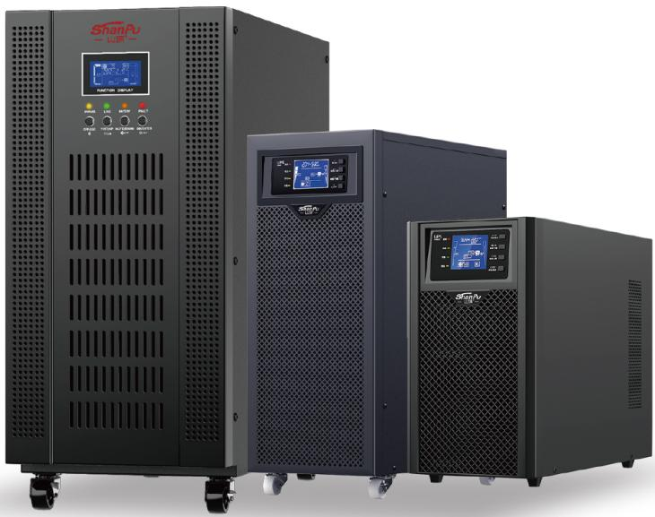 | 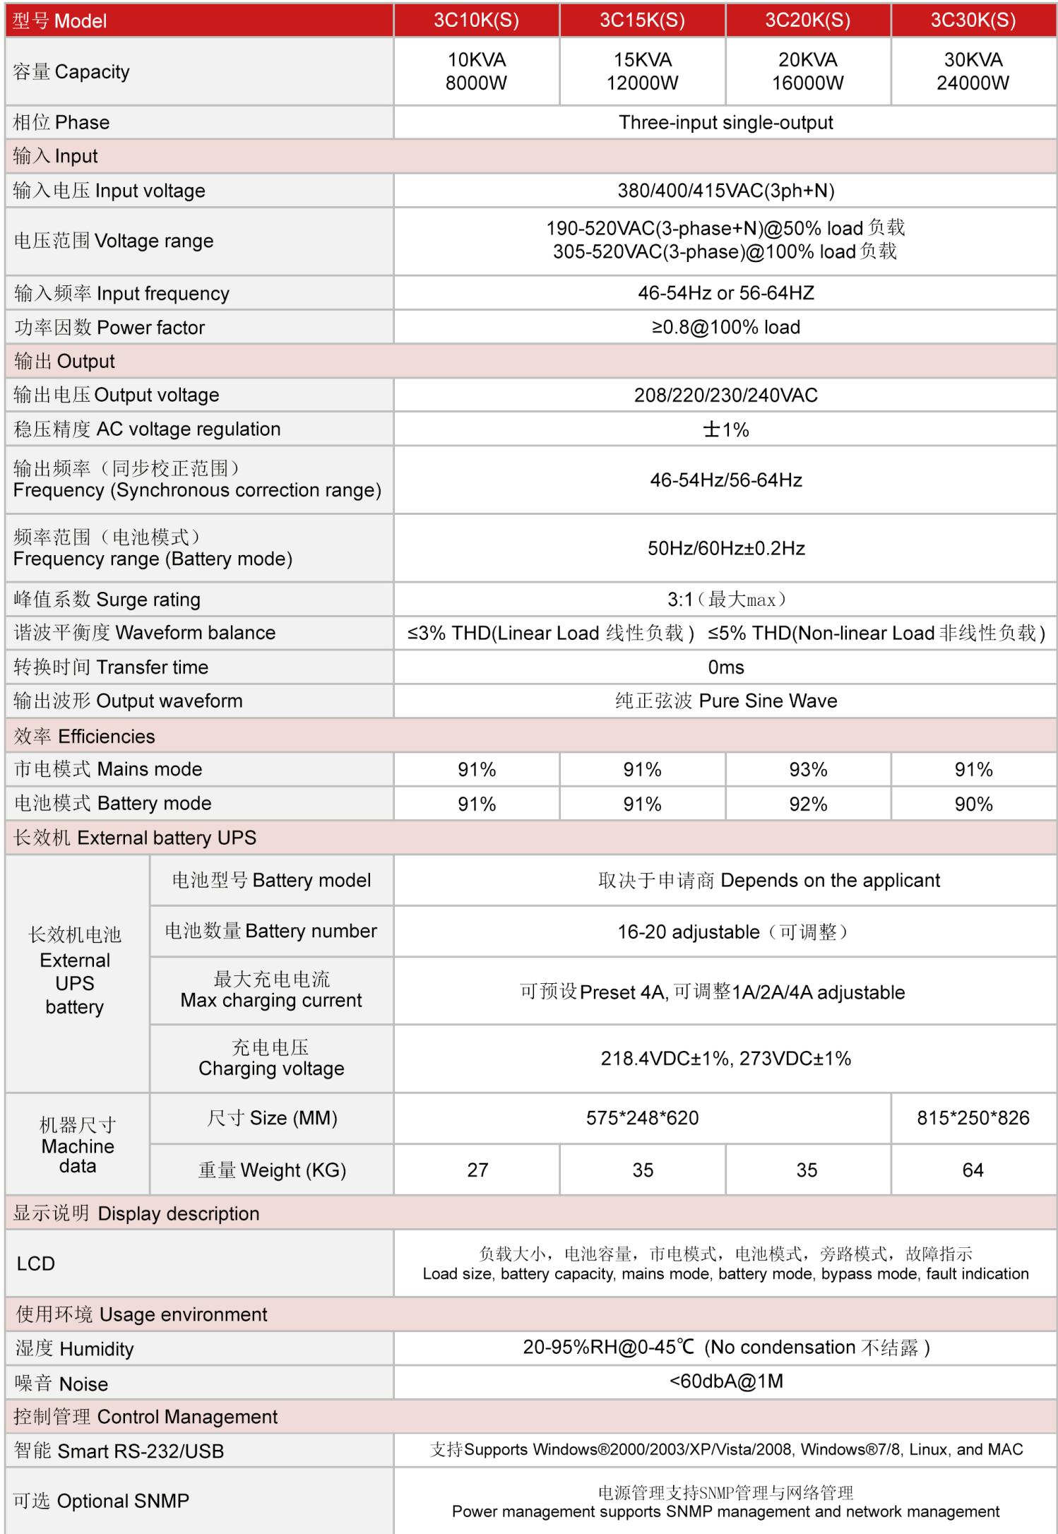
NX-UP-HF-003 · Primary | NX-UP-HF-003 · Gallery

PRODUCT OVERVIEW
Mid-power online UPS series with single/three-phase input flexibility. Four models from 10KVA to 30KVA with external battery bank configuration.
Product line | UPS Uninterruptible Power Supply
Series / family | Standalone model
Exact model | NX-UP-HF-003
Applications | Medium server rooms, Network centers, Banking and financial systems, Telecommunications infrastructure, Medical equipment, Industrial control
MODEL IDENTIFICATION
Exact model | Product / variant | Topology | Power Range | Phase
NX-UP-HF-003 | High Frequency Online UPS 10KVA-30KVA Series | Online Double Conversion | 10KVA–30KVA / 8000W–24000W | Three phase input / Single phase output
TECHNICAL SPECIFICATIONS
Parameter | Specification
Topology | Online Double Conversion
Power Range | 10KVA–30KVA / 8000W–24000W
Phase | Three phase input / Single phase output
Form Factor | Tower
Waveform | Pure sine wave
Power Factor | 0.8
Battery Types | External VRLA battery bank
SKU | NX-UP-HF-003
Available Configurations | 3C10K(S); 3C15K(S); 3C20K(S); 3C30K(S)
Exact Configuration | Confirm one listed configuration during RFQ review
Destination Requirements | To be confirmed
ENGINEERING TABLES
NX-UP-HF-003 · Complete Model Specifications — 3C10K(S) | 3C15K(S) | 3C20K(S) | 3C30K(S)
Parameter | 3C10K(S) | 3C15K(S) | 3C20K(S) | 3C30K(S)
Rated capacity | 10KVA / 8000W | 15KVA / 12000W | 20KVA / 16000W | 30KVA / 24000W
Battery configuration | External battery bank | External battery bank | External battery bank | External battery bank
Dimensions | Not provided | Not provided | Not provided | Not provided
Net weight | Not provided | Not provided | Not provided | Not provided
Transfer time | 0ms | 0ms | 0ms | 0ms
Efficiency | AC: 91%; Battery: 91% | AC: 91%; Battery: 91% | AC: 93%; Battery: 92% | AC: 91%; Battery: 90%
Model configuration — Rated capacity | 10KVA / 8000W | 15KVA / 12000W | 20KVA / 16000W | 30KVA / 24000W
Model configuration — Battery configuration | External battery bank | External battery bank | External battery bank | External battery bank
Model configuration — Transfer time | 0ms | 0ms | 0ms | 0ms
Model configuration — Efficiency | AC: 91%; Battery: 91% | AC: 91%; Battery: 91% | AC: 93%; Battery: 92% | AC: 91%; Battery: 90%
Input — Input voltage | 380/400/415VAC (3ph+N) | 380/400/415VAC (3ph+N) | 380/400/415VAC (3ph+N) | 380/400/415VAC (3ph+N)
Input — Input voltage range at 50% load | 190–520VAC | 190–520VAC | 190–520VAC | 190–520VAC
Input — Input voltage range at 100% load | 305–520VAC | 305–520VAC | 305–520VAC | 305–520VAC
Input — Input frequency | 46–54Hz / 56–64Hz | 46–54Hz / 56–64Hz | 46–54Hz / 56–64Hz | 46–54Hz / 56–64Hz
Input — Input power factor | ≥0.8 @100% load | ≥0.8 @100% load | ≥0.8 @100% load | ≥0.8 @100% load
Output — Output voltage | 208/220/230/240VAC | 208/220/230/240VAC | 208/220/230/240VAC | 208/220/230/240VAC
Output — Voltage regulation | ±1% | ±1% | ±1% | ±1%
Output — Synchronized frequency | 46–54Hz / 56–64Hz | 46–54Hz / 56–64Hz | 46–54Hz / 56–64Hz | 46–54Hz / 56–64Hz
Output — Battery-mode frequency | 50/60Hz ±0.2Hz | 50/60Hz ±0.2Hz | 50/60Hz ±0.2Hz | 50/60Hz ±0.2Hz
Output — Current crest ratio | 3:1 | 3:1 | 3:1 | 3:1
Output — THD (linear load) | ≤3% | ≤3% | ≤3% | ≤3%
Output — THD (non-linear load) | ≤5% | ≤5% | ≤5% | ≤5%
External battery configuration — Battery quantity | 16–20 (adjustable) | 16–20 (adjustable) | 16–20 (adjustable) | 16–20 (adjustable)
External battery configuration — Charging current | 4A preset; 1 / 2 / 4 / 6A adjustable | 4A preset; 1 / 2 / 4 / 6A adjustable | 4A preset; 1 / 2 / 4 / 6A adjustable | 4A preset; 1 / 2 / 4 / 6A adjustable
External battery configuration — Charging voltage | 218.4 / 273VDC ±1% | 218.4 / 273VDC ±1% | 218.4 / 273VDC ±1% | 218.4 / 273VDC ±1%
Communication & Monitoring — Communication interface | RS232 / USB | RS232 / USB | RS232 / USB | RS232 / USB
Communication & Monitoring — SNMP | Optional | Optional | Optional | Optional
Communication & Monitoring — Display | LCD | LCD | LCD | LCD
Environment — Operating temperature | 0–45°C | 0–45°C | 0–45°C | 0–45°C
Environment — Relative humidity | 20–95% RH (non-condensing) | 20–95% RH (non-condensing) | 20–95% RH (non-condensing) | 20–95% RH (non-condensing)
Environment — Noise level | <60dBA @1m | <60dBA @1m | <60dBA @1m | <60dBA @1m

