
UPS UNINTERRUPTIBLE POWER SUPPLY

DC Mini UPS 45W-120W Series
  - Exact model: NX-UP-DC-002
PRODUCT IMAGES
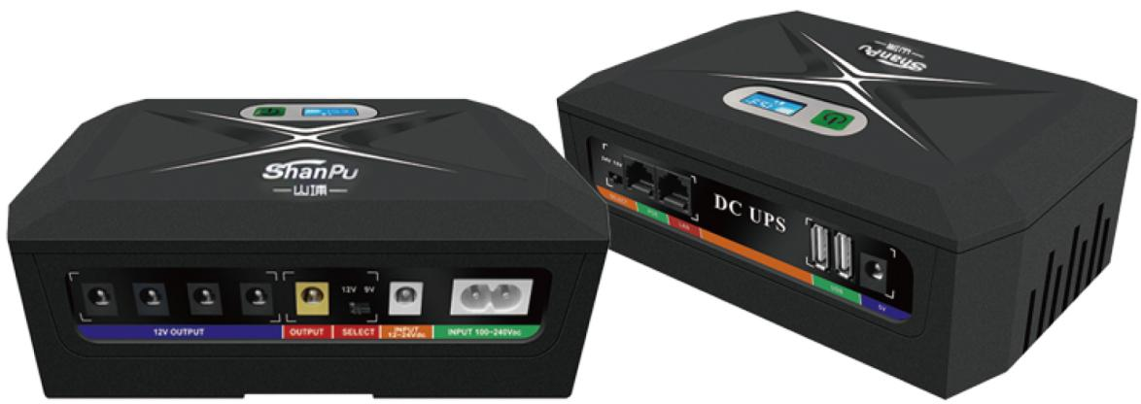 | 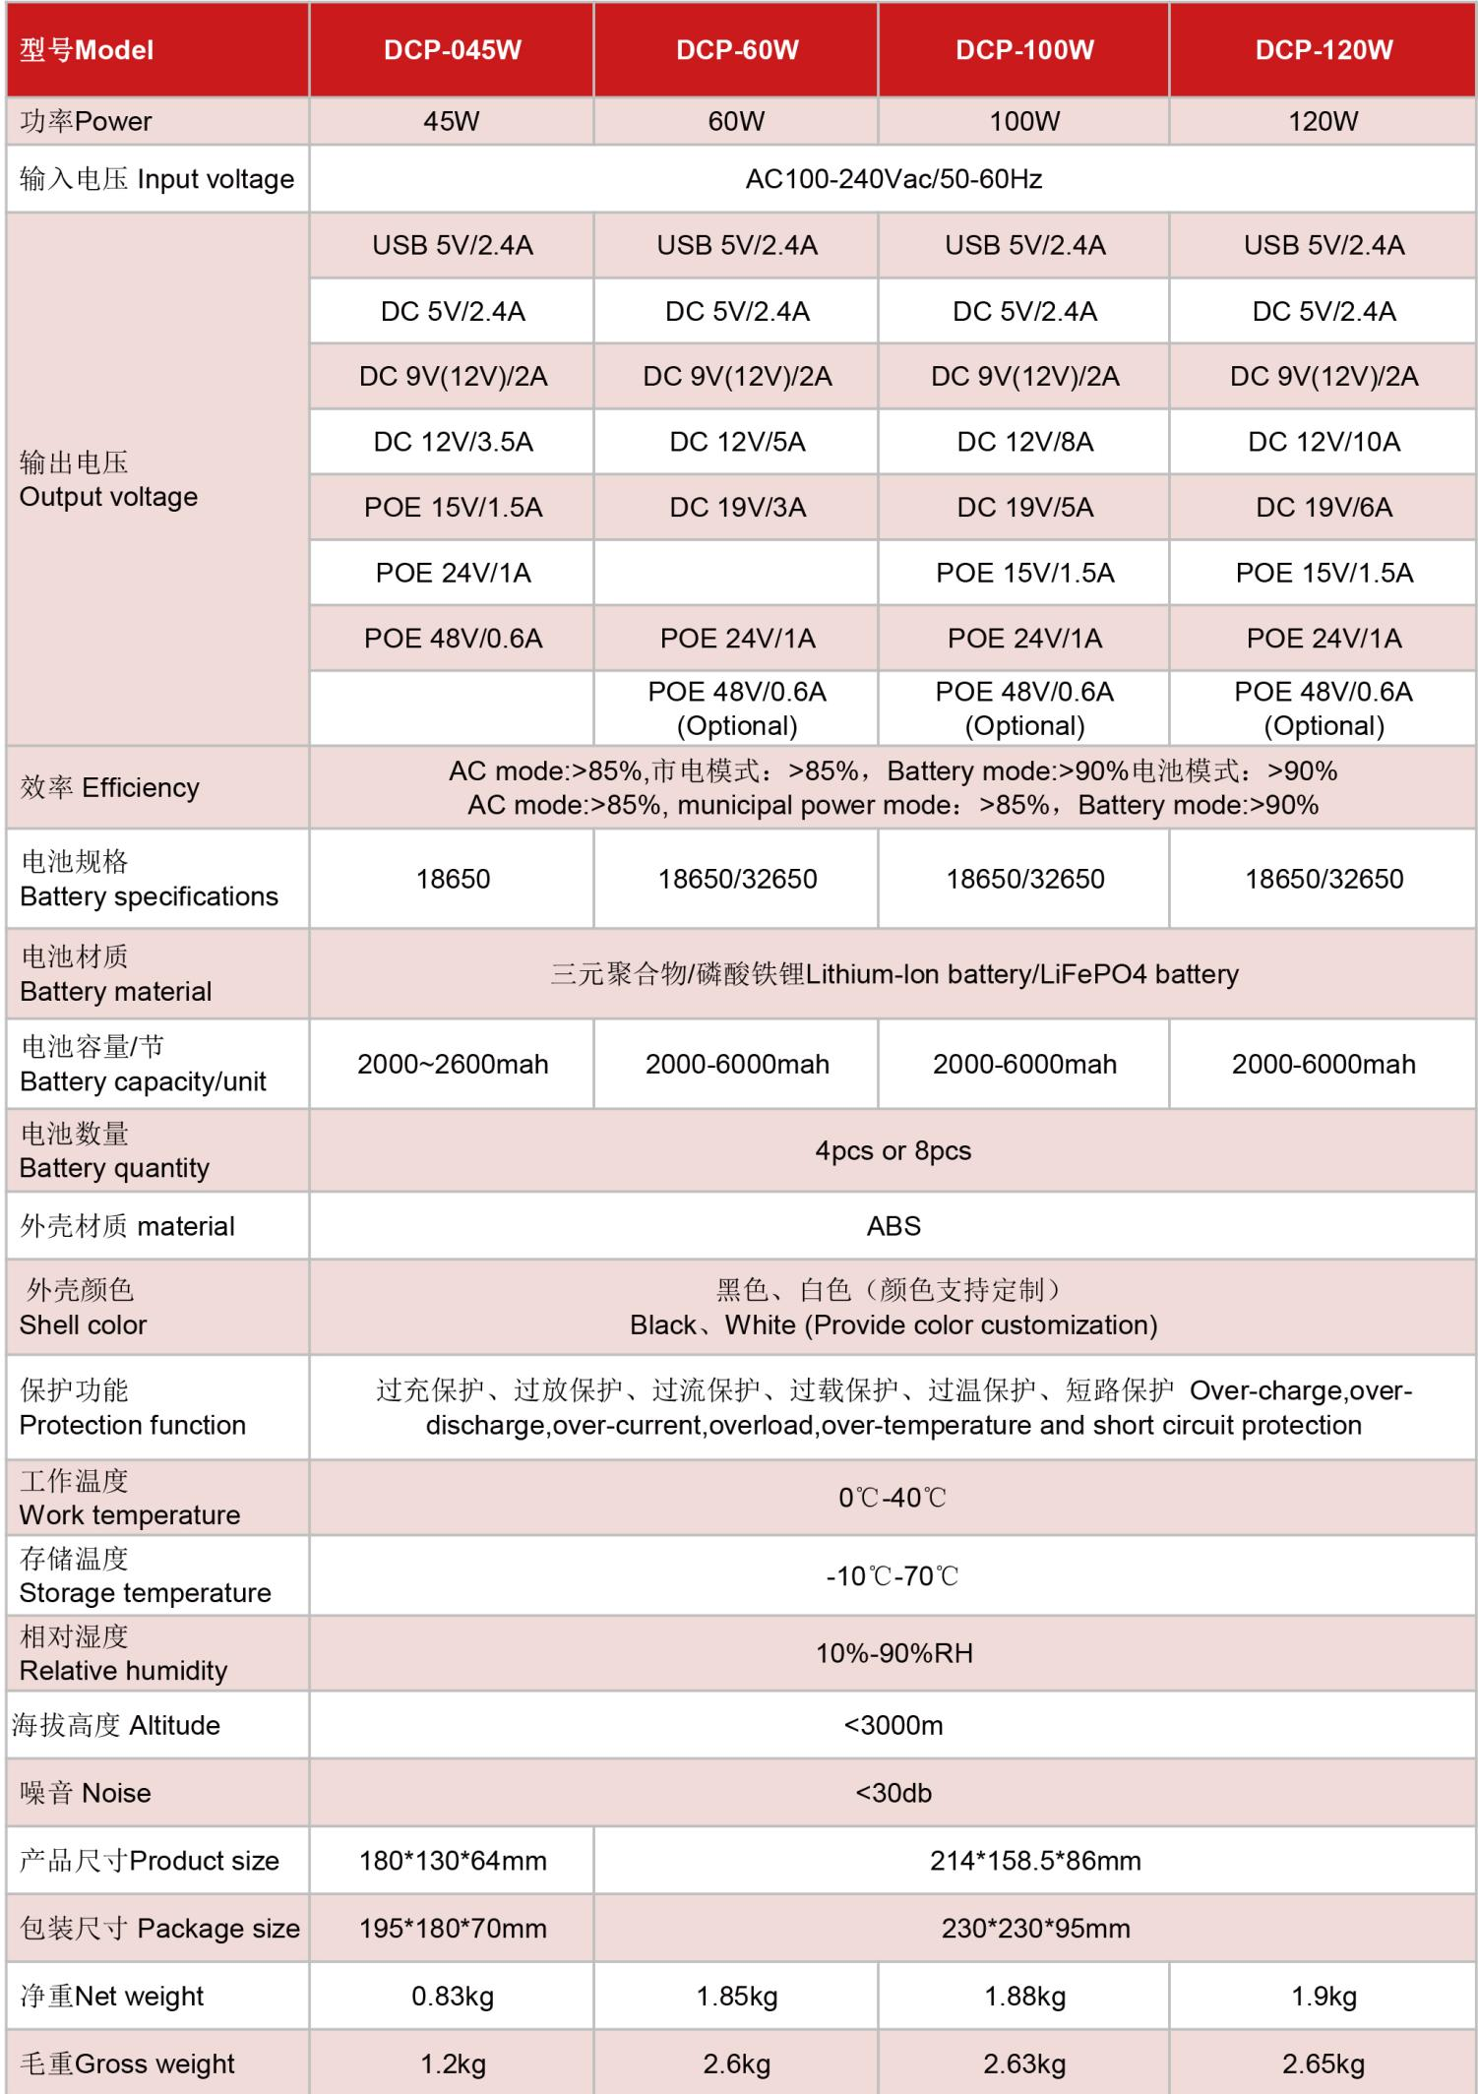
NX-UP-DC-002 · Primary | NX-UP-DC-002 · Gallery

PRODUCT OVERVIEW
Higher-power DC Mini UPS series with POE support for CCTV cameras, network equipment, and multi-voltage devices. Four model variants from 45W to 120W.
Product line | UPS Uninterruptible Power Supply
Series / family | Standalone model
Exact model | NX-UP-DC-002
Applications | CCTV systems, Routers and network terminals, POE-powered devices, Multi-voltage small equipment
MODEL IDENTIFICATION
Exact model | Product / variant | Topology | Power Range | Phase
NX-UP-DC-002 | DC Mini UPS 45W-120W Series | DC UPS with Li-ion battery & POE | 45W-120W | 100–240VAC, 50–60Hz input / DC / USB / PoE options output
TECHNICAL SPECIFICATIONS
Parameter | Specification
Topology | DC UPS with Li-ion battery & POE
Power Range | 45W-120W
Phase | 100–240VAC, 50–60Hz input / DC / USB / PoE options output
Form Factor | Compact DC Unit
Waveform | DC output
Power Factor | N/A (DC output)
Battery Types | Lithium-ion / LiFePO4
SKU | NX-UP-DC-002
Available Configurations | DCP-045W; DCP-60W; DCP-100W; DCP-120W
Exact Configuration | Confirm one listed configuration during RFQ review
Destination Requirements | To be confirmed
ENGINEERING TABLES
NX-UP-DC-002 · Complete Model Specifications — DCP-045W | DCP-60W | DCP-100W | DCP-120W
Parameter | DCP-045W | DCP-60W | DCP-100W | DCP-120W
Rated capacity | 45W | 60W | 100W | 120W
Battery configuration | 4 / 8 cells; 18650 | 4 / 8 cells; 18650 / 32650 | 4 / 8 cells; 18650 / 32650 | 4 / 8 cells; 18650 / 32650
Dimensions | 180×130×64mm | 214×158.5×86mm | 214×158.5×86mm | 214×158.5×86mm
Net weight | 0.83kg | 1.85kg | 1.88kg | 1.9kg
Transfer time | Not provided | Not provided | Not provided | Not provided
Efficiency | AC >85%; Battery >90% | AC >85%; Battery >90% | AC >85%; Battery >90% | AC >85%; Battery >90%
Model configuration — Rated capacity | 45W | 60W | 100W | 120W
Model configuration — Battery configuration | 4 / 8 cells; 18650 | 4 / 8 cells; 18650 / 32650 | 4 / 8 cells; 18650 / 32650 | 4 / 8 cells; 18650 / 32650
Model configuration — Product dimensions | 180×130×64mm | 214×158.5×86mm | 214×158.5×86mm | 214×158.5×86mm
Model configuration — Net weight | 0.83kg | 1.85kg | 1.88kg | 1.9kg
Model configuration — Efficiency | AC >85%; Battery >90% | AC >85%; Battery >90% | AC >85%; Battery >90% | AC >85%; Battery >90%
Input — Input voltage | 100–240VAC | 100–240VAC | 100–240VAC | 100–240VAC
Input — Input frequency | 50–60Hz | 50–60Hz | 50–60Hz | 50–60Hz
Battery — Battery chemistry | Lithium-ion / LiFePO4 | Lithium-ion / LiFePO4 | Lithium-ion / LiFePO4 | Lithium-ion / LiFePO4
Battery — Battery quantity | 4 / 8 | 4 / 8 | 4 / 8 | 4 / 8
Battery — Battery cell size | 18650 | 18650 / 32650 | 18650 / 32650 | 18650 / 32650
Battery — Cell capacity | 2000–2600mAh | 2000–6000mAh | 2000–6000mAh | 2000–6000mAh
Protection — Protection function | Over-charge, over-discharge, over-current, overload, over-temperature and short circuit | Over-charge, over-discharge, over-current, overload, over-temperature and short circuit | Over-charge, over-discharge, over-current, overload, over-temperature and short circuit | Over-charge, over-discharge, over-current, overload, over-temperature and short circuit
Environment — Operating temperature | 0–40°C | 0–40°C | 0–40°C | 0–40°C
Environment — Storage temperature | -10–70°C | -10–70°C | -10–70°C | -10–70°C
Environment — Relative humidity | 10–90% RH | 10–90% RH | 10–90% RH | 10–90% RH
Environment — Altitude | <3000m | <3000m | <3000m | <3000m
Environment — Noise level | <30dB | <30dB | <30dB | <30dB
Housing — Housing material | ABS | ABS | ABS | ABS
Housing — Housing color | Black / White | Black / White | Black / White | Black / White
Output — USB output | 5V/2.4A | 5V/2.4A | 5V/2.4A | 5V/2.4A
Output — DC 5V output | 5V/2.4A | 5V/2.4A | 5V/2.4A | 5V/2.4A
Output — DC 9V / 12V output | 9V(12V)/2A | 9V(12V)/2A | 9V(12V)/2A | 9V(12V)/2A
Output — DC 12V output | 12V/3.5A | 12V/5A | 12V/8A | 12V/10A
Output — PoE 15V output | 15V/1.5A | Not provided | 15V/1.5A | 15V/1.5A
Output — PoE 24V output | 24V/1A | 24V/1A | 24V/1A | 24V/1A
Output — PoE 48V output | 48V/0.6A | 48V/0.6A (optional) | 48V/0.6A (optional) | 48V/0.6A (optional)
Physical — Package dimensions | 195×180×70mm | 230×230×95mm | 230×230×95mm | 230×230×95mm
Physical — Gross weight | 1.2kg | 2.6kg | 2.63kg | 2.65kg
Output — DC 19V output | Not provided | 19V/3A | 19V/5A | 19V/6A

