
UPS UNINTERRUPTIBLE POWER SUPPLY

DC Mini UPS 18W-36W Series
  - Exact model: NX-UP-DC-001
PRODUCT IMAGES
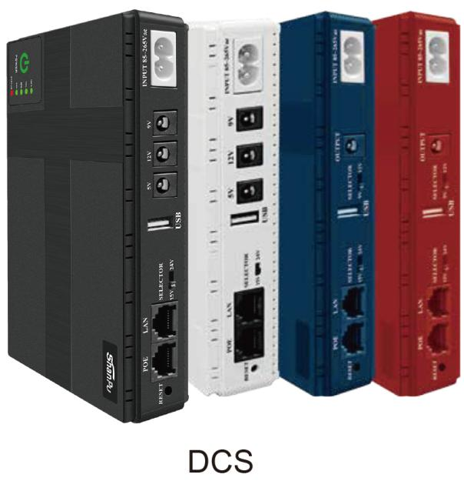 | 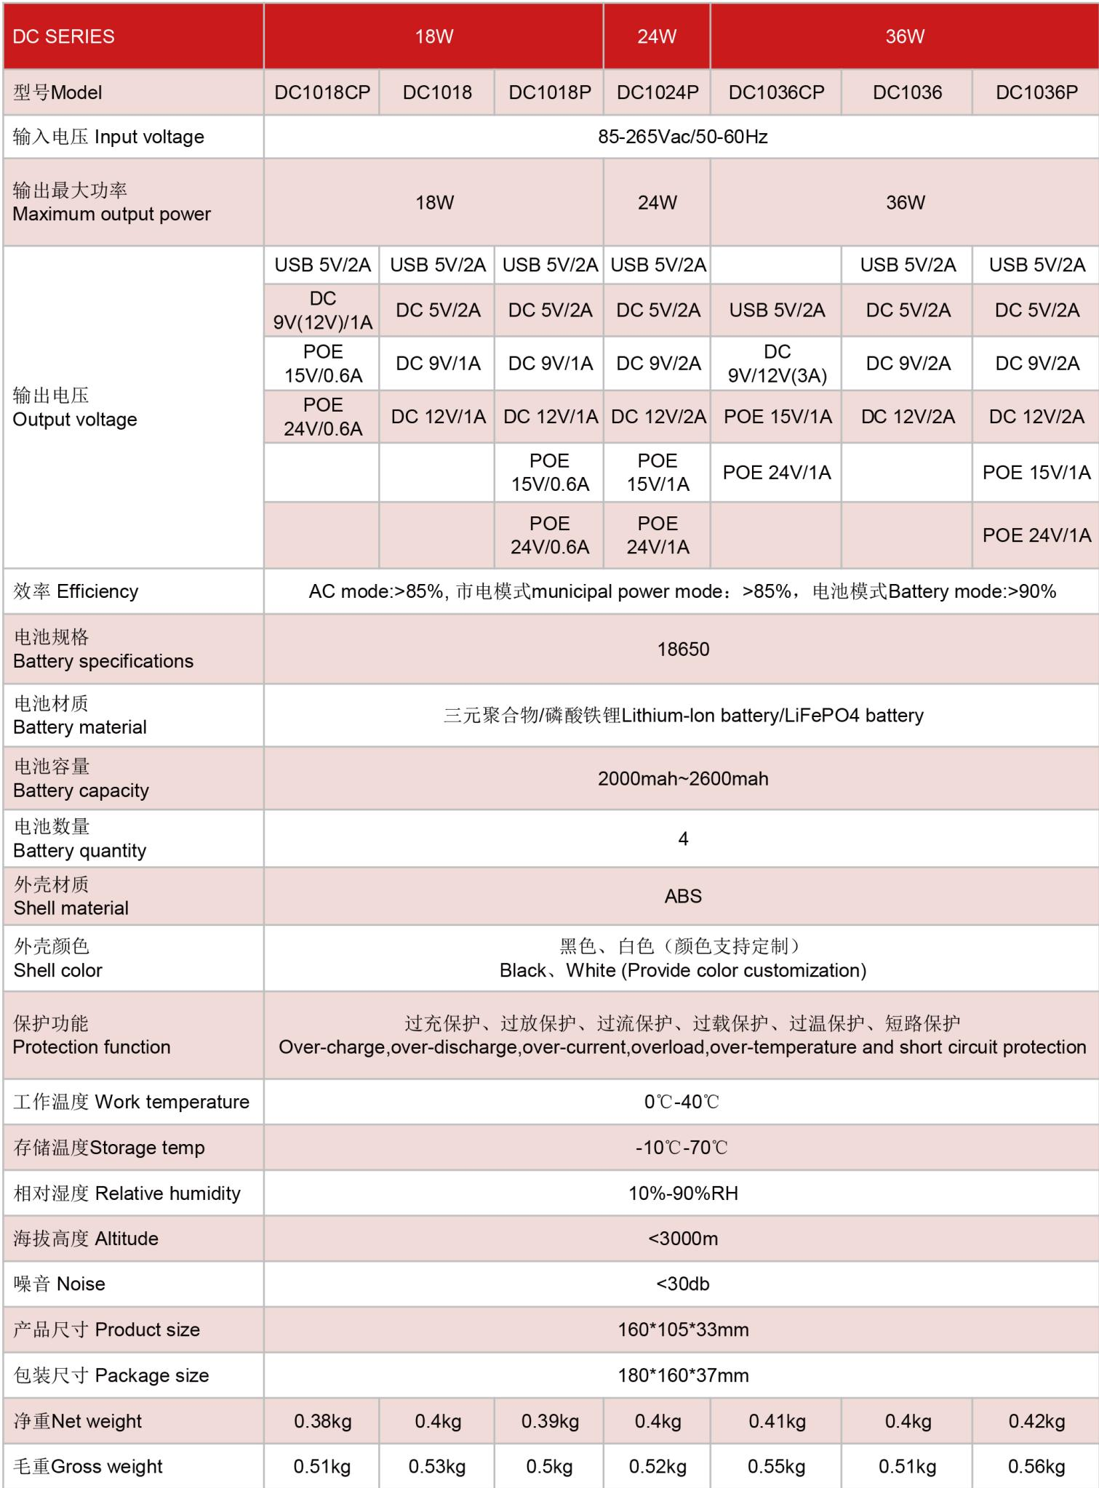
NX-UP-DC-001 · Primary | NX-UP-DC-001 · Gallery

PRODUCT OVERVIEW
Compact DC Mini UPS series with built-in lithium battery for routers, ONT devices, and small network equipment. Seven model variants from 18W to 36W.
Product line | UPS Uninterruptible Power Supply
Series / family | Standalone model
Exact model | NX-UP-DC-001
Applications | Routers and modems, Optical network terminals (ONT), CCTV cameras, Small network equipment, IoT devices
MODEL IDENTIFICATION
Exact model | Product / variant | Topology | Power Range | Phase
NX-UP-DC-001 | DC Mini UPS 18W-36W Series | DC UPS with Li-ion battery | 18W-36W | 85–265VAC, 50–60Hz input / DC / USB / PoE options output
TECHNICAL SPECIFICATIONS
Parameter | Specification
Topology | DC UPS with Li-ion battery
Power Range | 18W-36W
Phase | 85–265VAC, 50–60Hz input / DC / USB / PoE options output
Form Factor | Compact DC Unit
Waveform | DC output
Power Factor | N/A (DC output)
Battery Types | Lithium-ion / LiFePO4
SKU | NX-UP-DC-001
Available Configurations | DC1018CP; DC1018; DC1018P; DC1024P; DC1036CP; DC1036; DC1036P
Exact Configuration | Confirm one listed configuration during RFQ review
Destination Requirements | To be confirmed
ENGINEERING TABLES
NX-UP-DC-001 · Complete Model Specifications — DC1018CP | DC1018 | DC1018P | DC1024P
Parameter | DC1018CP | DC1018 | DC1018P | DC1024P
Rated capacity | 18W | 18W | 18W | 24W
Battery configuration | 4 × 18650; 2000–2600mAh/cell | 4 × 18650; 2000–2600mAh/cell | 4 × 18650; 2000–2600mAh/cell | 4 × 18650; 2000–2600mAh/cell
Dimensions | 160×105×33mm | 160×105×33mm | 160×105×33mm | 160×105×33mm
Net weight | 0.38kg | 0.4kg | 0.39kg | 0.4kg
Transfer time | Not provided | Not provided | Not provided | Not provided
Efficiency | AC >85%; Battery >90% | AC >85%; Battery >90% | AC >85%; Battery >90% | AC >85%; Battery >90%
Model configuration — Rated capacity | 18W | 18W | 18W | 24W
Model configuration — Battery configuration | 4 × 18650; 2000–2600mAh/cell | 4 × 18650; 2000–2600mAh/cell | 4 × 18650; 2000–2600mAh/cell | 4 × 18650; 2000–2600mAh/cell
Model configuration — Product dimensions | 160×105×33mm | 160×105×33mm | 160×105×33mm | 160×105×33mm
Model configuration — Net weight | 0.38kg | 0.4kg | 0.39kg | 0.4kg
Model configuration — Efficiency | AC >85%; Battery >90% | AC >85%; Battery >90% | AC >85%; Battery >90% | AC >85%; Battery >90%
Input — Input voltage | 85–265VAC | 85–265VAC | 85–265VAC | 85–265VAC
Input — Input frequency | 50–60Hz | 50–60Hz | 50–60Hz | 50–60Hz
Battery — Battery chemistry | Lithium-ion / LiFePO4 | Lithium-ion / LiFePO4 | Lithium-ion / LiFePO4 | Lithium-ion / LiFePO4
Battery — Battery cell size | 18650 | 18650 | 18650 | 18650
Battery — Cell capacity | 2000–2600mAh | 2000–2600mAh | 2000–2600mAh | 2000–2600mAh
Battery — Battery quantity | 4 | 4 | 4 | 4
Protection — Protection function | Over-charge, over-discharge, over-current, overload, over-temperature and short circuit | Over-charge, over-discharge, over-current, overload, over-temperature and short circuit | Over-charge, over-discharge, over-current, overload, over-temperature and short circuit | Over-charge, over-discharge, over-current, overload, over-temperature and short circuit
Environment — Operating temperature | 0–40°C | 0–40°C | 0–40°C | 0–40°C
Environment — Storage temperature | -10–70°C | -10–70°C | -10–70°C | -10–70°C
Environment — Relative humidity | 10–90% RH | 10–90% RH | 10–90% RH | 10–90% RH
Environment — Altitude | <3000m | <3000m | <3000m | <3000m
Environment — Noise level | <30dB | <30dB | <30dB | <30dB
Housing — Housing material | ABS | ABS | ABS | ABS
Housing — Housing color | Black / White | Black / White | Black / White | Black / White
Output — USB output | 5V/2A | 5V/2A | 5V/2A | 5V/2A
Output — DC output | 9V(12V)/1A | 5V/2A; 9V/1A; 12V/1A | 5V/2A; 9V/1A; 12V/1A | 5V/2A; 9V/2A; 12V/2A
Output — PoE output | 15V/0.6A; 24V/0.6A | Not provided | 15V/0.6A; 24V/0.6A | 15V/1A; 24V/1A
Physical — Package dimensions | 180×160×37mm | 180×160×37mm | 180×160×37mm | 180×160×37mm
Physical — Gross weight | 0.51kg | 0.53kg | 0.5kg | 0.52kg
NX-UP-DC-001 · Complete Model Specifications — DC1036CP | DC1036 | DC1036P
Parameter | DC1036CP | DC1036 | DC1036P
Rated capacity | 36W | 36W | 36W
Battery configuration | 4 × 18650; 2000–2600mAh/cell | 4 × 18650; 2000–2600mAh/cell | 4 × 18650; 2000–2600mAh/cell
Dimensions | 160×105×33mm | 160×105×33mm | 160×105×33mm
Net weight | 0.41kg | 0.4kg | 0.42kg
Transfer time | Not provided | Not provided | Not provided
Efficiency | AC >85%; Battery >90% | AC >85%; Battery >90% | AC >85%; Battery >90%
Model configuration — Rated capacity | 36W | 36W | 36W
Model configuration — Battery configuration | 4 × 18650; 2000–2600mAh/cell | 4 × 18650; 2000–2600mAh/cell | 4 × 18650; 2000–2600mAh/cell
Model configuration — Product dimensions | 160×105×33mm | 160×105×33mm | 160×105×33mm
Model configuration — Net weight | 0.41kg | 0.4kg | 0.42kg
Model configuration — Efficiency | AC >85%; Battery >90% | AC >85%; Battery >90% | AC >85%; Battery >90%
Input — Input voltage | 85–265VAC | 85–265VAC | 85–265VAC
Input — Input frequency | 50–60Hz | 50–60Hz | 50–60Hz
Battery — Battery chemistry | Lithium-ion / LiFePO4 | Lithium-ion / LiFePO4 | Lithium-ion / LiFePO4
Battery — Battery cell size | 18650 | 18650 | 18650
Battery — Cell capacity | 2000–2600mAh | 2000–2600mAh | 2000–2600mAh
Battery — Battery quantity | 4 | 4 | 4
Protection — Protection function | Over-charge, over-discharge, over-current, overload, over-temperature and short circuit | Over-charge, over-discharge, over-current, overload, over-temperature and short circuit | Over-charge, over-discharge, over-current, overload, over-temperature and short circuit
Environment — Operating temperature | 0–40°C | 0–40°C | 0–40°C
Environment — Storage temperature | -10–70°C | -10–70°C | -10–70°C
Environment — Relative humidity | 10–90% RH | 10–90% RH | 10–90% RH
Environment — Altitude | <3000m | <3000m | <3000m
Environment — Noise level | <30dB | <30dB | <30dB
Housing — Housing material | ABS | ABS | ABS
Housing — Housing color | Black / White | Black / White | Black / White
Output — USB output | 5V/2A | 5V/2A | 5V/2A
Output — DC output | 9V/12V (3A) | 5V/2A; 9V/2A; 12V/2A | 5V/2A; 9V/2A; 12V/2A
Output — PoE output | 15V/1A; 24V/1A | Not provided | 15V/1A; 24V/1A
Physical — Package dimensions | 180×160×37mm | 180×160×37mm | 180×160×37mm
Physical — Gross weight | 0.55kg | 0.51kg | 0.56kg

