
UPS UNINTERRUPTIBLE POWER SUPPLY

3-Phase Low Frequency UPS 10KVA-800KVA Series
  - Exact model: NX-UP-3P-002
PRODUCT IMAGES
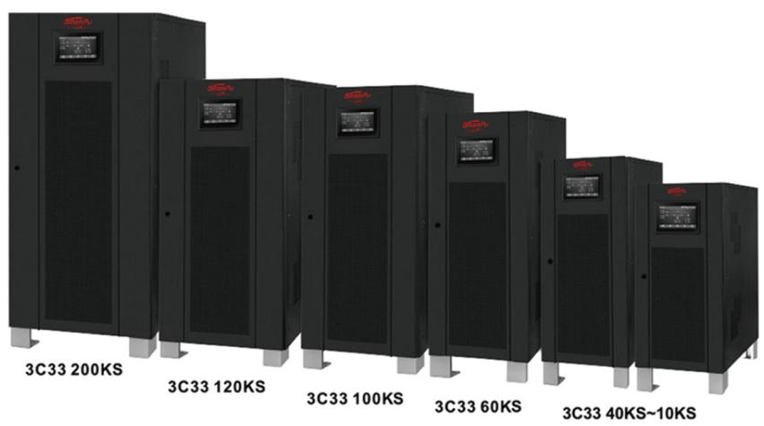 | 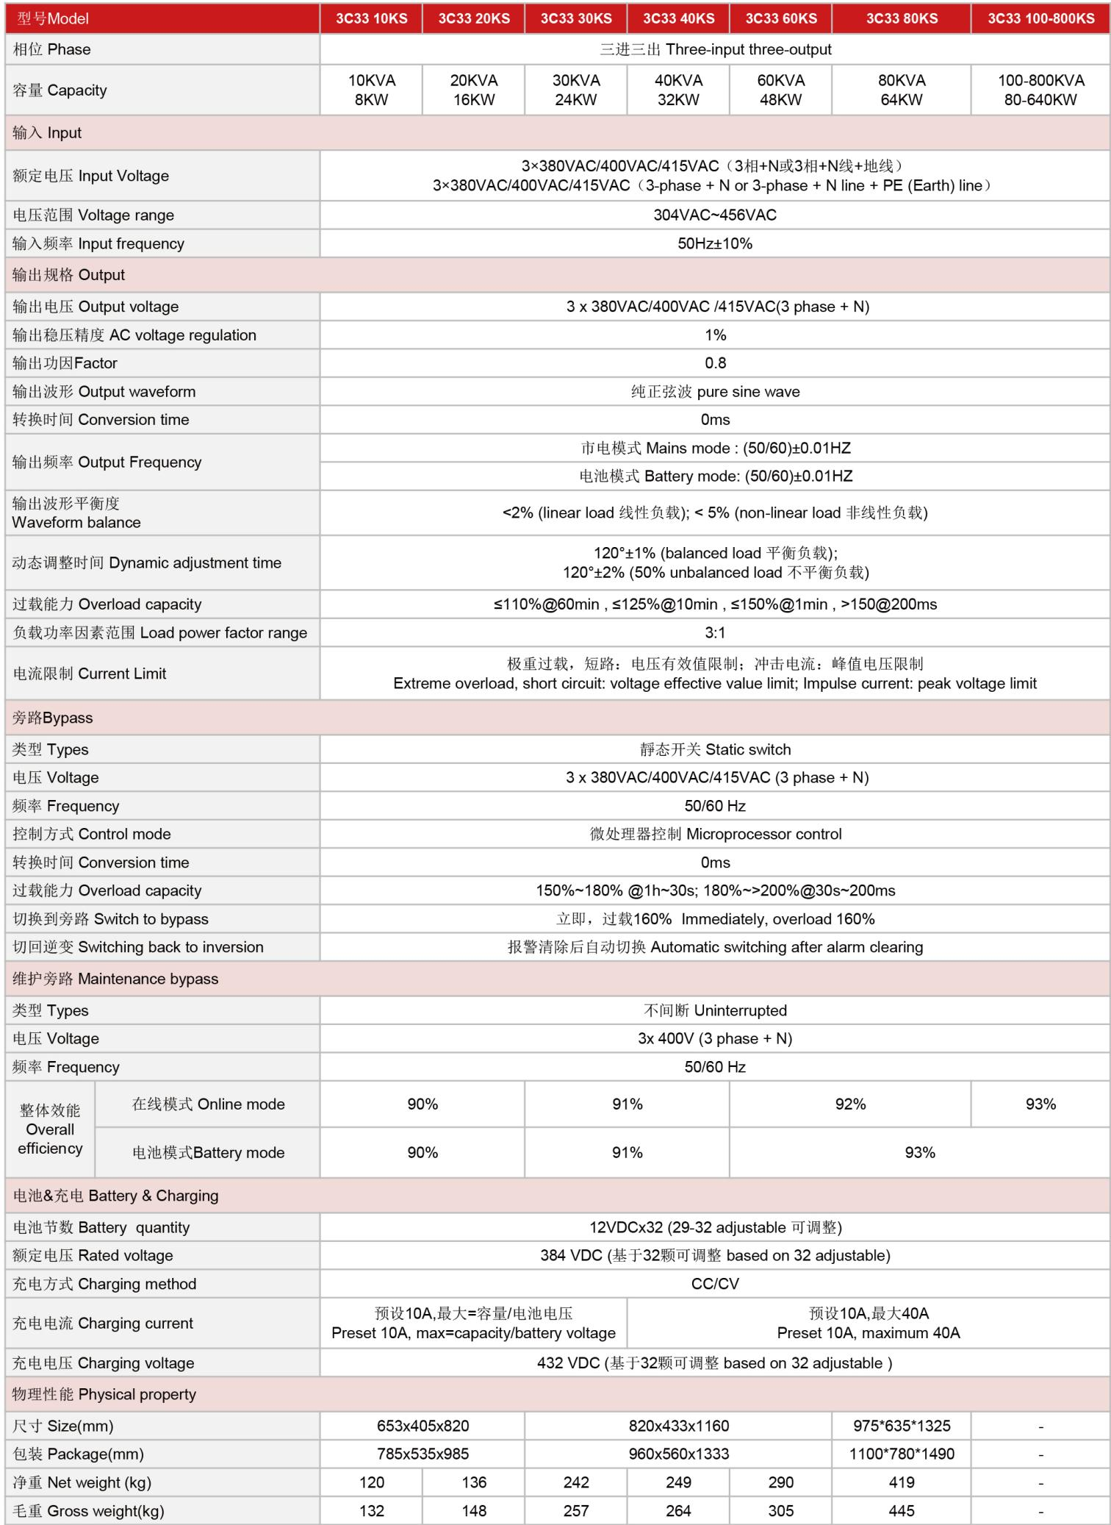
NX-UP-3P-002 · Primary | NX-UP-3P-002 · Gallery

PRODUCT OVERVIEW
Industrial-grade three-phase low frequency UPS with built-in output isolation transformer. Seven model variants from 10KVA to 800KVA for harsh environments and heavy industrial loads.
Product line | UPS Uninterruptible Power Supply
Series / family | Standalone model
Exact model | NX-UP-3P-002
Applications | Heavy industrial facilities, Large data centers, Manufacturing plants, Power grid substations, Oil and gas installations, Transportation hubs
MODEL IDENTIFICATION
Exact model | Product / variant | Topology | Power Range | Phase
NX-UP-3P-002 | 3-Phase Low Frequency UPS 10KVA-800KVA Series | Online Double Conversion with Isolation Transformer | 10KVA-800KVA / 8KW-640KW | 3-phase + N input / 3-phase + N output
TECHNICAL SPECIFICATIONS
Parameter | Specification
Topology | Online Double Conversion with Isolation Transformer
Power Range | 10KVA-800KVA / 8KW-640KW
Phase | 3-phase + N input / 3-phase + N output
Form Factor | Floor-standing
Waveform | Pure sine wave
Power Factor | 0.8
Battery Types | External VRLA battery bank (32×12VDC)
SKU | NX-UP-3P-002
Available Configurations | 3C33 10KS; 3C33 20KS; 3C33 30KS; 3C33 40KS; 3C33 60KS; 3C33 80KS; 3C33 100-800KS
Exact Configuration | Confirm one listed configuration during RFQ review
Destination Requirements | To be confirmed
ENGINEERING TABLES
NX-UP-3P-002 · Complete Model Specifications — 3C33 10KS | 3C33 20KS | 3C33 30KS | 3C33 40KS
Parameter | 3C33 10KS | 3C33 20KS | 3C33 30KS | 3C33 40KS
Rated capacity | 10KVA / 8KW | 20KVA / 16KW | 30KVA / 24KW | 40KVA / 32KW
Battery configuration | External 32×12VDC (384VDC) | External 32×12VDC (384VDC) | External 32×12VDC (384VDC) | External 32×12VDC (384VDC)
Dimensions | 653×405×820mm | 653×405×820mm | 820×433×1160mm | 820×433×1160mm
Net weight | 120kg | 136kg | 242kg | 249kg
Transfer time | 0ms | 0ms | 0ms | 0ms
Efficiency | AC: 90% / Battery: 90% | AC: 90% / Battery: 90% | AC: 91% / Battery: 91% | AC: 91% / Battery: 91%
Model configuration — Rated capacity | 10KVA / 8KW | 20KVA / 16KW | 30KVA / 24KW | 40KVA / 32KW
Model configuration — Battery configuration | External 32×12VDC (384VDC) | External 32×12VDC (384VDC) | External 32×12VDC (384VDC) | External 32×12VDC (384VDC)
Model configuration — Product dimensions | 653×405×820mm | 653×405×820mm | 820×433×1160mm | 820×433×1160mm
Model configuration — Net weight | 120kg | 136kg | 242kg | 249kg
Model configuration — Transfer time | 0ms | 0ms | 0ms | 0ms
Model configuration — Efficiency | AC: 90% / Battery: 90% | AC: 90% / Battery: 90% | AC: 91% / Battery: 91% | AC: 91% / Battery: 91%
Input — Input voltage | 3×380/400/415VAC (3ph+N) | 3×380/400/415VAC (3ph+N) | 3×380/400/415VAC (3ph+N) | 3×380/400/415VAC (3ph+N)
Input — Input voltage range | 304–456VAC | 304–456VAC | 304–456VAC | 304–456VAC
Input — Input frequency | 50Hz ±10% | 50Hz ±10% | 50Hz ±10% | 50Hz ±10%
Output — Output voltage | 3×380/400/415VAC (3ph+N) | 3×380/400/415VAC (3ph+N) | 3×380/400/415VAC (3ph+N) | 3×380/400/415VAC (3ph+N)
Output — Voltage regulation | 1% | 1% | 1% | 1%
Output — Output power factor | 0.8 | 0.8 | 0.8 | 0.8
Output — AC-mode frequency | 50/60Hz ±0.01Hz | 50/60Hz ±0.01Hz | 50/60Hz ±0.01Hz | 50/60Hz ±0.01Hz
Output — Battery-mode frequency | 50/60Hz ±0.01Hz | 50/60Hz ±0.01Hz | 50/60Hz ±0.01Hz | 50/60Hz ±0.01Hz
Output — THD (linear load) | <2% | <2% | <2% | <2%
Output — THD (non-linear load) | <5% | <5% | <5% | <5%
Output — Overload capacity | ≤110%: 60min; ≤125%: 10min; ≤150%: 1min; >150%: 200ms | ≤110%: 60min; ≤125%: 10min; ≤150%: 1min; >150%: 200ms | ≤110%: 60min; ≤125%: 10min; ≤150%: 1min; >150%: 200ms | ≤110%: 60min; ≤125%: 10min; ≤150%: 1min; >150%: 200ms
Bypass — Bypass type | Static switch | Static switch | Static switch | Static switch
Bypass — Bypass voltage | 3×380/400/415VAC (3ph+N) | 3×380/400/415VAC (3ph+N) | 3×380/400/415VAC (3ph+N) | 3×380/400/415VAC (3ph+N)
Bypass — Bypass frequency | 50/60Hz | 50/60Hz | 50/60Hz | 50/60Hz
Bypass — Control mode | Microprocessor control | Microprocessor control | Microprocessor control | Microprocessor control
Bypass — Transfer time | 0ms | 0ms | 0ms | 0ms
Bypass — Switch to bypass | Immediate at 160% overload | Immediate at 160% overload | Immediate at 160% overload | Immediate at 160% overload
Bypass — Return from bypass | Automatic after alarm clearing | Automatic after alarm clearing | Automatic after alarm clearing | Automatic after alarm clearing
Bypass — Maintenance bypass | Uninterrupted; 3×400V (3ph+N); 50/60Hz | Uninterrupted; 3×400V (3ph+N); 50/60Hz | Uninterrupted; 3×400V (3ph+N); 50/60Hz | Uninterrupted; 3×400V (3ph+N); 50/60Hz
Charging — Battery quantity | 32 × 12VDC; 29–32 adjustable | 32 × 12VDC; 29–32 adjustable | 32 × 12VDC; 29–32 adjustable | 32 × 12VDC; 29–32 adjustable
Charging — Rated battery voltage | 384VDC | 384VDC | 384VDC | 384VDC
Charging — Charging method | CC/CV | CC/CV | CC/CV | CC/CV
Charging — Charging voltage | 432VDC; based on 32 batteries | 432VDC; based on 32 batteries | 432VDC; based on 32 batteries | 432VDC; based on 32 batteries
NX-UP-3P-002 · Complete Model Specifications — 3C33 60KS | 3C33 80KS | 3C33 100-800KS
Parameter | 3C33 60KS | 3C33 80KS | 3C33 100-800KS
Rated capacity | 60KVA / 48KW | 80KVA / 64KW | 100KVA-800KVA / 80KW-640KW
Battery configuration | External 32×12VDC (384VDC) | External 32×12VDC (384VDC) | External 32×12VDC (384VDC)
Dimensions | 820×433×1160mm | 975×635×1325mm | Not provided
Net weight | 290kg | 419kg | Not provided
Transfer time | 0ms | 0ms | 0ms
Efficiency | AC: 92% / Battery: 93% | AC: 92% / Battery: 93% | AC: 93% / Battery: 93%
Model configuration — Rated capacity | 60KVA / 48KW | 80KVA / 64KW | 100KVA-800KVA / 80KW-640KW
Model configuration — Battery configuration | External 32×12VDC (384VDC) | External 32×12VDC (384VDC) | External 32×12VDC (384VDC)
Model configuration — Product dimensions | 820×433×1160mm | 975×635×1325mm | Not provided
Model configuration — Net weight | 290kg | 419kg | Not provided
Model configuration — Transfer time | 0ms | 0ms | 0ms
Model configuration — Efficiency | AC: 92% / Battery: 93% | AC: 92% / Battery: 93% | AC: 93% / Battery: 93%
Input — Input voltage | 3×380/400/415VAC (3ph+N) | 3×380/400/415VAC (3ph+N) | 3×380/400/415VAC (3ph+N)
Input — Input voltage range | 304–456VAC | 304–456VAC | 304–456VAC
Input — Input frequency | 50Hz ±10% | 50Hz ±10% | 50Hz ±10%
Output — Output voltage | 3×380/400/415VAC (3ph+N) | 3×380/400/415VAC (3ph+N) | 3×380/400/415VAC (3ph+N)
Output — Voltage regulation | 1% | 1% | 1%
Output — Output power factor | 0.8 | 0.8 | 0.8
Output — AC-mode frequency | 50/60Hz ±0.01Hz | 50/60Hz ±0.01Hz | 50/60Hz ±0.01Hz
Output — Battery-mode frequency | 50/60Hz ±0.01Hz | 50/60Hz ±0.01Hz | 50/60Hz ±0.01Hz
Output — THD (linear load) | <2% | <2% | <2%
Output — THD (non-linear load) | <5% | <5% | <5%
Output — Overload capacity | ≤110%: 60min; ≤125%: 10min; ≤150%: 1min; >150%: 200ms | ≤110%: 60min; ≤125%: 10min; ≤150%: 1min; >150%: 200ms | ≤110%: 60min; ≤125%: 10min; ≤150%: 1min; >150%: 200ms
Bypass — Bypass type | Static switch | Static switch | Static switch
Bypass — Bypass voltage | 3×380/400/415VAC (3ph+N) | 3×380/400/415VAC (3ph+N) | 3×380/400/415VAC (3ph+N)
Bypass — Bypass frequency | 50/60Hz | 50/60Hz | 50/60Hz
Bypass — Control mode | Microprocessor control | Microprocessor control | Microprocessor control
Bypass — Transfer time | 0ms | 0ms | 0ms
Bypass — Switch to bypass | Immediate at 160% overload | Immediate at 160% overload | Immediate at 160% overload
Bypass — Return from bypass | Automatic after alarm clearing | Automatic after alarm clearing | Automatic after alarm clearing
Bypass — Maintenance bypass | Uninterrupted; 3×400V (3ph+N); 50/60Hz | Uninterrupted; 3×400V (3ph+N); 50/60Hz | Uninterrupted; 3×400V (3ph+N); 50/60Hz
Charging — Battery quantity | 32 × 12VDC; 29–32 adjustable | 32 × 12VDC; 29–32 adjustable | 32 × 12VDC; 29–32 adjustable
Charging — Rated battery voltage | 384VDC | 384VDC | 384VDC
Charging — Charging method | CC/CV | CC/CV | CC/CV
Charging — Charging voltage | 432VDC; based on 32 batteries | 432VDC; based on 32 batteries | 432VDC; based on 32 batteries

