
UPS UNINTERRUPTIBLE POWER SUPPLY

3-Phase High Frequency UPS 10KVA-200KVA Series
  - Exact model: NX-UP-3P-001
PRODUCT IMAGES
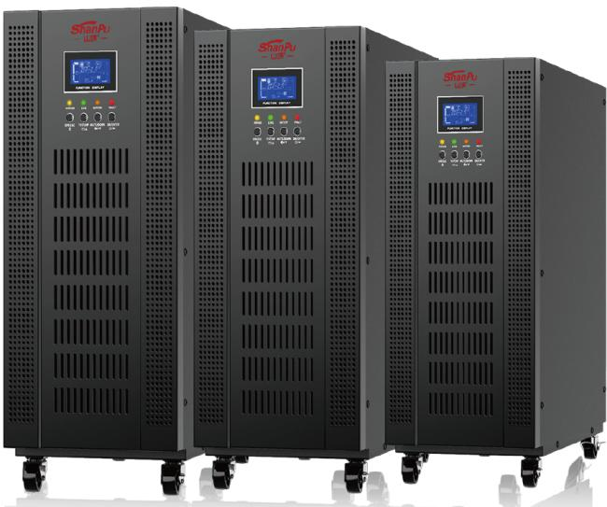 | 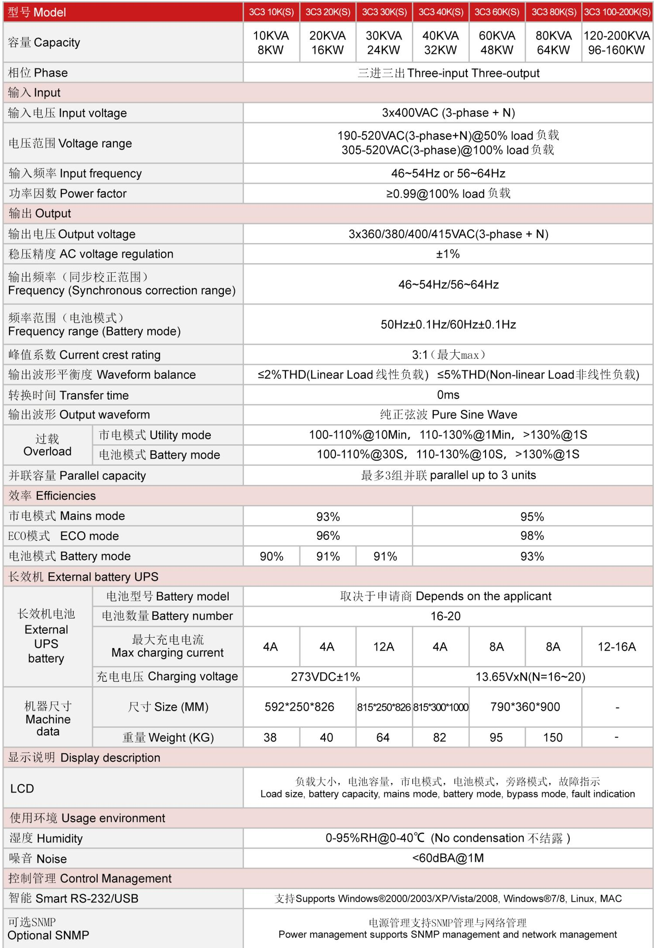
NX-UP-3P-001 · Primary | NX-UP-3P-001 · Gallery

PRODUCT OVERVIEW
Three-phase high frequency online UPS with DSP control and N+X parallel redundancy. Seven model variants covering 10KVA to 200KVA for data centers and commercial facilities.
Product line | UPS Uninterruptible Power Supply
Series / family | Standalone model
Exact model | NX-UP-3P-001
Applications | Data centers, Large server rooms, Financial institutions, Telecommunications hubs, Transportation systems, Power industry
MODEL IDENTIFICATION
Exact model | Product / variant | Topology | Power Range | Phase
NX-UP-3P-001 | 3-Phase High Frequency UPS 10KVA-200KVA Series | Online Double Conversion with DSP | 10KVA-200KVA / 8KW-160KW | 3-phase + N input / 3-phase + N output
TECHNICAL SPECIFICATIONS
Parameter | Specification
Topology | Online Double Conversion with DSP
Power Range | 10KVA-200KVA / 8KW-160KW
Phase | 3-phase + N input / 3-phase + N output
Form Factor | Tower; Floor-standing
Waveform | Pure sine wave
Power Factor | 0.8
Battery Types | External VRLA battery bank
SKU | NX-UP-3P-001
Available Configurations | 3C3 10K(S); 3C3 20K(S); 3C3 30K(S); 3C3 40K(S); 3C3 60K(S); 3C3 80K(S); 3C3 100-200K(S)
Exact Configuration | Confirm one listed configuration during RFQ review
Destination Requirements | To be confirmed
ENGINEERING TABLES
NX-UP-3P-001 · Complete Model Specifications — 3C3 10K(S) | 3C3 20K(S) | 3C3 30K(S) | 3C3 40K(S)
Parameter | 3C3 10K(S) | 3C3 20K(S) | 3C3 30K(S) | 3C3 40K(S)
Rated capacity | 10KVA / 8KW | 20KVA / 16KW | 30KVA / 24KW | 40KVA / 32KW
Battery configuration | External battery bank | External battery bank | External battery bank | External battery bank
Dimensions | 592×250×826mm | 592×250×826mm | 815×250×826mm | 815×300×1000mm
Net weight | 38kg | 40kg | 64kg | 82kg
Transfer time | 0ms | 0ms | 0ms | 0ms
Efficiency | AC: 93% / ECO: 96% / Battery: 90% | AC: 93% / ECO: 96% / Battery: 91% | AC: 93% / ECO: 96% / Battery: 91% | AC: 95% / ECO: 98% / Battery: 93%
Model configuration — Rated capacity | 10KVA / 8KW | 20KVA / 16KW | 30KVA / 24KW | 40KVA / 32KW
Model configuration — Battery configuration | External battery bank | External battery bank | External battery bank | External battery bank
Model configuration — Product dimensions | 592×250×826mm | 592×250×826mm | 815×250×826mm | 815×300×1000mm
Model configuration — Net weight | 38kg | 40kg | 64kg | 82kg
Model configuration — Transfer time | 0ms | 0ms | 0ms | 0ms
Model configuration — Efficiency | AC: 93% / ECO: 96% / Battery: 90% | AC: 93% / ECO: 96% / Battery: 91% | AC: 93% / ECO: 96% / Battery: 91% | AC: 95% / ECO: 98% / Battery: 93%
Input — Input voltage | 3×400VAC (3ph+N) | 3×400VAC (3ph+N) | 3×400VAC (3ph+N) | 3×400VAC (3ph+N)
Input — Input voltage range at 50% load | 190–520VAC | 190–520VAC | 190–520VAC | 190–520VAC
Input — Input voltage range at 100% load | 305–520VAC | 305–520VAC | 305–520VAC | 305–520VAC
Input — Input frequency | 46–54Hz / 56–64Hz | 46–54Hz / 56–64Hz | 46–54Hz / 56–64Hz | 46–54Hz / 56–64Hz
Input — Input power factor | ≥0.99 @100% load | ≥0.99 @100% load | ≥0.99 @100% load | ≥0.99 @100% load
Output — Output voltage | 3×360/380/400/415VAC (3ph+N) | 3×360/380/400/415VAC (3ph+N) | 3×360/380/400/415VAC (3ph+N) | 3×360/380/400/415VAC (3ph+N)
Output — Voltage regulation | ±1% | ±1% | ±1% | ±1%
Output — Synchronized frequency | 46–54Hz / 56–64Hz | 46–54Hz / 56–64Hz | 46–54Hz / 56–64Hz | 46–54Hz / 56–64Hz
Output — Battery-mode frequency | 50/60Hz ±0.1Hz | 50/60Hz ±0.1Hz | 50/60Hz ±0.1Hz | 50/60Hz ±0.1Hz
Output — Current crest ratio | 3:1 | 3:1 | 3:1 | 3:1
Output — THD (linear load) | ≤2% | ≤2% | ≤2% | ≤2%
Output — THD (non-linear load) | ≤5% | ≤5% | ≤5% | ≤5%
Output — Parallel capacity | Up to 3 units | Up to 3 units | Up to 3 units | Up to 3 units
Overload — AC-mode overload | 100–110%: 10min; 110–130%: 1min; >130%: 1s | 100–110%: 10min; 110–130%: 1min; >130%: 1s | 100–110%: 10min; 110–130%: 1min; >130%: 1s | 100–110%: 10min; 110–130%: 1min; >130%: 1s
Overload — Battery-mode overload | 100–110%: 30s; 110–130%: 10s; >130%: 1s | 100–110%: 30s; 110–130%: 10s; >130%: 1s | 100–110%: 30s; 110–130%: 10s; >130%: 1s | 100–110%: 30s; 110–130%: 10s; >130%: 1s
External battery configuration — Battery quantity | 16–20 | 16–20 | 16–20 | 16–20
Communication & Monitoring — Communication interface | RS232 / USB | RS232 / USB | RS232 / USB | RS232 / USB
Communication & Monitoring — SNMP | Optional | Optional | Optional | Optional
Communication & Monitoring — Display | LCD | LCD | LCD | LCD
Environment — Operating temperature | 0–40°C | 0–40°C | 0–40°C | 0–40°C
Environment — Relative humidity | 0–95% RH (non-condensing) | 0–95% RH (non-condensing) | 0–95% RH (non-condensing) | 0–95% RH (non-condensing)
Environment — Noise level | <60dBA @1m | <60dBA @1m | <60dBA @1m | <60dBA @1m
NX-UP-3P-001 · Complete Model Specifications — 3C3 60K(S) | 3C3 80K(S) | 3C3 100-200K(S)
Parameter | 3C3 60K(S) | 3C3 80K(S) | 3C3 100-200K(S)
Rated capacity | 60KVA / 48KW | 80KVA / 64KW | 100KVA-200KVA / 80KW-160KW
Battery configuration | External battery bank | External battery bank | External battery bank
Dimensions | 790×360×900mm | 790×360×900mm | Not provided
Net weight | 95kg | 150kg | Not provided
Transfer time | 0ms | 0ms | 0ms
Efficiency | AC: 95% / ECO: 98% / Battery: 93% | AC: 95% / ECO: 98% / Battery: 93% | AC: 95% / ECO: 98% / Battery: 93%
Model configuration — Rated capacity | 60KVA / 48KW | 80KVA / 64KW | 100KVA-200KVA / 80KW-160KW
Model configuration — Battery configuration | External battery bank | External battery bank | External battery bank
Model configuration — Product dimensions | 790×360×900mm | 790×360×900mm | Not provided
Model configuration — Net weight | 95kg | 150kg | Not provided
Model configuration — Transfer time | 0ms | 0ms | 0ms
Model configuration — Efficiency | AC: 95% / ECO: 98% / Battery: 93% | AC: 95% / ECO: 98% / Battery: 93% | AC: 95% / ECO: 98% / Battery: 93%
Input — Input voltage | 3×400VAC (3ph+N) | 3×400VAC (3ph+N) | 3×400VAC (3ph+N)
Input — Input voltage range at 50% load | 190–520VAC | 190–520VAC | 190–520VAC
Input — Input voltage range at 100% load | 305–520VAC | 305–520VAC | 305–520VAC
Input — Input frequency | 46–54Hz / 56–64Hz | 46–54Hz / 56–64Hz | 46–54Hz / 56–64Hz
Input — Input power factor | ≥0.99 @100% load | ≥0.99 @100% load | ≥0.99 @100% load
Output — Output voltage | 3×360/380/400/415VAC (3ph+N) | 3×360/380/400/415VAC (3ph+N) | 3×360/380/400/415VAC (3ph+N)
Output — Voltage regulation | ±1% | ±1% | ±1%
Output — Synchronized frequency | 46–54Hz / 56–64Hz | 46–54Hz / 56–64Hz | 46–54Hz / 56–64Hz
Output — Battery-mode frequency | 50/60Hz ±0.1Hz | 50/60Hz ±0.1Hz | 50/60Hz ±0.1Hz
Output — Current crest ratio | 3:1 | 3:1 | 3:1
Output — THD (linear load) | ≤2% | ≤2% | ≤2%
Output — THD (non-linear load) | ≤5% | ≤5% | ≤5%
Output — Parallel capacity | Up to 3 units | Up to 3 units | Up to 3 units
Overload — AC-mode overload | 100–110%: 10min; 110–130%: 1min; >130%: 1s | 100–110%: 10min; 110–130%: 1min; >130%: 1s | 100–110%: 10min; 110–130%: 1min; >130%: 1s
Overload — Battery-mode overload | 100–110%: 30s; 110–130%: 10s; >130%: 1s | 100–110%: 30s; 110–130%: 10s; >130%: 1s | 100–110%: 30s; 110–130%: 10s; >130%: 1s
External battery configuration — Battery quantity | 16–20 | 16–20 | 16–20
Communication & Monitoring — Communication interface | RS232 / USB | RS232 / USB | RS232 / USB
Communication & Monitoring — SNMP | Optional | Optional | Optional
Communication & Monitoring — Display | LCD | LCD | LCD
Environment — Operating temperature | 0–40°C | 0–40°C | 0–40°C
Environment — Relative humidity | 0–95% RH (non-condensing) | 0–95% RH (non-condensing) | 0–95% RH (non-condensing)
Environment — Noise level | <60dBA @1m | <60dBA @1m | <60dBA @1m

