
UPS UNINTERRUPTIBLE POWER SUPPLY

DCF Series Mini DC UPS
  - Exact model: DCF-SERIES-MINI-UPS
PRODUCT IMAGES
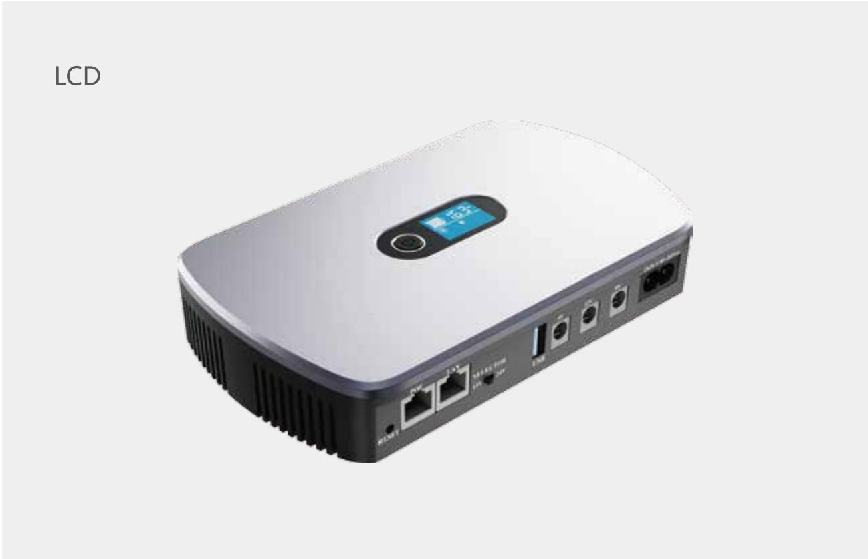 | 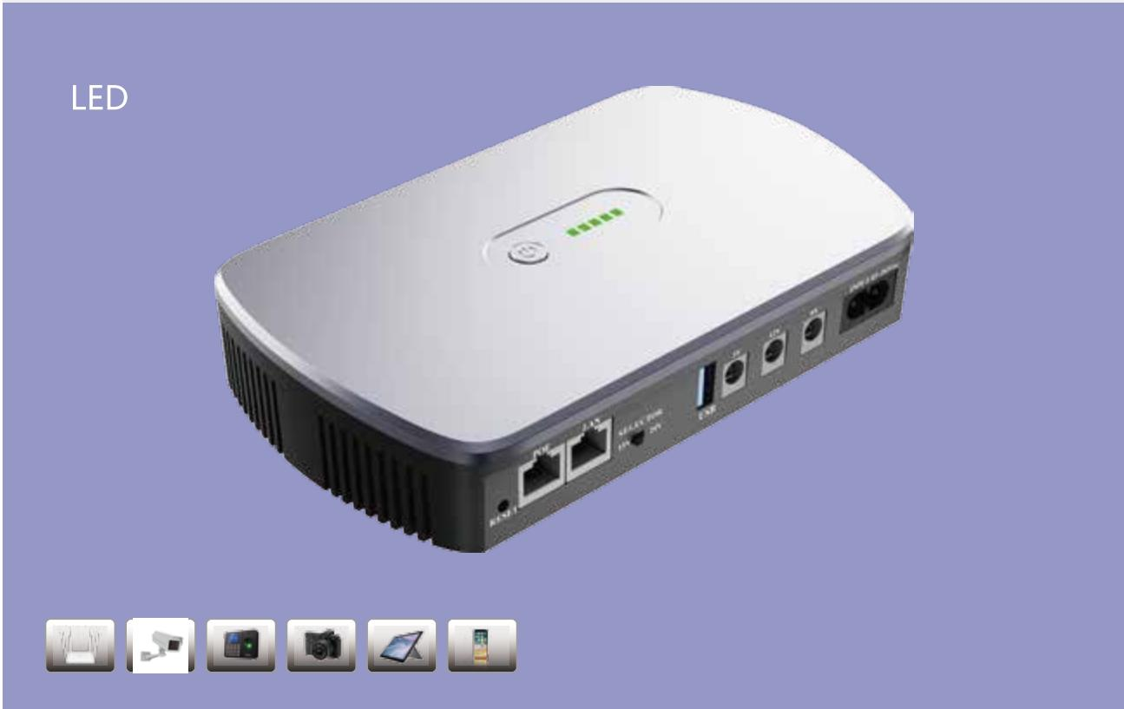
DCF-SERIES-MINI-UPS · Primary | DCF-SERIES-MINI-UPS · Gallery

PRODUCT OVERVIEW
DCF Series Mini DC UPS with 8 source-reviewed models for Network edge devices, CCTV cameras and communications equipment. Model configuration and destination-market requirements are confirmed during RFQ review.
Product line | UPS Uninterruptible Power Supply
Series / family | Standalone model
Exact model | DCF-SERIES-MINI-UPS
Applications | Network edge devices, CCTV cameras and communications equipment
MODEL IDENTIFICATION
Exact model | Product / variant | Topology | Power Range | Phase
DCF-SERIES-MINI-UPS | DCF Series Mini DC UPS | Display-equipped DC backup UPS | 18W–36W | 85–265VAC, 50–60Hz input / DC / USB / PoE options output
TECHNICAL SPECIFICATIONS
Parameter | Specification
Topology | Display-equipped DC backup UPS
Power Range | 18W–36W
Phase | 85–265VAC, 50–60Hz input / DC / USB / PoE options output
Form Factor | Compact desktop
Waveform | Regulated DC
Power Factor | Model-specific; confirm on quotation
Battery Types | Lithium-ion / LiFePO4
SKU | DCF-SERIES-MINI-UPS
Available Configurations | DCF-1018C; DCF-1018CP; DCF-1018; DCF-1018P; DCF-1036C; DCF-1036CP; DCF-1036; DCF-1036P
Exact Configuration | Confirm one listed configuration during RFQ review
Destination Requirements | To be confirmed
ENGINEERING TABLES
DCF-SERIES-MINI-UPS · Complete Model Specifications — DCF-1018C | DCF-1018CP | DCF-1018 | DCF-1018P
Parameter | DCF-1018C | DCF-1018CP | DCF-1018 | DCF-1018P
Rated capacity | 18W | 18W | 18W | 18W
Battery configuration | 4 × 18650; 2000–2600mAh/cell | 4 × 18650; 2000–2600mAh/cell | 4 × 18650; 2000–2600mAh/cell | 4 × 18650; 2000–2600mAh/cell
Dimensions | 186×114×37mm | 186×114×37mm | 186×114×37mm | 186×114×37mm
Net weight | 0.45kg | 0.47kg | 0.44kg | 0.47kg
Transfer time | Not provided | Not provided | Not provided | Not provided
Efficiency | AC >85%; Battery >90% | AC >85%; Battery >90% | AC >85%; Battery >90% | AC >85%; Battery >90%
Model configuration — Rated capacity | 18W | 18W | 18W | 18W
Model configuration — Battery configuration | 4 × 18650; 2000–2600mAh/cell | 4 × 18650; 2000–2600mAh/cell | 4 × 18650; 2000–2600mAh/cell | 4 × 18650; 2000–2600mAh/cell
Model configuration — Product dimensions | 186×114×37mm | 186×114×37mm | 186×114×37mm | 186×114×37mm
Model configuration — Net weight | 0.45kg | 0.47kg | 0.44kg | 0.47kg
Model configuration — Efficiency | AC >85%; Battery >90% | AC >85%; Battery >90% | AC >85%; Battery >90% | AC >85%; Battery >90%
Input — Input voltage | 85–265VAC | 85–265VAC | 85–265VAC | 85–265VAC
Input — Input frequency | 50–60Hz | 50–60Hz | 50–60Hz | 50–60Hz
Battery — Battery chemistry | Lithium-ion / LiFePO4 | Lithium-ion / LiFePO4 | Lithium-ion / LiFePO4 | Lithium-ion / LiFePO4
Battery — Battery cell size | 18650 | 18650 | 18650 | 18650
Battery — Cell capacity | 2000–2600mAh | 2000–2600mAh | 2000–2600mAh | 2000–2600mAh
Battery — Battery quantity | 4 | 4 | 4 | 4
Protection — Protection function | Over-charge, over-discharge, over-current, overload, over-temperature and short circuit | Over-charge, over-discharge, over-current, overload, over-temperature and short circuit | Over-charge, over-discharge, over-current, overload, over-temperature and short circuit | Over-charge, over-discharge, over-current, overload, over-temperature and short circuit
Environment — Operating temperature | 0–40°C | 0–40°C | 0–40°C | 0–40°C
Environment — Storage temperature | -10–70°C | -10–70°C | -10–70°C | -10–70°C
Environment — Relative humidity | 10–90% RH | 10–90% RH | 10–90% RH | 10–90% RH
Environment — Altitude | <3000m | <3000m | <3000m | <3000m
Environment — Noise level | <30dB | <30dB | <30dB | <30dB
Housing — Housing material | ABS + PC | ABS + PC | ABS + PC | ABS + PC
Housing — Housing color | Silver white / Silver gray | Silver white / Silver gray | Silver white / Silver gray | Silver white / Silver gray
Output — USB output | 5V/2A | 5V/2A | 5V/2A | 5V/2A
Output — DC output | 9V(12V)/1A | 9V(12V)/1A | 5V/2A; 9V/1A; 12V/1A | 5V/2A; 9V/1A; 12V/1A
Physical — Package dimensions | 210×170×45mm | 210×170×45mm | 210×170×45mm | 210×170×45mm
Physical — Gross weight | 0.58kg | 0.6kg | 0.57kg | 0.59kg
Output — PoE output | Not provided | 15V/0.6A; 24V/0.6A | Not provided | 15V/0.6A; 24V/0.6A
DCF-SERIES-MINI-UPS · Complete Model Specifications — DCF-1036C | DCF-1036CP | DCF-1036 | DCF-1036P
Parameter | DCF-1036C | DCF-1036CP | DCF-1036 | DCF-1036P
Rated capacity | 36W | 36W | 36W | 36W
Battery configuration | 4 × 18650; 2000–2600mAh/cell | 4 × 18650; 2000–2600mAh/cell | 4 × 18650; 2000–2600mAh/cell | 4 × 18650; 2000–2600mAh/cell
Dimensions | 186×114×37mm | 186×114×37mm | 186×114×37mm | 186×114×37mm
Net weight | 0.52kg | 0.54kg | 0.5kg | 0.54kg
Transfer time | Not provided | Not provided | Not provided | Not provided
Efficiency | AC >85%; Battery >90% | AC >85%; Battery >90% | AC >85%; Battery >90% | AC >85%; Battery >90%
Model configuration — Rated capacity | 36W | 36W | 36W | 36W
Model configuration — Battery configuration | 4 × 18650; 2000–2600mAh/cell | 4 × 18650; 2000–2600mAh/cell | 4 × 18650; 2000–2600mAh/cell | 4 × 18650; 2000–2600mAh/cell
Model configuration — Product dimensions | 186×114×37mm | 186×114×37mm | 186×114×37mm | 186×114×37mm
Model configuration — Net weight | 0.52kg | 0.54kg | 0.5kg | 0.54kg
Model configuration — Efficiency | AC >85%; Battery >90% | AC >85%; Battery >90% | AC >85%; Battery >90% | AC >85%; Battery >90%
Input — Input voltage | 85–265VAC | 85–265VAC | 85–265VAC | 85–265VAC
Input — Input frequency | 50–60Hz | 50–60Hz | 50–60Hz | 50–60Hz
Battery — Battery chemistry | Lithium-ion / LiFePO4 | Lithium-ion / LiFePO4 | Lithium-ion / LiFePO4 | Lithium-ion / LiFePO4
Battery — Battery cell size | 18650 | 18650 | 18650 | 18650
Battery — Cell capacity | 2000–2600mAh | 2000–2600mAh | 2000–2600mAh | 2000–2600mAh
Battery — Battery quantity | 4 | 4 | 4 | 4
Protection — Protection function | Over-charge, over-discharge, over-current, overload, over-temperature and short circuit | Over-charge, over-discharge, over-current, overload, over-temperature and short circuit | Over-charge, over-discharge, over-current, overload, over-temperature and short circuit | Over-charge, over-discharge, over-current, overload, over-temperature and short circuit
Environment — Operating temperature | 0–40°C | 0–40°C | 0–40°C | 0–40°C
Environment — Storage temperature | -10–70°C | -10–70°C | -10–70°C | -10–70°C
Environment — Relative humidity | 10–90% RH | 10–90% RH | 10–90% RH | 10–90% RH
Environment — Altitude | <3000m | <3000m | <3000m | <3000m
Environment — Noise level | <30dB | <30dB | <30dB | <30dB
Housing — Housing material | ABS + PC | ABS + PC | ABS + PC | ABS + PC
Housing — Housing color | Silver white / Silver gray | Silver white / Silver gray | Silver white / Silver gray | Silver white / Silver gray
Output — USB output | 5V/2A | 5V/2A | 5V/2A | 5V/2A
Output — DC output | 9V/12V (3A) | 9V/12V (3A) | 5V/2A; 9V/2A; 12V/2A | 5V/2A; 9V/2A; 12V/2A
Physical — Package dimensions | 210×170×45mm | 210×170×45mm | 210×170×45mm | 210×170×45mm
Physical — Gross weight | 0.65kg | 0.67kg | 0.64kg | 0.67kg
Output — PoE output | Not provided | 15V/1A; 24V/1A | Not provided | 15V/1A; 24V/1A

