
UPS UNINTERRUPTIBLE POWER SUPPLY

AR Series Line-Interactive UPS
  - Exact model: AR-LINE-INTERACTIVE-UPS
PRODUCT IMAGES
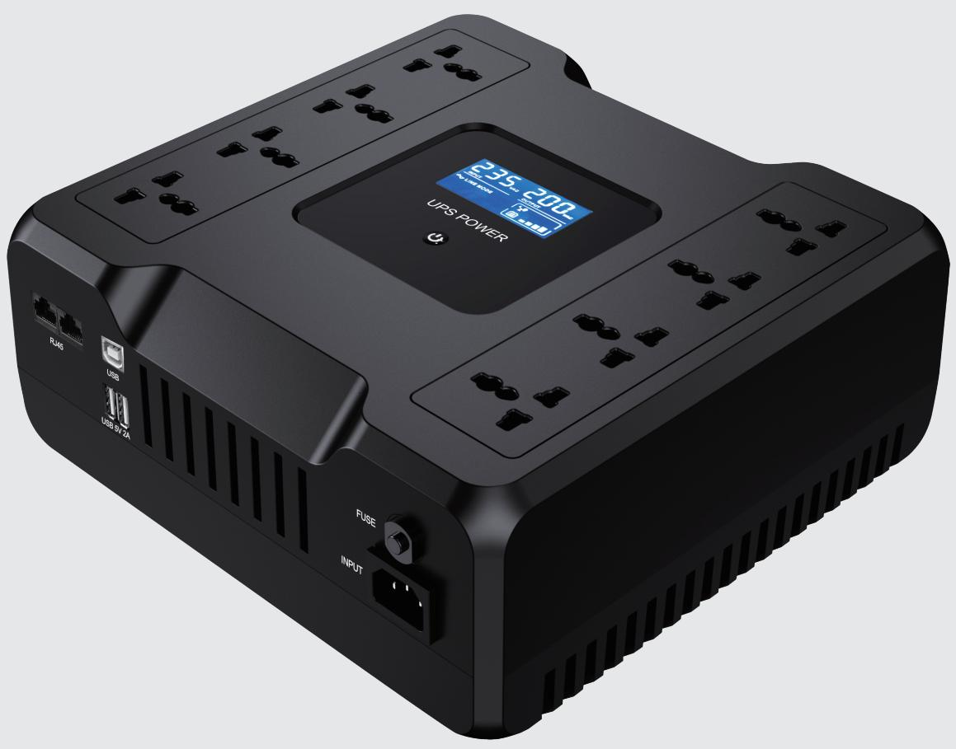
AR-LINE-INTERACTIVE-UPS · Primary

PRODUCT OVERVIEW
AR Series Line-Interactive UPS with 3 source-reviewed models for Office PCs, POS terminals, CCTV recorders and small network equipment. Model configuration and destination-market requirements are confirmed during RFQ review.
Product line | UPS Uninterruptible Power Supply
Series / family | Standalone model
Exact model | AR-LINE-INTERACTIVE-UPS
Applications | Office PCs, POS terminals, CCTV recorders and small network equipment
MODEL IDENTIFICATION
Exact model | Product / variant | Topology | Power Range | Phase
AR-LINE-INTERACTIVE-UPS | AR Series Line-Interactive UPS | Line-interactive UPS with AVR | 650VA/360W to 1000VA/600W | Single phase input / Single phase output
TECHNICAL SPECIFICATIONS
Parameter | Specification
Topology | Line-interactive UPS with AVR
Power Range | 650VA/360W to 1000VA/600W
Phase | Single phase input / Single phase output
Form Factor | Tower
Waveform | Simulated sine wave
Power Factor | Model-specific; confirm on quotation
Battery Types | Model-dependent
SKU | AR-LINE-INTERACTIVE-UPS
Available Configurations | AR650; AR850; AR1000
Exact Configuration | Confirm one listed configuration during RFQ review
Destination Requirements | To be confirmed
ENGINEERING TABLES
AR-LINE-INTERACTIVE-UPS · Complete Model Specifications — AR650 | AR850 | AR1000
Parameter | AR650 | AR850 | AR1000
Rated capacity | 650VA/360W | 850VA/480W | 1000VA/600W
Battery configuration | 12V/7Ah × 1 | 12V/9Ah × 1 | 12V/9Ah × 1
Dimensions | 115×115×40mm | 115×115×40mm | 115×115×40mm
Net weight | 5.8kg | 6kg | 6kg
Transfer time | 4-6ms | 4-6ms | 4-6ms
Efficiency | Not provided | Not provided | Not provided
Model configuration — Rated capacity | 650VA/360W | 850VA/480W | 1000VA/600W
Model configuration — Battery configuration | 12V/7Ah × 1 | 12V/9Ah × 1 | 12V/9Ah × 1
Model configuration — Product dimensions | 115×115×40mm | 115×115×40mm | 115×115×40mm
Model configuration — Net weight | 5.8kg | 6kg | 6kg
Model configuration — Transfer time | 4-6ms | 4-6ms | 4-6ms
Input — Input voltage | 110/120VAC or 220/230/240VAC | 110/120VAC or 220/230/240VAC | 110/120VAC or 220/230/240VAC
Input — Input voltage range | 81–145VAC or 145–275VAC | 81–145VAC or 145–275VAC | 81–145VAC or 145–275VAC
Input — Input frequency | 50/60Hz (auto sensing) | 50/60Hz (auto sensing) | 50/60Hz (auto sensing)
Output — Output voltage | 110/120VAC or 220/230/240VAC | 110/120VAC or 220/230/240VAC | 110/120VAC or 220/230/240VAC
Output — Voltage regulation | ±10% | ±10% | ±10%
Output — Battery-mode frequency | 50/60Hz ±1Hz | 50/60Hz ±1Hz | 50/60Hz ±1Hz
Output — Output waveform | Simulated sine wave | Simulated sine wave | Simulated sine wave
Charging — Charging time | 8h to 90% capacity | 8h to 90% capacity | 8h to 90% capacity
Protection — Protection function | Discharge, short circuit and overload | Discharge, short circuit and overload | Discharge, short circuit and overload
Display & Alarms — Display | LCD | LCD | LCD
Display & Alarms — Battery mode alarm | Every 4 seconds | Every 4 seconds | Every 4 seconds
Display & Alarms — Low battery alarm | Every second | Every second | Every second
Display & Alarms — Overload alarm | Every second | Every second | Every second
Display & Alarms — Fault alarm | Continuous | Continuous | Continuous
Communication & Monitoring — Communication interface | RJ45 / USB 5V (2A) | RJ45 / USB 5V (2A) | RJ45 / USB 5V (2A)
Environment — Operating temperature | 0–40°C | 0–40°C | 0–40°C
Environment — Relative humidity | 0–90% RH (non-condensing) | 0–90% RH (non-condensing) | 0–90% RH (non-condensing)
Environment — Noise level | <40dB | <40dB | <40dB

