
UPS UNINTERRUPTIBLE POWER SUPPLY

APS Series Portable Power Stations
  - Exact model: APS-PORTABLE-POWER-STATION
PRODUCT IMAGES
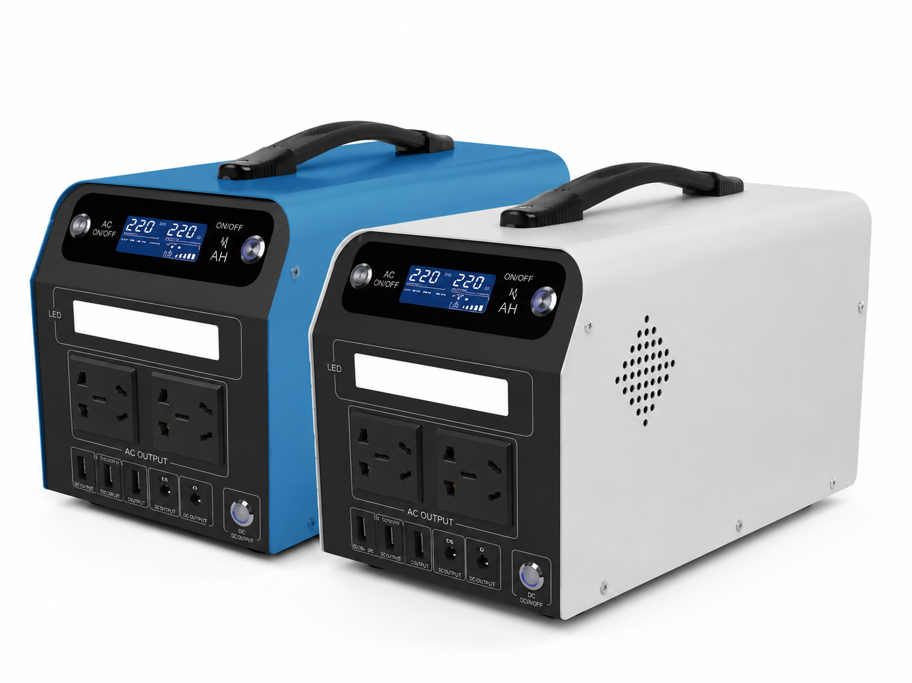
APS-PORTABLE-POWER-STATION · Primary

PRODUCT OVERVIEW
APS Series Portable Power Stations with 2 source-reviewed models for Mobile service teams, emergency backup, field communications and lighting. Model configuration and destination-market requirements are confirmed during RFQ review.
Product line | UPS Uninterruptible Power Supply
Series / family | Standalone model
Exact model | APS-PORTABLE-POWER-STATION
Applications | Mobile service teams, emergency backup, field communications and lighting
MODEL IDENTIFICATION
Exact model | Product / variant | Topology | Power Range | Phase
APS-PORTABLE-POWER-STATION | APS Series Portable Power Stations | Portable LiFePO4 power station | APS-500W to APS-1000W | AC, solar and vehicle charging input / AC and DC output
TECHNICAL SPECIFICATIONS
Parameter | Specification
Topology | Portable LiFePO4 power station
Power Range | APS-500W to APS-1000W
Phase | AC, solar and vehicle charging input / AC and DC output
Form Factor | Portable
Waveform | Sine wave
Power Factor | Model-specific; confirm on quotation
Battery Types | Source-defined lithium or LiFePO4 configuration
SKU | APS-PORTABLE-POWER-STATION
Available Configurations | APS-500W; APS-1000W
Exact Configuration | Confirm one listed configuration during RFQ review
Destination Requirements | To be confirmed
ENGINEERING TABLES
APS-PORTABLE-POWER-STATION · Complete Model Specifications — APS-500W | APS-1000W
Parameter | APS-500W | APS-1000W
Rated capacity | APS-500W | APS-1000W
Battery configuration | 307WH 12.8V/24AH | 615WH 12.8V/48AH
Dimensions | 366x169x175 | 366x169x175
Net weight | 6.6kg | 9.7kg
Transfer time | Not provided | Not provided
Efficiency | Not provided | Not provided
Input — AC input | INV mode INV 70~145VAC OR 140 ~260VAC | INV mode INV 70~145VAC OR 140 ~260VAC
Input — AC charging | 14.4V/8A | 14.4V/8A
Input — Solar charging | 10A (max) | 10A (max)
AC — Output voltage | 220Vac | 220Vac
AC — Output frequency | 50Hz or 60Hz | 50Hz or 60Hz
AC — Output waveform | sine wave | sine wave
AC — Max output power | 500W | 1000W
Technical Data — DC port | 12V/10A(max) | 12V/10A(max)
Technical Data — Net weight | 6.6kg | 9.7kg
DC — USB | 2*5V/2.4A USB-A ports + 1*QC2.0 fast chargingUSB-A port_ 2 5V/2.4AUSB-A +1 QC2.0 USB-A | 2*5V/2.4A USB-A ports + 1*QC2.0 fast chargingUSB-A port_ 2 5V/2.4AUSB-A +1 QC2.0 USB-A
Battery Specification — Battery type | LiFePO4 | LiFePO4
Battery Specification — Battery Numbers | 16 | 32
Battery Specification — Battery capacity | 307WH 12.8V/24AH | 615WH 12.8V/48AH
Physical Parameters — Size /(mm) | 366x169x175 | 366x169x175

