
UPS UNINTERRUPTIBLE POWER SUPPLY

AL-Vertical Home Energy Storage
  - Exact model: AL-VERTICAL-ESS
PRODUCT IMAGES
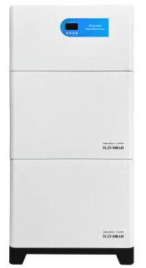 | 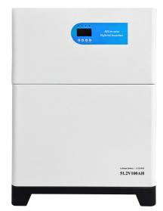
AL-VERTICAL-ESS · Primary | AL-VERTICAL-ESS · Gallery

PRODUCT OVERVIEW
AL-Vertical Home Energy Storage with 2 source-reviewed models for Residential solar storage and compact floor-standing backup systems. Model configuration and destination-market requirements are confirmed during RFQ review.
Product line | UPS Uninterruptible Power Supply
Series / family | Standalone model
Exact model | AL-VERTICAL-ESS
Applications | Residential solar storage and compact floor-standing backup systems
MODEL IDENTIFICATION
Exact model | Product / variant | Topology | Power Range | Phase
AL-VERTICAL-ESS | AL-Vertical Home Energy Storage | Vertical integrated energy storage system | 5.5KW / 5.12KWH to 5.5KW / 10KWH | AC and PV input / Single phase AC output
TECHNICAL SPECIFICATIONS
Parameter | Specification
Topology | Vertical integrated energy storage system
Power Range | 5.5KW / 5.12KWH to 5.5KW / 10KWH
Phase | AC and PV input / Single phase AC output
Form Factor | Floor standing
Waveform | Pure sine wave
Power Factor | Model-specific; confirm on quotation
Battery Types | Source-defined lithium or LiFePO4 configuration
SKU | AL-VERTICAL-ESS
Available Configurations | AL-VERTICAL-5KW.H; AL-VERTICAL-10KW.H
Exact Configuration | Confirm one listed configuration during RFQ review
Destination Requirements | To be confirmed
ENGINEERING TABLES
AL-VERTICAL-ESS · Complete Model Specifications — AL-VERTICAL-5KW.H | AL-VERTICAL-10KW.H
Parameter | AL-VERTICAL-5KW.H | AL-VERTICAL-10KW.H
Rated capacity | 5.5KW / 5.12KWH | 5.5KW / 10KWH
Battery configuration | 5.12kWh × 1 | 5.12kWh × 2
Dimensions | Not provided | Not provided
Net weight | Not provided | Not provided
Transfer time | Not provided | Not provided
Efficiency | Not provided | Not provided
Model configuration — Rated capacity | 5.5KW / 5.12KWH | 5.5KW / 10KWH
Model configuration — Battery configuration | 5.12kWh × 1 | 5.12kWh × 2
Input — DC input voltage | 120–500V | 120–500V
Input — DC input power | 5500W | 5500W
Output — Output voltage | 210–230VAC | 210–230VAC
Output — Output frequency | 50/60Hz | 50/60Hz
Output — Maximum power | 5500W | 5500W
Battery — Battery energy | 5.12kWh | 5.12kWh × 2
Battery — Battery configuration | 3.2V 100Ah; 16S1P per module | 3.2V 100Ah; 16S1P per module
Packaging — Battery package dimensions | 670×500×285mm × 1 | 670×500×285mm × 2
Packaging — Wooden crate dimensions | 680×510×300mm × 1 | 680×510×300mm × 2
Packaging — Inverter package dimensions | 670×500×285mm | 670×500×285mm
Packaging — Gross weight | 17.3kg + 66.05kg | 17.3kg + 66.05kg + 66.65kg

