
UPS UNINTERRUPTIBLE POWER SUPPLY

3.6kW Modular Home Energy Storage
  - Exact model: 3.6KW-MODULAR-ESS
PRODUCT IMAGES
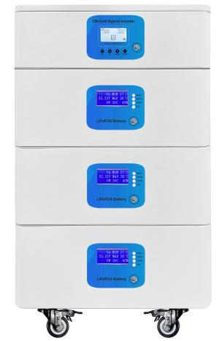 | 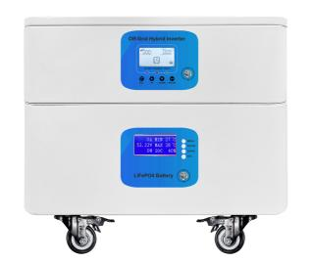 | 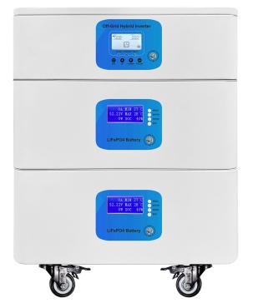
3.6KW-MODULAR-ESS · Primary | 3.6KW-MODULAR-ESS · Gallery | 3.6KW-MODULAR-ESS · Gallery

PRODUCT OVERVIEW
3.6kW Modular Home Energy Storage with 3 source-reviewed models for Residential backup, solar self-consumption and capacity expansion. Model configuration and destination-market requirements are confirmed during RFQ review.
Product line | UPS Uninterruptible Power Supply
Series / family | Standalone model
Exact model | 3.6KW-MODULAR-ESS
Applications | Residential backup, solar self-consumption and capacity expansion
MODEL IDENTIFICATION
Exact model | Product / variant | Topology | Power | Phase
3.6KW-MODULAR-ESS | 3.6kW Modular Home Energy Storage | Modular home energy storage system | 3.6KW / 3.84KWH to 3.6KW / 11.52KWH | Single phase AC
TECHNICAL SPECIFICATIONS
Parameter | Specification
Topology | Modular home energy storage system
Power | 3.6KW / 3.84KWH to 3.6KW / 11.52KWH
Phase | AC and PV / Single phase AC
SKU | 3.6KW-MODULAR-ESS
Power Range | 3.6KW / 3.84KWH to 3.6KW / 11.52KWH
Waveform | Pure sine wave
Power Factor | Model-specific; confirm on quotation
Quotation Type | Bulk project quotation
OEM/ODM | Available
Documents | Datasheet and installation reference
Category | UPS Power
APPLICATIONS & RFQ CONFIRMATION
Typical applications | Confirm in the project RFQ
Residential backup  solar self-consumption and capacity expansion | Confirm the exact model and required configuration.  Confirm quantity, destination, packing, branding, and documentation requirements.
Project supply: MOQ — Confirm by project quantity · Lead time — Confirm by project list · FOB port — China main ports · OEM/ODM — Available; confirm project scope
PROJECT CONFIGURATION CHECKLIST
Exact model | 3.6KW-MODULAR-ESS
Application and site conditions | Confirm installation environment and operating requirements.
Quantity and model mix | Confirm forecast quantity, phase plan and required variants.
Interfaces and accessories | Confirm compatible interfaces, accessories and system integration scope.
Finish, branding and packing | Confirm only when project customization is required.
Documentation and destination | Confirm drawings, datasheets, packing documents and destination country or port.

