
UPS UNINTERRUPTIBLE POWER SUPPLY

SP-12KW/48VPro Parallel Hybrid Inverter
  - Exact model: SP-12KW-48VPRO-PARALLEL-INVERTER
PRODUCT IMAGES
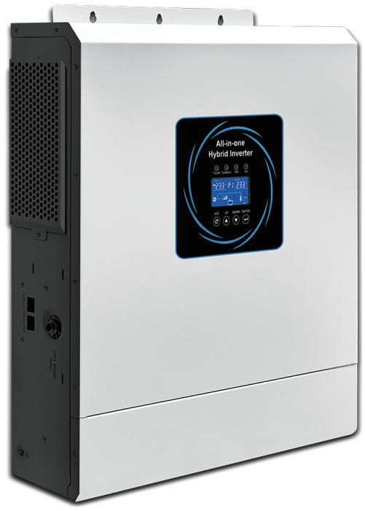 | 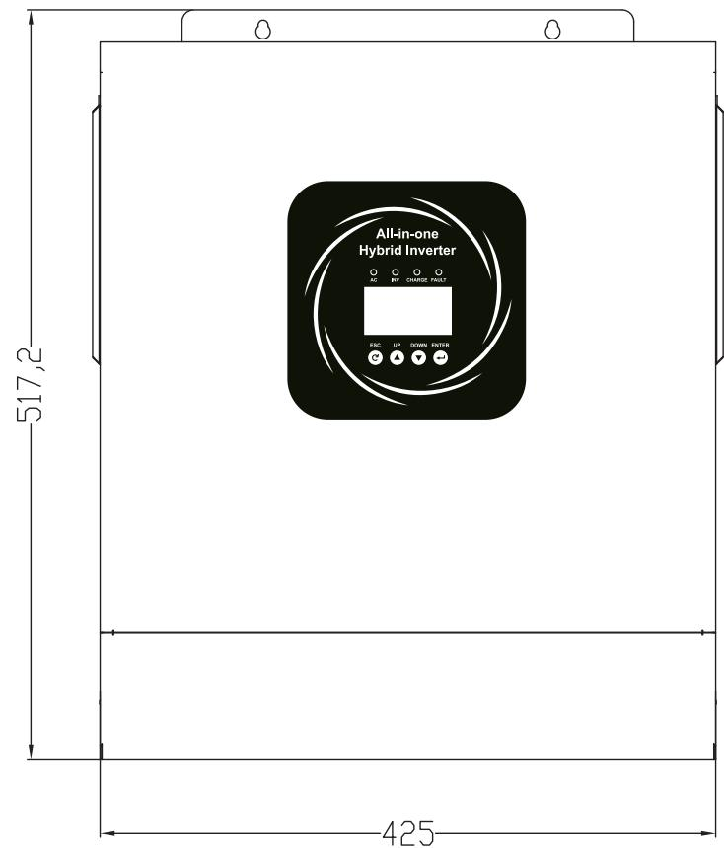 | 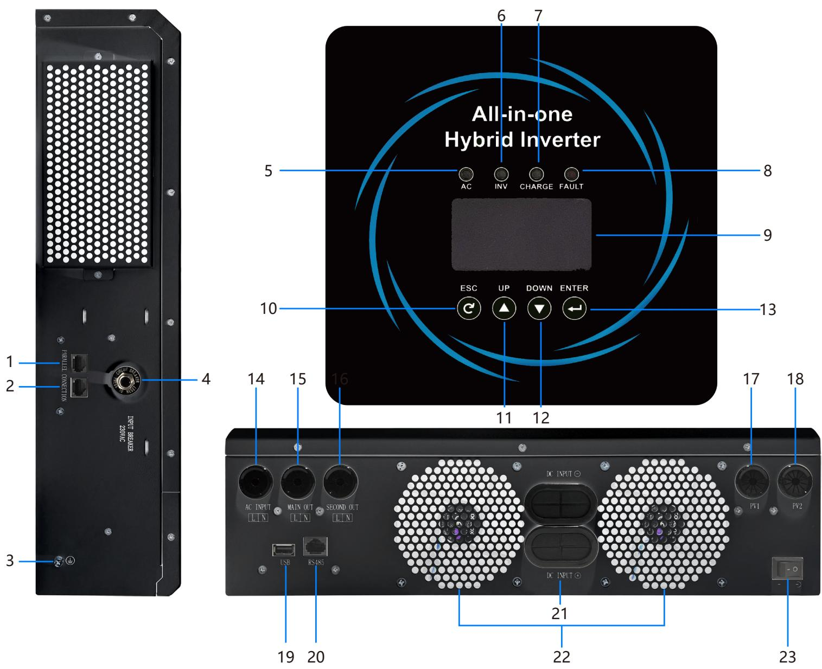 | 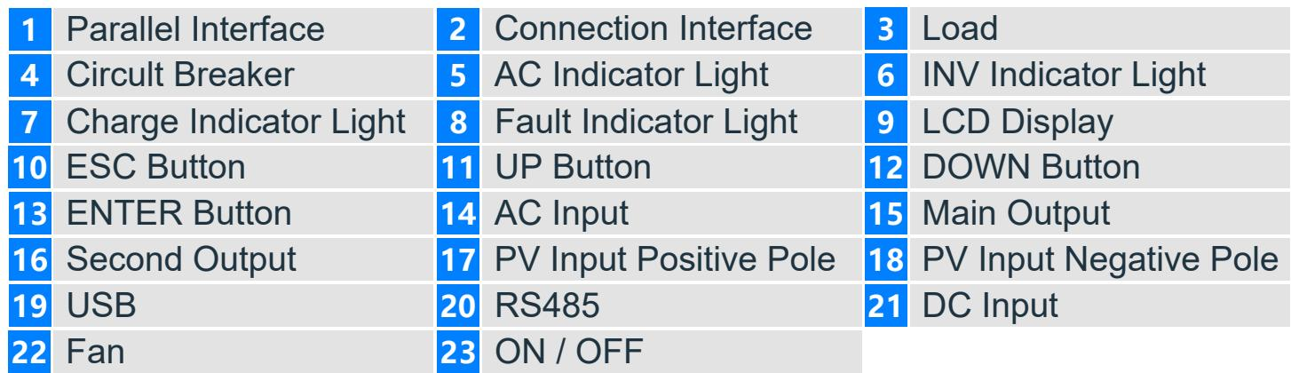
SP-12KW-48VPRO-PARALLEL-INVERTER · Primary | SP-12KW-48VPRO-PARALLEL-INVERTER · Gallery | SP-12KW-48VPRO-PARALLEL-INVERTER · Gallery | SP-12KW-48VPRO-PARALLEL-INVERTER · Gallery

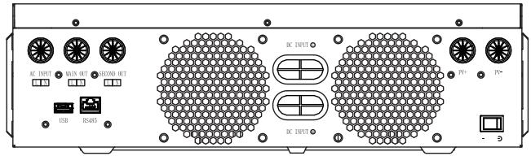 | 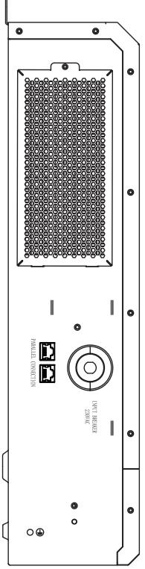 | 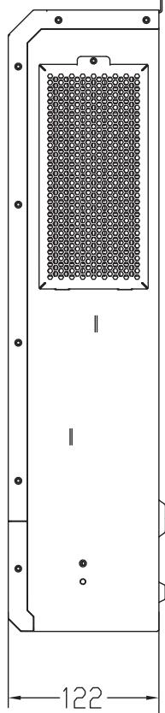 | 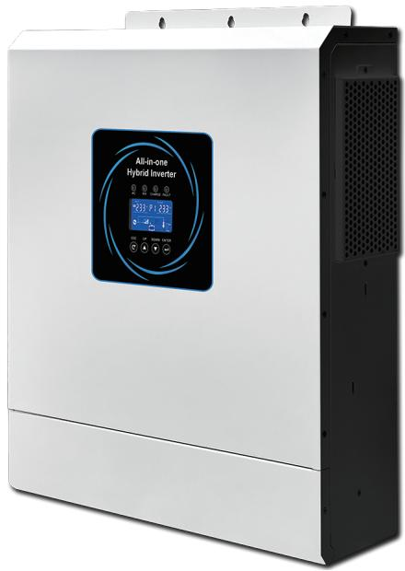
SP-12KW-48VPRO-PARALLEL-INVERTER · Gallery | SP-12KW-48VPRO-PARALLEL-INVERTER · Gallery | SP-12KW-48VPRO-PARALLEL-INVERTER · Gallery | SP-12KW-48VPRO-PARALLEL-INVERTER · Gallery

PRODUCT OVERVIEW
SP-12KW/48VPro Parallel Hybrid Inverter with 1 source-reviewed model for Higher-load residential storage and small commercial energy systems. Model configuration and destination-market requirements are confirmed during RFQ review.
Product line | UPS Uninterruptible Power Supply
Series / family | Standalone model
Exact model | SP-12KW-48VPRO-PARALLEL-INVERTER
Applications | Higher-load residential storage and small commercial energy systems
MODEL IDENTIFICATION
Exact model | Product / variant | Topology | Power Range | Phase
SP-12KW-48VPRO-PARALLEL-INVERTER | SP-12KW/48VPro Parallel Hybrid Inverter | Parallel hybrid solar inverter | 12KVA/12KW | Single phase AC and PV input / Single phase AC output
TECHNICAL SPECIFICATIONS
Parameter | Specification
Topology | Parallel hybrid solar inverter
Power Range | 12KVA/12KW
Phase | Single phase AC and PV input / Single phase AC output
Form Factor | Wall mounted
Waveform | Pure sine wave
Power Factor | Model-specific; confirm on quotation
Battery Types | Model-dependent
SKU | SP-12KW-48VPRO-PARALLEL-INVERTER
Available Configurations | SP-12KW-48VPRO
Exact Configuration | Confirm one listed configuration during RFQ review
Destination Requirements | To be confirmed
ENGINEERING TABLES
SP-12KW-48VPRO-PARALLEL-INVERTER · Complete Model Specifications — SP-12KW-48VPRO
Parameter | SP-12KW-48VPRO
Rated capacity | 12KVA/12KW
Battery configuration | Not provided
Dimensions | 517*425*122
Net weight | 16.2
Transfer time | 10ms(For personal Computer);20ms(For Home Appliances)
Efficiency | 99%
Technical Data — Capacity | 12KVA/12KW
Technical Data — Maximum PV Input Power | 15KW
Technical Data — Twin AC Output Function | Yes
Technical Data — Maximum Main Output Power | 12KVA/12KW
Technical Data — Maximum Total Output Power | 12KVA/12KW
Technical Data — Parallel Mode | Yes
Technical Data — Lithium Battery Communication | Yes (RS485)
Technical Data — Lithium Battery Activation | YES(By PV or Utility)
Technical Data — Built-in WIFI | Optional
Technical Data — Solar Charger TYPE | MPPT
Technical Data — Max.PV Array Power | Single 9000W Dual 7500W*2
Technical Data — Max. PV Array Open Circuit Voltage | 500VDC
Technical Data — PV Array MPPT Voltage Range | 60VDC~500VDC
Technical Data — Max. Solar Input Current | 27A*2
Technical Data — Max. Solar Charge Current | 160A
Technical Data — Max. AC Charge Current | 160A
Technical Data — Max. Charge Current PV+AC | 160A
Technical Data — Operating Temperature Range | -10 to 55
Technical Data — Storage temperature | -15 ~ 60°
Technical Data — Humidity | 5% to 95% Relative Humidity (Non-condensing)
Technical Data — Ingress Protection | IP21
Input — Nominal Voltage | 230VAC
Input — Acceptable Voltage Range | 170-280VAC(For personal Computer);90-280VAC(For Home Appliances)
Input — Frequency | 50 /60 Hz (Auto sensing)
Output — Nominal Voltage | 220 /230 /240VAC
Output — Surge Power | 22000VA
Output — Frequency | 50 /60 Hz
Output — Waveform | Pure Sine Wave
Output — Transfer Time | 10ms(For personal Computer);20ms(For Home Appliances)
Output — Peak Efficiency (PV to INV) | 99%
Output — Peak Efficiency(Battery to INV) | 93%
Output — Overload Protection | 5s@>=140% load; 10s@110%~140% load
Output — Crest Factor | 3:1
Output — Admissible Power Factor | 0.6~1 (inductive or capacitive)
Battery — Battery Voltage | 48VDC
Battery — Maximum Discharge Current | 220A
Battery — Floating Charge Voltage | 54VDC
Battery — OverCharge Protection | 63VDC
Battery — Charging Method | CC /CV
Physical — Dimensions, length x width x height (mm) | 517*425*122
Physical — Net weight (Kgs) | 16.2
Physical — Communication interface | RS232 /RS485 /Dry Contact
Physical — LCD | Yes

