
UPS UNINTERRUPTIBLE POWER SUPPLY

Lithium Rack-Mounted Online UPS 1KVA-3KVA Series
  - Exact model: NX-UP-RM-002
PRODUCT IMAGES
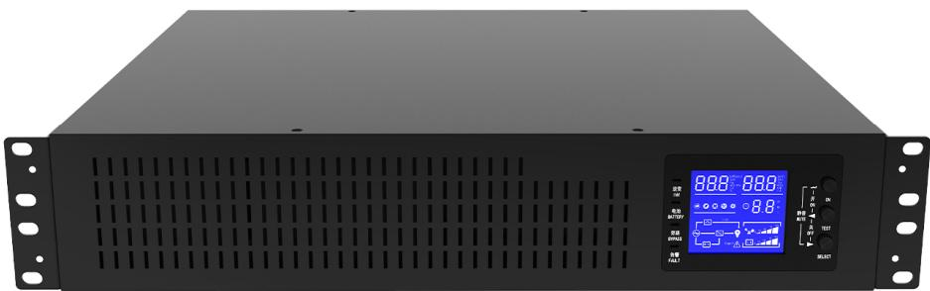 | 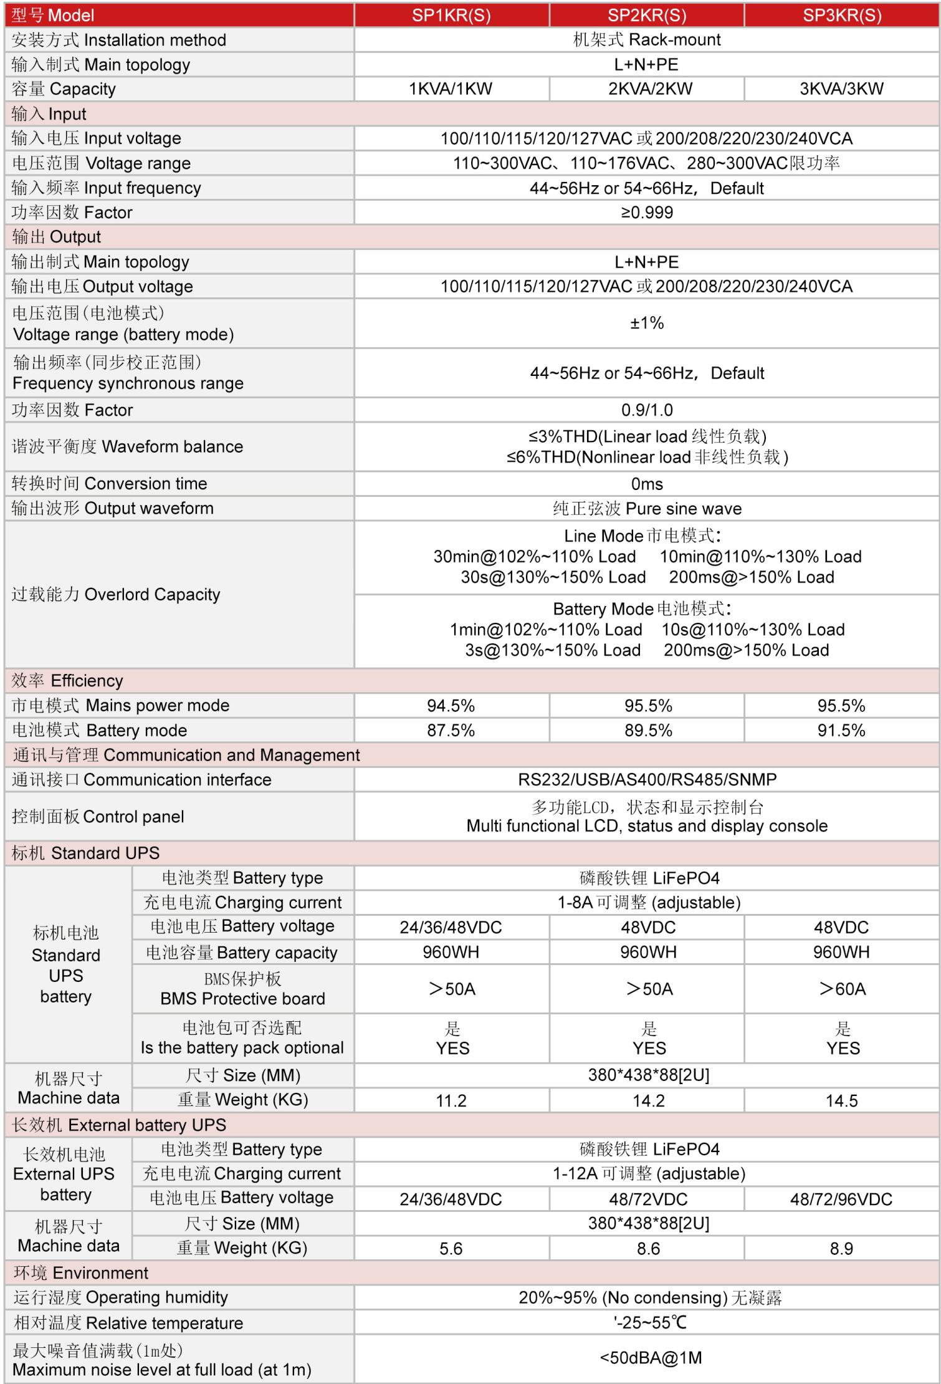
NX-UP-RM-002 · Primary | NX-UP-RM-002 · Gallery

PRODUCT OVERVIEW
19-inch rack-mountable online UPS with built-in LiFePO4 lithium battery. Lighter weight and longer cycle life for space-constrained server cabinets.
Product line | UPS Uninterruptible Power Supply
Series / family | Standalone model
Exact model | NX-UP-RM-002
Applications | Server racks and cabinets, Network infrastructure, Data centers, Telecommunications, Limited space installations
MODEL IDENTIFICATION
Exact model | Product / variant | Topology | Power Range | Phase
NX-UP-RM-002 | Lithium Rack-Mounted Online UPS 1KVA-3KVA Series | Online Double Conversion | 1KVA-3KVA / 900W-2700W | Single phase input / Single phase output
TECHNICAL SPECIFICATIONS
Parameter | Specification
Topology | Online Double Conversion
Power Range | 1KVA-3KVA / 900W-2700W
Phase | Single phase input / Single phase output
Form Factor | 19-inch Rack Mount
Waveform | Pure sine wave
Power Factor | 0.9
Battery Types | LiFePO4 (Lithium Iron Phosphate)
SKU | NX-UP-RM-002
Available Configurations | SP1KR(S); SP2KR(S); SP3KR(S)
Exact Configuration | Confirm one listed configuration during RFQ review
Destination Requirements | To be confirmed
ENGINEERING TABLES
NX-UP-RM-002 · Complete Model Specifications — SP1KR(S) | SP2KR(S) | SP3KR(S)
Parameter | SP1KR(S) | SP2KR(S) | SP3KR(S)
Rated capacity | 1KVA / 900W | 2KVA / 1800W | 3KVA / 2700W
Battery configuration | Built-in LiFePO4 | Built-in LiFePO4 | Built-in LiFePO4
Dimensions | Not provided | Not provided | Not provided
Net weight | Not provided | Not provided | Not provided
Transfer time | 0ms | 0ms | 0ms
Efficiency | AC: 94.5%; Battery: 87.5% | AC: 95.5%; Battery: 89.5% | AC: 95.5%; Battery: 91.5%
Model configuration — Rated capacity | 1KVA / 900W | 2KVA / 1800W | 3KVA / 2700W
Model configuration — Battery configuration | Built-in LiFePO4 | Built-in LiFePO4 | Built-in LiFePO4
Model configuration — Transfer time | 0ms | 0ms | 0ms
Model configuration — Efficiency | AC: 94.5%; Battery: 87.5% | AC: 95.5%; Battery: 89.5% | AC: 95.5%; Battery: 91.5%
Input — Input voltage | 100/110/115/120/127VAC or 200/208/220/230/240VAC | 100/110/115/120/127VAC or 200/208/220/230/240VAC | 100/110/115/120/127VAC or 200/208/220/230/240VAC
Input — Input voltage range | 110–300VAC | 110–300VAC | 110–300VAC
Input — Derating range | 110–176VAC / 280–300VAC | 110–176VAC / 280–300VAC | 110–176VAC / 280–300VAC
Input — Input frequency | 44–56Hz / 54–66Hz | 44–56Hz / 54–66Hz | 44–56Hz / 54–66Hz
Input — Input power factor | ≥0.999 | ≥0.999 | ≥0.999
Input — Wiring | L+N+PE | L+N+PE | L+N+PE
Output — Output voltage | 100/110/115/120/127VAC or 200/208/220/230/240VAC | 100/110/115/120/127VAC or 200/208/220/230/240VAC | 100/110/115/120/127VAC or 200/208/220/230/240VAC
Output — Voltage regulation | ±1% | ±1% | ±1%
Output — Synchronized frequency | 44–56Hz / 54–66Hz | 44–56Hz / 54–66Hz | 44–56Hz / 54–66Hz
Output — Output power factor | 0.9 / 1.0 | 0.9 / 1.0 | 0.9 / 1.0
Output — THD (linear load) | ≤3% | ≤3% | ≤3%
Output — THD (non-linear load) | ≤6% | ≤6% | ≤6%
Overload — AC-mode overload | 102–110%: 30min; 110–130%: 10min; 130–150%: 30s; >150%: 200ms | 102–110%: 30min; 110–130%: 10min; 130–150%: 30s; >150%: 200ms | 102–110%: 30min; 110–130%: 10min; 130–150%: 30s; >150%: 200ms
Overload — Battery-mode overload | 102–110%: 1min; 110–130%: 10s; 130–150%: 3s; >150%: 200ms | 102–110%: 1min; 110–130%: 10s; 130–150%: 3s; >150%: 200ms | 102–110%: 1min; 110–130%: 10s; 130–150%: 3s; >150%: 200ms
Charging — Charging current | 1–8A (adjustable) | 1–8A (adjustable) | 1–8A (adjustable)
Charging — Optional battery pack | Yes | Yes | Yes
Communication & Monitoring — Communication interface | RS232 / USB / AS400 / RS485 / SNMP | RS232 / USB / AS400 / RS485 / SNMP | RS232 / USB / AS400 / RS485 / SNMP
Communication & Monitoring — Display | LCD | LCD | LCD
Environment — Operating temperature | -25–55°C | -25–55°C | -25–55°C
Environment — Relative humidity | 20–95% RH (non-condensing) | 20–95% RH (non-condensing) | 20–95% RH (non-condensing)
Environment — Noise level | <50dBA @1m | <50dBA @1m | <50dBA @1m
Battery — Battery voltage | 24/36/48VDC | 48VDC | 48VDC
Battery — Battery energy | 960Wh | 960Wh | 960Wh
Battery — BMS current | >50A | >50A | >60A
External battery configuration — Charging current | 1–12A (adjustable) | 1–12A (adjustable) | 1–12A (adjustable)
External battery configuration — Battery voltage | 24/36/48VDC | 48/72VDC | 48/72/96VDC
External battery configuration — Net weight | 5.6kg | 8.6kg | 8.9kg

