
UPS UNINTERRUPTIBLE POWER SUPPLY

Rack-Mounted Online UPS 1KVA-10KVA Series
  - Exact model: NX-UP-RM-001
PRODUCT IMAGES
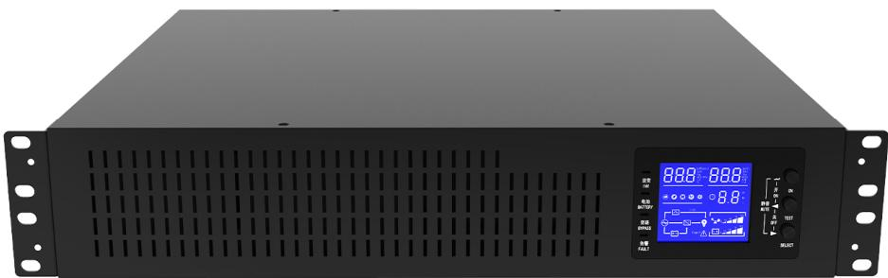 | 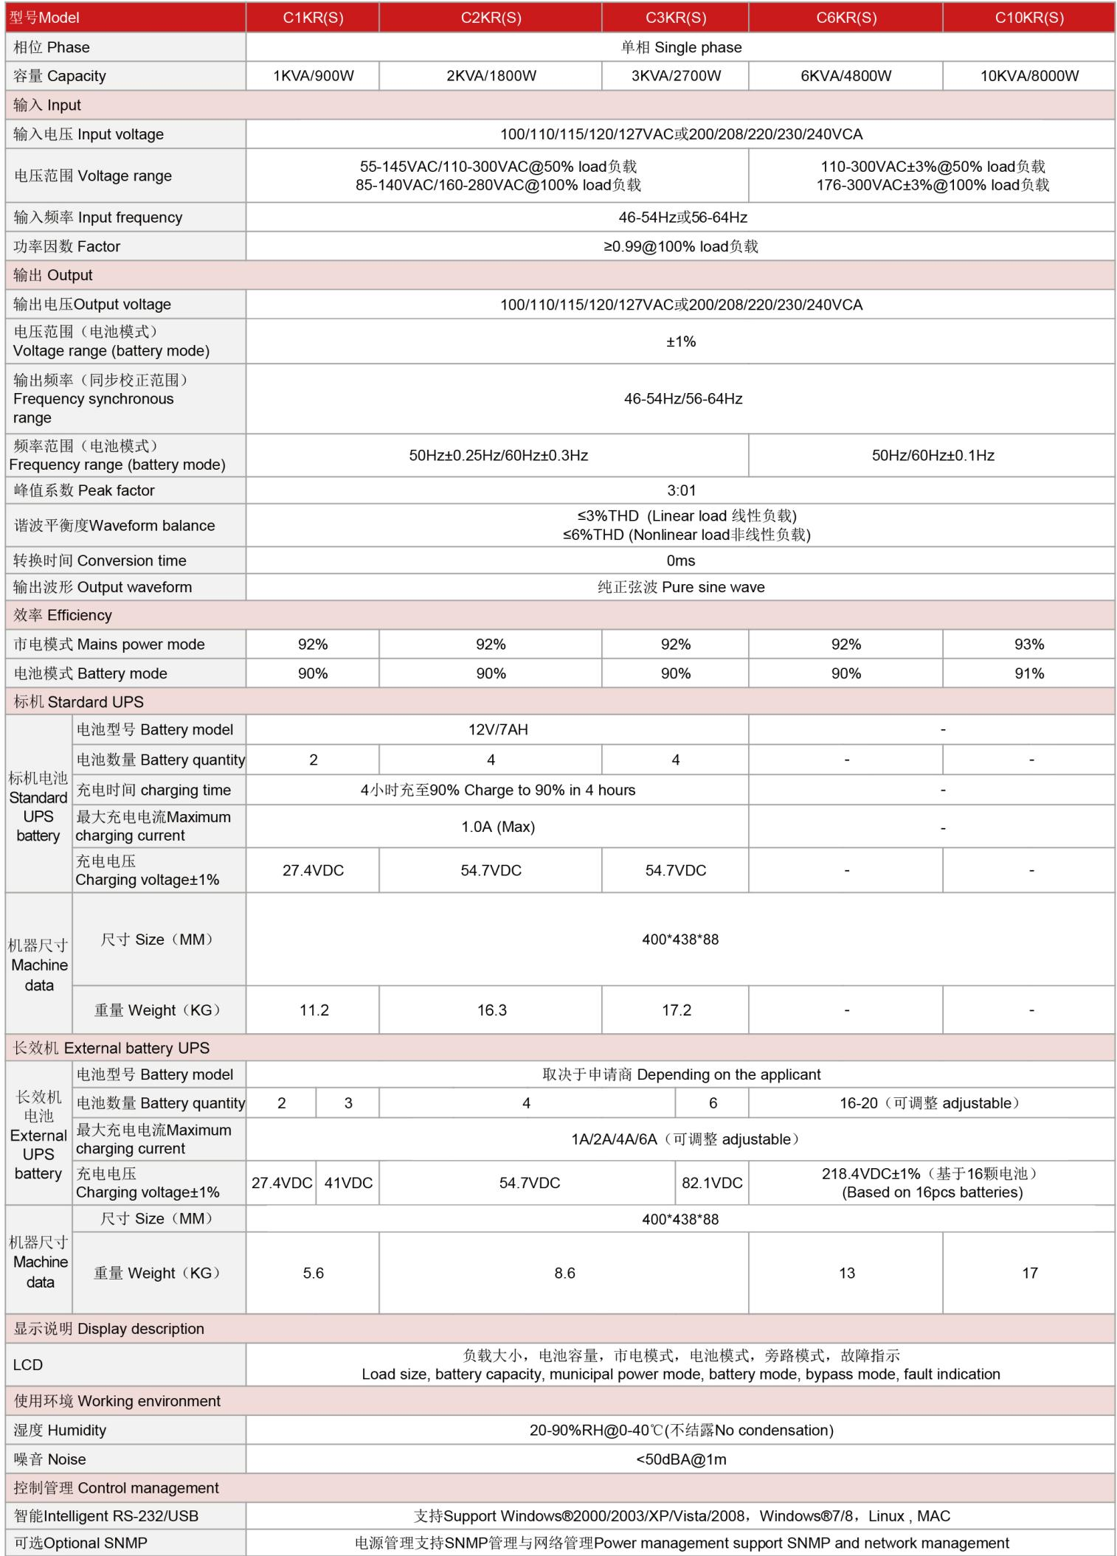
NX-UP-RM-001 · Primary | NX-UP-RM-001 · Gallery

PRODUCT OVERVIEW
19-inch rack-mountable online UPS series with true double conversion. Five models from 1KVA to 10KVA for server cabinet and structured cabling integration.
Product line | UPS Uninterruptible Power Supply
Series / family | Standalone model
Exact model | NX-UP-RM-001
Applications | Server racks and cabinets, Network infrastructure, Data centers, Telecommunications, Industrial control systems
MODEL IDENTIFICATION
Exact model | Product / variant | Topology | Power Range | Phase
NX-UP-RM-001 | Rack-Mounted Online UPS 1KVA-10KVA Series | Online Double Conversion | 1KVA-10KVA / 900W-9000W | Single phase input / Single phase output
TECHNICAL SPECIFICATIONS
Parameter | Specification
Topology | Online Double Conversion
Power Range | 1KVA-10KVA / 900W-9000W
Phase | Single phase input / Single phase output
Form Factor | 19-inch Rack Mount
Waveform | Pure sine wave
Power Factor | 0.9 (1–3kVA); 0.8 (6–10kVA)
Battery Types | VRLA sealed lead-acid; External battery (extended runtime)
SKU | NX-UP-RM-001
Available Configurations | C1KR(S); C2KR(S); C3KR(S); C6KR(S); C10KR(S)
Exact Configuration | Confirm one listed configuration during RFQ review
Destination Requirements | To be confirmed
ENGINEERING TABLES
NX-UP-RM-001 · Complete Model Specifications — C1KR(S) | C2KR(S) | C3KR(S) | C6KR(S)
Parameter | C1KR(S) | C2KR(S) | C3KR(S) | C6KR(S)
Rated capacity | 1KVA / 900W | 2KVA / 1800W | 3KVA / 2700W | 6KVA / 4800W
Battery configuration | Internal VRLA | Internal VRLA | Internal VRLA | Internal VRLA + External option
Dimensions | Not provided | Not provided | Not provided | Not provided
Net weight | Not provided | Not provided | Not provided | Not provided
Transfer time | 0ms | 0ms | 0ms | 0ms
Efficiency | AC: 92%; Battery: 90% | AC: 92%; Battery: 90% | AC: 92%; Battery: 90% | AC: 92%; Battery: 90%
Model configuration — Rated capacity | 1KVA / 900W | 2KVA / 1800W | 3KVA / 2700W | 6KVA / 4800W
Model configuration — Battery configuration | Internal VRLA | Internal VRLA | Internal VRLA | Internal VRLA + External option
Model configuration — Transfer time | 0ms | 0ms | 0ms | 0ms
Model configuration — Efficiency | AC: 92%; Battery: 90% | AC: 92%; Battery: 90% | AC: 92%; Battery: 90% | AC: 92%; Battery: 90%
Input — Input voltage | 100/110/115/120/127VAC or 200/208/220/230/240VAC | 100/110/115/120/127VAC or 200/208/220/230/240VAC | 100/110/115/120/127VAC or 200/208/220/230/240VAC | 100/110/115/120/127VAC or 200/208/220/230/240VAC
Input — Input frequency | 46–54Hz / 56–64Hz | 46–54Hz / 56–64Hz | 46–54Hz / 56–64Hz | 46–54Hz / 56–64Hz
Input — Input power factor | ≥0.99 @100% load | ≥0.99 @100% load | ≥0.99 @100% load | ≥0.99 @100% load
Input — Input voltage range at 50% load | 55–145VAC / 110–300VAC | 55–145VAC / 110–300VAC | 55–145VAC / 110–300VAC | 110–300VAC ±3%
Input — Input voltage range at 100% load | 85–140VAC / 160–280VAC | 85–140VAC / 160–280VAC | 85–140VAC / 160–280VAC | 176–300VAC ±3%
Output — Output voltage | 100/110/115/120/127VAC or 200/208/220/230/240VAC | 100/110/115/120/127VAC or 200/208/220/230/240VAC | 100/110/115/120/127VAC or 200/208/220/230/240VAC | 100/110/115/120/127VAC or 200/208/220/230/240VAC
Output — Voltage regulation | ±1% | ±1% | ±1% | ±1%
Output — Synchronized frequency | 46–54Hz / 56–64Hz | 46–54Hz / 56–64Hz | 46–54Hz / 56–64Hz | 46–54Hz / 56–64Hz
Output — Current crest ratio | 3:1 | 3:1 | 3:1 | 3:1
Output — THD (linear load) | ≤3% | ≤3% | ≤3% | ≤3%
Output — THD (non-linear load) | ≤6% | ≤6% | ≤6% | ≤6%
Output — Battery-mode frequency | 50Hz ±0.25Hz / 60Hz ±0.3Hz | 50Hz ±0.25Hz / 60Hz ±0.3Hz | 50Hz ±0.25Hz / 60Hz ±0.3Hz | 50/60Hz ±0.1Hz
Communication & Monitoring — Communication interface | RS232 / USB | RS232 / USB | RS232 / USB | RS232 / USB
Communication & Monitoring — SNMP | Optional | Optional | Optional | Optional
Communication & Monitoring — Display | LCD | LCD | LCD | LCD
Environment — Operating temperature | 0–40°C | 0–40°C | 0–40°C | 0–40°C
Environment — Relative humidity | 20–90% RH (non-condensing) | 20–90% RH (non-condensing) | 20–90% RH (non-condensing) | 20–90% RH (non-condensing)
Environment — Noise level | <50dBA @1m | <50dBA @1m | <50dBA @1m | <50dBA @1m
External battery configuration — Charging current | 1 / 2 / 4 / 6A (adjustable) | 1 / 2 / 4 / 6A (adjustable) | 1 / 2 / 4 / 6A (adjustable) | 1 / 2 / 4 / 6A (adjustable)
External battery configuration — Battery quantity | 2 / 3 | 4 | 6 | 16–20 (adjustable)
External battery configuration — Product dimensions | 400×438×88mm | 400×438×88mm | 400×438×88mm | 400×438×88mm
External battery configuration — Net weight | 5.6kg | 8.6kg | 8.6kg | 13kg
NX-UP-RM-001 · Complete Model Specifications — C10KR(S)
Parameter | C10KR(S)
Rated capacity | 10KVA / 8000W
Battery configuration | Internal VRLA + External option
Dimensions | Not provided
Net weight | Not provided
Transfer time | 0ms
Efficiency | AC: 93%; Battery: 91%
Model configuration — Rated capacity | 10KVA / 8000W
Model configuration — Battery configuration | Internal VRLA + External option
Model configuration — Transfer time | 0ms
Model configuration — Efficiency | AC: 93%; Battery: 91%
Input — Input voltage | 100/110/115/120/127VAC or 200/208/220/230/240VAC
Input — Input frequency | 46–54Hz / 56–64Hz
Input — Input power factor | ≥0.99 @100% load
Input — Input voltage range at 50% load | 110–300VAC ±3%
Input — Input voltage range at 100% load | 176–300VAC ±3%
Output — Output voltage | 100/110/115/120/127VAC or 200/208/220/230/240VAC
Output — Voltage regulation | ±1%
Output — Synchronized frequency | 46–54Hz / 56–64Hz
Output — Current crest ratio | 3:1
Output — THD (linear load) | ≤3%
Output — THD (non-linear load) | ≤6%
Output — Battery-mode frequency | 50/60Hz ±0.1Hz
Communication & Monitoring — Communication interface | RS232 / USB
Communication & Monitoring — SNMP | Optional
Communication & Monitoring — Display | LCD
Environment — Operating temperature | 0–40°C
Environment — Relative humidity | 20–90% RH (non-condensing)
Environment — Noise level | <50dBA @1m
External battery configuration — Charging current | 1 / 2 / 4 / 6A (adjustable)
External battery configuration — Battery quantity | 16–20 (adjustable)
External battery configuration — Product dimensions | 400×438×88mm
External battery configuration — Net weight | 17kg

