
UPS UNINTERRUPTIBLE POWER SUPPLY

High Frequency Online UPS 1KVA-10KVA Series
  - Exact model: NX-UP-HF-001
PRODUCT IMAGES
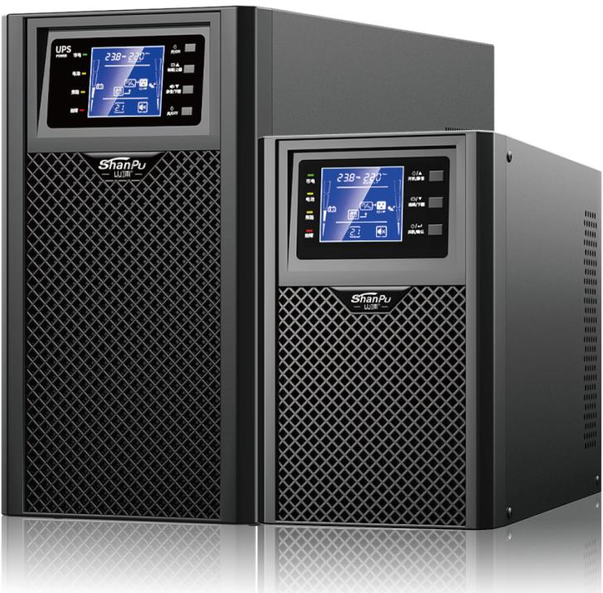 | 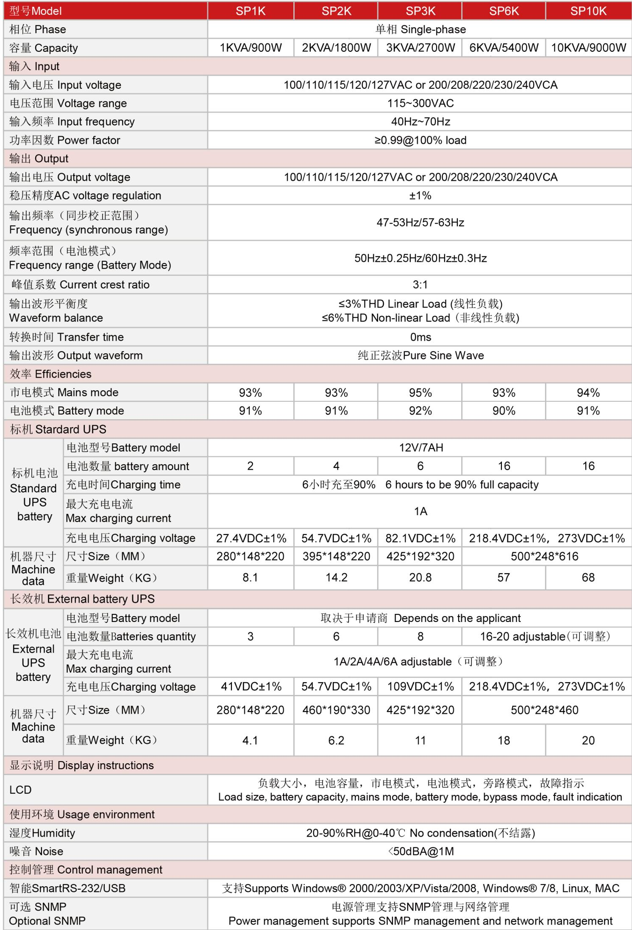
NX-UP-HF-001 · Primary | NX-UP-HF-001 · Gallery

PRODUCT OVERVIEW
True online double conversion UPS series delivering pure sine wave output with zero transfer time. Five models from 1KVA to 10KVA with VRLA battery.
Product line | UPS Uninterruptible Power Supply
Series / family | Standalone model
Exact model | NX-UP-HF-001
Applications | Network management centers, Banking and securities, Telecommunications, Medical equipment, Industrial control systems, Government and defense data systems
MODEL IDENTIFICATION
Exact model | Product / variant | Topology | Power Range | Phase
NX-UP-HF-001 | High Frequency Online UPS 1KVA-10KVA Series | Online Double Conversion | 1KVA-10KVA / 900W-9000W | Single phase input / Single phase output
TECHNICAL SPECIFICATIONS
Parameter | Specification
Topology | Online Double Conversion
Power Range | 1KVA-10KVA / 900W-9000W
Phase | Single phase input / Single phase output
Form Factor | Tower
Waveform | Pure sine wave
Power Factor | 0.9
Battery Types | VRLA sealed lead-acid
SKU | NX-UP-HF-001
Available Configurations | SP1K; SP2K; SP3K; SP6K; SP10K
Exact Configuration | Confirm one listed configuration during RFQ review
Destination Requirements | To be confirmed
ENGINEERING TABLES
NX-UP-HF-001 · Complete Model Specifications — SP1K | SP2K | SP3K | SP6K
Parameter | SP1K | SP2K | SP3K | SP6K
Rated capacity | 1KVA / 900W | 2KVA / 1800W | 3KVA / 2700W | 6KVA / 5400W
Battery configuration | 12V/7Ah × 2 | 12V/7Ah × 4 | 12V/7Ah × 6 | 12V/7Ah × 16
Dimensions | 280×148×220mm | 395×148×220mm | 425×192×320mm | 500×248×616mm
Net weight | 8.1kg | 14.2kg | 20.8kg | 57kg
Transfer time | 0ms | 0ms | 0ms | 0ms
Efficiency | AC: 93% / Battery: 91% | AC: 93% / Battery: 91% | AC: 95% / Battery: 92% | AC: 93% / Battery: 90%
Model configuration — Rated capacity | 1KVA / 900W | 2KVA / 1800W | 3KVA / 2700W | 6KVA / 5400W
Model configuration — Battery configuration | 12V/7Ah × 2 | 12V/7Ah × 4 | 12V/7Ah × 6 | 12V/7Ah × 16
Model configuration — Product dimensions | 280×148×220mm | 395×148×220mm | 425×192×320mm | 500×248×616mm
Model configuration — Net weight | 8.1kg | 14.2kg | 20.8kg | 57kg
Model configuration — Transfer time | 0ms | 0ms | 0ms | 0ms
Model configuration — Efficiency | AC: 93% / Battery: 91% | AC: 93% / Battery: 91% | AC: 95% / Battery: 92% | AC: 93% / Battery: 90%
Input — Input voltage | 100/110/115/120/127VAC or 200/208/220/230/240VAC | 100/110/115/120/127VAC or 200/208/220/230/240VAC | 100/110/115/120/127VAC or 200/208/220/230/240VAC | 100/110/115/120/127VAC or 200/208/220/230/240VAC
Input — Input voltage range | 115–300VAC | 115–300VAC | 115–300VAC | 115–300VAC
Input — Input frequency | 40–70Hz | 40–70Hz | 40–70Hz | 40–70Hz
Input — Input power factor | ≥0.99 @100% load | ≥0.99 @100% load | ≥0.99 @100% load | ≥0.99 @100% load
Output — Output voltage | 100/110/115/120/127VAC or 200/208/220/230/240VAC | 100/110/115/120/127VAC or 200/208/220/230/240VAC | 100/110/115/120/127VAC or 200/208/220/230/240VAC | 100/110/115/120/127VAC or 200/208/220/230/240VAC
Output — Voltage regulation | ±1% | ±1% | ±1% | ±1%
Output — Synchronized frequency | 47–53Hz / 57–63Hz | 47–53Hz / 57–63Hz | 47–53Hz / 57–63Hz | 47–53Hz / 57–63Hz
Output — Battery-mode frequency | 50Hz ±0.25Hz / 60Hz ±0.3Hz | 50Hz ±0.25Hz / 60Hz ±0.3Hz | 50Hz ±0.25Hz / 60Hz ±0.3Hz | 50Hz ±0.25Hz / 60Hz ±0.3Hz
Output — Current crest ratio | 3:1 | 3:1 | 3:1 | 3:1
Output — THD (linear load) | ≤3% | ≤3% | ≤3% | ≤3%
Output — THD (non-linear load) | ≤6% | ≤6% | ≤6% | ≤6%
Charging — Standard battery | 12V/7Ah | 12V/7Ah | 12V/7Ah | 12V/7Ah
Charging — Charging time | 6h to 90% capacity | 6h to 90% capacity | 6h to 90% capacity | 6h to 90% capacity
Charging — Charging current | 1A | 1A | 1A | 1A
Charging — Standard charging voltage | 27.4VDC ±1% | 54.7VDC ±1% | 82.1VDC ±1% | 218.4VDC ±1%
Communication & Monitoring — Communication interface | RS232 / USB | RS232 / USB | RS232 / USB | RS232 / USB
Communication & Monitoring — SNMP | Optional | Optional | Optional | Optional
Communication & Monitoring — Display | LCD | LCD | LCD | LCD
Environment — Operating temperature | 0–40°C | 0–40°C | 0–40°C | 0–40°C
Environment — Relative humidity | 20–90% RH (non-condensing) | 20–90% RH (non-condensing) | 20–90% RH (non-condensing) | 20–90% RH (non-condensing)
Environment — Noise level | <50dBA @1m | <50dBA @1m | <50dBA @1m | <50dBA @1m
External battery configuration — Battery quantity | 3 | 6 | 8 | 16–20 (adjustable)
External battery configuration — Charging current | 1 / 2 / 4 / 6A (adjustable) | 1 / 2 / 4 / 6A (adjustable) | 1 / 2 / 4 / 6A (adjustable) | 1 / 2 / 4 / 6A (adjustable)
External battery configuration — Charging voltage | 41VDC ±1% | 54.7VDC ±1% | 109VDC ±1% | 218.4VDC ±1%
External battery configuration — Product dimensions | 280×148×220mm | 460×190×330mm | 425×192×320mm | 500×248×460mm
External battery configuration — Net weight | 4.1kg | 6.2kg | 11kg | 18kg
NX-UP-HF-001 · Complete Model Specifications — SP10K
Parameter | SP10K
Rated capacity | 10KVA / 9000W
Battery configuration | 12V/7Ah × 16
Dimensions | 500×248×616mm
Net weight | 68kg
Transfer time | 0ms
Efficiency | AC: 94% / Battery: 91%
Model configuration — Rated capacity | 10KVA / 9000W
Model configuration — Battery configuration | 12V/7Ah × 16
Model configuration — Product dimensions | 500×248×616mm
Model configuration — Net weight | 68kg
Model configuration — Transfer time | 0ms
Model configuration — Efficiency | AC: 94% / Battery: 91%
Input — Input voltage | 100/110/115/120/127VAC or 200/208/220/230/240VAC
Input — Input voltage range | 115–300VAC
Input — Input frequency | 40–70Hz
Input — Input power factor | ≥0.99 @100% load
Output — Output voltage | 100/110/115/120/127VAC or 200/208/220/230/240VAC
Output — Voltage regulation | ±1%
Output — Synchronized frequency | 47–53Hz / 57–63Hz
Output — Battery-mode frequency | 50Hz ±0.25Hz / 60Hz ±0.3Hz
Output — Current crest ratio | 3:1
Output — THD (linear load) | ≤3%
Output — THD (non-linear load) | ≤6%
Charging — Standard battery | 12V/7Ah
Charging — Charging time | 6h to 90% capacity
Charging — Charging current | 1A
Charging — Standard charging voltage | 273VDC ±1%
Communication & Monitoring — Communication interface | RS232 / USB
Communication & Monitoring — SNMP | Optional
Communication & Monitoring — Display | LCD
Environment — Operating temperature | 0–40°C
Environment — Relative humidity | 20–90% RH (non-condensing)
Environment — Noise level | <50dBA @1m
External battery configuration — Battery quantity | 16–20 (adjustable)
External battery configuration — Charging current | 1 / 2 / 4 / 6A (adjustable)
External battery configuration — Charging voltage | 273VDC ±1%
External battery configuration — Product dimensions | 500×248×460mm
External battery configuration — Net weight | 20kg

