
UPS UNINTERRUPTIBLE POWER SUPPLY

IFR 48V Rack-Mounted LiFePO4 Battery
  - Exact model: NX-UP-BA-003
PRODUCT IMAGES
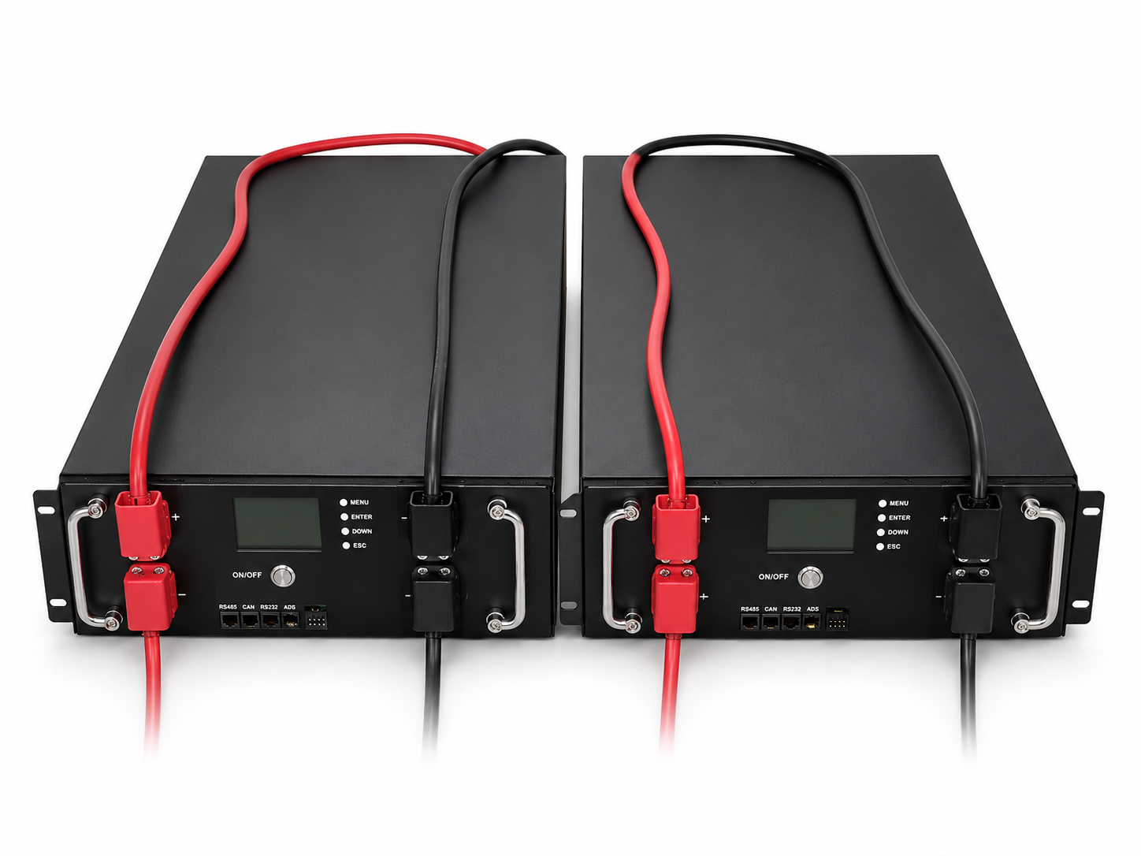 | 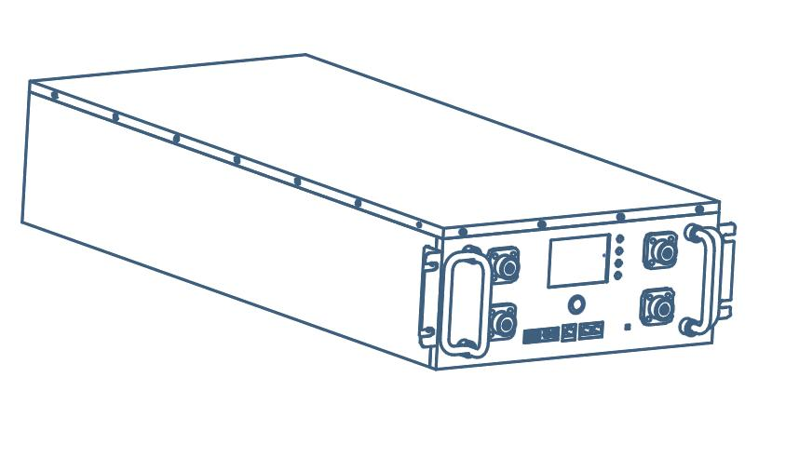 | 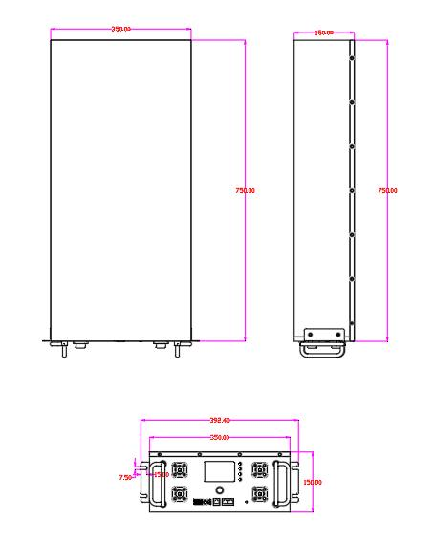 | 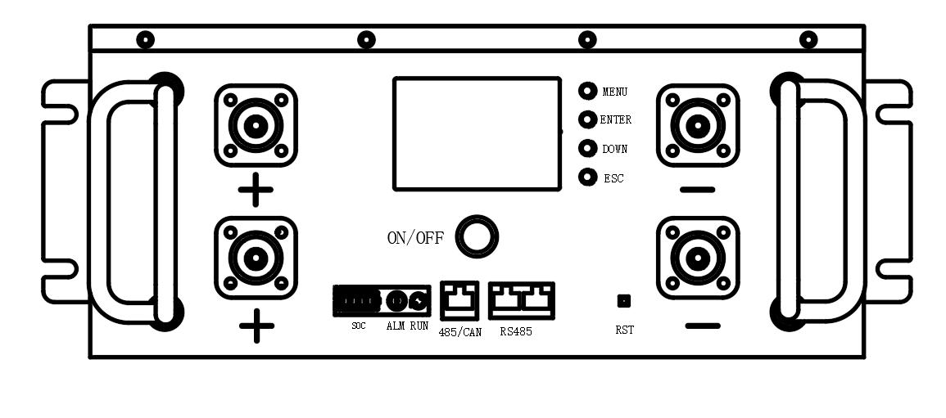
NX-UP-BA-003 · Primary | NX-UP-BA-003 · Gallery | NX-UP-BA-003 · Gallery | NX-UP-BA-003 · Gallery

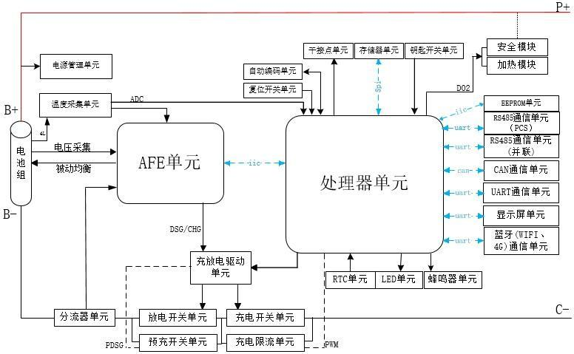 | 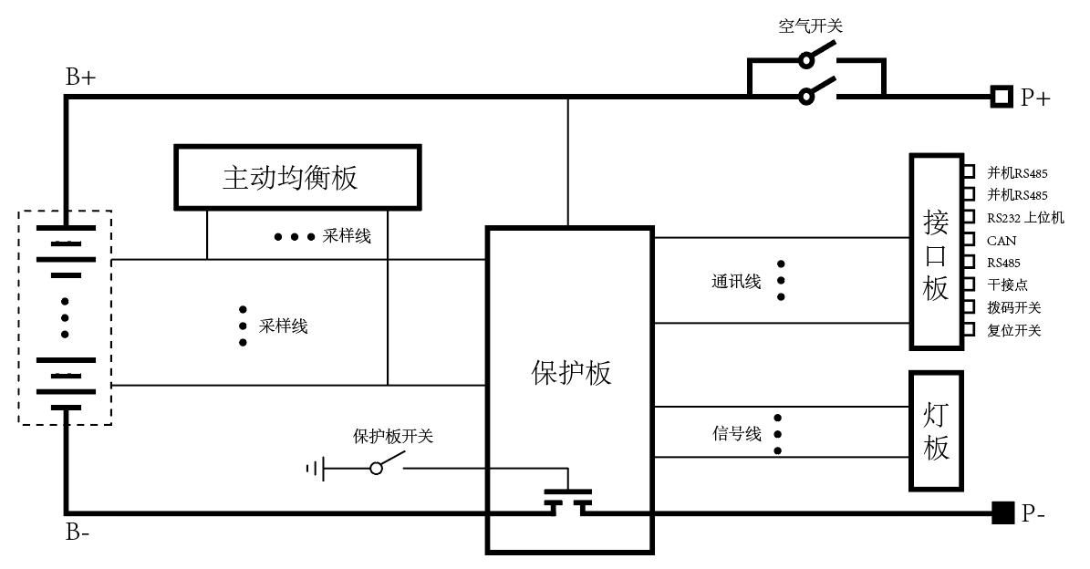 | 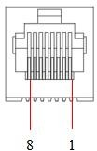 | 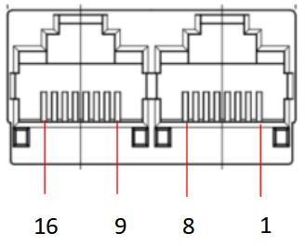
NX-UP-BA-003 · Gallery | NX-UP-BA-003 · Gallery | NX-UP-BA-003 · Gallery | NX-UP-BA-003 · Gallery

PRODUCT OVERVIEW
IFR 48V Rack-Mounted LiFePO4 Battery with 1 source-reviewed model for UPS DC backup, telecom backup and residential energy storage. Model configuration and destination-market requirements are confirmed during RFQ review.
Product line | UPS Uninterruptible Power Supply
Series / family | Standalone model
Exact model | NX-UP-BA-003
Applications | UPS DC backup, telecom backup and residential energy storage
MODEL IDENTIFICATION
Exact model | Product / variant | Topology | Power | Phase
NX-UP-BA-003 | IFR 48V Rack-Mounted LiFePO4 Battery | 48V rack-mounted LiFePO4 battery | 48V / 200Ah / 9.6kWh | DC discharge
TECHNICAL SPECIFICATIONS
Parameter | Specification
Topology | 48V rack-mounted LiFePO4 battery
Power | 48V / 200Ah / 9.6kWh
Phase | DC charge / DC discharge
SKU | NX-UP-BA-003
Power Range | 48V / 200Ah / 9.6kWh
Waveform | DC
Power Factor | Model-specific; confirm on quotation
Quotation Type | Bulk project quotation
OEM/ODM | Available
Documents | Datasheet and installation reference
Category | UPS Power
APPLICATIONS & RFQ CONFIRMATION
Typical applications | Confirm in the project RFQ
UPS DC backup  telecom backup and residential energy storage | Confirm the exact model and required configuration.  Confirm quantity, destination, packing, branding, and documentation requirements.
Project supply: MOQ — Confirm by project quantity · Lead time — Confirm by project list · FOB port — China main ports · OEM/ODM — Available; confirm project scope
PROJECT CONFIGURATION CHECKLIST
Exact model | NX-UP-BA-003
Application and site conditions | Confirm installation environment and operating requirements.
Quantity and model mix | Confirm forecast quantity, phase plan and required variants.
Interfaces and accessories | Confirm compatible interfaces, accessories and system integration scope.
Finish, branding and packing | Confirm only when project customization is required.
Documentation and destination | Confirm drawings, datasheets, packing documents and destination country or port.

