
UPS UNINTERRUPTIBLE POWER SUPPLY

VRLA Maintenance-Free Battery Series
  - Exact model: NX-UP-BA-001
PRODUCT IMAGES
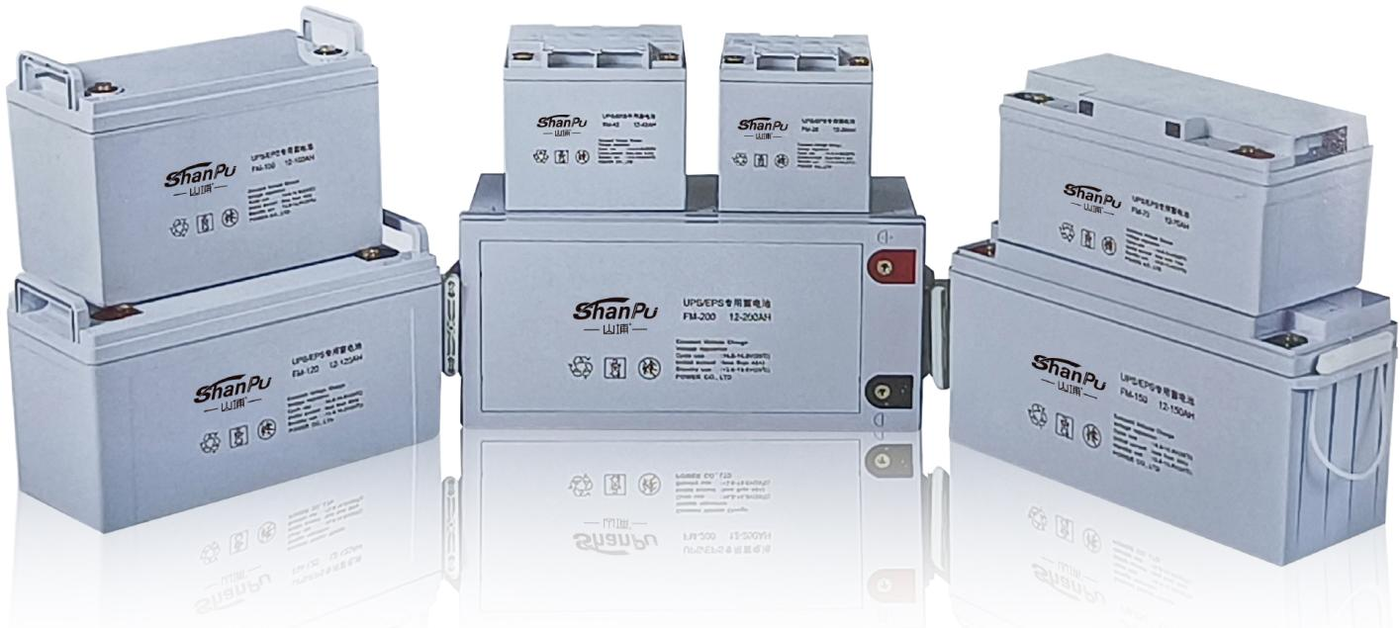 | 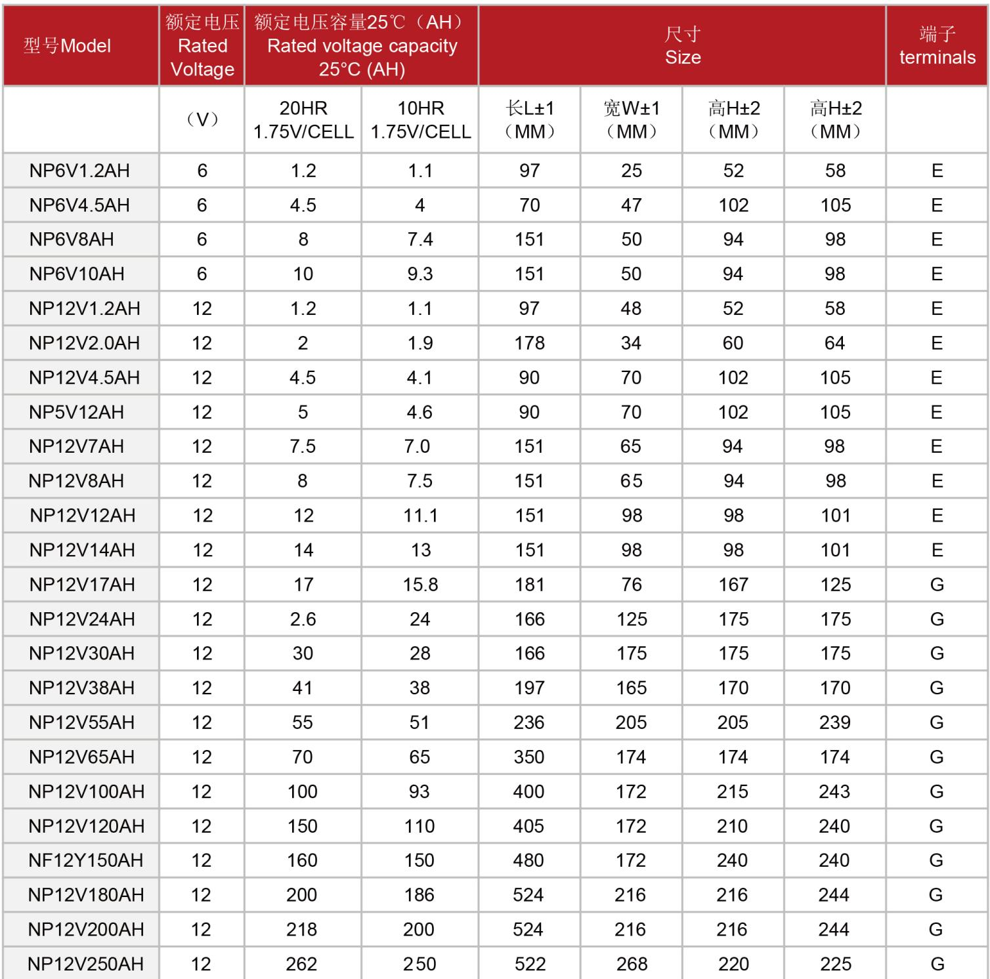
NX-UP-BA-001 · Primary | NX-UP-BA-001 · Gallery

PRODUCT OVERVIEW
VRLA AGM maintenance-free batteries in 6V and 12V, from 1.2AH to 200AH. 21 models for UPS systems, emergency backup, and power applications.
Product line | UPS Uninterruptible Power Supply
Series / family | Standalone model
Exact model | NX-UP-BA-001
Applications | Uninterruptible Power Supply (UPS), Electric Power Systems (EPS), Emergency backup systems, Emergency lighting, Railway and aircraft signals, Alarm and security systems
MODEL IDENTIFICATION
Exact model | Product / variant | Topology | Power Range | Phase
NX-UP-BA-001 | VRLA Maintenance-Free Battery Series | N/A (Battery) | 1.2AH-200AH (6V and 12V) | N/A input / N/A output
TECHNICAL SPECIFICATIONS
Parameter | Specification
Topology | N/A (Battery)
Power Range | 1.2AH-200AH (6V and 12V)
Phase | N/A input / N/A output
Form Factor | Battery Block
Waveform | N/A
Power Factor | N/A
Battery Types | VRLA AGM maintenance-free
SKU | NX-UP-BA-001
Available Configurations | NP6V1.2AH; NP6V4AH; NP6V4.5AH; NP6V7AH; NP6V10AH; NP12V1.2AH; NP12V2.3AH; NP12V3.4AH; NP12V4AH; NP12V4.5AH; NP12V7AH; NP12V9AH; NP12V12AH; NP12V17AH; NP12V24AH; NP12V38AH; NP12V65AH; NP12V100AH; NP12V120AH; NP12V150AH; NP12V200AH
Exact Configuration | Confirm one listed configuration during RFQ review
Destination Requirements | To be confirmed
ENGINEERING TABLES
NX-UP-BA-001 · Complete Model Specifications — NP6V1.2AH | NP6V4AH | NP6V4.5AH | NP6V7AH
Parameter | NP6V1.2AH | NP6V4AH | NP6V4.5AH | NP6V7AH
Rated capacity | 6V / 1.2AH | 6V / 4AH | 6V / 4.5AH | 6V / 7AH
Battery configuration | 6V / 1.2AH | 6V / 4AH | 6V / 4.5AH | 6V / 7AH
Dimensions | Not provided | Not provided | Not provided | Not provided
Net weight | Not provided | Not provided | Not provided | Not provided
Transfer time | Not provided | Not provided | Not provided | Not provided
Efficiency | Not provided | Not provided | Not provided | Not provided
Model configuration — Rated capacity | 6V / 1.2AH | 6V / 4AH | 6V / 4.5AH | 6V / 7AH
Model configuration — Battery configuration | 6V / 1.2AH | 6V / 4AH | 6V / 4.5AH | 6V / 7AH
Battery — Battery technology | VRLA AGM | VRLA AGM | VRLA AGM | VRLA AGM
Battery — Capacity reference temperature | 25°C | 25°C | 25°C | 25°C
Battery — Discharge endpoint | 1.75V/cell | 1.75V/cell | 1.75V/cell | 1.75V/cell
Battery — 20h capacity at 25°C / 1.75V per cell | 1.2Ah | Not provided | 4.5Ah | Not provided
Battery — 10h capacity at 25°C / 1.75V per cell | 1.1Ah | Not provided | 4Ah | Not provided
Physical — Length | 97mm ±1mm | Not provided | 70mm ±1mm | Not provided
Physical — Width | 25mm ±1mm | Not provided | 47mm ±1mm | Not provided
Physical — Body height | 52mm ±2mm | Not provided | 102mm ±2mm | Not provided
Physical — Overall height | 58mm ±2mm | Not provided | 105mm ±2mm | Not provided
Physical — Terminal type | E | Not provided | E | Not provided
NX-UP-BA-001 · Complete Model Specifications — NP6V10AH | NP12V1.2AH | NP12V2.3AH | NP12V3.4AH
Parameter | NP6V10AH | NP12V1.2AH | NP12V2.3AH | NP12V3.4AH
Rated capacity | 6V / 10AH | 12V / 1.2AH | 12V / 2.3AH | 12V / 3.4AH
Battery configuration | 6V / 10AH | 12V / 1.2AH | 12V / 2.3AH | 12V / 3.4AH
Dimensions | Not provided | Not provided | Not provided | Not provided
Net weight | Not provided | Not provided | Not provided | Not provided
Transfer time | Not provided | Not provided | Not provided | Not provided
Efficiency | Not provided | Not provided | Not provided | Not provided
Model configuration — Rated capacity | 6V / 10AH | 12V / 1.2AH | 12V / 2.3AH | 12V / 3.4AH
Model configuration — Battery configuration | 6V / 10AH | 12V / 1.2AH | 12V / 2.3AH | 12V / 3.4AH
Battery — Battery technology | VRLA AGM | VRLA AGM | VRLA AGM | VRLA AGM
Battery — Capacity reference temperature | 25°C | 25°C | 25°C | 25°C
Battery — Discharge endpoint | 1.75V/cell | 1.75V/cell | 1.75V/cell | 1.75V/cell
Battery — 20h capacity at 25°C / 1.75V per cell | 10Ah | 1.2Ah | Not provided | Not provided
Battery — 10h capacity at 25°C / 1.75V per cell | 9.3Ah | 1.1Ah | Not provided | Not provided
Physical — Length | 151mm ±1mm | 97mm ±1mm | Not provided | Not provided
Physical — Width | 50mm ±1mm | 48mm ±1mm | Not provided | Not provided
Physical — Body height | 94mm ±2mm | 52mm ±2mm | Not provided | Not provided
Physical — Overall height | 98mm ±2mm | 58mm ±2mm | Not provided | Not provided
Physical — Terminal type | E | E | Not provided | Not provided
NX-UP-BA-001 · Complete Model Specifications — NP12V4AH | NP12V4.5AH | NP12V7AH | NP12V9AH
Parameter | NP12V4AH | NP12V4.5AH | NP12V7AH | NP12V9AH
Rated capacity | 12V / 4AH | 12V / 4.5AH | 12V / 7AH | 12V / 9AH
Battery configuration | 12V / 4AH | 12V / 4.5AH | 12V / 7AH | 12V / 9AH
Dimensions | Not provided | Not provided | Not provided | Not provided
Net weight | Not provided | Not provided | Not provided | Not provided
Transfer time | Not provided | Not provided | Not provided | Not provided
Efficiency | Not provided | Not provided | Not provided | Not provided
Model configuration — Rated capacity | 12V / 4AH | 12V / 4.5AH | 12V / 7AH | 12V / 9AH
Model configuration — Battery configuration | 12V / 4AH | 12V / 4.5AH | 12V / 7AH | 12V / 9AH
Battery — Battery technology | VRLA AGM | VRLA AGM | VRLA AGM | VRLA AGM
Battery — Capacity reference temperature | 25°C | 25°C | 25°C | 25°C
Battery — Discharge endpoint | 1.75V/cell | 1.75V/cell | 1.75V/cell | 1.75V/cell
Battery — 20h capacity at 25°C / 1.75V per cell | Not provided | 4.5Ah | 7.5Ah | Not provided
Battery — 10h capacity at 25°C / 1.75V per cell | Not provided | 4.1Ah | 7Ah | Not provided
Physical — Length | Not provided | 90mm ±1mm | 151mm ±1mm | Not provided
Physical — Width | Not provided | 70mm ±1mm | 65mm ±1mm | Not provided
Physical — Body height | Not provided | 102mm ±2mm | 94mm ±2mm | Not provided
Physical — Overall height | Not provided | 105mm ±2mm | 98mm ±2mm | Not provided
Physical — Terminal type | Not provided | E | E | Not provided
NX-UP-BA-001 · Complete Model Specifications — NP12V12AH | NP12V17AH | NP12V24AH | NP12V38AH
Parameter | NP12V12AH | NP12V17AH | NP12V24AH | NP12V38AH
Rated capacity | 12V / 12AH | 12V / 17AH | 12V / 24AH | 12V / 38AH
Battery configuration | 12V / 12AH | 12V / 17AH | 12V / 24AH | 12V / 38AH
Dimensions | Not provided | Not provided | Not provided | Not provided
Net weight | Not provided | Not provided | Not provided | Not provided
Transfer time | Not provided | Not provided | Not provided | Not provided
Efficiency | Not provided | Not provided | Not provided | Not provided
Model configuration — Rated capacity | 12V / 12AH | 12V / 17AH | 12V / 24AH | 12V / 38AH
Model configuration — Battery configuration | 12V / 12AH | 12V / 17AH | 12V / 24AH | 12V / 38AH
Battery — Battery technology | VRLA AGM | VRLA AGM | VRLA AGM | VRLA AGM
Battery — Capacity reference temperature | 25°C | 25°C | 25°C | 25°C
Battery — Discharge endpoint | 1.75V/cell | 1.75V/cell | 1.75V/cell | 1.75V/cell
Battery — 20h capacity at 25°C / 1.75V per cell | 12Ah | 17Ah | Requires confirmation | 41Ah
Battery — 10h capacity at 25°C / 1.75V per cell | 11.1Ah | 15.8Ah | 24Ah | 38Ah
Physical — Length | 151mm ±1mm | 181mm ±1mm | 166mm ±1mm | 197mm ±1mm
Physical — Width | 98mm ±1mm | 76mm ±1mm | 125mm ±1mm | 165mm ±1mm
Physical — Body height | 98mm ±2mm | 167mm ±2mm | 175mm ±2mm | 170mm ±2mm
Physical — Overall height | 101mm ±2mm | 125mm ±2mm | 175mm ±2mm | 170mm ±2mm
Physical — Terminal type | E | G | G | G
NX-UP-BA-001 · Complete Model Specifications — NP12V65AH | NP12V100AH | NP12V120AH | NP12V150AH
Parameter | NP12V65AH | NP12V100AH | NP12V120AH | NP12V150AH
Rated capacity | 12V / 65AH | 12V / 100AH | 12V / 120AH | 12V / 150AH
Battery configuration | 12V / 65AH | 12V / 100AH | 12V / 120AH | 12V / 150AH
Dimensions | Not provided | Not provided | Not provided | Not provided
Net weight | Not provided | Not provided | Not provided | Not provided
Transfer time | Not provided | Not provided | Not provided | Not provided
Efficiency | Not provided | Not provided | Not provided | Not provided
Model configuration — Rated capacity | 12V / 65AH | 12V / 100AH | 12V / 120AH | 12V / 150AH
Model configuration — Battery configuration | 12V / 65AH | 12V / 100AH | 12V / 120AH | 12V / 150AH
Battery — Battery technology | VRLA AGM | VRLA AGM | VRLA AGM | VRLA AGM
Battery — Capacity reference temperature | 25°C | 25°C | 25°C | 25°C
Battery — Discharge endpoint | 1.75V/cell | 1.75V/cell | 1.75V/cell | 1.75V/cell
Battery — 20h capacity at 25°C / 1.75V per cell | 70Ah | 100Ah | 150Ah | Not provided
Battery — 10h capacity at 25°C / 1.75V per cell | 65Ah | 93Ah | 110Ah | Not provided
Physical — Length | 350mm ±1mm | 400mm ±1mm | 405mm ±1mm | Not provided
Physical — Width | 174mm ±1mm | 172mm ±1mm | 172mm ±1mm | Not provided
Physical — Body height | 174mm ±2mm | 215mm ±2mm | 210mm ±2mm | Not provided
Physical — Overall height | 174mm ±2mm | 243mm ±2mm | 240mm ±2mm | Not provided
Physical — Terminal type | G | G | G | Not provided
NX-UP-BA-001 · Complete Model Specifications — NP12V200AH
Parameter | NP12V200AH
Rated capacity | 12V / 200AH
Battery configuration | 12V / 200AH
Dimensions | Not provided
Net weight | Not provided
Transfer time | Not provided
Efficiency | Not provided
Model configuration — Rated capacity | 12V / 200AH
Model configuration — Battery configuration | 12V / 200AH
Battery — Battery technology | VRLA AGM
Battery — Capacity reference temperature | 25°C
Battery — Discharge endpoint | 1.75V/cell
Battery — 20h capacity at 25°C / 1.75V per cell | 218Ah
Battery — 10h capacity at 25°C / 1.75V per cell | 200Ah
Physical — Length | 524mm ±1mm
Physical — Width | 216mm ±1mm
Physical — Body height | 216mm ±2mm
Physical — Overall height | 244mm ±2mm
Physical — Terminal type | G

