
UPS UNINTERRUPTIBLE POWER SUPPLY

FPS-500 Portable Power Station
  - Exact model: FPS-500-PORTABLE-POWER-STATION
PRODUCT IMAGES
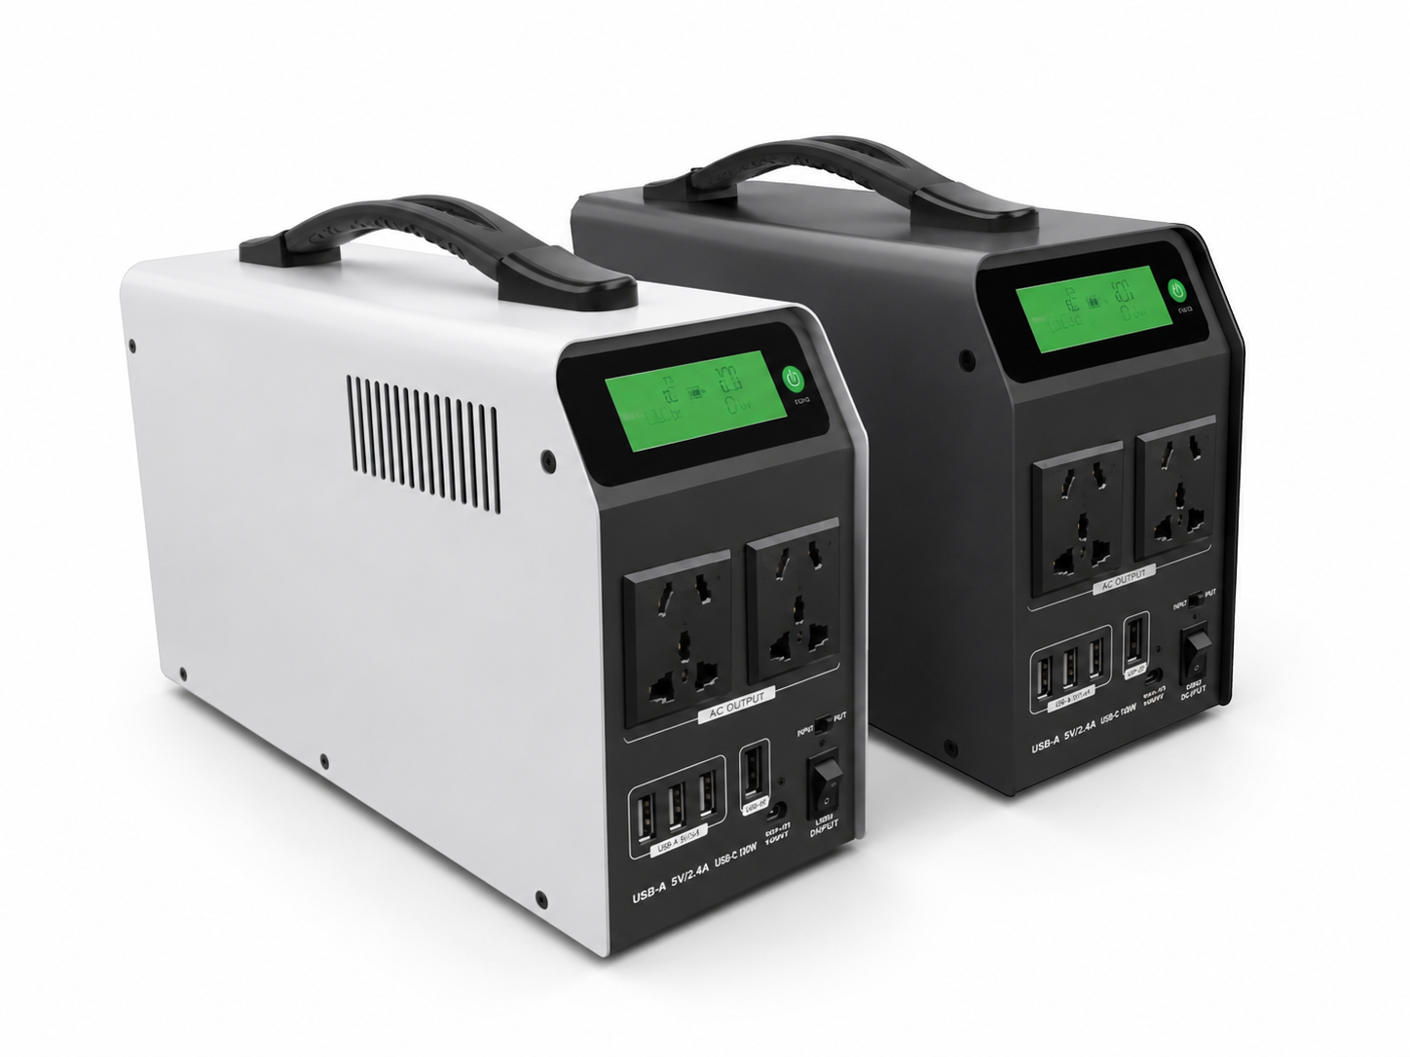
FPS-500-PORTABLE-POWER-STATION · Primary

PRODUCT OVERVIEW
FPS-500 Portable Power Station with 1 source-reviewed model for Emergency response, field work, temporary offices and mobile equipment. Model configuration and destination-market requirements are confirmed during RFQ review.
Product line | UPS Uninterruptible Power Supply
Series / family | Standalone model
Exact model | FPS-500-PORTABLE-POWER-STATION
Applications | Emergency response, field work, temporary offices and mobile equipment
MODEL IDENTIFICATION
Exact model | Product / variant | Topology | Power Range | Phase
FPS-500-PORTABLE-POWER-STATION | FPS-500 Portable Power Station | Portable energy storage power station | 500W / 230Wh | AC and solar charging input / AC and DC output
TECHNICAL SPECIFICATIONS
Parameter | Specification
Topology | Portable energy storage power station
Power Range | 500W / 230Wh
Phase | AC and solar charging input / AC and DC output
Form Factor | Portable
Waveform | Modified sine wave
Power Factor | Model-specific; confirm on quotation
Battery Types | Source-defined lithium or LiFePO4 configuration
SKU | FPS-500-PORTABLE-POWER-STATION
Available Configurations | FPS-500
Exact Configuration | Confirm one listed configuration during RFQ review
Destination Requirements | To be confirmed
ENGINEERING TABLES
FPS-500-PORTABLE-POWER-STATION · Complete Model Specifications — FPS-500
Parameter | FPS-500
Rated capacity | 500W / 230Wh
Battery configuration | Not provided
Dimensions | 317*107*175mm
Net weight | 5.1KG
Transfer time | Not provided
Efficiency | Not provided
Model configuration — Rated capacity | 500W / 230Wh
Model configuration — Product dimensions | 317*107*175mm
Model configuration — Net weight | 5.1KG
AC Output — Output Voltage | 220VAC
AC Output — Max Power | 500W
AC Output — Wave Form | Modified Sine Wave
AC Output — Frequency | 50Hz/60HZ
DC Output — USB | 4PCS USB output 5V/3A(total current)
DC Output — DC | 2PCS DC5.5/2.1 output 12V/5A(total current) (Option)
Input — AC Input | INV mode 70~145VAC OR 140 ~260VAC
Input — AC AC Charging | 4hours
Input — Solar Charging | Standard 5A
Input — Car Charging | 14.6V/4A(Option)
Battery — Capacity | Standard 230WH 12.8V/18AH
Battery — Battery type | LiFePO4 battery
PHYSICAL — Size /(mm) | 317*107*175mm
PHYSICAL — Net weight | 5.1KG
PHYSICAL — Size/CTN(mm) | 380*359*488
PHYSICAL — Gross (KG) | 23.8
PHYSICAL — PCS per CTN | 4

