
UPS UNINTERRUPTIBLE POWER SUPPLY

DCP Series Multi-Output DC UPS
  - Exact model: DCP-SERIES-DC-UPS
PRODUCT IMAGES
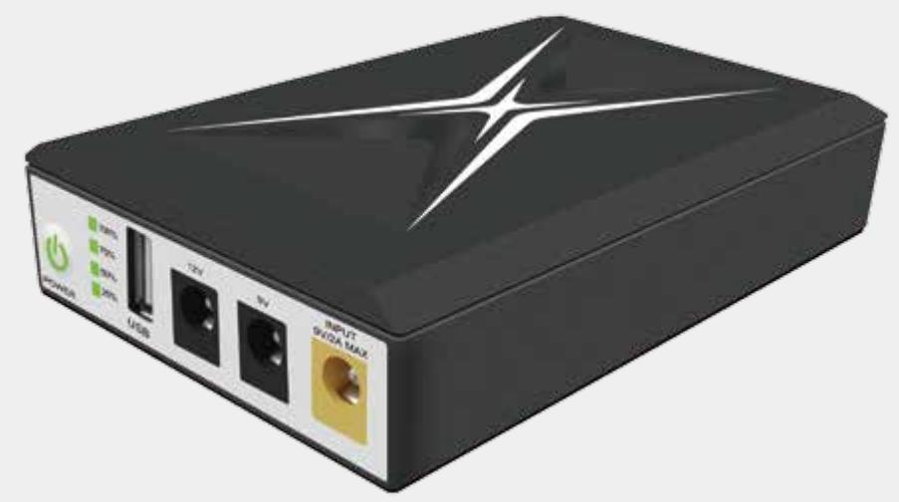 | 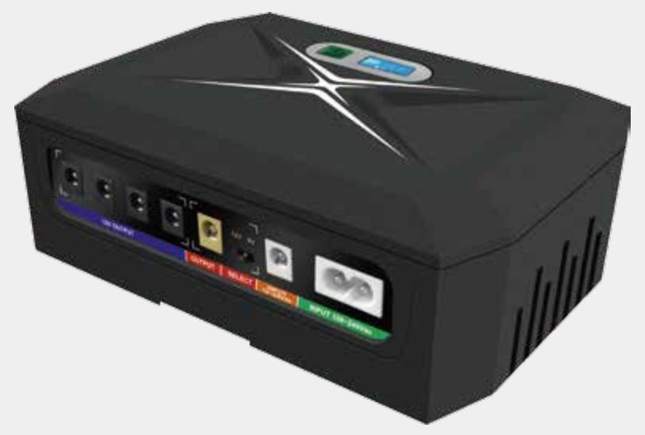 | 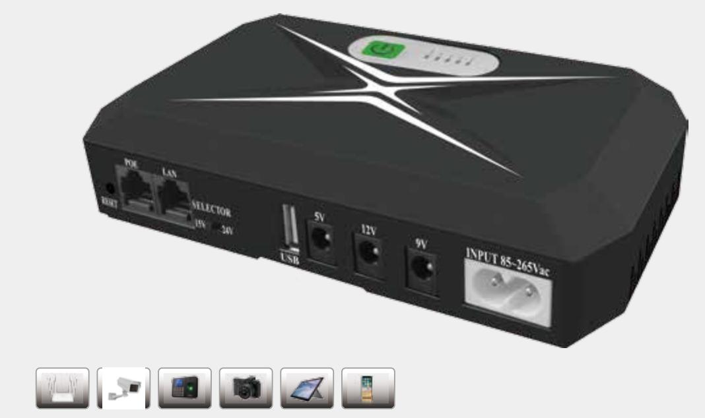 | 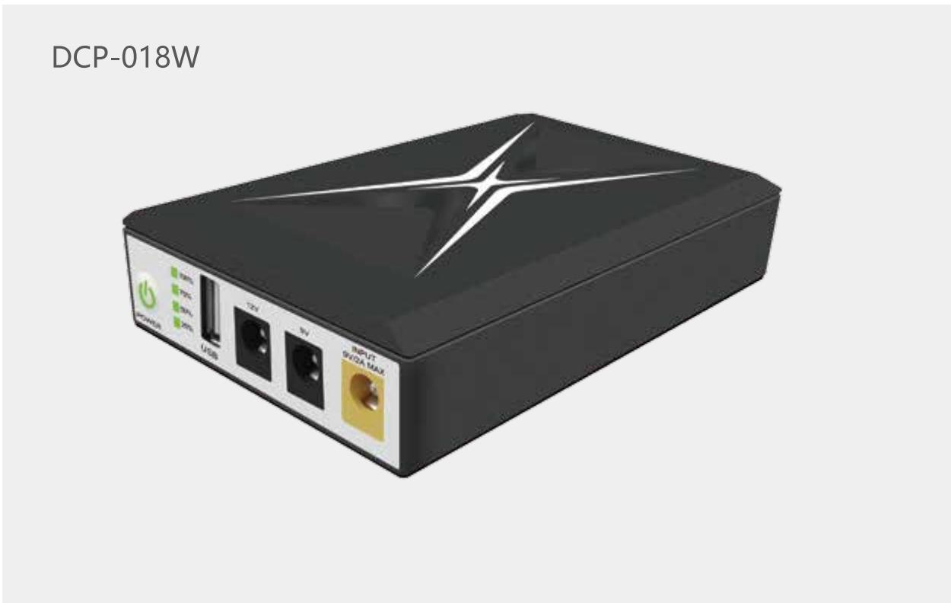
DCP-SERIES-DC-UPS · Primary | DCP-SERIES-DC-UPS · Gallery | DCP-SERIES-DC-UPS · Gallery | DCP-SERIES-DC-UPS · Gallery

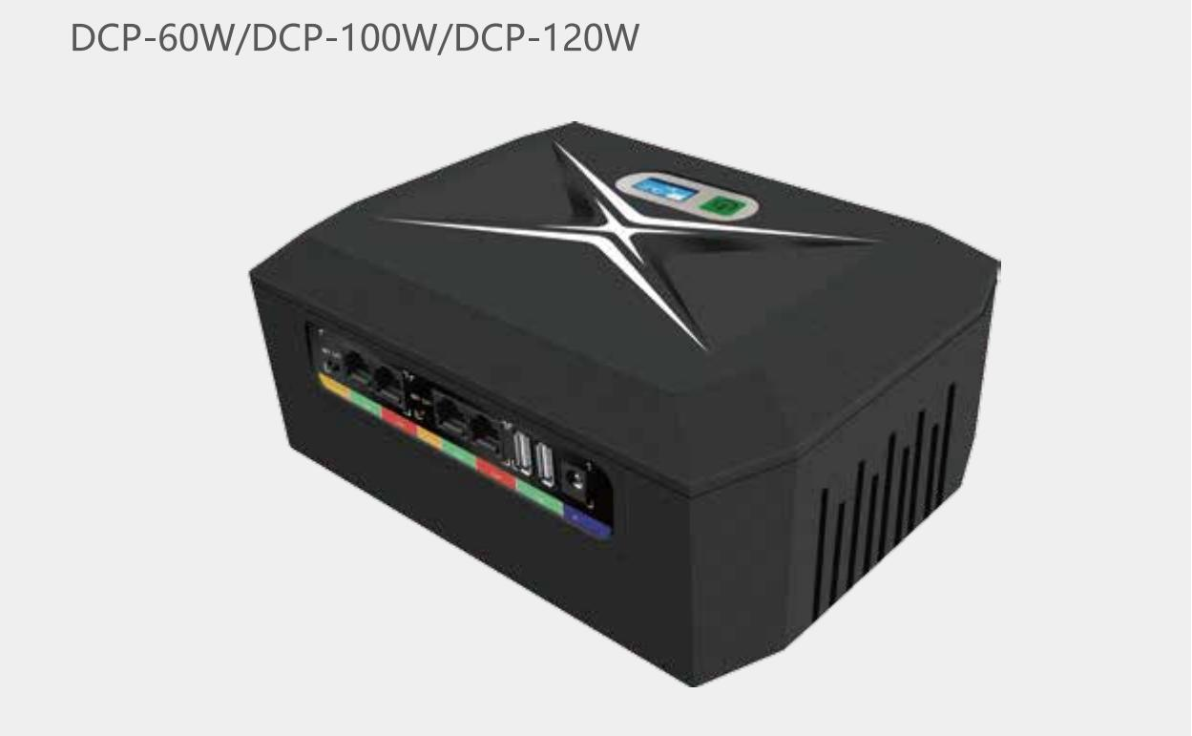
DCP-SERIES-DC-UPS · Gallery

PRODUCT OVERVIEW
DCP Series Multi-Output DC UPS with 10 source-reviewed models for Routers, CCTV cameras, access control and PoE edge devices. Model configuration and destination-market requirements are confirmed during RFQ review.
Product line | UPS Uninterruptible Power Supply
Series / family | Standalone model
Exact model | DCP-SERIES-DC-UPS
Applications | Routers, CCTV cameras, access control and PoE edge devices
MODEL IDENTIFICATION
Exact model | Product / variant | Topology | Power Range | Phase
DCP-SERIES-DC-UPS | DCP Series Multi-Output DC UPS | Multi-output DC backup UPS | 18W DC UPS to 120W DC UPS | AC or DC adapter input / DC, USB and PoE options output
TECHNICAL SPECIFICATIONS
Parameter | Specification
Topology | Multi-output DC backup UPS
Power Range | 18W DC UPS to 120W DC UPS
Phase | AC or DC adapter input / DC, USB and PoE options output
Form Factor | Compact desktop
Waveform | Regulated DC
Power Factor | Model-specific; confirm on quotation
Battery Types | Lithium-ion / LiFePO4
SKU | DCP-SERIES-DC-UPS
Available Configurations | DCP-018W; DCP-18W; DCP-6018W; DCP-36W; DCP-6036W; DCP-045W; DCP-060W; DCP-60W; DCP-100W; DCP-120W
Exact Configuration | Confirm one listed configuration during RFQ review
Destination Requirements | To be confirmed
ENGINEERING TABLES
DCP-SERIES-DC-UPS · Complete Model Specifications — DCP-018W | DCP-18W | DCP-6018W | DCP-36W
Parameter | DCP-018W | DCP-18W | DCP-6018W | DCP-36W
Rated capacity | 18W DC UPS | 18W DC UPS | 18W DC UPS | 36W DC UPS
Battery configuration | 4 cells; 18650 | 4 cells; 18650 | 4/8 cells; 18650/21700/32700 | 4 cells; 18650
Dimensions | 128mm*77mm*27mm | 180mm*106*40mm | 214mm*158.5mm*86mm | 180*106*40mm
Net weight | 0.26kg | 0.43kg | 1.68kg (max) | 0.43kg
Transfer time | Not provided | Not provided | Not provided | Not provided
Efficiency | AC mode >85%; battery mode >90% | AC mode >85%; battery mode >90% | AC mode >85%; battery mode >90% | AC mode >85%; battery mode >90%
Model configuration — Rated capacity | 18W DC UPS | 18W DC UPS | 18W DC UPS | 36W DC UPS
Model configuration — Battery configuration | 4 cells; 18650 | 4 cells; 18650 | 4/8 cells; 18650/21700/32700 | 4 cells; 18650
Model configuration — Product dimensions | 128mm*77mm*27mm | 180mm*106*40mm | 214mm*158.5mm*86mm | 180*106*40mm
Model configuration — Net weight | 0.26kg | 0.43kg | 1.68kg (max) | 0.43kg
Model configuration — Efficiency | AC mode >85%; battery mode >90% | AC mode >85%; battery mode >90% | AC mode >85%; battery mode >90% | AC mode >85%; battery mode >90%
Technical Data — Maximum output power | 18W | 18W | 18W | 36W
Technical Data — Input | DC 9V/2A max. | AC 100–240V, 50–60Hz | AC 100–240V, 50–60Hz | AC 100–240V, 50–60Hz
Technical Data — Output ports | USB 5V/2A; DC 9V/1A; DC 12V/1A | USB 5V/2A; DC 5V/2A; DC 9V/1A; DC 12V/1A; PoE 15V/0.6A; PoE 24V/0.6A | USB 5V/2A; DC 5V/2A; DC 9V/1A; DC 12V/1A; PoE 15V/0.6A; PoE 24V/0.6A | USB 5V/2A; DC 5V/2A; DC 9V/1A; DC 12V/1A; PoE 15V/1A; PoE 24V/1A
Technical Data — Battery cell size | 18650 | 18650 | 18650/21700/32700 | 18650
Technical Data — Cell capacity | 2000-2600mah | 2000-2600mah | 2000-6000mah | 2000-2600mah
Technical Data — Battery quantity | 4 | 4 | 4/8 | 4
Technical Data — Efficiency | AC mode >85%; battery mode >90% | AC mode >85%; battery mode >90% | AC mode >85%; battery mode >90% | AC mode >85%; battery mode >90%
Technical Data — Battery chemistry | Lithium-ion or LiFePO4 | Lithium-ion or LiFePO4 | Lithium-ion or LiFePO4 | Lithium-ion or LiFePO4
Technical Data — Housing | ABS, black or white | ABS, black or white | ABS, black or white | ABS, black or white
Technical Data — Protection | Over-charge, over-discharge, over-current, overload, over-temperature and short-circuit protection | Over-charge, over-discharge, over-current, overload, over-temperature and short-circuit protection | Over-charge, over-discharge, over-current, overload, over-temperature and short-circuit protection | Over-charge, over-discharge, over-current, overload, over-temperature and short-circuit protection
Technical Data — Operating temperature | 0–40°C | 0–40°C | 0–40°C | 0–40°C
Technical Data — Storage temperature | -10–70°C | -10–70°C | -10–70°C | -10–70°C
Technical Data — Humidity | 10–90% RH | 10–90% RH | 10–90% RH | 10–90% RH
Technical Data — Altitude | <3000 m | <3000 m | <3000 m | <3000 m
Technical Data — Noise | <30 dB | <30 dB | <30 dB | <30 dB
Technical Data — Product dimensions | 128mm*77mm*27mm | 180mm*106*40mm | 214mm*158.5mm*86mm | 180*106*40mm
Technical Data — Package dimensions | 178mm*85mm*33mm(Without adaptor) | 190mm*160mm*50mm | 230mm*230mm*95mm | 190mm*160mm*50mm
Technical Data — Net weight | 0.26kg | 0.43kg | 1.68kg (max) | 0.43kg
Technical Data — Gross weight | 0.32kg | 0.56kg | 2.43kg (max) | 0.56kg
DCP-SERIES-DC-UPS · Complete Model Specifications — DCP-6036W | DCP-045W | DCP-060W | DCP-60W
Parameter | DCP-6036W | DCP-045W | DCP-060W | DCP-60W
Rated capacity | 36W DC UPS | 45W DC UPS | 60W DC UPS | 60W DC UPS
Battery configuration | 4/8 cells; 18650/21700/32700 | 4/8 cells; 18650 | 4/8 cells; 18650 | 4/8 cells; 18650/21700/32700
Dimensions | 214mm*158.5mm*86mm | 180mm*130mm*64mm | 180mm*130mm*64mm | 214mm*158.5mm*86mm
Net weight | 1.69kg (max) | 0.83kg (max) | 0.85kg (max) | 1.85kg (max)
Transfer time | Not provided | Not provided | Not provided | Not provided
Efficiency | AC mode >85%; battery mode >90% | AC mode >85%; battery mode >90% | AC mode >85%; battery mode >90% | AC mode >85%; battery mode >90%
Model configuration — Rated capacity | 36W DC UPS | 45W DC UPS | 60W DC UPS | 60W DC UPS
Model configuration — Battery configuration | 4/8 cells; 18650/21700/32700 | 4/8 cells; 18650 | 4/8 cells; 18650 | 4/8 cells; 18650/21700/32700
Model configuration — Product dimensions | 214mm*158.5mm*86mm | 180mm*130mm*64mm | 180mm*130mm*64mm | 214mm*158.5mm*86mm
Model configuration — Net weight | 1.69kg (max) | 0.83kg (max) | 0.85kg (max) | 1.85kg (max)
Model configuration — Efficiency | AC mode >85%; battery mode >90% | AC mode >85%; battery mode >90% | AC mode >85%; battery mode >90% | AC mode >85%; battery mode >90%
Technical Data — Maximum output power | 36W | 45W | 60W | 60W
Technical Data — Input | AC 100–240V, 50–60Hz | AC 100–240V, 50–60Hz | AC 100–240V, 50–60Hz | AC 100–240V, 50–60Hz
Technical Data — Output ports | USB 5V/2A; DC 5V/2A; DC 9V/1A; DC 12V/1A; PoE 15V/1A; PoE 24V/1A; PoE 48V/0.6A | USB 5V/2.4A; DC 5V/2.4A; DC 9V(12V)/2A; DC 12V/3.5A; PoE 15V/1.5A; PoE 24V/1A; PoE 48V/0.6A | USB 5V/2.4A; DC 5V/2.4A; DC 9V(12V)/2A; DC 12V/5A; PoE 15V/1.5A; PoE 24V/1A; PoE 48V/0.6A | USB 5V/2.4A; DC 5V/2.4A; DC 9V(12V)/2A; DC 12V/5A; DC 19V/3A; PoE 15V/1.5A; PoE 24V/1A; PoE 48V/0.6A (optional)
Technical Data — Battery cell size | 18650/21700/32700 | 18650 | 18650 | 18650/21700/32700
Technical Data — Cell capacity | 2000-6000mah | 2000-2600mah | 2000-2600mah | 2000-6000mah
Technical Data — Battery quantity | 4/8 | 4/8 | 4/8 | 4/8
Technical Data — Efficiency | AC mode >85%; battery mode >90% | AC mode >85%; battery mode >90% | AC mode >85%; battery mode >90% | AC mode >85%; battery mode >90%
Technical Data — Battery chemistry | Lithium-ion or LiFePO4 | Lithium-ion or LiFePO4 | Lithium-ion or LiFePO4 | Lithium-ion or LiFePO4
Technical Data — Housing | ABS, black or white | ABS, black or white | ABS, black or white | ABS, black or white
Technical Data — Protection | Over-charge, over-discharge, over-current, overload, over-temperature and short-circuit protection | Over-charge, over-discharge, over-current, overload, over-temperature and short-circuit protection | Over-charge, over-discharge, over-current, overload, over-temperature and short-circuit protection | Over-charge, over-discharge, over-current, overload, over-temperature and short-circuit protection
Technical Data — Operating temperature | 0–40°C | 0–40°C | 0–40°C | 0–40°C
Technical Data — Storage temperature | -10–70°C | -10–70°C | -10–70°C | -10–70°C
Technical Data — Humidity | 10–90% RH | 10–90% RH | 10–90% RH | 10–90% RH
Technical Data — Altitude | <3000 m | <3000 m | <3000 m | <3000 m
Technical Data — Noise | <30 dB | <30 dB | <30 dB | <45 dB
Technical Data — Product dimensions | 214mm*158.5mm*86mm | 180mm*130mm*64mm | 180mm*130mm*64mm | 214mm*158.5mm*86mm
Technical Data — Package dimensions | 230mm*230mm*95mm | 195mm*180mm*70mm | 195mm*180mm*70mm | 230mm*230mm*95mm
Technical Data — Net weight | 1.69kg (max) | 0.83kg (max) | 0.85kg (max) | 1.85kg (max)
Technical Data — Gross weight | 2.44kg (max) | 1.2kg (max) | 1.3kg (max) | 2.6kg (max)
DCP-SERIES-DC-UPS · Complete Model Specifications — DCP-100W | DCP-120W
Parameter | DCP-100W | DCP-120W
Rated capacity | 100W DC UPS | 120W DC UPS
Battery configuration | 4/8 cells; 18650/21700/32700 | 4/8 cells; 18650/21700/32700
Dimensions | 214mm*158.5mm*86mm | 214mm*158.5mm*86mm
Net weight | 1.88kg (max) | 1.9kg (max)
Transfer time | Not provided | Not provided
Efficiency | AC mode >85%; battery mode >90% | AC mode >85%; battery mode >90%
Model configuration — Rated capacity | 100W DC UPS | 120W DC UPS
Model configuration — Battery configuration | 4/8 cells; 18650/21700/32700 | 4/8 cells; 18650/21700/32700
Model configuration — Product dimensions | 214mm*158.5mm*86mm | 214mm*158.5mm*86mm
Model configuration — Net weight | 1.88kg (max) | 1.9kg (max)
Model configuration — Efficiency | AC mode >85%; battery mode >90% | AC mode >85%; battery mode >90%
Technical Data — Maximum output power | 100W | 120W
Technical Data — Input | AC 100–240V, 50–60Hz | AC 100–240V, 50–60Hz
Technical Data — Output ports | USB 5V/2.4A; DC 5V/2.4A; DC 9V(12V)/2A; DC 12V/8A; DC 19V/5A; PoE 15V/1.5A; PoE 24V/1A; PoE 48V/0.6A (optional) | USB 5V/2.4A; DC 5V/2.4A; DC 9V(12V)/2A; DC 12V/10A; DC 19V/6A; PoE 15V/1.5A; PoE 24V/1A; PoE 48V/0.6A (optional)
Technical Data — Battery cell size | 18650/21700/32700 | 18650/21700/32700
Technical Data — Cell capacity | 2000-6000mah | 2000-6000mah
Technical Data — Battery quantity | 4/8 | 4/8
Technical Data — Efficiency | AC mode >85%; battery mode >90% | AC mode >85%; battery mode >90%
Technical Data — Battery chemistry | Lithium-ion or LiFePO4 | Lithium-ion or LiFePO4
Technical Data — Housing | ABS, black or white | ABS, black or white
Technical Data — Protection | Over-charge, over-discharge, over-current, overload, over-temperature and short-circuit protection | Over-charge, over-discharge, over-current, overload, over-temperature and short-circuit protection
Technical Data — Operating temperature | 0–40°C | 0–40°C
Technical Data — Storage temperature | -10–70°C | -10–70°C
Technical Data — Humidity | 10–90% RH | 10–90% RH
Technical Data — Altitude | <3000 m | <3000 m
Technical Data — Noise | <45 dB | <45 dB
Technical Data — Product dimensions | 214mm*158.5mm*86mm | 214mm*158.5mm*86mm
Technical Data — Package dimensions | 230mm*230mm*95mm | 230mm*230mm*95mm
Technical Data — Net weight | 1.88kg (max) | 1.9kg (max)
Technical Data — Gross weight | 2.63kg (max) | 2.65kg (max)

