
UPS UNINTERRUPTIBLE POWER SUPPLY

C Series Online Double-Conversion UPS
  - Exact model: C-SERIES-ONLINE-UPS
PRODUCT IMAGES
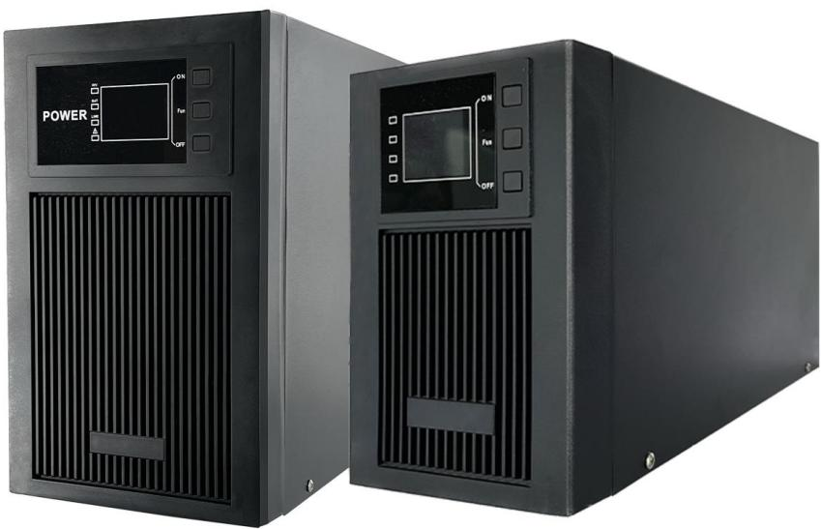
C-SERIES-ONLINE-UPS · Primary

PRODUCT OVERVIEW
C Series Online Double-Conversion UPS with 9 source-reviewed models for Servers, network rooms, CCTV control rooms and communication systems. Model configuration and destination-market requirements are confirmed during RFQ review.
Product line | UPS Uninterruptible Power Supply
Series / family | Standalone model
Exact model | C-SERIES-ONLINE-UPS
Applications | Servers, network rooms, CCTV control rooms and communication systems
MODEL IDENTIFICATION
Exact model | Product / variant | Topology | Power Range | Phase
C-SERIES-ONLINE-UPS | C Series Online Double-Conversion UPS | Online UPS | 1000VA / 800W Standard Battery to 10kVA / 8kW Long-Run | Single phase input / Single phase output
TECHNICAL SPECIFICATIONS
Parameter | Specification
Topology | Online UPS
Power Range | 1000VA / 800W Standard Battery to 10kVA / 8kW Long-Run
Phase | Single phase input / Single phase output
Form Factor | Tower
Waveform | Pure sine wave
Power Factor | Model-specific; confirm on quotation
Battery Types | Model-dependent
SKU | C-SERIES-ONLINE-UPS
Available Configurations | C1K-STANDARD; C1KS-LONG-RUN; C2K-STANDARD; C2KS-LONG-RUN; C3K-STANDARD; C3KS-LONG-RUN; C5K-STANDARD; C6KS-LONG-RUN; C10KS-LONG-RUN
Exact Configuration | Confirm one listed configuration during RFQ review
Destination Requirements | To be confirmed
ENGINEERING TABLES
C-SERIES-ONLINE-UPS · Complete Model Specifications — C1K-STANDARD | C1KS-LONG-RUN | C2K-STANDARD | C2KS-LONG-RUN
Parameter | C1K-STANDARD | C1KS-LONG-RUN | C2K-STANDARD | C2KS-LONG-RUN
Rated capacity | 1000VA / 800W Standard Battery | 1000VA / 800W Long-Run | 2000VA / 1600W Standard Battery | 2000VA / 1600W Long-Run
Battery configuration | 2 × 12V 7Ah | 3 × 12V external batteries; Ah selected by project | 4 × 12V 7Ah | 6 × 12V external batteries; Ah selected by project
Dimensions | 360 × 147 × 220 mm | 360 × 147 × 220 mm | 440 × 192 × 340 mm | 440 × 192 × 340 mm
Net weight | 11.9 kg | 8.5 kg | 22 kg | 16 kg
Transfer time | 0 ms | 0 ms | 0 ms | 0 ms
Efficiency | Not provided | Not provided | Not provided | Not provided
Model configuration — Rated capacity | 1000VA / 800W Standard Battery | 1000VA / 800W Long-Run | 2000VA / 1600W Standard Battery | 2000VA / 1600W Long-Run
Model configuration — Battery configuration | 2 × 12V 7Ah | 3 × 12V external batteries; Ah selected by project | 4 × 12V 7Ah | 6 × 12V external batteries; Ah selected by project
Model configuration — Product dimensions | 360 × 147 × 220 mm | 360 × 147 × 220 mm | 440 × 192 × 340 mm | 440 × 192 × 340 mm
Model configuration — Net weight | 11.9 kg | 8.5 kg | 22 kg | 16 kg
Model configuration — Transfer time | 0 ms | 0 ms | 0 ms | 0 ms
Technical Data — Topology | Online UPS | Online UPS | Online UPS | Online UPS
Technical Data — Output voltage | 220 VAC | 220 VAC | 220 VAC | 220 VAC
Technical Data — AC voltage regulation | ±10% | ±10% | ±10% | ±10%
Technical Data — Battery-mode frequency | 50 Hz ±0.25 Hz or 60 Hz ±0.3 Hz | 50 Hz ±0.25 Hz or 60 Hz ±0.3 Hz | 50 Hz ±0.25 Hz or 60 Hz ±0.3 Hz | 50 Hz ±0.25 Hz or 60 Hz ±0.3 Hz
Technical Data — Transfer time | 0 ms | 0 ms | 0 ms | 0 ms
Technical Data — Output waveform | Pure sine wave | Pure sine wave | Pure sine wave | Pure sine wave
Technical Data — Overload 105–110% | Alarm, no shutdown | Alarm, no shutdown | Alarm, no shutdown | Alarm, no shutdown
Technical Data — Overload 110–130% | Auto shutdown after 30 seconds | Auto shutdown after 30 seconds | Auto shutdown after 30 seconds | Auto shutdown after 30 seconds
Technical Data — Overload >130% | Immediate shutdown | Immediate shutdown | Immediate shutdown | Immediate shutdown
Technical Data — Environment | 20–90% RH, 0–40°C, non-condensing | 20–90% RH, 0–40°C, non-condensing | 20–90% RH, 0–40°C, non-condensing | 20–90% RH, 0–40°C, non-condensing
Technical Data — Noise | <55 dBA at 1 m | <55 dBA at 1 m | <55 dBA at 1 m | <55 dBA at 1 m
Technical Data — Management | RS-232; optional SNMP/web management | RS-232; optional SNMP/web management | RS-232; optional SNMP/web management | RS-232; optional SNMP/web management
Technical Data — Capacity | 1000VA /800W | 1000VA /800W | 2000VA /1600W | 2000VA /1600W
Technical Data — Input voltage range | 145–275 VAC ±5V | 145–275 VAC ±5V | 145–275 VAC ±5V | 145–275 VAC ±5V
Technical Data — Input frequency | 50–60 Hz | 50–60 Hz | 50–60 Hz | 50–60 Hz
Technical Data — Battery configuration | 2 × 12V 7Ah | 3 × 12V external batteries; Ah selected by project | 4 × 12V 7Ah | 6 × 12V external batteries; Ah selected by project
Technical Data — Maximum charging current | 1A ±10%; optional max. 1A or 2A | >5 A | 1A ±10%; optional max. 1A or 2A | >5 A
Technical Data — Charging voltage | 27.3 VDC ±1% | 27.4 VDC ±1% | 54.7 VDC ±1% | 82.1 VDC ±1%
Technical Data — Dimensions | 360 × 147 × 220 mm | 360 × 147 × 220 mm | 440 × 192 × 340 mm | 440 × 192 × 340 mm
Technical Data — Net weight | 11.9 kg | 8.5 kg | 22 kg | 16 kg
C-SERIES-ONLINE-UPS · Complete Model Specifications — C3K-STANDARD | C3KS-LONG-RUN | C5K-STANDARD | C6KS-LONG-RUN
Parameter | C3K-STANDARD | C3KS-LONG-RUN | C5K-STANDARD | C6KS-LONG-RUN
Rated capacity | 3000VA / 2400W Standard Battery | 3000VA / 2400W Long-Run | 5000VA / 3000W Standard Battery | 6000VA / 4.8kW Long-Run
Battery configuration | 6 × 12V 7Ah | 8 × 12V external batteries; Ah selected by project | 4 × 12V 17Ah | 16 × 12V external batteries; Ah selected by project
Dimensions | 440 × 192 × 340 mm | 440 × 192 × 340 mm | 440 × 190 × 320 mm | 520 × 240 × 460 mm
Net weight | 27.9 kg | 18.2 kg | 33 kg | 30.5 kg
Transfer time | 0 ms | 0 ms | 0 ms | 0 ms
Efficiency | Not provided | Not provided | Not provided | Not provided
Model configuration — Rated capacity | 3000VA / 2400W Standard Battery | 3000VA / 2400W Long-Run | 5000VA / 3000W Standard Battery | 6000VA / 4.8kW Long-Run
Model configuration — Battery configuration | 6 × 12V 7Ah | 8 × 12V external batteries; Ah selected by project | 4 × 12V 17Ah | 16 × 12V external batteries; Ah selected by project
Model configuration — Product dimensions | 440 × 192 × 340 mm | 440 × 192 × 340 mm | 440 × 190 × 320 mm | 520 × 240 × 460 mm
Model configuration — Net weight | 27.9 kg | 18.2 kg | 33 kg | 30.5 kg
Model configuration — Transfer time | 0 ms | 0 ms | 0 ms | 0 ms
Technical Data — Topology | Online UPS | Online UPS | Online UPS | Online UPS
Technical Data — Output voltage | 220 VAC | 220 VAC | 220 VAC | 220 VAC
Technical Data — AC voltage regulation | ±10% | ±10% | ±10% | ±10%
Technical Data — Battery-mode frequency | 50 Hz ±0.25 Hz or 60 Hz ±0.3 Hz | 50 Hz ±0.25 Hz or 60 Hz ±0.3 Hz | 50 Hz ±0.25 Hz or 60 Hz ±0.3 Hz | 50 Hz ±0.25 Hz or 60 Hz ±0.3 Hz
Technical Data — Transfer time | 0 ms | 0 ms | 0 ms | 0 ms
Technical Data — Output waveform | Pure sine wave | Pure sine wave | Pure sine wave | Pure sine wave
Technical Data — Overload 105–110% | Alarm, no shutdown | Alarm, no shutdown | Alarm, no shutdown | Alarm, no shutdown
Technical Data — Overload 110–130% | Auto shutdown after 30 seconds | Auto shutdown after 30 seconds | Auto shutdown after 30 seconds | Auto shutdown after 30 seconds
Technical Data — Overload >130% | Immediate shutdown | Immediate shutdown | Immediate shutdown | Immediate shutdown
Technical Data — Environment | 20–90% RH, 0–40°C, non-condensing | 20–90% RH, 0–40°C, non-condensing | 20–90% RH, 0–40°C, non-condensing | 20–90% RH, 0–40°C, non-condensing
Technical Data — Noise | <55 dBA at 1 m | <55 dBA at 1 m | <55 dBA at 1 m | <55 dBA at 1 m
Technical Data — Management | RS-232; optional SNMP/web management | RS-232; optional SNMP/web management | RS-232; optional SNMP/web management | RS-232; optional SNMP/web management
Technical Data — Capacity | 3000VA /2400W | 3000VA /2400W | 5000VA /3000W | 6000VA /4.8kW
Technical Data — Input voltage range | 145–275 VAC ±5V | 145–275 VAC ±5V | 165–275 VAC ±5V | 165–275 VAC ±5V
Technical Data — Input frequency | 50–60 Hz | 50–60 Hz | 50–60 Hz | 50–60 Hz
Technical Data — Battery configuration | 6 × 12V 7Ah | 8 × 12V external batteries; Ah selected by project | 4 × 12V 17Ah | 16 × 12V external batteries; Ah selected by project
Technical Data — Maximum charging current | 1A ±10%; optional max. 1A or 2A | >5 A | 1A ±10%; optional max. 1A or 2A | >5 A
Technical Data — Charging voltage | 82.0 VDC ±1% | 109.4 VDC ±1% | 54.7 VDC ±1% | 218.4 VDC ±1%
Technical Data — Dimensions | 440 × 192 × 340 mm | 440 × 192 × 340 mm | 440 × 190 × 320 mm | 520 × 240 × 460 mm
Technical Data — Net weight | 27.9 kg | 18.2 kg | 33 kg | 30.5 kg
C-SERIES-ONLINE-UPS · Complete Model Specifications — C10KS-LONG-RUN
Parameter | C10KS-LONG-RUN
Rated capacity | 10kVA / 8kW Long-Run
Battery configuration | 16 × 12V external batteries; Ah selected by project
Dimensions | 520 × 240 × 460 mm
Net weight | 35 kg
Transfer time | 0 ms
Efficiency | Not provided
Model configuration — Rated capacity | 10kVA / 8kW Long-Run
Model configuration — Battery configuration | 16 × 12V external batteries; Ah selected by project
Model configuration — Product dimensions | 520 × 240 × 460 mm
Model configuration — Net weight | 35 kg
Model configuration — Transfer time | 0 ms
Technical Data — Topology | Online UPS
Technical Data — Output voltage | 220 VAC
Technical Data — AC voltage regulation | ±10%
Technical Data — Battery-mode frequency | 50 Hz ±0.25 Hz or 60 Hz ±0.3 Hz
Technical Data — Transfer time | 0 ms
Technical Data — Output waveform | Pure sine wave
Technical Data — Overload 105–110% | Alarm, no shutdown
Technical Data — Overload 110–130% | Auto shutdown after 30 seconds
Technical Data — Overload >130% | Immediate shutdown
Technical Data — Environment | 20–90% RH, 0–40°C, non-condensing
Technical Data — Noise | <55 dBA at 1 m
Technical Data — Management | RS-232; optional SNMP/web management
Technical Data — Capacity | 10kVA /8kW
Technical Data — Input voltage range | 165–275 VAC ±5V
Technical Data — Input frequency | 50–60 Hz
Technical Data — Battery configuration | 16 × 12V external batteries; Ah selected by project
Technical Data — Maximum charging current | >5 A
Technical Data — Charging voltage | 218.4 VDC ±1%
Technical Data — Dimensions | 520 × 240 × 460 mm
Technical Data — Net weight | 35 kg

