
UPS UNINTERRUPTIBLE POWER SUPPLY

AL-WM Wall-Mounted LiFePO4 Batteries
  - Exact model: AL-WM-WALL-BATTERY
PRODUCT IMAGES
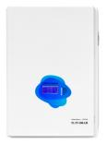 | 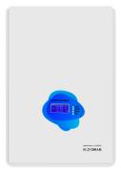 | 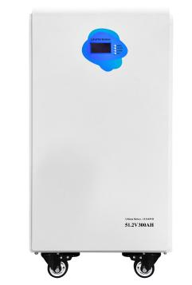 | 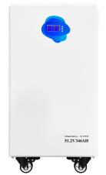
AL-WM-WALL-BATTERY · Primary | AL-WM-WALL-BATTERY · Gallery | AL-WM-WALL-BATTERY · Gallery | AL-WM-WALL-BATTERY · Gallery

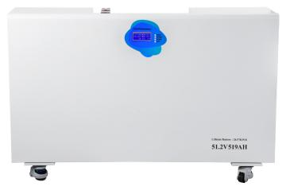
AL-WM-WALL-BATTERY · Gallery

PRODUCT OVERVIEW
AL-WM Wall-Mounted LiFePO4 Batteries with 4 source-reviewed models for Residential storage, inverter battery banks and DC backup systems. Model configuration and destination-market requirements are confirmed during RFQ review.
Product line | UPS Uninterruptible Power Supply
Series / family | Standalone model
Exact model | AL-WM-WALL-BATTERY
Applications | Residential storage, inverter battery banks and DC backup systems
MODEL IDENTIFICATION
Exact model | Product / variant | Topology | Power Range | Phase
AL-WM-WALL-BATTERY | AL-WM Wall-Mounted LiFePO4 Batteries | Wall-mounted LiFePO4 battery | 10KWH to 26KWH | DC charge input / DC discharge output
TECHNICAL SPECIFICATIONS
Parameter | Specification
Topology | Wall-mounted LiFePO4 battery
Power Range | 10KWH to 26KWH
Phase | DC charge input / DC discharge output
Form Factor | Wall mounted
Waveform | DC
Power Factor | Model-specific; confirm on quotation
Battery Types | Source-defined lithium or LiFePO4 configuration
SKU | AL-WM-WALL-BATTERY
Available Configurations | AL-WM512200; AL-WM512300; AL-WM512346; AL-WM512519
Exact Configuration | Confirm one listed configuration during RFQ review
Destination Requirements | To be confirmed
ENGINEERING TABLES
AL-WM-WALL-BATTERY · Complete Model Specifications — AL-WM512200 | AL-WM512300 | AL-WM512346 | AL-WM512519
Parameter | AL-WM512200 | AL-WM512300 | AL-WM512346 | AL-WM512519
Rated capacity | 10KWH | 15KWH | 18KWH | 26KWH
Battery configuration | 51.2V 200Ah / 10kWh | 51.2V 300Ah / 15kWh | 51.2V 346Ah / 18kWh | 51.2V 519Ah / 26kWh
Dimensions | Not provided | Not provided | Not provided | Not provided
Net weight | 87kg | 129kg | 132.2kg | 174kg
Transfer time | Not provided | Not provided | Not provided | Not provided
Efficiency | Not provided | Not provided | Not provided | Not provided
Model configuration — Rated capacity | 10KWH | 15KWH | 18KWH | 26KWH
Model configuration — Battery configuration | 51.2V 200Ah / 10kWh | 51.2V 300Ah / 15kWh | 51.2V 346Ah / 18kWh | 51.2V 519Ah / 26kWh
Model configuration — Net weight | 87kg | 129kg | 132.2kg | 174kg
Battery — Battery configuration | 16S1P | 16S1P | 16S1P | 16S1P
Battery — Battery energy | 10kWh (catalog rating) | 15kWh (catalog rating) | 18kWh (catalog rating) | 26kWh (catalog rating)
Communication & Monitoring — Communication interface | RS485 / CAN | RS485 / CAN | RS485 / CAN | RS485 / CAN
Communication & Monitoring — Battery management | BMS | BMS | BMS | BMS
Communication & Monitoring — Display | LCD (optional) | LCD (optional) | LCD (optional) | LCD (optional)
Packaging — Package dimensions | 725×520×310mm | 740×570×420mm | 740×570×420mm | 1050×665×215mm
Packaging — Wooden crate dimensions | 765×550×445mm | 775×600×555mm | 775×600×555mm | 1200×700×320mm
Packaging — Gross weight | 105.15kg | 146kg | 149.2kg | 194kg
Accessories — Accessories | Positive/negative cables: 1200mm × 1 each; RJ45 (RS485): 1500mm × 1; User manual | Positive/negative cables: 1200mm × 1 each; RJ45 (RS485): 1500mm × 1; User manual | Positive/negative cables: 1200mm × 1 each; RJ45 (RS485): 1500mm × 1; User manual | Positive/negative cables: 1200mm × 1 each; RJ45 (RS485): 1500mm × 1; User manual

