
UPS UNINTERRUPTIBLE POWER SUPPLY

AL-BP 12.8V LiFePO4 Batteries
  - Exact model: AL-BP-12V-BATTERY
PRODUCT IMAGES
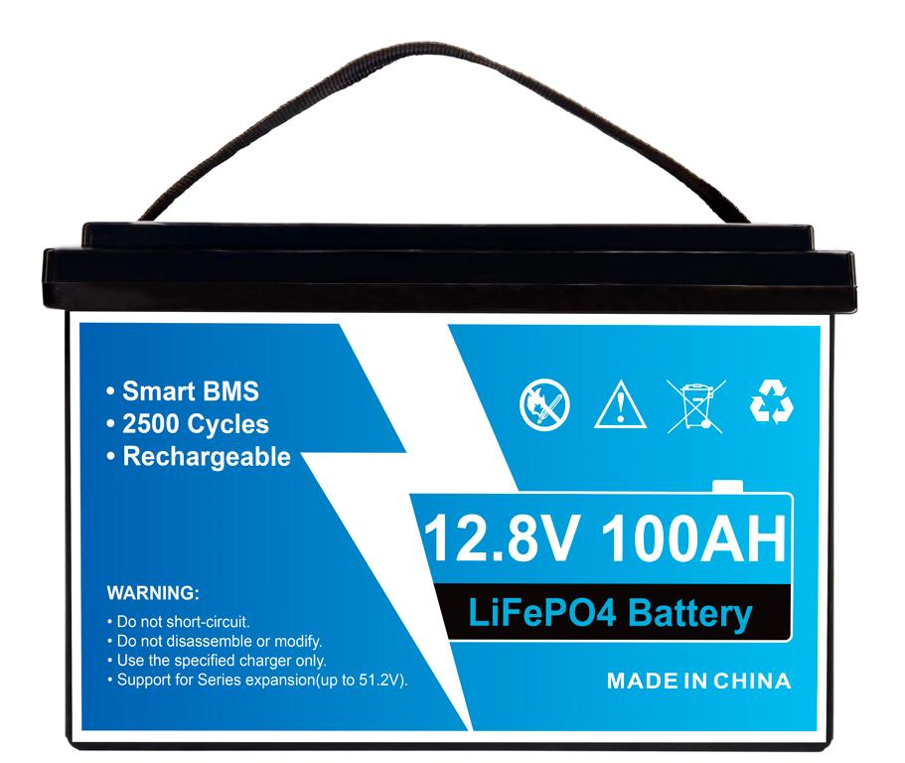 | 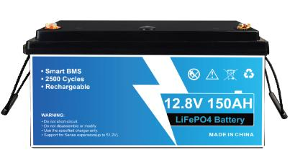 | 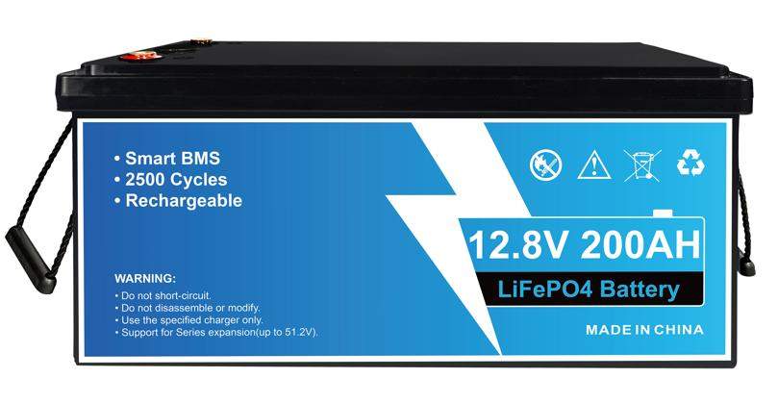 | 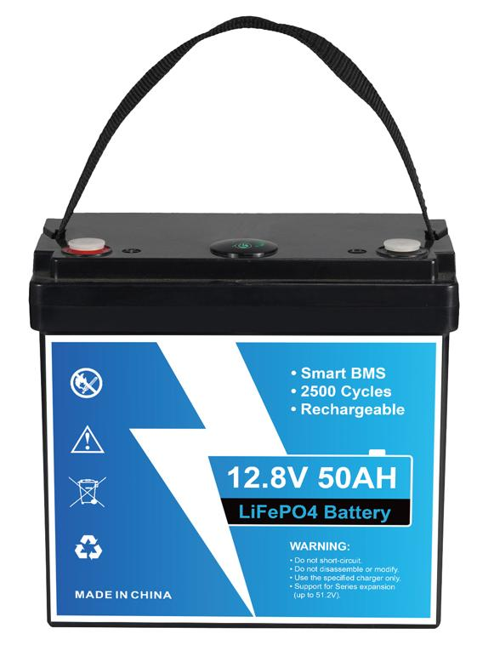
AL-BP-12V-BATTERY · Primary | AL-BP-12V-BATTERY · Gallery | AL-BP-12V-BATTERY · Gallery | AL-BP-12V-BATTERY · Gallery

PRODUCT OVERVIEW
AL-BP 12.8V LiFePO4 Batteries with 4 source-reviewed models for UPS battery replacement, solar storage, mobility and auxiliary DC power. Model configuration and destination-market requirements are confirmed during RFQ review.
Product line | UPS Uninterruptible Power Supply
Series / family | Standalone model
Exact model | AL-BP-12V-BATTERY
Applications | UPS battery replacement, solar storage, mobility and auxiliary DC power
MODEL IDENTIFICATION
Exact model | Product / variant | Topology | Power | Phase
AL-BP-12V-BATTERY | AL-BP 12.8V LiFePO4 Batteries | 12.8V LiFePO4 battery | 640WH to 2560WH | DC discharge
TECHNICAL SPECIFICATIONS
Parameter | Specification
Topology | 12.8V LiFePO4 battery
Power | 640WH to 2560WH
Phase | DC charge / DC discharge
SKU | AL-BP-12V-BATTERY
Power Range | 640WH to 2560WH
Waveform | DC
Power Factor | Model-specific; confirm on quotation
Quotation Type | Bulk project quotation
OEM/ODM | Available
Documents | Datasheet and installation reference
Category | UPS Power
APPLICATIONS & RFQ CONFIRMATION
Typical applications | Confirm in the project RFQ
UPS battery replacement  solar storage  mobility and auxiliary DC power | Confirm the exact model and required configuration.  Confirm quantity, destination, packing, branding, and documentation requirements.
Project supply: MOQ — Confirm by project quantity · Lead time — Confirm by project list · FOB port — China main ports · OEM/ODM — Available; confirm project scope
PROJECT CONFIGURATION CHECKLIST
Exact model | AL-BP-12V-BATTERY
Application and site conditions | Confirm installation environment and operating requirements.
Quantity and model mix | Confirm forecast quantity, phase plan and required variants.
Interfaces and accessories | Confirm compatible interfaces, accessories and system integration scope.
Finish, branding and packing | Confirm only when project customization is required.
Documentation and destination | Confirm drawings, datasheets, packing documents and destination country or port.

