
UPS UNINTERRUPTIBLE POWER SUPPLY

11kW Modular Home Energy Storage
  - Exact model: 11KW-MODULAR-ESS
PRODUCT IMAGES
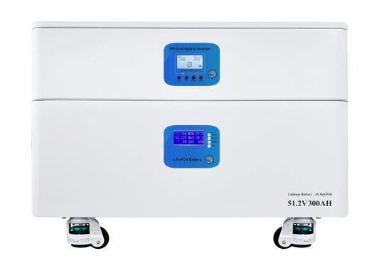 | 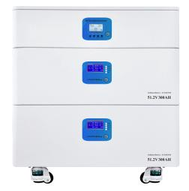 | 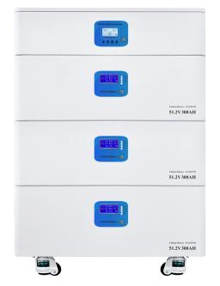 | 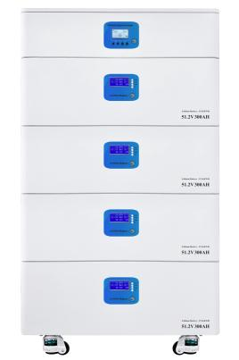
11KW-MODULAR-ESS · Primary | 11KW-MODULAR-ESS · Gallery | 11KW-MODULAR-ESS · Gallery | 11KW-MODULAR-ESS · Gallery

PRODUCT OVERVIEW
11kW Modular Home Energy Storage with 1 source-reviewed model for Large homes, villas and small commercial backup systems. Model configuration and destination-market requirements are confirmed during RFQ review.
Product line | UPS Uninterruptible Power Supply
Series / family | Standalone model
Exact model | 11KW-MODULAR-ESS
Applications | Large homes, villas and small commercial backup systems
MODEL IDENTIFICATION
Exact model | Product / variant | Topology | Power | Phase
11KW-MODULAR-ESS | 11kW Modular Home Energy Storage | High-capacity modular energy storage system | 11KW / 15KWH | Single phase AC
TECHNICAL SPECIFICATIONS
Parameter | Specification
Topology | High-capacity modular energy storage system
Power | 11KW / 15KWH
Phase | AC and PV / Single phase AC
SKU | 11KW-MODULAR-ESS
Power Range | 11KW / 15KWH
Waveform | Pure sine wave
Power Factor | Model-specific; confirm on quotation
Quotation Type | Bulk project quotation
OEM/ODM | Available
Documents | Datasheet and installation reference
Category | UPS Power
APPLICATIONS & RFQ CONFIRMATION
Typical applications | Confirm in the project RFQ
Large homes  villas and small commercial backup systems | Confirm the exact model and required configuration.  Confirm quantity, destination, packing, branding, and documentation requirements.
Project supply: MOQ — Confirm by project quantity · Lead time — Confirm by project list · FOB port — China main ports · OEM/ODM — Available; confirm project scope
PROJECT CONFIGURATION CHECKLIST
Exact model | 11KW-MODULAR-ESS
Application and site conditions | Confirm installation environment and operating requirements.
Quantity and model mix | Confirm forecast quantity, phase plan and required variants.
Interfaces and accessories | Confirm compatible interfaces, accessories and system integration scope.
Finish, branding and packing | Confirm only when project customization is required.
Documentation and destination | Confirm drawings, datasheets, packing documents and destination country or port.

