
PATCH PANELS, FACEPLATES & KEYSTONE MODULES

Voice Patch Panel Series
  - Models: SP6025 | SP6050
PRODUCT IMAGES
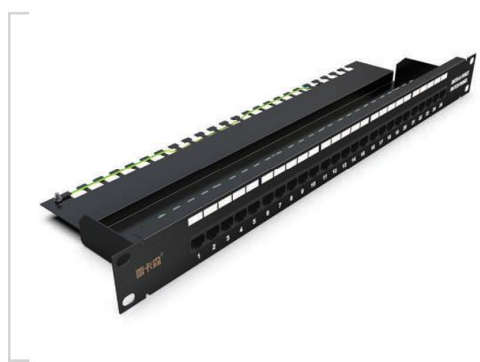 | 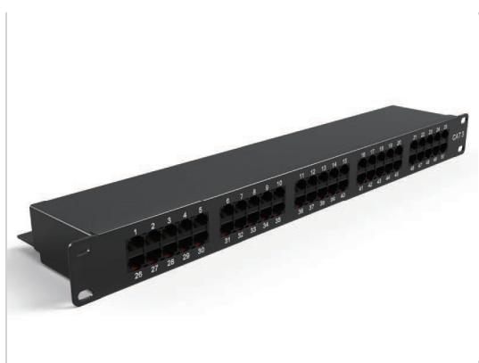
SP6025 · Primary | SP6050 · Primary

PRODUCT OVERVIEW
Rack-mounted voice patch panels for telephone and voice cabling.
Product line | Patch Panels, Faceplates & Keystone Modules
Series / family | patch-voice
Exact model | SP6025 | SP6050
Applications | Voice cabling, Telecom rooms, Structured cabling racks
MODEL COMPARISON
Exact model | Product / variant | Specification | Material | Application
SP6025 | SP6025 Cat3 25-port voice patch panel | Cat3 25 portsvoice patch panel | Cold-rolled steel | Connect voice equipment and distribute voice circuits
SP6050 | SP6050 Cat3 50-port voice patch panel | Cat3 50 portsvoice patch panel | Cold-rolled steel | Connect voice equipment and distribute voice circuits
TECHNICAL SPECIFICATIONS
Parameter | SP6025 | SP6050
Specification | Cat3 25 portsvoice patch panel | Cat3 50 portsvoice patch panel
Material | Cold-rolled steel | Cold-rolled steel
Application | Connect voice equipment and distribute voice circuits | Connect voice equipment and distribute voice circuits
Height | 1U | 1U
Dimensions | 483 × 44.5 × 132 mm | 483 × 44.5 × 112 mm
Product series | Voice Patch Panel Series | Voice Patch Panel Series
Product category | Patch Panel | Patch Panel
APPLICATIONS & RFQ CONFIRMATION
Typical applications | Confirm in the project RFQ
Voice cabling  Telecom rooms  Structured cabling racks | Confirm the application, rack or room position, destination-market interface and mounting requirement.  Confirm electrical, network, accessory or protection scope from the product family and project drawings.  Confirm quantity, labeling, packing and required documents before purchase order.
Project supply: MOQ — Confirm by model and project quantity · Lead time — Confirm after configuration review · FOB port — Confirm in project quotation · OEM/ODM — To be confirmed
PROJECT CONFIGURATION CHECKLIST
Exact model | SP6025
Application and site conditions | Confirm installation environment and operating requirements.
Quantity and model mix | Confirm forecast quantity, phase plan and required variants.
Interfaces and accessories | Confirm compatible interfaces, accessories and system integration scope.
Finish, branding and packing | Confirm only when project customization is required.
Documentation and destination | Confirm drawings, datasheets, packing documents and destination country or port.

