
PATCH PANELS, FACEPLATES & KEYSTONE MODULES

Data Patch Panel Series
  - Models: SP5524 | SP5648
PRODUCT IMAGES
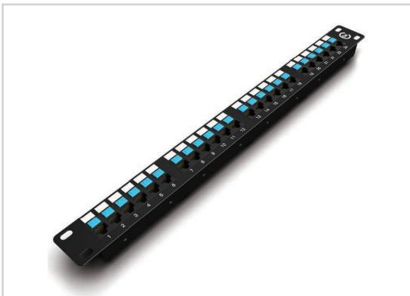 | 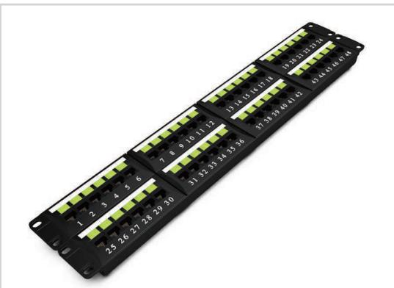
SP5524 · Primary | SP5648 · Primary

PRODUCT OVERVIEW
Rack-mounted data patch panels for structured network cabling.
Product line | Patch Panels, Faceplates & Keystone Modules
Series / family | patch-data
Exact model | SP5524 | SP5648
Applications | Data patching, Network cabinets, ELV cabling projects
MODEL COMPARISON
Exact model | Product / variant | Specification | Material | Application
SP5524 | SP5524 Cat5e 24-port data patch panel | Cat5e 24 ports | Cold-rolled steel | Connect network equipment and route data cabling
SP5648 | SP5648 Cat6 48-port data patch panel | Cat6 48 ports | Cold-rolled steel | Connect network equipment and route data cabling
TECHNICAL SPECIFICATIONS
Parameter | SP5524 | SP5648
Specification | Cat5e 24 ports | Cat6 48 ports
Material | Cold-rolled steel | Cold-rolled steel
Application | Connect network equipment and route data cabling | Connect network equipment and route data cabling
Height | 1U | 2U
Dimensions | 483 × 44.5 × 86 mm (including cable-management rings) | 483 × 88 × 92 mm (including cable-management rings)
Product series | Data Patch Panel Series | Data Patch Panel Series
Product category | Patch Panel | Patch Panel
APPLICATIONS & RFQ CONFIRMATION
Typical applications | Confirm in the project RFQ
Data patching  Network cabinets  ELV cabling projects | Confirm the application, rack or room position, destination-market interface and mounting requirement.  Confirm electrical, network, accessory or protection scope from the product family and project drawings.  Confirm quantity, labeling, packing and required documents before purchase order.
Project supply: MOQ — Confirm by model and project quantity · Lead time — Confirm after configuration review · FOB port — Confirm in project quotation · OEM/ODM — To be confirmed
PROJECT CONFIGURATION CHECKLIST
Exact model | SP5524
Application and site conditions | Confirm installation environment and operating requirements.
Quantity and model mix | Confirm forecast quantity, phase plan and required variants.
Interfaces and accessories | Confirm compatible interfaces, accessories and system integration scope.
Finish, branding and packing | Confirm only when project customization is required.
Documentation and destination | Confirm drawings, datasheets, packing documents and destination country or port.

