
PATCH PANELS, FACEPLATES & KEYSTONE MODULES

SP868P Cat6 Shielded Tool-Free Module
  - Exact model: SP868P
PRODUCT IMAGES
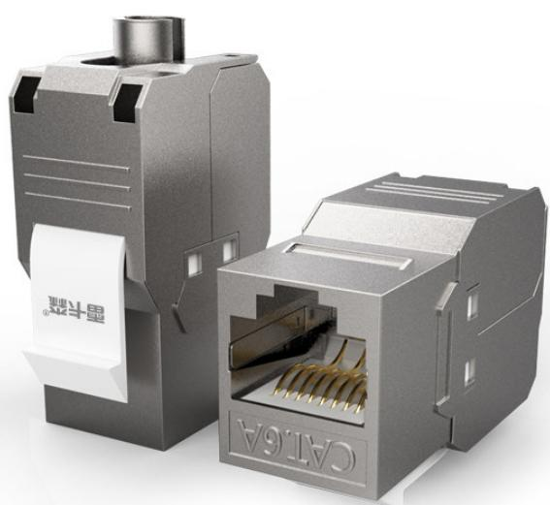
SP868P · Primary

PRODUCT OVERVIEW
Network and voice keystone modules for structured cabling termination.
Product line | Patch Panels, Faceplates & Keystone Modules
Series / family | modules
Exact model | SP868P
Applications | Keystone module installation, Patch panels and faceplates, Voice and data cabling
MODEL IDENTIFICATION
Exact model | Product / variant | Product | Type | Material
SP868P | SP868P Cat6 Shielded Tool-Free Module | Network module | Class VI / Cat6 module | Metal
TECHNICAL SPECIFICATIONS
Parameter | Specification
Product | Network module
Type | Class VI / Cat6 module
Material | Metal
Features | Shielded, tool-free / feed-through
Application | Connection module between faceplate and network cable
Product series | Network & Voice Keystone Module Series
Product category | Structured Cabling Accessory
APPLICATIONS & RFQ CONFIRMATION
Typical applications | Confirm in the project RFQ
Keystone module installation  Patch panels and faceplates  Voice and data cabling | Confirm the application, rack or room position, destination-market interface and mounting requirement.  Confirm electrical, network, accessory or protection scope from the product family and project drawings.  Confirm quantity, labeling, packing and required documents before purchase order.
Project supply: MOQ — Confirm by model and project quantity · Lead time — Confirm after configuration review · FOB port — Confirm in project quotation · OEM/ODM — To be confirmed
PROJECT CONFIGURATION CHECKLIST
Exact model | SP868P
Application and site conditions | Confirm installation environment and operating requirements.
Quantity and model mix | Confirm forecast quantity, phase plan and required variants.
Interfaces and accessories | Confirm compatible interfaces, accessories and system integration scope.
Finish, branding and packing | Confirm only when project customization is required.
Documentation and destination | Confirm drawings, datasheets, packing documents and destination country or port.

