
PATCH PANELS, FACEPLATES & KEYSTONE MODULES

SP8602 86-Type 2-Port Network Faceplate
  - Exact model: SP8602
PRODUCT IMAGES
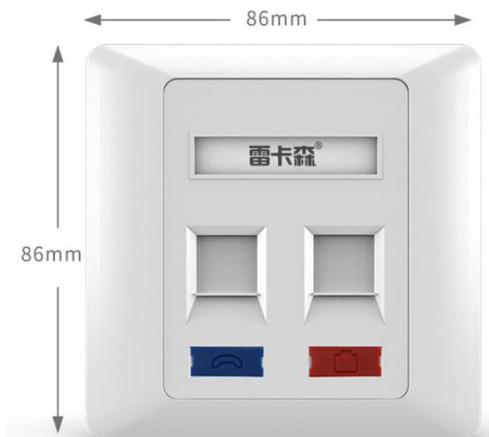
SP8602 · Primary

PRODUCT OVERVIEW
86 × 86 mm information faceplates for modular network and voice outlets.
Product line | Patch Panels, Faceplates & Keystone Modules
Series / family | faceplate
Exact model | SP8602
Applications | Office network outlets, ELV cabling projects, Wall-mounted data points
MODEL IDENTIFICATION
Exact model | Product / variant | Specification | Material | Application Environment
SP8602 | SP8602 86-Type 2-Port Network Faceplate | 2-port faceplate | Flame-retardant PC | Home, internet cafe, office and similar installations
TECHNICAL SPECIFICATIONS
Parameter | Specification
Specification | 2-port faceplate
Material | Flame-retardant PC
Application Environment | Home, internet cafe, office and similar installations
Dimensions | 86 × 86 mm
Mounting Hole Spacing | 60 mm
Product series | 86-Type Information Faceplate Series
Product category | Structured Cabling Accessory
APPLICATIONS & RFQ CONFIRMATION
Typical applications | Confirm in the project RFQ
Office network outlets  ELV cabling projects  Wall-mounted data points | Confirm the application, rack or room position, destination-market interface and mounting requirement.  Confirm electrical, network, accessory or protection scope from the product family and project drawings.  Confirm quantity, labeling, packing and required documents before purchase order.
Project supply: MOQ — Confirm by model and project quantity · Lead time — Confirm after configuration review · FOB port — Confirm in project quotation · OEM/ODM — To be confirmed
PROJECT CONFIGURATION CHECKLIST
Exact model | SP8602
Application and site conditions | Confirm installation environment and operating requirements.
Quantity and model mix | Confirm forecast quantity, phase plan and required variants.
Interfaces and accessories | Confirm compatible interfaces, accessories and system integration scope.
Finish, branding and packing | Confirm only when project customization is required.
Documentation and destination | Confirm drawings, datasheets, packing documents and destination country or port.

