
PATCH PANELS, FACEPLATES & KEYSTONE MODULES

SP739 CA T3 90° voice/telephone module
  - Exact model: SP739
PRODUCT IMAGES
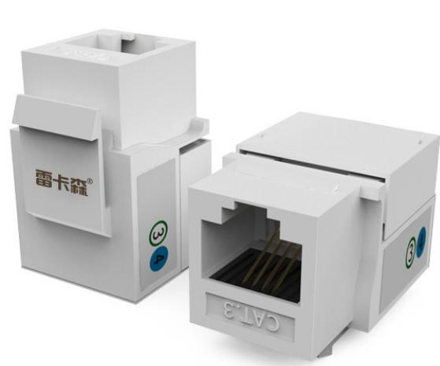
SP739 · Primary

PRODUCT OVERVIEW
Network and voice keystone modules for structured cabling termination.
Product line | Patch Panels, Faceplates & Keystone Modules
Series / family | modules
Exact model | SP739
Applications | Keystone module installation, Patch panels and faceplates, Voice and data cabling
MODEL IDENTIFICATION
Exact model | Product / variant | Product | Type | Material
SP739 | SP739 CA T3 90° voice/telephone module | Network / voice module | CAT3 voice/telephone module | Impact-resistant ABS
TECHNICAL SPECIFICATIONS
Parameter | Specification
Product | Network / voice module
Type | CAT3 voice/telephone module
Material | Impact-resistant ABS
Features | 90° punch-down / labeling
Application | Connection module between terminal equipment and network/telephone cable
Product series | Network & Voice Keystone Module Series
Product category | Structured Cabling Accessory
APPLICATIONS & RFQ CONFIRMATION
Typical applications | Confirm in the project RFQ
Keystone module installation  Patch panels and faceplates  Voice and data cabling | Confirm the application, rack or room position, destination-market interface and mounting requirement.  Confirm electrical, network, accessory or protection scope from the product family and project drawings.  Confirm quantity, labeling, packing and required documents before purchase order.
Project supply: MOQ — Confirm by model and project quantity · Lead time — Confirm after configuration review · FOB port — Confirm in project quotation · OEM/ODM — To be confirmed
PROJECT CONFIGURATION CHECKLIST
Exact model | SP739
Application and site conditions | Confirm installation environment and operating requirements.
Quantity and model mix | Confirm forecast quantity, phase plan and required variants.
Interfaces and accessories | Confirm compatible interfaces, accessories and system integration scope.
Finish, branding and packing | Confirm only when project customization is required.
Documentation and destination | Confirm drawings, datasheets, packing documents and destination country or port.

