
SMART LOCK & ELECTRONIC ACCESS HARDWARE

NexPro Smartphone App Fingerprint Password Smart Lock NX-SL-2067
  - Exact model: NX-SL-2067
PRODUCT IMAGES
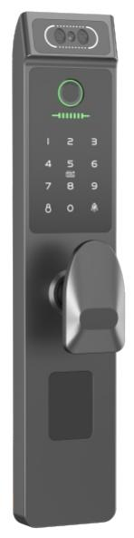 | 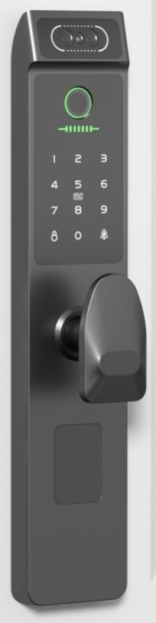 | 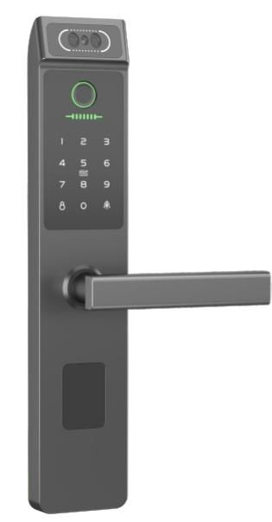 | 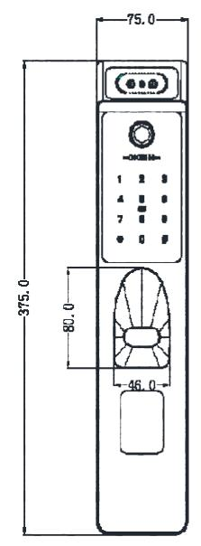
NX-SL-2067 · Primary | NX-SL-2067 · Gallery | NX-SL-2067 · Gallery | NX-SL-2067 · Gallery

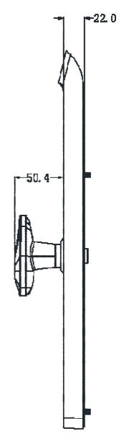 | 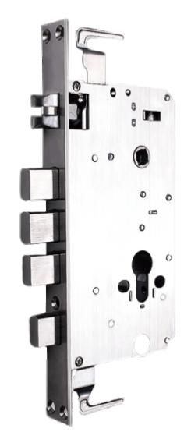 | 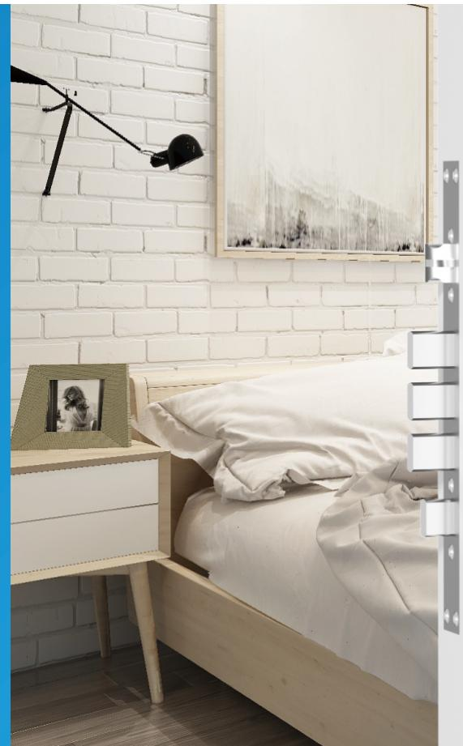
NX-SL-2067 · Gallery | NX-SL-2067 · Gallery | NX-SL-2067 · Gallery

PRODUCT OVERVIEW
A smartphone app, fingerprint, password, card, mechanical key smart door lock with zinc alloy, 304 stainless steel construction. Designed for apartment, commercial building, office access applications.
Product line | Smart Lock & Electronic Access Hardware
Series / family | Face-recognition Anti-theft Lock
Exact model | NX-SL-2067
Applications | Apartment, Commercial Building, Office Access, Rental Property
MODEL IDENTIFICATION
Exact model | Product / variant | Product family | Access | Application
NX-SL-2067 | NexPro Smartphone App Fingerprint Password Smart Lock NX-SL-2067 | Smart Door Locks | Smartphone App / Fingerprint / Password | Apartment
TECHNICAL SPECIFICATIONS
Parameter | Specification
Product family | Smart Door Locks; Smart Lock
Access | Smartphone App / Fingerprint / Password
Application | Apartment
Sensor resistance | 4H pencil, 20cm continuous 1000 impacts without damage
Sensor resolution | 500dp / 500dpi
Start time | < 1 second seconds
Rejection rate | <=1%
Fake admission rate | <=0.0001%
Fingerprint capacity | 100 pieces
Comparison method | 1:N
Finger usage angle | 360 degrees °
Fingerprint registration | Generate at once
Fingerprint update | Automatic update
Data retention | No loss due to power outage
Light interference | Avoid direct sunlight
Working temperature | -10 to 55 C °C
Storage temperature | -20 to 70 C °C
Working humidity | 10% to 90%
Battery life | Open the door 11000 times
Working voltage | DC 6V
Power supply | Battery powered
Low pressure alarm | 4.9V
Backup power | Power bank or other mobile power supply
Antistatic | Contact discharge 8KV / Air discharge 15KV
Code capacity | 100 sets pieces
Password design | Change at will combination
Password length | 8 digits
Series | Face-recognition Anti-theft Lock
Quotation type | Project and bulk quotation
OEM/ODM | Confirm branding, finish, packaging and software scope

