
SMART LOCK & ELECTRONIC ACCESS HARDWARE

NX-HL-SP04 Series
  - Models: NX-HL-SP04 | NX-HL-SP04-V122 | NX-HL-SP04-V126
PRODUCT IMAGES
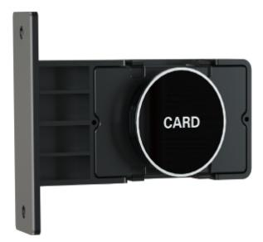 | 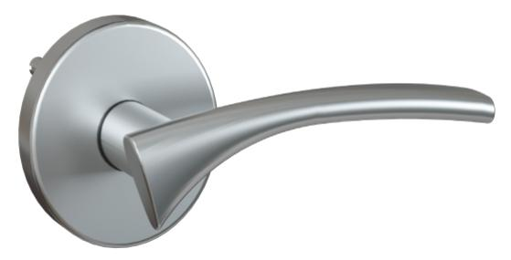 | 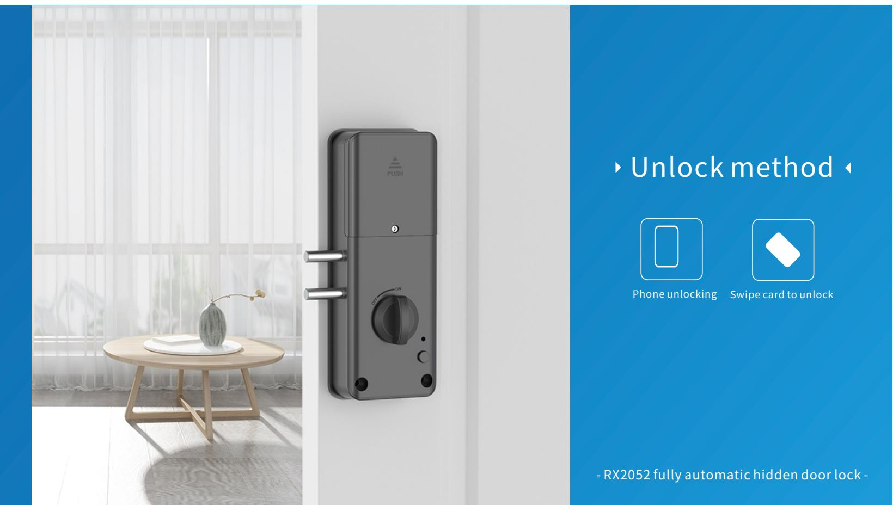
NX-HL-SP04 · Primary | NX-HL-SP04-V122 · Primary | NX-HL-SP04-V122 · Gallery | NX-HL-SP04-V126 · Primary

PRODUCT OVERVIEW
A card, mechanical key smart door lock with zinc alloy, stainless steel construction. Designed for hotel, apartment, office applications.
Product line | Smart Lock & Electronic Access Hardware
Series / family | Hotel Electronic Locks
Exact model | NX-HL-SP04 | NX-HL-SP04-V122 | NX-HL-SP04-V126
Applications | Hotel, Apartment, Office, Commercial Building
MODEL COMPARISON
Exact model | Product / variant | Product family | Access | Application
NX-HL-SP04 | NexPro IC Card Hotel Lock NX-HL-SP04 | Hotel Lock Systems | IC Card / Mechanical Key | Hotel
NX-HL-SP04-V122 | NexPro IC Card Hotel Lock NX-HL-SP04-V122 | Hotel Lock Systems | IC Card / Mechanical Key | Hotel
NX-HL-SP04-V126 | NexPro IC Card Hotel Lock NX-HL-SP04-V126 | Hotel Lock Systems | IC Card / Mechanical Key | Hotel
TECHNICAL SPECIFICATIONS
Parameter | NX-HL-SP04 | NX-HL-SP04-V122 | NX-HL-SP04-V126
Product family | Hotel Lock Systems | Hotel Lock Systems | Hotel Lock Systems
Access | IC Card / Mechanical Key | IC Card / Mechanical Key | IC Card / Mechanical Key
Application | Hotel | Hotel | Hotel
Chip | Texas Instruments TI Instrument Chip | Texas Instruments TI Instrument Chip | Texas Instruments TI Instrument Chip
Card specs | ATMEL Temic induction card | ATMEL Temic induction card | ATMEL Temic induction card
Production process | Sheet metal insertion on PVC surface | Sheet metal insertion on PVC surface | Sheet metal insertion on PVC surface
System logic | Conflict prevention mechanism | Conflict prevention mechanism | Conflict prevention mechanism
Card reading | Non-contact induction type | Non-contact induction type | Non-contact induction type
Read/write | Read, write, and encrypt | Read, write, and encrypt | Read, write, and encrypt
Opening time | Press handle once after door opening; 7 seconds auto-lock | Press handle once after door opening; 7 seconds auto-lock | Press handle once after door opening; 7 seconds auto-lock
Unlock record | Store latest unlock record in lock loop | Store latest unlock record in lock loop | Store latest unlock record in lock loop
Applicable scope | Special lock for anti-theft doors, suitable for family, apartments, office buildings | Special lock for anti-theft doors, suitable for family, apartments, office buildings | Special lock for anti-theft doors, suitable for family, apartments, office buildings
Working voltage | 6A / 4 knots high energy alkaline battery V | 6A / 4 knots high energy alkaline battery V | 6A / 4 knots high energy alkaline battery V
Static power consumption | < 30 microamperes | < 30 microamperes | < 30 microamperes
Dynamic power consumption | Approximately 200 amps mA | Approximately 200 amps mA | Approximately 200 amps mA
Undervoltage index | Below 4.8V still able to unlock >200 times | Below 4.8V still able to unlock >200 times | Below 4.8V still able to unlock >200 times
Battery life | Normal continuous opening over 10000 times | Normal continuous opening over 10000 times | Normal continuous opening over 10000 times
Storage capacity | 32 bytes | 32 bytes | 32 bytes
Installation | Conventional side strip 24x240 / 30x240, customized | Conventional side strip 24x240 / 30x240, customized | Conventional side strip 24x240 / 30x240, customized
Series | Hotel Electronic Locks | Hotel Electronic Locks | Hotel Electronic Locks
Quotation type | Project and bulk quotation | Project and bulk quotation | Project and bulk quotation
OEM/ODM | Confirm branding, finish, packaging and software scope | Confirm branding, finish, packaging and software scope | Confirm branding, finish, packaging and software scope

