
SMART LOCK & ELECTRONIC ACCESS HARDWARE

NX-CL-RX2056 Series
  - Models: NX-CL-RX2056 | NX-CL-RX2056-V56
PRODUCT IMAGES
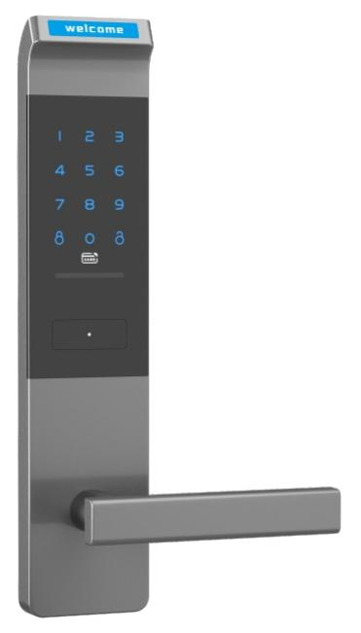 | 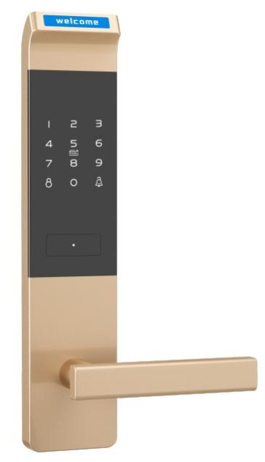
NX-CL-RX2056 · Primary | NX-CL-RX2056-V56 · Primary

PRODUCT OVERVIEW
A password, mechanical key smart door lock. Designed for residential, apartment, office applications.
Product line | Smart Lock & Electronic Access Hardware
Series / family | Cabinet Electronic Locks
Exact model | NX-CL-RX2056 | NX-CL-RX2056-V56
Applications | Residential, Apartment, Office
MODEL COMPARISON
Exact model | Product / variant | Product family | Access | Application
NX-CL-RX2056 | NexPro Password Cabinet Lock NX-CL-RX2056 | Cabinet & Locker Locks | Password / Mechanical Key | Residential
NX-CL-RX2056-V56 | NexPro Password Cabinet Lock NX-CL-RX2056-V56 | Cabinet & Locker Locks | Password / Mechanical Key | Residential
TECHNICAL SPECIFICATIONS
Parameter | NX-CL-RX2056 | NX-CL-RX2056-V56
Product family | Cabinet & Locker Locks; Cabinet Lock | Cabinet & Locker Locks; Cabinet Lock
Access | Password / Mechanical Key | Password / Mechanical Key
Application | Residential | Residential
Series | Cabinet Electronic Locks | Cabinet Electronic Locks
Quotation type | Project and bulk quotation | Project and bulk quotation
OEM/ODM | Confirm branding, finish, packaging and software scope | Confirm branding, finish, packaging and software scope
APPLICATIONS & RFQ CONFIRMATION
Typical applications | Confirm in the project RFQ
Residential  Apartment  Office | Confirm door type in the RFQ.  Confirm lock body type in the RFQ.  Confirm finish color in the RFQ.  Confirm quantity in the RFQ.  Confirm branding requirement in the RFQ.  Confirm project country in the RFQ.
Project supply: MOQ — Confirm by model mix and customization scope · Lead time — Confirm after sample and project requirements review · FOB port — China main ports · OEM/ODM — Available; confirm project scope
PROJECT CONFIGURATION CHECKLIST
Exact model | NX-CL-RX2056
Application and site conditions | Confirm installation environment and operating requirements.
Quantity and model mix | Confirm forecast quantity, phase plan and required variants.
Interfaces and accessories | Confirm compatible interfaces, accessories and system integration scope.
Finish, branding and packing | Confirm only when project customization is required.
Documentation and destination | Confirm drawings, datasheets, packing documents and destination country or port.

