
SMART LOCK & ELECTRONIC ACCESS HARDWARE

NX-CL-169-BT Series
  - Models: NX-CL-169-BT | NX-CL-169-BT-V160
PRODUCT IMAGES
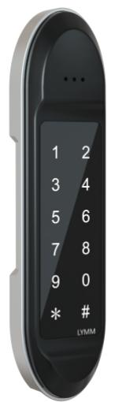 | 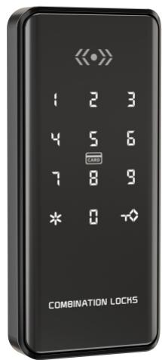
NX-CL-169-BT · Primary | NX-CL-169-BT-V160 · Primary

PRODUCT OVERVIEW
A cabinet smart lock with smartphone app, password unlocking. Designed for cabinet, drawer, and locker security in office, home, and commercial furniture applications.
Product line | Smart Lock & Electronic Access Hardware
Series / family | App-Enabled Smart Locks
Exact model | NX-CL-169-BT | NX-CL-169-BT-V160
Applications | Cabinet, Office, Furniture
MODEL COMPARISON
Exact model | Product / variant | Product family | Access | Application
NX-CL-169-BT | NexPro Smartphone App Password Cabinet Lock NX-CL-169-BT | Cabinet & Locker Locks | Smartphone App / Password | Cabinet
NX-CL-169-BT-V160 | NexPro Smartphone App Password Cabinet Lock NX-CL-169-BT-V160 | Cabinet & Locker Locks | Smartphone App / Password | Cabinet
TECHNICAL SPECIFICATIONS
Parameter | NX-CL-169-BT | NX-CL-169-BT-V160
Product family | Cabinet & Locker Locks; Cabinet Lock | Cabinet & Locker Locks; Cabinet Lock
Access | Smartphone App / Password | Smartphone App / Password
Application | Cabinet | Cabinet
Series | App-Enabled Smart Locks | App-Enabled Smart Locks
Quotation type | Project and bulk quotation | Project and bulk quotation
OEM/ODM | Confirm branding, finish, packaging and software scope | Confirm branding, finish, packaging and software scope
APPLICATIONS & RFQ CONFIRMATION
Typical applications | Confirm in the project RFQ
Cabinet  Office  Furniture | Confirm door type in the RFQ.  Confirm lock body type in the RFQ.  Confirm finish color in the RFQ.  Confirm quantity in the RFQ.  Confirm branding requirement in the RFQ.  Confirm project country in the RFQ.
Project supply: MOQ — Confirm by model mix and customization scope · Lead time — Confirm after sample and project requirements review · FOB port — China main ports · OEM/ODM — Available; confirm project scope
PROJECT CONFIGURATION CHECKLIST
Exact model | NX-CL-169-BT
Application and site conditions | Confirm installation environment and operating requirements.
Quantity and model mix | Confirm forecast quantity, phase plan and required variants.
Interfaces and accessories | Confirm compatible interfaces, accessories and system integration scope.
Finish, branding and packing | Confirm only when project customization is required.
Documentation and destination | Confirm drawings, datasheets, packing documents and destination country or port.

