
SMART LOCK & ELECTRONIC ACCESS HARDWARE

NX-BL-2017 Series
  - Models: NX-BL-2017 | NX-BL-2017-V40
PRODUCT IMAGES
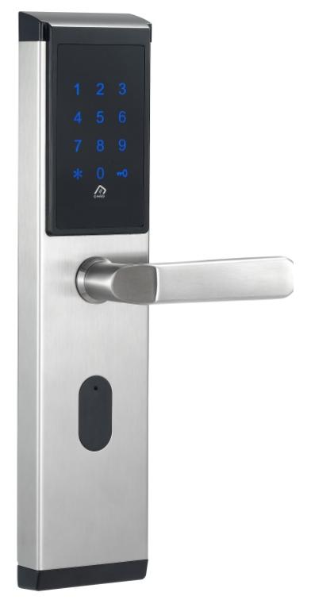 | 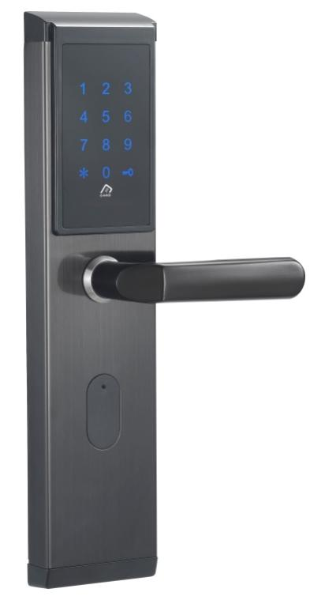 | 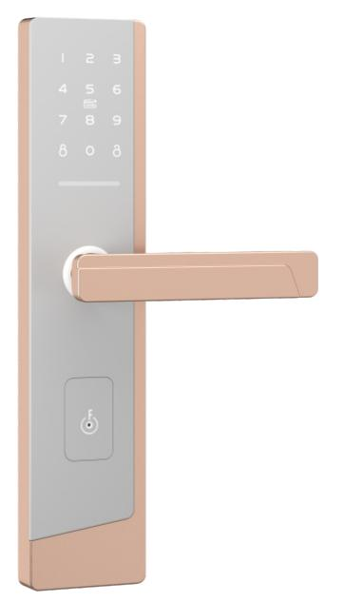 | 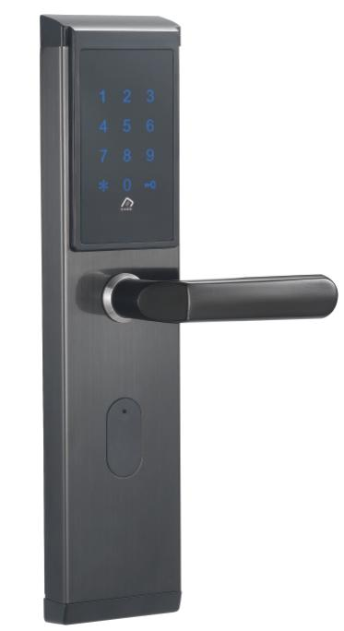
NX-BL-2017 · Primary | NX-BL-2017-V40 · Primary | NX-BL-2017-V40 · Gallery | NX-BL-2017-V40 · Gallery

PRODUCT OVERVIEW
A smartphone app, card, password, mechanical key smart door lock with zinc alloy, abs plastic construction. Designed for apartment, rental property, office applications.
Product line | Smart Lock & Electronic Access Hardware
Series / family | App-Enabled Smart Locks
Exact model | NX-BL-2017 | NX-BL-2017-V40
Applications | Apartment, Rental Property, Office, Residential
MODEL COMPARISON
Exact model | Product / variant | Product family | Access | Application
NX-BL-2017 | NexPro Smartphone App IC Card Password Bluetooth Lock NX-BL-2017 | Bluetooth & App Locks | Smartphone App / IC Card / Password | Apartment
NX-BL-2017-V40 | NexPro Smartphone App IC Card Password Bluetooth Lock NX-BL-2017-V40 | Bluetooth & App Locks | Smartphone App / IC Card / Password | Apartment
TECHNICAL SPECIFICATIONS
Parameter | NX-BL-2017 | NX-BL-2017-V40
Product family | Bluetooth & App Locks; Bluetooth Lock | Bluetooth & App Locks; Bluetooth Lock
Access | Smartphone App / IC Card / Password | Smartphone App / IC Card / Password
Application | Apartment | Apartment
Bluetooth standard | Bluetooth 4.0 BLE | Bluetooth 4.0 BLE
Support card types | MIFARE M1 card | MIFARE M1 card
Supported mobile systems | Android 4.3 / 10 or above | Android 4.3 / 10 or above
Unlock time | ~1.5 seconds | ~1.5 seconds
Door opening methods | APP, password, IC card, mechanical key | APP, password, IC card, mechanical key
IC card capacity | 200 groups | 200 groups
Power supply | 4 alkaline dry batteries | 4 alkaline dry batteries
Low battery alarm | 4.8V | 4.8V
Standby current | 60 microamperes μA | 60 microamperes μA
Working current | < 200 mA μA | < 200 mA μA
Operating temperature | -40 to 70 C °C | -40 to 70 C °C
Key type | Capacitive touch button | Capacitive touch button
Password capacity | APP sends password / unlimited custom / 150 groups | APP sends password / unlimited custom / 150 groups
Temporary password | Temporary password can be added | Temporary password can be added
Series | App-Enabled Smart Locks | App-Enabled Smart Locks
Quotation type | Project and bulk quotation | Project and bulk quotation
OEM/ODM | Confirm branding, finish, packaging and software scope | Confirm branding, finish, packaging and software scope
APPLICATIONS & RFQ CONFIRMATION
Typical applications | Confirm in the project RFQ
Apartment  Rental Property  Office  Residential | Confirm door type in the RFQ.  Confirm lock body type in the RFQ.  Confirm finish color in the RFQ.  Confirm quantity in the RFQ.  Confirm branding requirement in the RFQ.  Confirm project country in the RFQ.
Project supply: MOQ — Confirm by model mix and customization scope · Lead time — Confirm after sample and project requirements review · FOB port — China main ports · OEM/ODM — Available; confirm project scope
PROJECT CONFIGURATION CHECKLIST
Exact model | NX-BL-2017
Application and site conditions | Confirm installation environment and operating requirements.
Quantity and model mix | Confirm forecast quantity, phase plan and required variants.
Interfaces and accessories | Confirm compatible interfaces, accessories and system integration scope.
Finish, branding and packing | Confirm only when project customization is required.
Documentation and destination | Confirm drawings, datasheets, packing documents and destination country or port.

