
SMART LOCK & ELECTRONIC ACCESS HARDWARE

NexPro Smartphone App IC Card Password Cabinet Lock NX-CL-2067
  - Exact model: NX-CL-2067
PRODUCT IMAGES
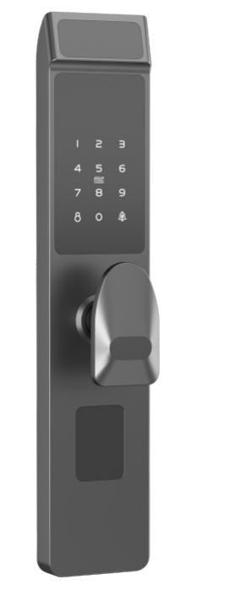 | 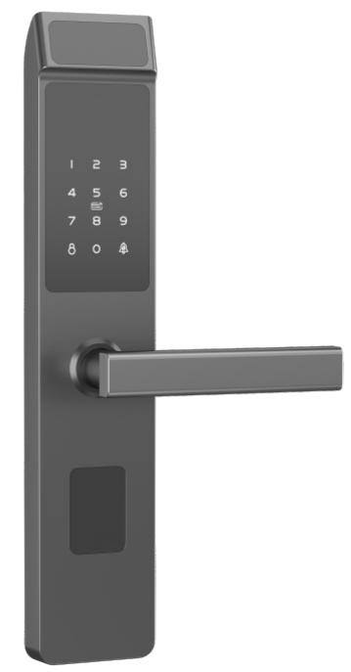
NX-CL-2067 · Primary | NX-CL-2067 · Gallery

PRODUCT OVERVIEW
A smartphone app, card, password, mechanical key smart door lock. Designed for residential, apartment, office applications.
Product line | Smart Lock & Electronic Access Hardware
Series / family | App-Enabled Smart Locks
Exact model | NX-CL-2067
Applications | Residential, Apartment, Office
MODEL IDENTIFICATION
Exact model | Product / variant | Product family | Access | Application
NX-CL-2067 | NexPro Smartphone App IC Card Password Cabinet Lock NX-CL-2067 | Cabinet & Locker Locks | Smartphone App / IC Card / Password | Residential
TECHNICAL SPECIFICATIONS
Parameter | Specification
Product family | Cabinet & Locker Locks; Cabinet Lock
Access | Smartphone App / IC Card / Password
Application | Residential
Series | App-Enabled Smart Locks
Quotation type | Project and bulk quotation
OEM/ODM | Confirm branding, finish, packaging and software scope
APPLICATIONS & RFQ CONFIRMATION
Typical applications | Confirm in the project RFQ
Residential  Apartment  Office | Confirm door type in the RFQ.  Confirm lock body type in the RFQ.  Confirm finish color in the RFQ.  Confirm quantity in the RFQ.  Confirm branding requirement in the RFQ.  Confirm project country in the RFQ.
Project supply: MOQ — Confirm by model mix and customization scope · Lead time — Confirm after sample and project requirements review · FOB port — China main ports · OEM/ODM — Available; confirm project scope
PROJECT CONFIGURATION CHECKLIST
Exact model | NX-CL-2067
Application and site conditions | Confirm installation environment and operating requirements.
Quantity and model mix | Confirm forecast quantity, phase plan and required variants.
Interfaces and accessories | Confirm compatible interfaces, accessories and system integration scope.
Finish, branding and packing | Confirm only when project customization is required.
Documentation and destination | Confirm drawings, datasheets, packing documents and destination country or port.

