
RACK CABINETS & DATA CENTER CONTAINMENT

KP-C Electromagnetic Shielding Cabinet Series
  - Exact model: KP-C
PRODUCT IMAGES
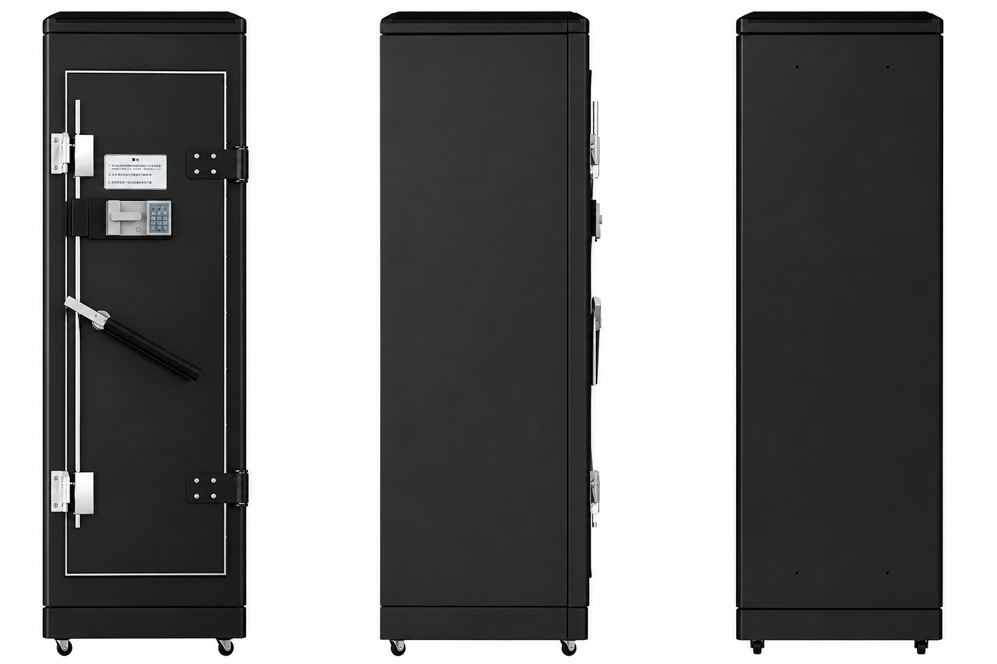 | 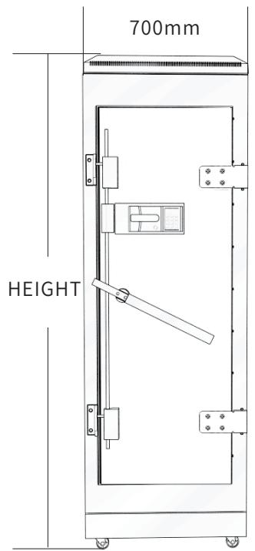 | 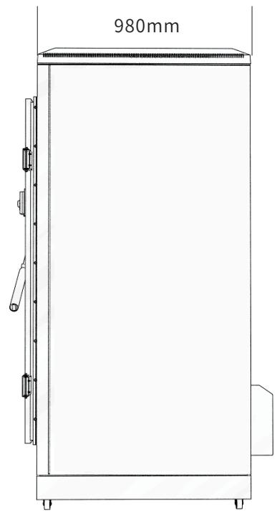 | 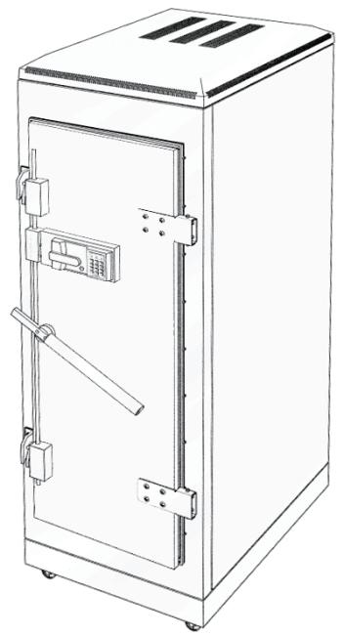
KP-C · Primary · Series Reference View | KP-C · Technical Drawing · Series Reference View | KP-C · Technical Drawing · Series Reference View | KP-C · Technical Drawing · Series Reference View

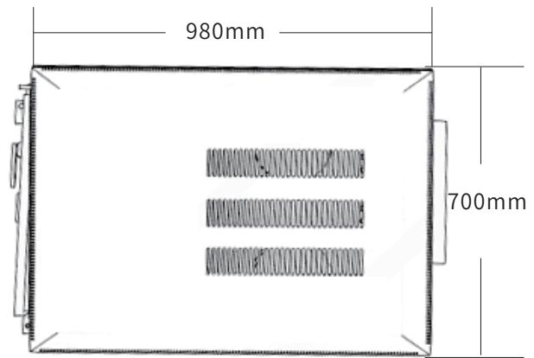 | 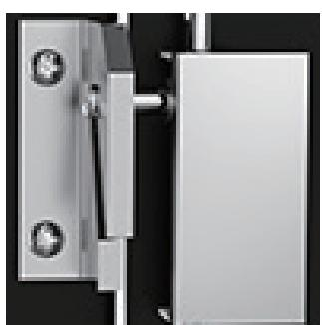 | 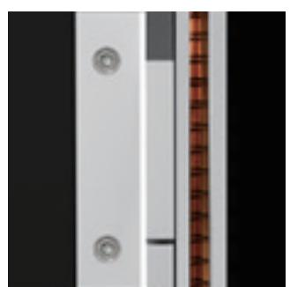 | 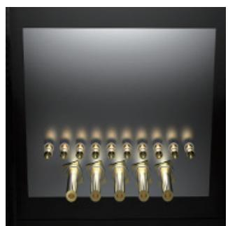
KP-C · Technical Drawing · Series Reference View | KP-C · Structural Detail · Series Reference View | KP-C · Structural Detail · Series Reference View | KP-C · Structural Detail · Series Reference View

PRODUCT OVERVIEW
14 documented configurations are consolidated on this product-group page so buyers can compare specifications without duplicate catalog cards.
Product line | Rack Cabinets & Data Center Containment
Series / family | shielding
Exact model | KP-C
Applications | EMI-sensitive equipment rooms, Data rooms, Security and communication cabinets
MODEL IDENTIFICATION
Exact model | Product / variant | Configurations | Rack Height | Net Weight
KP-C | KP-C Electromagnetic Shielding Cabinet Series | 14 | 10U | 100kg
TECHNICAL SPECIFICATIONS
Parameter | Specification
Configurations | 14
Rack Height | 10U
Net Weight | 100kg
Overall Dimensions | 700 × 980 × 800 mm
Standard Configuration | 10 network-cable waveguides; 5 fiber waveguides; 1 × 16 A filter; 2–3 shelves; 1 × 16 A 6-outlet PDU; 4 adjustable fans; 2 ventilation waveguide windows  (catalog: 300 × 30 type)
Optional Configuration | Humidity monitoring, alarm display, combination lock, fingerprint access, four fan groups / high-power fans, waveguide window, opening rear door, air-conditioner extension, air duct, top cable entry, filter, PDU and other options
Product series | KP-C Electromagnetic Shielding Cabinet Series
Entity type | Product group with selectable configurations
APPLICATIONS & RFQ CONFIRMATION
Typical applications | Confirm in the project RFQ
EMI-sensitive equipment rooms  Data rooms  Security and communication cabinets | Confirm the application, rack or room position, destination-market interface and mounting requirement.  Confirm electrical, network, accessory or protection scope from the product family and project drawings.  Confirm quantity, labeling, packing and required documents before purchase order.
Project supply: MOQ — Confirm by model and project quantity · Lead time — Confirm after configuration review · FOB port — Confirm in project quotation · OEM/ODM — To be confirmed
PROJECT CONFIGURATION CHECKLIST
Exact model | KP-C
Application and site conditions | Confirm installation environment and operating requirements.
Quantity and model mix | Confirm forecast quantity, phase plan and required variants.
Interfaces and accessories | Confirm compatible interfaces, accessories and system integration scope.
Finish, branding and packing | Confirm only when project customization is required.
Documentation and destination | Confirm drawings, datasheets, packing documents and destination country or port.

