
RACK CABINETS & DATA CENTER CONTAINMENT

K2 Network Cabinet Series
  - Models: K2-6620 | K2-6622
PRODUCT IMAGES
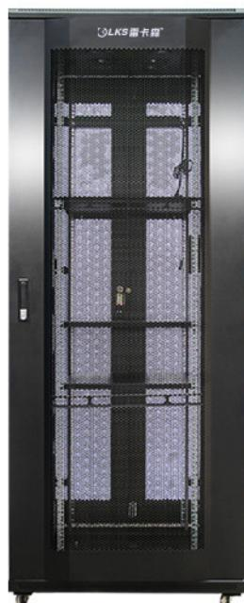 | 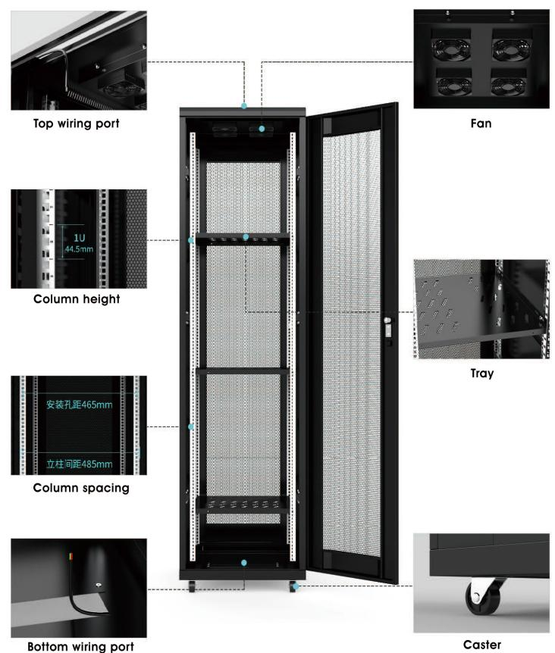 | 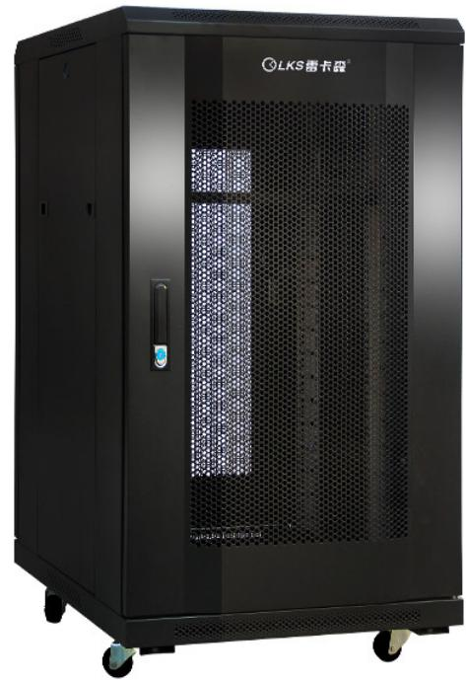
K2-6620 · Primary | K2-6620 · Diagram · Series Reference View | K2-6622 · Primary | K2-6622 · Diagram · Series Reference View

PRODUCT OVERVIEW
19-inch network cabinets for medium-capacity equipment installation.
Product line | Rack Cabinets & Data Center Containment
Series / family | k2
Exact model | K2-6620 | K2-6622
Applications | Network rooms, ELV equipment cabinets, Structured cabling racks
MODEL COMPARISON
Exact model | Product / variant | Type | Dimensions | Height
K2-6620 | K2-6620 20U K2 network cabinet | Network cabinet | 600 × 600 × 1000 mm | 20U
K2-6622 | K2-6622 22U K2 network cabinet | Network cabinet | 600 × 600 × 1200 mm | 22U
TECHNICAL SPECIFICATIONS
Parameter | K2-6620 | K2-6622
Type | Network cabinet | Network cabinet
Dimensions | 600 × 600 × 1000 mm | 600 × 600 × 1200 mm
Height | 20U | 22U
Mounting Rail Spacing | 485 mm (19-inch standard) | 485 mm (19-inch standard)
Sheet Thickness | mounting rails 2.0 mm; other panels 1.0 mm | mounting rails 2.0 mm; other panels 1.0 mm
Material / Finish | SPCC cold-rolled steel, degreased and powder-coated | SPCC cold-rolled steel, degreased and powder-coated
Series Load Capacity | ≤400kg | ≤400kg
Standard Configuration | PDU × 1、cage nuts and screws × 20、M12leveling feet × 4、20Umounting rails × 4、front and rear mesh doors × 1、side panels × 2、fans × 1、shelves × 1、casters × 4 | PDU × 1、cage nuts and screws × 20、M12leveling feet × 4、22Umounting rails × 4、front and rear mesh doors × 1、side panels × 2、fans × 1、shelves × 1、casters × 4
Recommended Equipment Depth | <450 mm | <450 mm
Product series | K2 Network Cabinet Series | K2 Network Cabinet Series
Product category | Data Center Cabinet | Data Center Cabinet
APPLICATIONS & RFQ CONFIRMATION
Typical applications | Confirm in the project RFQ
Network rooms  ELV equipment cabinets  Structured cabling racks | Confirm the application, rack or room position, destination-market interface and mounting requirement.  Confirm electrical, network, accessory or protection scope from the product family and project drawings.  Confirm quantity, labeling, packing and required documents before purchase order.
Project supply: MOQ — Confirm by model and project quantity · Lead time — Confirm after configuration review · FOB port — Confirm in project quotation · OEM/ODM — To be confirmed
PROJECT CONFIGURATION CHECKLIST
Exact model | K2-6620
Application and site conditions | Confirm installation environment and operating requirements.
Quantity and model mix | Confirm forecast quantity, phase plan and required variants.
Interfaces and accessories | Confirm compatible interfaces, accessories and system integration scope.
Finish, branding and packing | Confirm only when project customization is required.
Documentation and destination | Confirm drawings, datasheets, packing documents and destination country or port.

