
RACK CABINETS & DATA CENTER CONTAINMENT

K1 Network & Server Cabinet Series
  - Models: K1-5006 | K1-5012 | K1-6042 | K1-6638 | K1-6642
PRODUCT IMAGES
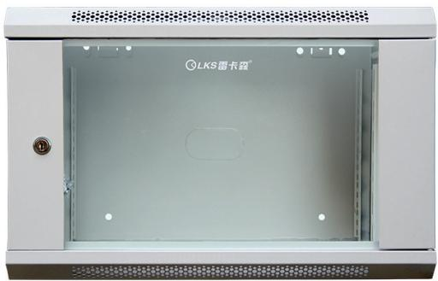 | 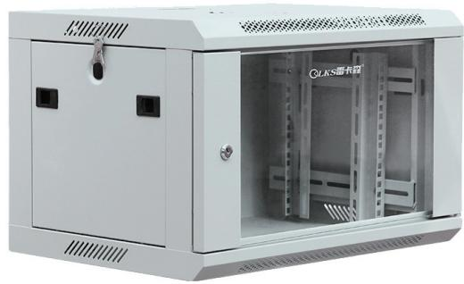 | 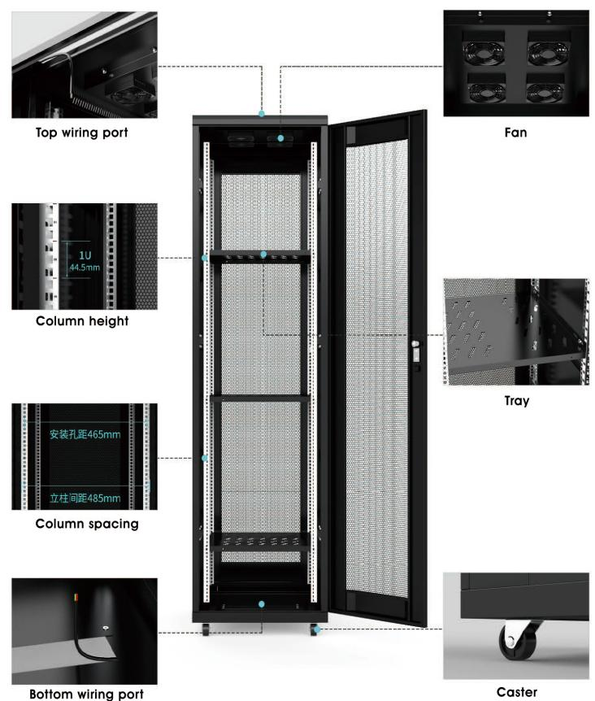 | 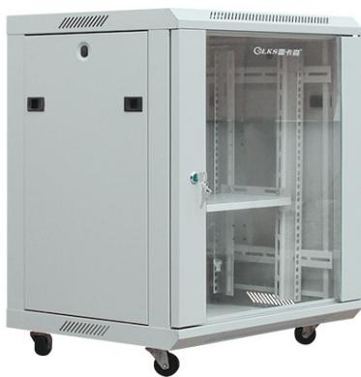
K1-5006 · Primary | K1-5006 · Gallery | K1-5006 · Diagram · Series Reference View | K1-5012 · Primary

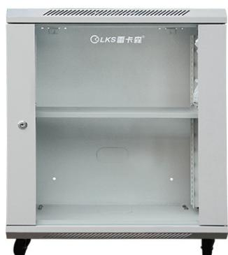 |  | 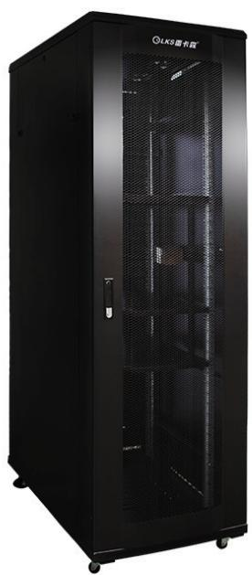 | 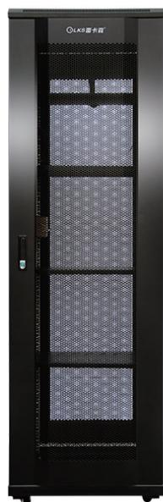
K1-5012 · Gallery | K1-5012 · Diagram · Series Reference View | K1-6042 · Primary | K1-6042 · Gallery

PRODUCT OVERVIEW
19-inch network and server cabinets for standard IT, networking and security equipment.
Product line | Rack Cabinets & Data Center Containment
Series / family | k1
Exact model | K1-5006 | K1-5012 | K1-6042 | K1-6638 | K1-6642
Applications | Wall-mount network cabinets, CCTV and ELV equipment racks, Small server rooms
MODEL COMPARISON
Exact model | Product / variant | Type | Dimensions | Height
K1-5006 | K1-5006 6U wall-mount network cabinet | Network cabinet / wall-mount cabinet | 350 × 550 × 400 mm | 6U
K1-5012 | K1-5012 12U Compact Network Cabinet | Network cabinet | 450 × 550 × 700 mm | 12U
K1-6042 | K1-6042 42U K1 server cabinet | Server cabinet | 600 × 1000 × 2000 mm | 42U
K1-6638 | K1-6638 38U K1 network cabinet | Network cabinet | 600 × 600 × 1800 mm | 38U
K1-6642 | K1-6642 42U K1 Cabinet (Duplicate Catalog Specification) | Catalog classification: server cabinet | catalog states 600 × 1000 × 2000 mm | Not provided
TECHNICAL SPECIFICATIONS
Models: K1-5006 | K1-5012 | K1-6042 | K1-6638
Parameter | K1-5006 | K1-5012 | K1-6042 | K1-6638
Type | Network cabinet / wall-mount cabinet | Network cabinet | Server cabinet | Network cabinet
Dimensions | 350 × 550 × 400 mm | 450 × 550 × 700 mm | 600 × 1000 × 2000 mm | 600 × 600 × 1800 mm
Height | 6U | 12U | 42U | 38U
Mounting Rail Spacing | 485 mm (19-inch standard) | 485 mm (19-inch standard) | 485 mm (19-inch standard) | 485 mm (19-inch standard)
Sheet Thickness | mounting rails 2.0 mm; other panels 1.0 mm | mounting rails 2.0 mm; other panels 1.0 mm | mounting rails 2.0 mm; other / main load-bearing beam approx. 1.1±0.1 mm | mounting rails 2.0 mm; other panels 1.1 mm
Material / Finish | SPCC cold-rolled steel, degreased and powder-coated | SPCC cold-rolled steel, degreased and powder-coated | SPCC cold-rolled steel, degreased and powder-coated | SPCC cold-rolled steel, degreased and powder-coated
Series Load Capacity | Wall-mount small-cabinet load rating: ≤50 kg | Small-cabinet catalog load rating: ≤50 kg | K1 series catalog load rating: ≤600 kg | ≤600kg
Standard Configuration | cage nuts and screws × 20、6Umounting rails × 4、glass door × 1、side panels × 2 | cage nuts and screws × 20、12Umounting rails × 4、glass door × 1、side panels × 2、shelves × 1、casters × 4 | PDU × 1、cage nuts and screws × 20、M12leveling feet × 4、42Umounting rails × 4、front and rear mesh doors × 1、side panels × 2、fans × 2、shelves × 3、casters × 4 | PDU × 1、cage nuts and screws × 20、M12leveling feet × 4、38Umounting rails × 4、front and rear mesh doors × 1、side panels × 2、fans × 1、shelves × 3、casters × 4
Recommended Equipment Depth | <300 mm | <350 mm | <850 mm | <450 mm
Product series | K1 Network & Server Cabinet Series | K1 Network & Server Cabinet Series | K1 Network & Server Cabinet Series | K1 Network & Server Cabinet Series
Product category | Data Center Cabinet | Data Center Cabinet | Data Center Cabinet | Data Center Cabinet
Models: K1-6642
Parameter | Specification
Type | Catalog classification: server cabinet
Dimensions | catalog states 600 × 1000 × 2000 mm
Mounting Rail Spacing | 485 mm (19-inch standard)
Sheet Thickness | mounting rails 2.0 mm; main load-bearing beam approx. 1.1±0.1 mm
Material / Finish | SPCC cold-rolled steel, degreased and powder-coated
Standard Configuration | Same catalog specification as K1-6042
Recommended Equipment Depth | <850 mm
Product series | K1 Network & Server Cabinet Series
Product category | Data Center Cabinet
APPLICATIONS & RFQ CONFIRMATION
Typical applications | Confirm in the project RFQ
Wall-mount network cabinets  CCTV and ELV equipment racks  Small server rooms | Confirm the application, rack or room position, destination-market interface and mounting requirement.  Confirm electrical, network, accessory or protection scope from the product family and project drawings.  Confirm quantity, labeling, packing and required documents before purchase order.
Project supply: MOQ — Confirm by model and project quantity · Lead time — Confirm after configuration review · FOB port — Confirm in project quotation · OEM/ODM — To be confirmed
PROJECT CONFIGURATION CHECKLIST
Exact model | K1-5006
Application and site conditions | Confirm installation environment and operating requirements.
Quantity and model mix | Confirm forecast quantity, phase plan and required variants.
Interfaces and accessories | Confirm compatible interfaces, accessories and system integration scope.
Finish, branding and packing | Confirm only when project customization is required.
Documentation and destination | Confirm drawings, datasheets, packing documents and destination country or port.

