
RACK CABINETS & DATA CENTER CONTAINMENT

Custom Cold Aisle Containment Series / Manufacturer Model Not Provided
  - Exact model: COLD-AISLE-CUSTOM
PRODUCT IMAGES
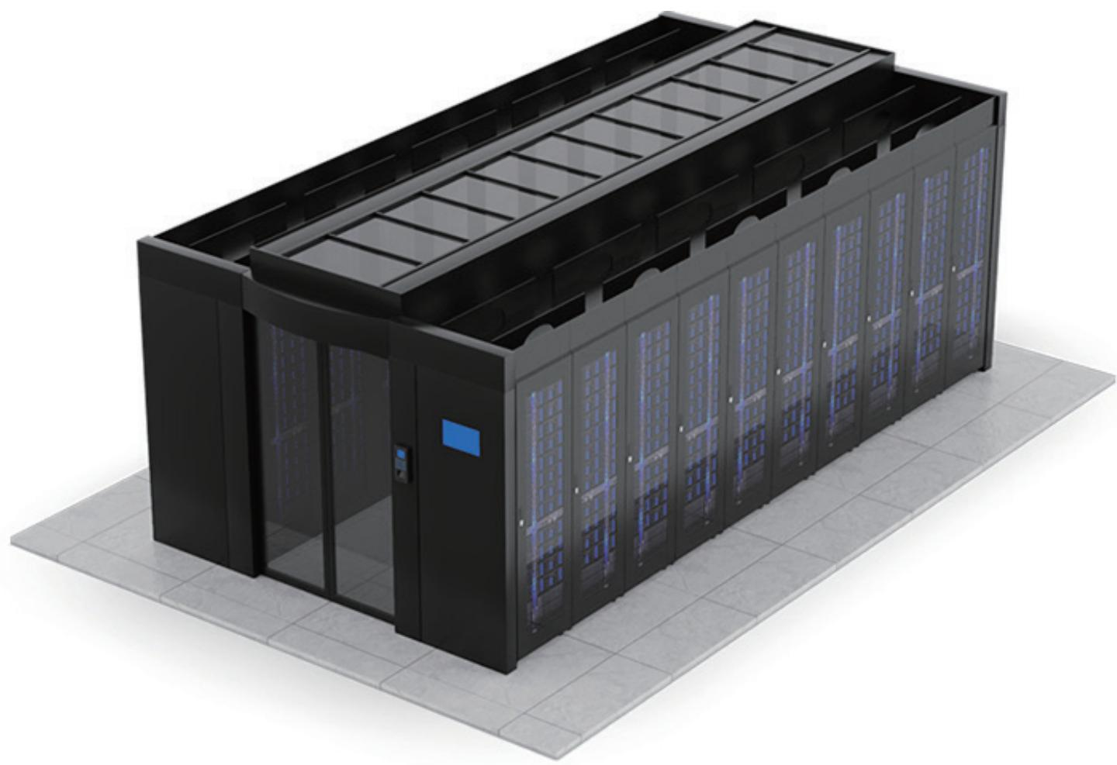 | 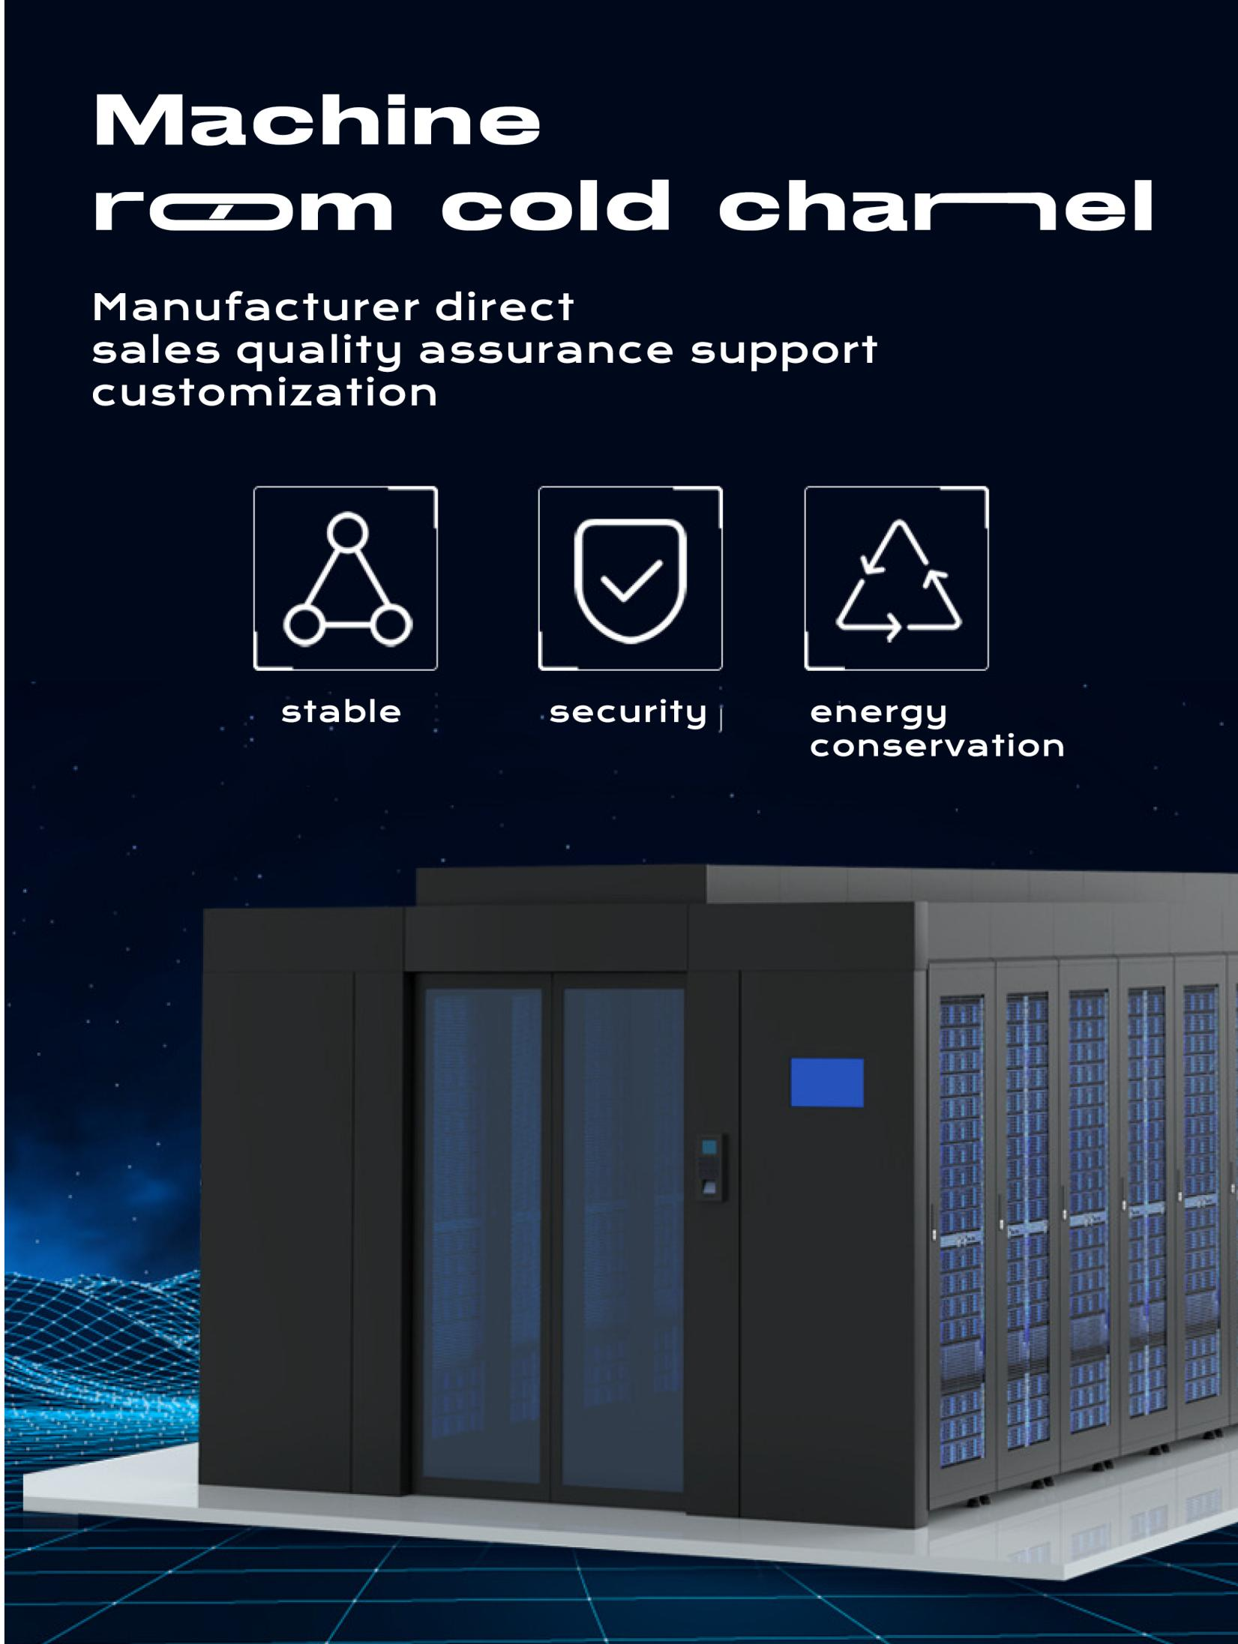
COLD-AISLE-CUSTOM · Primary · Series Reference View | COLD-AISLE-CUSTOM · Gallery

PRODUCT OVERVIEW
Modular cold aisle containment for data centers, designed to separate hot and cold airflow and support project integration.
Product line | Rack Cabinets & Data Center Containment
Series / family | cold-aisle
Exact model | COLD-AISLE-CUSTOM
Applications | Data centers, Server rooms, Energy-efficiency retrofit projects
MODEL IDENTIFICATION
Exact model | Product / variant | Catalog Dimension Reference | Structure | End Door
COLD-AISLE-CUSTOM | Custom Cold Aisle Containment Series / Manufacturer Model Not Provided | Catalog illustration: aisle width approx. 700 mm; cabinet-row/module depth approx. 980 mm | Single-row or dual-row modular enclosed aisle | High-transparency tempered-glass end door; hinged or sliding configuration
TECHNICAL SPECIFICATIONS
Parameter | Specification
Catalog Dimension Reference | Catalog illustration: aisle width approx. 700 mm; cabinet-row/module depth approx. 980 mm
Structure | Single-row or dual-row modular enclosed aisle
End Door | High-transparency tempered-glass end door; hinged or sliding configuration
Roof | High-transparency roof skylight
Airflow | Perforated cabinet doors support aisle airflow
System Integration | Can integrate with the data-room fire protection system
Expansion | Interfaces reserved for cameras, temperature detection and other modules
Product series | Data Center Cold Aisle Containment System
Product category | Cold Aisle Containment
APPLICATIONS & RFQ CONFIRMATION
Typical applications | Confirm in the project RFQ
Data centers  Server rooms  Energy-efficiency retrofit projects | Confirm the application, rack or room position, destination-market interface and mounting requirement.  Confirm electrical, network, accessory or protection scope from the product family and project drawings.  Confirm quantity, labeling, packing and required documents before purchase order.
Project supply: MOQ — Confirm by model and project quantity · Lead time — Confirm after configuration review · FOB port — Confirm in project quotation · OEM/ODM — To be confirmed
PROJECT CONFIGURATION CHECKLIST
Exact model | COLD-AISLE-CUSTOM
Application and site conditions | Confirm installation environment and operating requirements.
Quantity and model mix | Confirm forecast quantity, phase plan and required variants.
Interfaces and accessories | Confirm compatible interfaces, accessories and system integration scope.
Finish, branding and packing | Confirm only when project customization is required.
Documentation and destination | Confirm drawings, datasheets, packing documents and destination country or port.

