
RACK CABINETS & DATA CENTER CONTAINMENT

K5-8842 42U 800 × 800 K5 server cabinet
  - Exact model: K5-8842
PRODUCT IMAGES
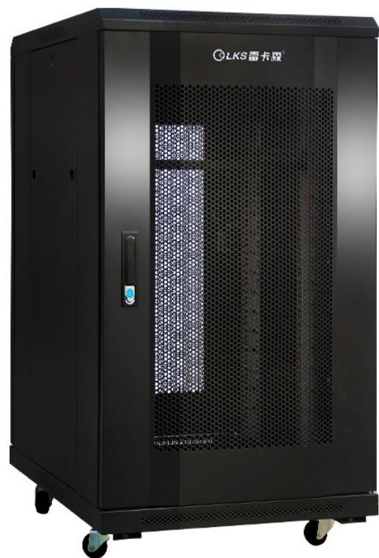 | 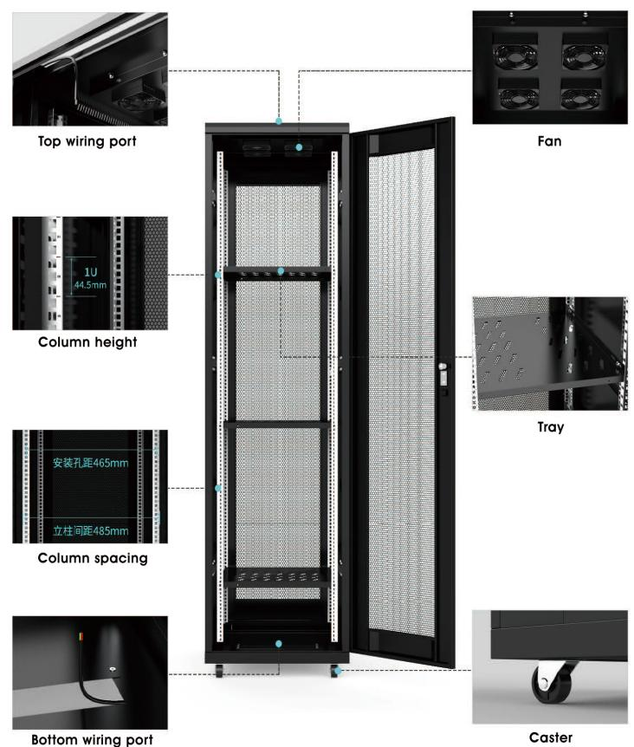
K5-8842 · Primary | K5-8842 · Diagram · Series Reference View

PRODUCT OVERVIEW
Heavy-duty 19-inch server cabinets for higher load and deeper equipment configurations.
Product line | Rack Cabinets & Data Center Containment
Series / family | k5
Exact model | K5-8842
Applications | Server rooms, Data-room racks, High-load equipment cabinets
MODEL IDENTIFICATION
Exact model | Product / variant | Type | Dimensions | Height
K5-8842 | K5-8842 42U 800 × 800 K5 server cabinet | Server cabinet | 800 × 800 × 2000 mm | 42U
TECHNICAL SPECIFICATIONS
Parameter | Specification
Type | Server cabinet
Dimensions | 800 × 800 × 2000 mm
Height | 42U
Mounting Rail Spacing | 485 mm (19-inch standard)
Sheet Thickness | Product table: mounting rails 2.0 mm and other panels 1.1 mm; series heading: other panels 1.2 mm
Material / Finish | SPCC cold-rolled steel, degreased and powder-coated
Series Load Capacity | ≤700kg
Standard Configuration | PDU × 1、cage nuts and screws × 20、M12leveling feet × 4、42Umounting rails × 4、front and rear mesh doors × 1、side panels × 2、fans × 1、shelves × 1、casters × 4、cable channels × 2
Recommended Equipment Depth | <650 mm
Product series | K5 Heavy-Duty Server Cabinet Series
Product category | Data Center Cabinet
APPLICATIONS & RFQ CONFIRMATION
Typical applications | Confirm in the project RFQ
Server rooms  Data-room racks  High-load equipment cabinets | Confirm the application, rack or room position, destination-market interface and mounting requirement.  Confirm electrical, network, accessory or protection scope from the product family and project drawings.  Confirm quantity, labeling, packing and required documents before purchase order.
Project supply: MOQ — Confirm by model and project quantity · Lead time — Confirm after configuration review · FOB port — Confirm in project quotation · OEM/ODM — To be confirmed
PROJECT CONFIGURATION CHECKLIST
Exact model | K5-8842
Application and site conditions | Confirm installation environment and operating requirements.
Quantity and model mix | Confirm forecast quantity, phase plan and required variants.
Interfaces and accessories | Confirm compatible interfaces, accessories and system integration scope.
Finish, branding and packing | Confirm only when project customization is required.
Documentation and destination | Confirm drawings, datasheets, packing documents and destination country or port.

