
RACK CABINETS & DATA CENTER CONTAINMENT

K5-61242 42U 1200 mm-Deep K5 Server Cabinet
  - Exact model: K5-61242
PRODUCT IMAGES
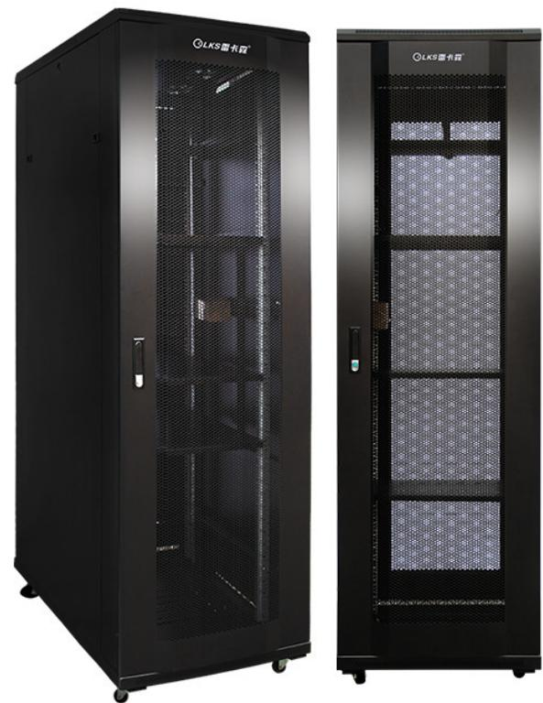 | 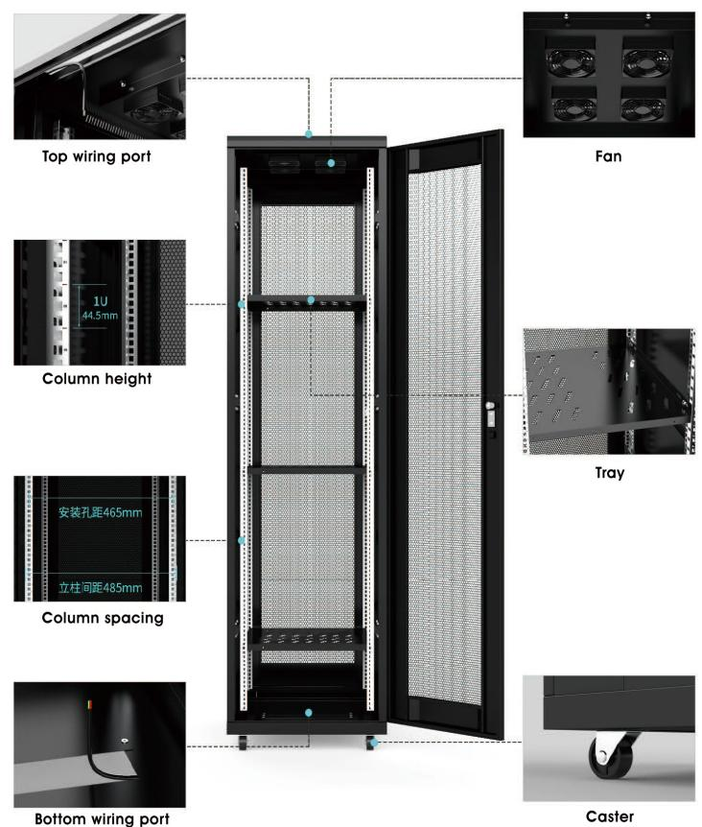
K5-61242 · Primary | K5-61242 · Diagram · Series Reference View

PRODUCT OVERVIEW
Heavy-duty 19-inch server cabinets for higher load and deeper equipment configurations.
Product line | Rack Cabinets & Data Center Containment
Series / family | k5
Exact model | K5-61242
Applications | Server rooms, Data-room racks, High-load equipment cabinets
MODEL IDENTIFICATION
Exact model | Product / variant | Type | Dimensions | Height
K5-61242 | K5-61242 42U 1200 mm-Deep K5 Server Cabinet | Server cabinet | 600 × 1200 × 2000 mm | 42U
TECHNICAL SPECIFICATIONS
Parameter | Specification
Type | Server cabinet
Dimensions | 600 × 1200 × 2000 mm
Height | 42U
Mounting Rail Spacing | 485 mm (19-inch standard)
Sheet Thickness | mounting rails 2.0 mm; other panels 1.2 mm
Material / Finish | SPCC cold-rolled steel, degreased and powder-coated
Series Load Capacity | K5 series catalog load rating on page 13: ≤700 kg
Standard Configuration | PDU × 1、cage nuts and screws × 20、M12leveling feet × 4、42Umounting rails × 4、front and rear mesh doors × 1、side panels × 2、fans × 4、shelves × 3、casters × 4
Recommended Equipment Depth | <1050 mm
Product series | K5 Heavy-Duty Server Cabinet Series
Product category | Data Center Cabinet
APPLICATIONS & RFQ CONFIRMATION
Typical applications | Confirm in the project RFQ
Server rooms  Data-room racks  High-load equipment cabinets | Confirm the application, rack or room position, destination-market interface and mounting requirement.  Confirm electrical, network, accessory or protection scope from the product family and project drawings.  Confirm quantity, labeling, packing and required documents before purchase order.
Project supply: MOQ — Confirm by model and project quantity · Lead time — Confirm after configuration review · FOB port — Confirm in project quotation · OEM/ODM — To be confirmed
PROJECT CONFIGURATION CHECKLIST
Exact model | K5-61242
Application and site conditions | Confirm installation environment and operating requirements.
Quantity and model mix | Confirm forecast quantity, phase plan and required variants.
Interfaces and accessories | Confirm compatible interfaces, accessories and system integration scope.
Finish, branding and packing | Confirm only when project customization is required.
Documentation and destination | Confirm drawings, datasheets, packing documents and destination country or port.

